Employing micro-aeration in anaerobic digestion of poultry litter and wheat straw: Batch kinetics and continuous performance

Yuanhang Zhan^{1*}, Jun Zhu¹, Yiting Xiao¹, Leland C. Schrader¹, Sarah Xiao Wu², Ndeddy Aka Robinson Jr², Zhiwu Wang³

¹Department of Biological and Agricultural Engineering, University of Arkansas, Fayetteville, AR 72701, USA
²Department of Chemical and Biological Engineering, University of Idaho, Moscow, ID 83844, USA
³Department of Biological Systems Engineering, Virginia Tech, Blacksburg, VA 24060, USA

*Correspondence: yz062@uark.edu; Tel.: +1-479-575-2688

Table S1. The pretrial experimental data of batch anaerobic co-digestion of poultry litter and wheat straw (mean and standard deviation (SD)).
Pretrial No. | Poultry litter (g) | Wheat straw (g) | Volatile solids (g) | Inoculum sludge (mL) | Reactor configuration | Cumulative methane yield (mL CH₄/g VS _{added})
1 | 5.00 | 5.00 | 8.23 | 200 | 0.5 L, 37 °C | 197.12
2 |  |  |  |  |  | 197.74
3 |  |  |  |  |  | 197.33
Mean |  |  |  |  |  | 197.40
Standard deviation |  |  |  |  |  | 0.32

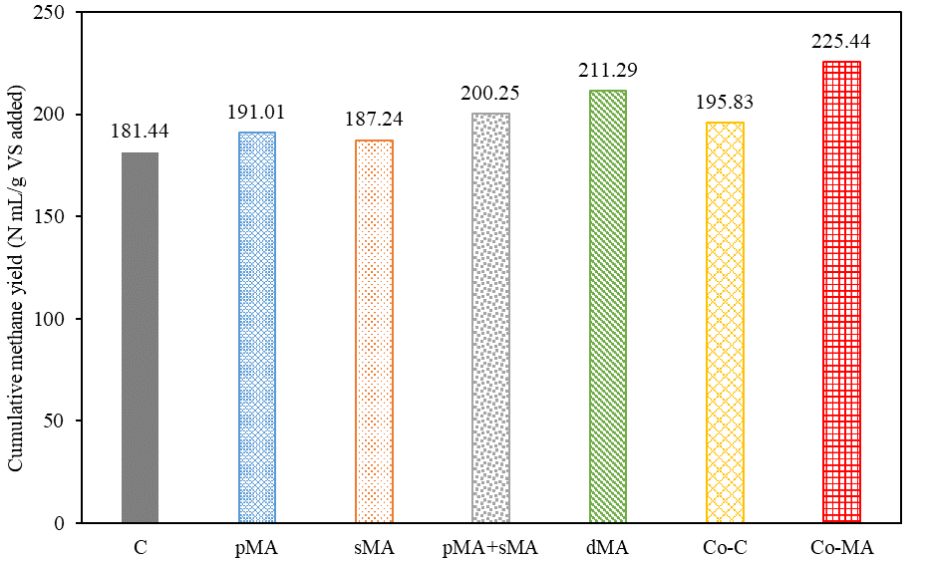

Figure S1. The cumulative methane yield, N mL CH₄/g VS added, in batch reactors of Mo-AD and Co-AD experiments.
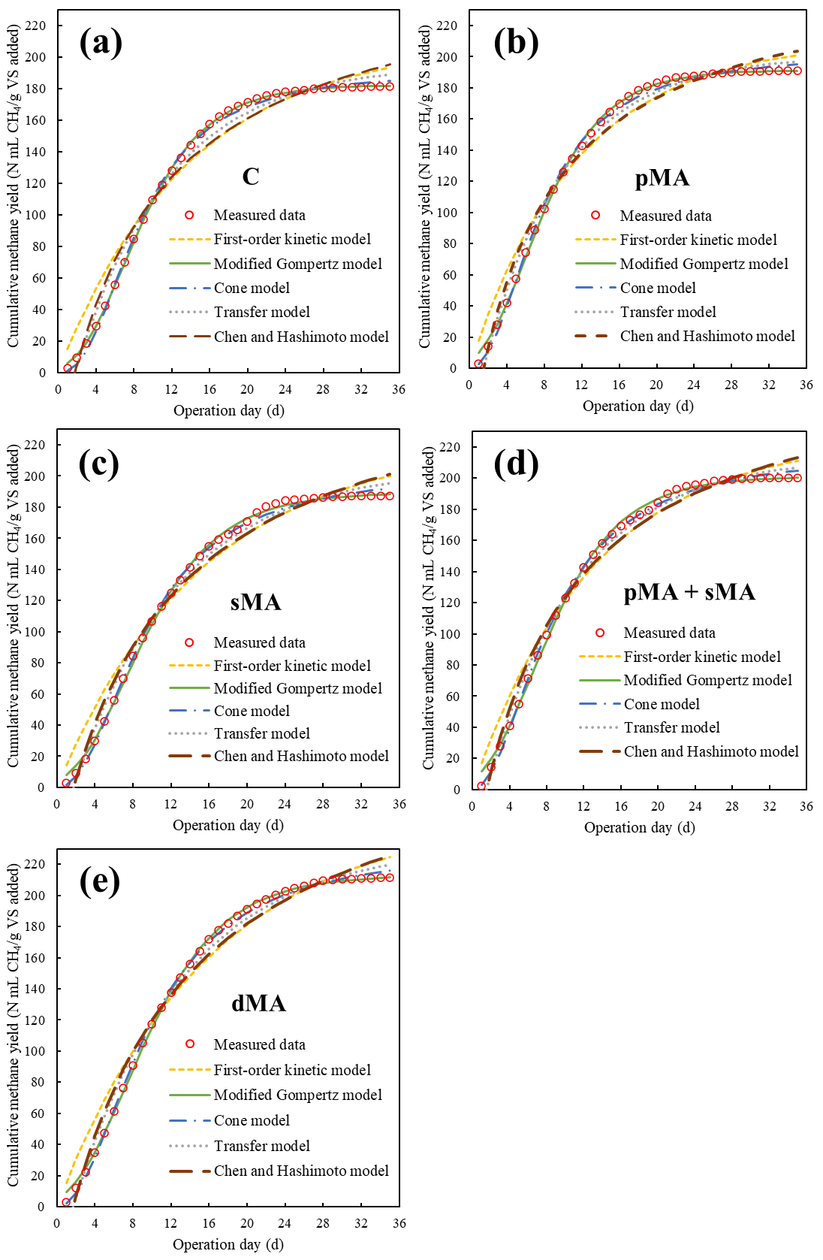

Figure S2. The measured cumulative methane yield and kinetic models fitting of the anaerobic mono-digestion of wheat straw in the group of (a) C; (b) pMA; (c) sMA; (d) pMA+sMA; and (e) dMA. C: control, no micro-aeration; pMA: pretreatment micro-aeration; sMA: secondary micro-aeration; dMA: daily micro-aeration.
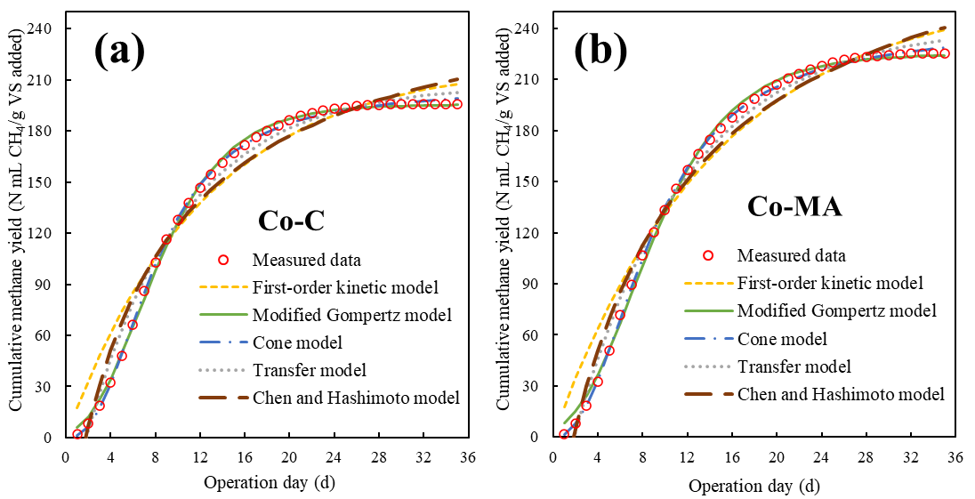

Figure S3. The measured cumulative methane yield and kinetic models fitting of the anaerobic co-digestion of wheat straw and poultry litter in (a) Co-C; (b) Co-MA. Co-C: the control; Co-MA: the group with daily micro-aeration.

