Micro-aeration and leachate recirculation for the acceleration of landfill stabilization: Enhanced hydrolytic acidification by facultative bacteria

Kaili Liu ^{a,1}, Longyi Lv ^{a,*,1}, Weiguang Li^{b}, Xinyuan Wang ª, Muda Han ª, Zhijun Ren ª, Wenfang Gao ª, Pengfei Wang ª, Xiaoyang Liu ª, Li Sun ª, Guangming Zhang ^{a,}*

ª Tianjin Key Laboratory of Clean Energy and Pollution Control, School of Energy and Environmental Engineering, Hebei University of Technology, Tianjin 300401, PR China
^{b} State Key Laboratory of Urban Water Resource and Environment, Harbin Institute of Technology (SKLUWRE, HIT), Harbin 150090, PR China
¹Authors contributed equally to this paper

* Corresponding author:

Longyi Lv, E-mail: lvlongyi@hebut.edu.cn, Tianjin Key Laboratory of Clean Energy and Pollution Control, School of Energy and Environmental Engineering, Hebei University of Technology, 5340 Xiping Road, Beichen District, Tianjin 300401, PR China.

Guangming Zhang, E-mail: 2020017@hebut.edu.cn, Tianjin Key Laboratory of Clean Energy and Pollution Control, School of Energy and Environmental Engineering, Hebei University of Technology, 5340 Xiping Road, Beichen District, Tianjin 300401, PR China.

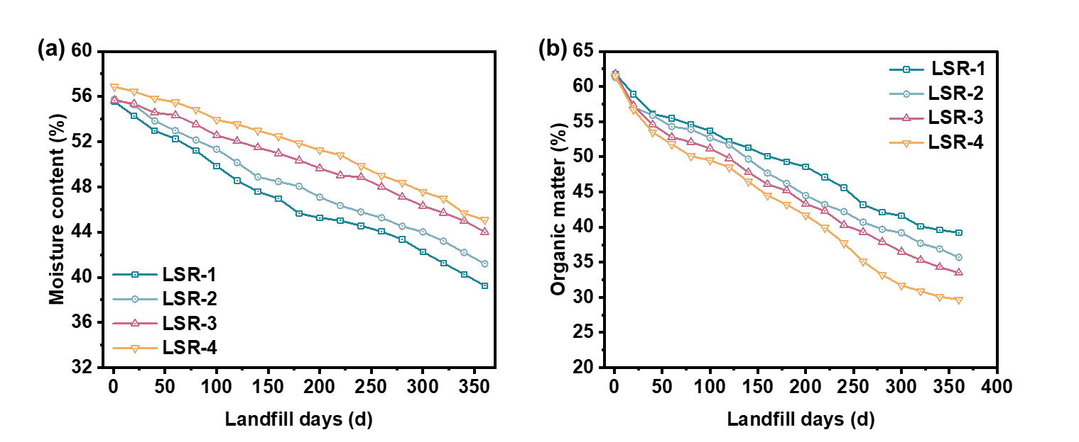
Fig. S1. (a) Change of organic matter with time; and (b) change of moisture content with time.

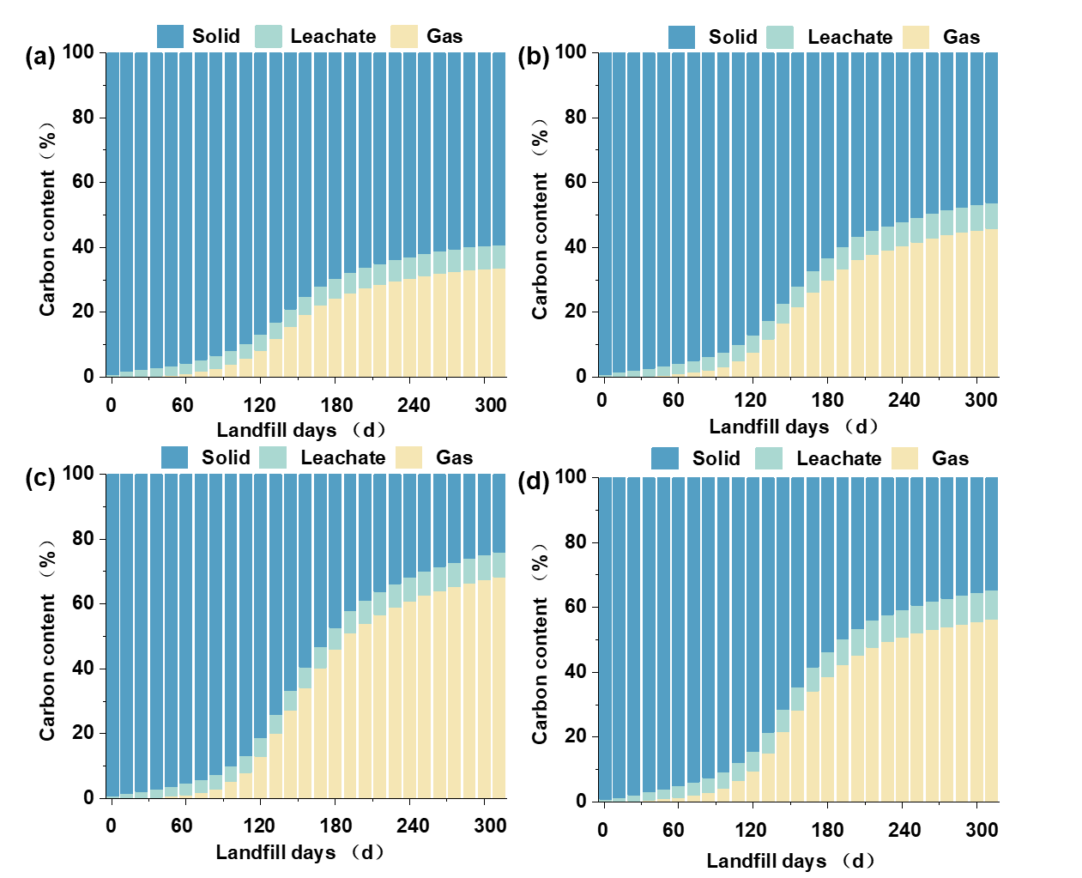
Fig. S2. Carbon balance of solid-liquid-gas phases in landfill piles (0~300d).

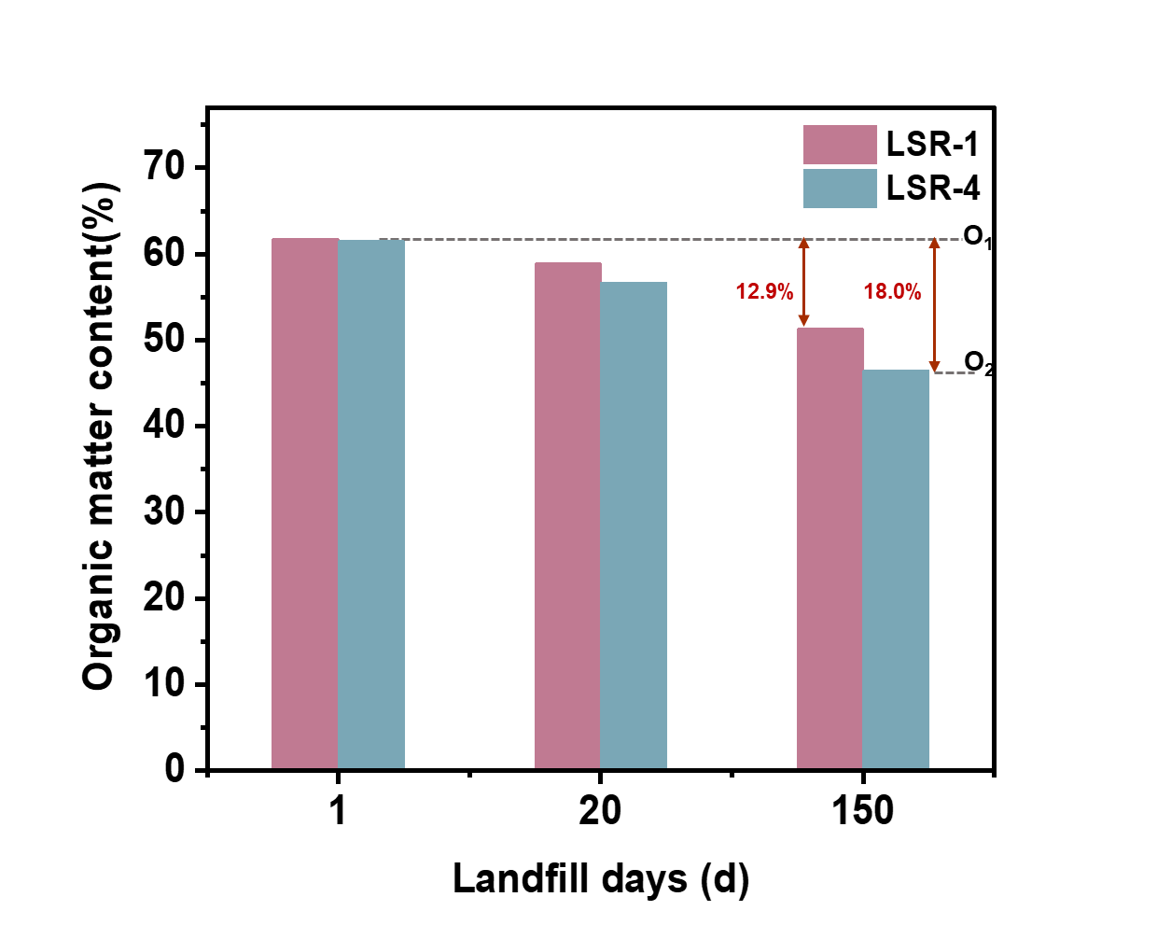
Fig. S3. Changes in organic matter of the landfill waste during the hydrolysis stage.

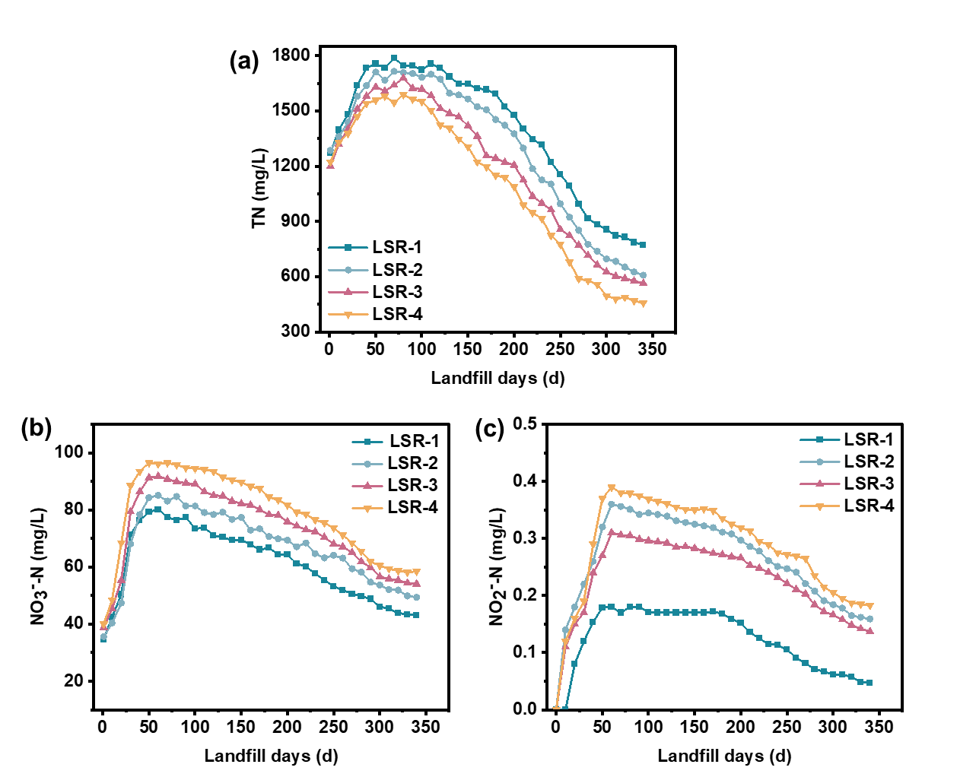
Fig. S4. Changes in concentration of different forms of nitrogen: (a) Change of TN concentration in leachate; (b) Change of NO₃⁻-N concentration in leachate; (c) Change of NO₂⁻-N concentration in leachate.

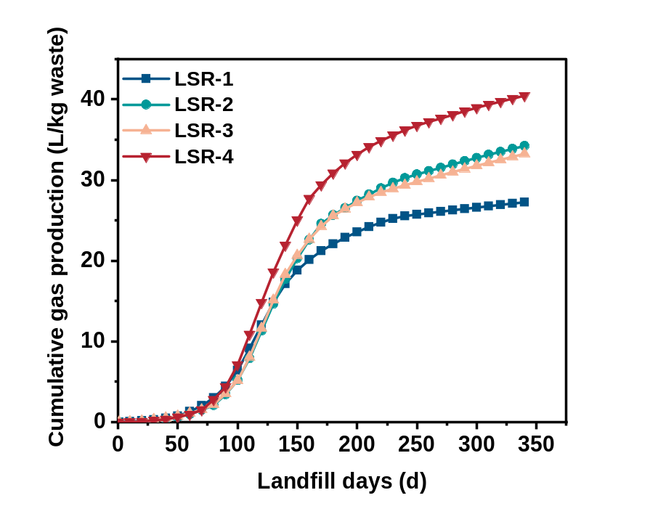
Fig. S5. Cumulative gas production during landfill experiments.

Table S1. Changes in DO (dissolved oxygen) before and after aeration (0~120 min) of the reactor (DO: mg/L).
Time  Number | 0 | 5 | 15 | 30 | 40 | 50 | 60 | 100 | 120
LSR-1 | 0.30 | - | - | - | - | - | - | - | -
LSR-2 | 0.45 | 6.81 | 8.6 | 7.1 | 6.9 | 5.6 | 4.6 | 2.12 | 1.01
LSR-3 | 0.31 | - | - | - | - | - | - | - | -
LSR-4 | 0.42 | 6.78 | 8.1 | 6.9 | 5.8 | 5.4 | 4.62 | 2.31 | 1.13
Description: The DO concentration of LSR-1 and LSR-3 has been maintained at 0.3 to 0.4 mg/L. For LSR-2 and LSR-4, the DO concentration was measured during the period from the beginning of aeration (0 to 15 min) to the end of aeration (15 to 120 min).

