Supplementary information of
Non-targeted facilitation of primary sludge anaerobic fermentation by micro-aeration and the simultaneous nutrients transformations
Caihong Liu¹, Tanglong Zhang¹, Lin Li^{1, *}, Shaowu Liu² Jingjun Bo¹, Mohammed Mouhib³, Qiang He^{1, *}
¹ Key laboratory of the Three Gorges Reservoir Region's Eco-environment, Ministry of Education, College of Environment and Ecology, Chongqing University, Chongqing 400045, China
² Chongqing Water Group Co., Ltd., Chongqing 400000, China;
³ Institute of Chemical Sciences and Engineering (ISIC), Ecole Polytechnique Federale de Lausanne (EPFL), 1015 Lausanne, Switzerland;

Corresponding author: Lin Li, li.lin@cqu.edu.cn

Text S1 Enzyme activities and Excitation emission matrix fluorescence spectra
Lactate dehydrogenase (LDH) and catalase (CAT) activities were investigated to reveal the effects of micro-aeration on the microbial activities. To assess the influence of micro-aeration on hydrolysis, acetogenesis and methanogenesis steps, activities of protease, acetate kinase (AK), coenzyme F420 and ACS were determined, respectively. Activities of the above enzymes were determined using corresponding reagent kits (Shanghai Hengyuan, China) according to the manufacturers’ guidelines. The sludge slurry was centrifuged at 8000 rpm and the supernatant was passed through a 0.45 μm filter. A fluorescence spectrophotometer (F-7000, Hitachi, Japan) was used to obtain EEM spectra of the filtrates. The obtained spectra could be divided into five regions according to previous literature. The fluorescence regional integration (FRI) technique was utilized to calculate the fluorescent intensities of each region (Chen et al., 2003).
Text S2 The extraction of P from primary sludge solids
The P of primary sludge solids was extracted according a previous literature (Xu et al., 2023). 50 mL of the sludge was collected and freeze-dried for 48 h. After grinding and screening through the 70-mesh screen, take 0.2 g of sludge in a 50 mL centrifuge tube. Add 20 mL of 1 M MgCl₂ to the centrifuge tube and mix them at 25℃ for 2 h, the P in the supernatant was regarded as Loosely-P; Sediments from the former step were then mixed with 20 mL of 0.2% 2,2-bipyridine at 50℃ for 24 h, the P in the supernatant is determined as Fe (Ⅱ)-P; Then, 20 mL of 0.5 M NH₄F was added into the sediment and mixed at 25℃ for 1 h, the supernatant P was determined as Al-P; Further mix 20 mL of 0.1 M NaOH with the former sediment at 25℃ for 17 h, the supernatant P is determined as Fe (Ⅲ)-P; Continue to mix 20 mL of solution (0.3 M Na₃C₃H₆O₇ + 1 M Na₂S₂O₄ + 1 M NaHCO₃) with the sediment at 85℃ for 15 min, the supernatant P is regarded as Reductant-P; After that, mix 20 mL 1 M HCl with the obtained sediment for 16 h at 25℃, the supernatant P is determined as Ca-P; Finally, the obtained sediment is calcined at 550℃ for 2 h. After cooling, mix it with 20mL 1 M HCl at 25℃ for 16 h, the supernatant P is determined as Organic-P.
Text S3 real-time quantitative PCR (RT-qPCR)
The RT-qPCR were conducted by Majorbio Bio-pharm Technology Co., Ltd (Shanghai, China). Genes encoding the formyl tetrahydrofolate synthetase (FTHFS), ACS (EC: 6.2.1.1), methyl coenzyme reductase (mcrA, EC: 2.8.4.1), and nitrate reductase (narG), related to acetogenesis, methanogenesis, and nitrogen transformation, were quantified by RT-PCR according to previous literature (Liu et al., 2022).
Text S4 16S rRNA gene sequencing
The 16S rRNA gene sequencing were conducted by Majorbio Bio-pharm Technology Co., Ltd. (Shanghai, China). The sludge samples were collected at the end of anaerobic fermentation (day 30). They were centrifugated at 10000 rpm for 10 min, and the pellets were stored in a sterile tube at -80°C. The DNA was extracted according to E.Z.N.A® soil kit instructions (OMEGA soil DNA Kit, Omega Bio tek, USA). The concentration and purity of DNA were determined by an ultra-micro spectrophotometer (NanoDrop2000, Thermo Scientific, USA). After quality determination by 1% agarose gel electrophoresis, the extracted DNA was amplified by polymerase chain reaction (PCR) with the universal bacterial primers 338F-806R (5′-ACTCCTACGGGGAGGCAGCAG-3′, 5′-GGACTACNNGGGTATCTAAT-3′) and archaeal primers Arch344F- Arch 915R (5'-ACGGGGYGCAGCAGGCGCGA-3', 5'-GTGCTCCCCCGCCAATTCCT-3'). The PCR products were used for the subsequent paired-end sequencing on an Illumina platform by Majorbio Bio-pharm Technology Co., Ltd.

Table S1. The main characteristics of the primary sludge and inoculum for the batch and semi-continuous experiments
Parameter | Batch experiments | Semi-continuous experiment
Parameter | primary sludge | primary sludge | inoculum
SCOD (mg/L) | 1302.24±87.56 | 1216.90±34.51 | 2975.27±66.58
VFA  (mg COD/L) | 873.85±68.02 | 800.72±47.95 | 2106.32±24.16
Protein (mg/L) | 247.57±16.32 | 175.12±8.76 | 587.51±46.57
Polysaccharide (mg/L) | 15.23±2.50 | 21.44±1.97 | 52.54±3.45
NH₄⁺-N (mg/L) | 145.62±2.14 | 124.22±3.15 | 288.67±5.49
NO₃⁻-N (mg/L) | 2.24±0.07 | 3.71±0.47 | 9.21±1.41
NO₂⁻-N (mg/L) | 0.92±0.01 | 1.42±0.21 | 0.34±0.05
PO₄³⁻-P (mg/L) | 23.41±1.14 | 38.14±4.02 | 32.39±2.68
VSS (mg/L) | 22400±700 | 23720±1250 | 19580±980

Table S2. primers for qPCR analysis
Primer | Target gene | Primer/Probe sequence | Reference
FTHFS-Fw | FTHFS | TTYACWGGHGAYTTCCATGC | (Liu et al., 2022)
FTHFS-Rv | FTHFS | GTATTGDGTYTTRGCCATACA | (Liu et al., 2022)
ACS-Fw | ACS | TAATCCGCCAAAAGAGTTGG | (Liu et al., 2022)
ACS-Rv | ACS | TCTTCTGGACTGGCTGGTCT | (Liu et al., 2022)
mcrA-Fw | mcrA | TTCGGTGGATCDCARAGRGC | (Chen et al., 2021)
mcrA-Rv | mcrA | GBARGTCGWAWCCGTAGAATCC | (Chen et al., 2021)
narG-Fw | narG | TAYGTSGGGCAGGARAAACTG | (Chen et al., 2021)
narG-Rv | narG | CGTAGAAGAAGCTGGTGCTGTT | (Chen et al., 2021)

Table S3. Regional integration of fluorescence intensity of EEM spectra
Region | Ex(nm) | Em(nm) | Type of organic matter | Reference
Ⅰ | ＜250 | ＜330 | Simple aromatic proteins Ⅰ | (Xie et al., 2012)
Ⅱ | ＜250 | 330-380 | Simple aromatic proteins Ⅱ | (Xie et al., 2012)
Ⅲ | ＜250 | 380-500 | Fulvic acid-like | (Xie et al., 2012)
Ⅳ | 250-280 | ＜380 | Soluble microbial products | (Xie et al., 2012)
Ⅴ | ＞250 | 380-500 | Humic acid-like | (Xie et al., 2012)

Table S4. The C content distribution of semi-continuous samples
 | Influent | Control | Micro-aeration
TC-Solid | 269.43±4.52 mg/g | 227.39±3.87 mg/g | 231.50±12.42 mg/g
IC-Solid | 24.19±2.13 mg/g | 37.23±1.79 mg/g | 28.26±4.96 mg/g
TOC-Solid | 245.24±2.49 mg/g | 190.16±3.15 mg/g | 203.24±9.93 mg/g
TOC-Liquid | 4.56±0.21 mg/L | 10.34±0.38 mg/L | 12.10±0.42 mg/L
CH₄ | - | 1308.25±179.36 ppm | 192.39±16.91 ppm

Table S5. The total C mass distribution of semi-continuous samples
 | Influent | Control | Micro-aeration
TOC-Solid | 20.89±0.67 g | 16.72±0.34 g | 14.34±0.27 g
TOC-Liquid | 1.30±0.13 g | 2.92±0.11 g | 3.27±0.11 g
CH₄ | - | 0.93±0.13 g | 1.10±0.10 g
Others | - | 0.33±0.22 g | 4.17± 0.32 g

Table S6. The N content distribution of semi-continuous samples
 | Influent | Control | Micro-aeration
TN-Solid (mg/L) | 744.12±8.10 | 558.00±10.67 | 521.67±8.22
NH₄⁺-N-Liquid (mg/L) | 126.55±2.10 | 297.44±2.28 | 251.70±1.36
NO₃⁻-N-Liquid (mg/L) | 0.38±0.34 | 1.63±0.40 | 1.64±0.18
NO₂⁻-N-Liquid (mg/L) | 0.02±0.01 | 0.02±0.01 | 6.02±0.67

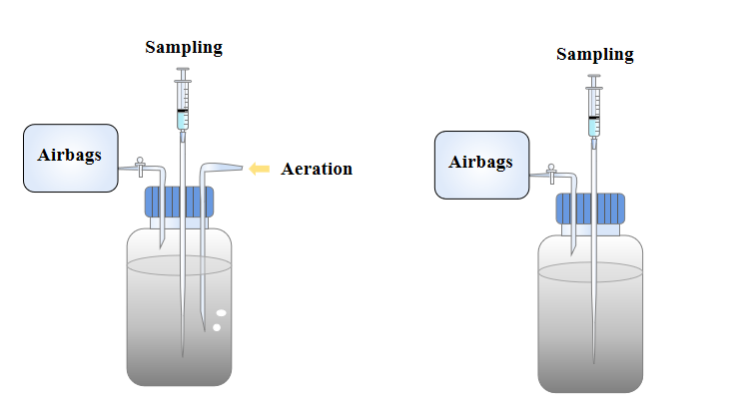
Fig. S1. Serum bottle setup for the batch experiments.

Fig. S2. Distribution of the fluorescence regional integration from EEM spectra.

Fig. S3. Nitrogen conversion during batch fermentation: (a) The variations of soluble N distribution in control and micro-aeration groups during the fermentation; (b) The distribution of N in the solid and liquid phases (Day 9).

Fig. S4. The VFA growth rate of effluent compared to the influent during the semi-continuous fermentation process.

Fig. S5. ORP variation after addition of new influent in the semi-continuous reactors.

Fig. S6. The P distribution based on sequential extraction: (a) the P content in solid phase, (b) the P proportion in the solid phase and (c) the total P content distributed in the liquid and solid phases in the semi-continuous reactors.

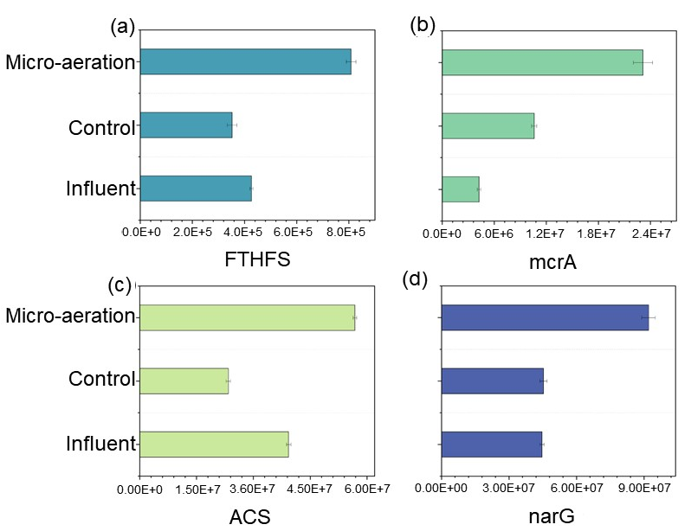
Fig. S7. RT-qPCR analysis of key functional genes in the semi-continuous reactors: (a) narG, (b) FTHFS, (c) mcrA, and (d) ACS.

Reference:

Chen, C., Shen, Y., Li, Y.H., Zhang, W.W. and Zhao, F.J. 2021. Demethylation of the Antibiotic Methylarsenite is Coupled to Denitrification in Anoxic Paddy Soil. Environ. Sci. Technol. 55(22), 15484-15494.
Chen, W., Westerhoff, P., Leenheer, J.A. and Booksh, K. 2003. Fluorescence excitation - Emission matrix regional integration to quantify spectra for dissolved organic matter. Environ. Sci. Technol. 37(24), 5701-5710.
Liu, X.R., Lu, Q., Du, M.T., Xu, Q. and Wang, D.B. 2022. Hormesis-Like Effects of Tetrabromobisphenol A on Anaerobic Digestion: Responses of Metabolic Activity and Microbial Community. Environ. Sci. Technol. 56(16), 11277-11287.
Xie, W.M., Ni, B.J., Seviour, T., Sheng, G.P. and Yu, H.Q. 2012. Characterization of autotrophic and heterotrophic soluble microbial product (SMP) fractions from activated sludge. Water Res. 46(19), 6210-6217.
Xu, X.F., Xu, Q.Y., Du, Z.X., Gu, L., Chen, C., Huangfu, X.L. and Shi, D.Z. 2023. Enhanced phosphorus release from waste activated sludge using ascorbic acid reduction and acid dissolution. Water Res. 229, 11.

