Supporting Information
A Novel Microbubbles-Assisted Fe-C Micro-Electrolysis System to Bridge the Anaerobic Digestion and Microalgae Cultivation: The Dual Drive of Electron Transfer and Coagulation

Xiaogang You^{a,b}, Libin Yang^{a,b}, Mingchao Yang^{a,b}, Jiaying Ma^{a,b}, Futao Yi^{a,b}, Tongcai Liu^{a,b}, Bo-Yu Peng^{a,b}, Jiabin Chen^{a,b}, Huaqiang Chu^{a,b}, Buchun Si^{c,d}, Xuefei Zhou^{a,b}, Yalei Zhang^{a,b}
a State Key Laboratory of Water Pollution Control and Green Resource Recycling, Shanghai 200092, China
b College of Environmental Science and Engineering, Tongji University, Shanghai 200092, China
c College of Water Resources and Civil Engineering, China Agricultural University, Beijing 100083, China
d Department of Agricultural & Biological Engineering, University of Illinois at Urbana-Champaign, Urbana 61801, USA

The supporting information file includes 14 texts, 16 Figures, and 7 tables.

CONTENTS

Text S1. Properties and characterization of Fe-C particles used in this study 4
Text S2. Microalgae cultivation in different treatment systems of biogas slurry 5
Text S3. Detailed test methods for water quality 6
Text S4. EEM Spectral Analysis 7
Text S5. 2D-COS analysis methods and details 9
Text S6. Characterization of Fe-C corrosion products 10
Text S7. Electrode preparation methods and electrochemical testing 11
Text S8. Determination of active species during the reaction 12
Text S9. Elemental composition analysis of Fe-C particles and floc samples 13
Text S10. SR-FTIR analysis of floc samples 14
Text S11. EXAFS test and analysis methods 15
Text S12. Analysis of oxidative stress in microalgae cell 16
Text S13. Analysis of variation in TN, NH₄⁺-N, and PO₄³⁻-P 17
Text S14. Analysis of UV 2D-COS results 18
Fig. S1. Characterization of Fe-C particles 19
Fig. S2. Characterization of microbubbles 20
Fig. S3. Changes in water quality during pretreatment 21
Fig. S4. Variation of floc settlement of biogas slurry 22
Fig. S5. EEM spectra of supernatant in RBS, and different systems 23
Fig. S6. EEM spectra of C1 and C2 24
Fig. S7. Fluorescence EEM contours of two PARAFAC components 25
Fig. S8. The result of fluorescence regional integration (FRI) 26
Fig. S9. Variation in relevant spectroscopic indicators 27
Fig. S10. 2D-COS plots of the UV–Vis absorption spectrum 28
Fig. S11. Spearman correlation analysis between indicators in different systems 29
Fig. S12. XRD and Fe(IV) analysis 30
Fig. S13. XPS survey spectra of flocs in MFC and CFC systems 31
Fig. S14. Wavelet transform plots of standard mineral 32
Fig. S15. Effect on microalgae growth after pretreatment of biogas slurry 33
Fig. S16. Effect on microalgae growth after pretreatment of biogas slurry with phosphorus supplementation 34
Table S1. Characteristics of the row biogas slurry 35
Table S2. Abbreviations for water quality indexes 36
Table S3. Signs of cross-peaks in synchronous (asynchronous) spectrum 37
Table S4. FRI of DOM in biogas slurry of different systems 38
Table S5. Weight ratio of each element in EDS analysis (wt%) 39
Table S6. OpenFluor matches for PARAFAC components 40
Table S7. EXAFS fitting parameters at the Fe K-edge for various samples 41
References 42

Text S1. Properties and characterization of Fe-C particles used in this study
Fe-C particles (Fig. S1a) with a specific surface area of 1.2 m²/g, physical strength of 800 kg/m², bulk density of 1100~1300 g/L, and porosity greater than 65 % (this data is from the supplier), were prepared by washing with diluted H₂SO₄ solution and deionized water to scour off the oxide coating on the surface (Huang et al., 2022).
Analysis via scanning electron microscope (SEM) illustrates the rough, porous surface structure of Fe-C particles possessing adsorption properties (Fig. S1b). Numerous small iron particles adhered to the surface of Fe-C particles and penetrated the particles' interior through embedding or encapsulation. EDS (Fig. S1c) and XPS (Fig. S1d) analyses indicate that the elements in the Fe-C particles are mainly dominated by C, O, Fe, and Si. The XRD spectra (Fig. S1e) show that the iron in the Fe-C particles is mainly dominated by Fe⁰ and Fe₃O₄. Additionally, the iron content in the Fe-C particles was verified to exceed 50% via testing conducted using an ICP-OES instrument (Agilent 5110 ICP-OES, America). The Fe-C particles exhibit a broad absorption peak at 3415 cm⁻¹ (Fig. S1f), which is related to the stretching and bending vibrations of −OH, indicating that the surface contains a large number of −OH groups (Wang et al., 2013). The absorption peaks at 1630 cm⁻¹ and 970 cm⁻¹ correspond to the vibration of C=O and C-O, respectively (Lai et al., 2012). The infrared wavelength at 568 cm⁻¹ is correlated with the stretching vibration of Fe-O in Fe₃O₄, while the absorption peak at 473 cm⁻¹ is correlated with the vibration of γ-Fe₂O₃ (Ma et al., 2017).

Text S2. Microalgae cultivation in different treatment systems of biogas slurry
The biogas slurry from different treatment systems was filtered through a 0.45 μm filter membrane before being used for microalgae cultivation. The impact of varying pretreatment durations and dilutions of the biogas slurry on microalgae growth was confirmed through biomass changes assessed in a 96-well plate. Specifically, the biogas slurry underwent dilution at varying treatment durations—2, 5, and 10 times with deionized water—followed by microalgae inoculation after 1 day of nutrient deprivation. The prepared microalgae solution was dispensed into a 96-well plate and incubated in a constant-temperature light incubator (25°C) for 2 days. Biomass variations in microalgae (measured as OD680 values) were assessed pre-and post-incubation using an enzyme meter (Thermo Scientific Multiskan Sky, America).
The supernatant from RBS and treated biogas slurry was diluted 10-fold into 100 mL serum bottles and then inoculated with microalgae at 0.2 g/L. To regulate the nutrient ratios, 8.4 mg/L phosphate (TAP medium phosphate solution) was further supplemented to the biogas slurry. Regular sampling intervals were observed to analyze both the physiological characteristics of the microalgae and the utilization of pollutants in the biogas slurry. Microalgae were cultured in a lighted incubator at 25°C, cycling between 12-hour periods of cool-white fluorescent light at 5500 ± 100 lx and darkness. A 5% CO₂ gas flow at 20 mL/min was maintained in the serum bottles throughout microalgae cultivation.

Text S3. Detailed test methods for water quality
Samples obtained in each system were filtered by a 0.45 μm membrane filter before the following measurements. Concentrations of NH₄⁺-N, NO³⁻-N, NO²⁻-N, PO₄³⁻-P, and TP were determined according to the Chinese State Environmental Protection Agency Standard Methods (SEPA, 2002). Turbidity is measured using a turbidimeter (Hash, 2100Q, America). Dissolved oxygen (DO) was measured using a portable dissolved oxygen meter (JPB-607A, Shanghai Leici, China). Total organic carbon (TOC) and total nitrogen (TN) were measured by a total organic carbon analyzer (TOC-VCPN, Shimadzu, Japan). UV−visible absorbance spectra were measured by UV spectroscope (M7, MAPADA, China). The concentration of Fe(II) and Fe(III) in the solution was determined by the phenanthroline spectrophotometry method at 512 nm (Tamura et al., 1974). Metal ion content was quantified using an inductively coupled plasma emission spectrometer (ICP-OES, Optima 2100DV, PerkinElmer, USA).

Text S4. EEM Spectral Analysis
3D excitation−emission matrix (EEM) spectrofluorometry (Aqualog, Horiba, Japan) was used to characterize the fluorescent components. For this, a parallel factor (PARAFAC) analysis was performed using the DOMFluor Toolbox in MATLAB 2023a software, as previously reported (Stedmon and Bro, 2008). The PARAFAC components were compared to previous studies by using the OpenFluor database (Murphy et al., 2014).
The EEM spectra were divided into five wavelength regions, and fluorescence regional integration (FRI) was calculated according to the following method (Chen et al., 2003).
The cumulative fluorescence intensity of DOM with similar properties can be obtained by integrating the integral volume (Φi) of a specific fluorescence region. Then Φi is normalized to obtain the integral standard volume (Φi,n) of a specific fluorescence region, thus reflecting the relative content of organic matter with specific structure in this region. Finally, the ratio of the integrated standard volume of a particular fluorescence region to the total integrated standard volume is calculated as Pi,n. The relevant formula is as follows:
$Φ_{i,n}={MF_{i}Φ_{i}=MF_{i}∫}_{ex}∫_{em}I(λ_{ex}λ_{em})dλ_{ex}dλ_{em}$ S(1)
$Φ_{T,n}=\sum_{i=1}^{5}{Φ_{i,n}}$ S(2)
$P_{i,n}=\frac{Φ_{i,n}}{Φ_{T,n}}×100\%$ S(3)
Where Φ_{i}, Φ_{i,n} represent the integral volume and standard volume of fluorescence region i, respectively, au·nm². λ_{ex} and λ_{em} are the excitation and emission wavelengths, respectively, nm. MF_{i} is the multiplication factor, i.e., the reciprocal of the ratio of the integrated area of a particular fluorescent region i to the total integrated area of the fluorescent region. I (λ_{ex}λ_{em}) is the fluorescence intensity corresponding to the excitation and emission wavelengths, au. Φ_{T,n} is the total fluorescence area-integrated standard volume, au·nm². P_{i,n} is the ratio of the integrated standard volume of a particular fluorescence region i to the total integrated standard volume, %.

Text S5. 2D-COS analysis methods and details
For the spectral changes of y (n, t), as a function of a spectral variable (n) and an external variable (t), the dynamic spectrum (y(v,t)) is defined as follows:
$\tilde{y}\left(v,t\right)=\left\{\begin{aligned}y\left(v,t\right) T_{min}≪t≪T_{max} \\ 0, otherwise \end{aligned}\right.$ S(4)
$\tilde{y}\left(v\right)=\frac{1}{T}\int_{-\frac{T}{2}}^{\frac{T}{2}}{y\left(v,t\right)dt}$ S(5)
$Φ\left(v1,v2\right)=\frac{1}{T_{max}-T_{min}}\int_{T}^{T_{max}}{\tilde{y}\left(v1,t\right)dt}×\tilde{y}\left(v2,t\right)dt$ S(6)
$Φ\left(v1,v2\right)=\frac{1}{T_{max}-T_{min}}\int_{T}^{T_{max}}{\tilde{y}\left(v1,t\right)dt}×\tilde{z}\left(v2,t\right)dt$ S(7)
Where y is the reference spectrum of the system, z(y2, t) is the Hilbert-transformed orthogonal spectrum, and Φ(v1,v2) and Ψ(v1,v2) are the 2D synchronous spectrum and 2D asynchronous spectrum, respectively.
The off-diagonal peaks in the synchronous graph represent the direction of characteristic signal change; the off-diagonal peaks on the asynchronous graph represent the sequence of signal responses. According to Noda’s rules, the judgment method is as follows: When both v1 and v2 are greater than or less than zero, v1 precedes v2; when one of v1 and v2 is positive, and the other is negative, v2 precedes v1.
The corresponding changes of different wavelengths can be obtained by analyzing the signal changes of UV spectra over time. In this study, functions were constructed to correlate the different treatment systems with time.

Text S6. Characterization of Fe-C corrosion products
The surface morphology of the Fe-C particles was observed by scanning electron microscopy (SEM, ZEISS GeminiSEM 300, German), and the surface elemental composition and content were analyzed by electron spectroscopy (EDS). The characteristic crystal information of the Fe-C corrosion products was analyzed by X-ray diffraction (XRD, Rigaku Ultima IV, Japan).

Text S7. Electrode preparation methods and electrochemical testing
The Fe/C particles were dispersed in ethanol to prepare a suspension with a concentration of 10 mg/mL. A 5% Nafion solution was included as a binder and ultrasonically dispersed for 30 minutes. The fully dispersed Fe/C suspension was gradually added dropwise to the lower half (1 × 1 cm) of a 1 × 2 cm carbon paper multiple times. The upper half of the carbon paper was utilized to secure the electrode holder. The Fe/C loading on the working electrode was set at 1 mg. Electrochemical testing employed a 0.1 M NaCl solution. Pt and Ag/AgCl electrodes served as the counter and reference electrodes, respectively. Electrochemical testing was conducted concurrently with the reaction process.
Cyclic voltammetry (CV) analysis was conducted with a scanning voltage range of -1.0 V ~ +1.0 V and a scanning rate of 10 mV/s. Electrochemical impedance spectroscopy (EIS) measurements were carried out over a frequency range of 0.1 Hz ~ 1 MHz (Zhao et al., 2021). The EIS results were fitted using Zview 3.1 software (ZiffNet, USA).

Text S8. Determination of active species during the reaction
The presence of Fe (IV) was detected by the sulfoxide probe method. Methyl phenyl sulfoxide (PMSO) and methyl phenyl sulfone (PMSO₂) concentrations were quantified using high-performance liquid chromatography (HPLC, Agilent 1260, USA) equipped with a UV detector and an Agilent Exend-C18 reversed-phase column (250 × 4.6 mm, 5 µm) (Liu et al., 2023). The amounts of •O₂⁻ and •OH are determined by nitroblue tetrazolium (NBT) transformation and terephthalic acid photoluminescence (TA-PL) probing means, respectively (Huang et al., 2017).

Text S9. Elemental composition analysis of Fe-C particles and floc samples
The content of C, H, O, and N in the sample was tested by an organic element analyzer (Thermo Scientific Flash 2000, America). The metal element content of the samples was analyzed by ICP-OES instruments (Agilent 5110 ICP-OES, America).
Before the metal ion analysis, the sample underwent the following digestion process. The appropriate amount of sample was put into a polytetrafluoroethylene ablation tube and 1 mL of nitric acid (HNO₃, 65%, SCR, China) and 1 mL of hydrogen peroxide (H₂O₂, 30%, SCR, China) were added to react for 12 h. After the reaction, 3 mL of concentrated hydrochloric acid (HCl, 36%, SCR, China) was added. The samples were digested by an ablator at 60°C, 120°C, and 165°C for 1 h, 1 h, and 2 h, respectively. The liquid phase was evaporated through the residual temperature and then 0.5 mL of HNO₃ was added. The samples were dissolved in deionized water and used for further analysis.
The surface functional groups of flocs were analyzed by Fourier Transform Infrared Spectroscopy (FTIR, Thermo Scientific Nicolet iS20, America). X-ray photoelectron spectroscopy (XPS, Thermo Scientific K-Alpha, America) was used to estimate the elemental composition and valence.

Text S10. SR-FTIR analysis of floc samples
The floc samples were dissolved in distilled water and dispersed by ultrasonication for 15 min. 150 μL of the suspension was dropped to the embedded bas and frozen at -20 °C. Thin sections (5 μm in thickness) were then cut on a cryosectioner (Leica CM1860, Germany). The samples were subsequently air-dried at room temperature so that the effect of the embedding agent on the infrared spectra of the samples could be neglected (Du et al., 2021). The Synchrotron radiation-based Fourier transform infrared (SR-FTIR) spectra were obtained at the beam-line BL01B1 of National Facility for Protein Science in Shanghai (NFPS). Spectra were recorded in reflectance mode using a Thermo Nicolet 6700 FT-IR spectrometer and a continuous infrared microscope to record regions of interest. Spectral maps were processed using the OPUS 8.1 software (Bruker Corporation, German).

Text S11. EXAFS test and analysis methods
Extended x-ray absorption fine structure (EXAFS) of coordination environment of Fe within flocs was analyzed by bulk Fe K-edge (7112 eV) on beamline BL14W1 of the NFPS. Data were acquired in transmission mode at room temperature. The pre-edge and post-edge information on samples and Fe foil were collected simultaneously to correct slight energy offsets. The obtained data was processed and analyzed using the Demeter software package (Ravel and Newville, 2005). Wavelet transform (WT) analysis of k3-weighted EXAFS spectra was implemented using MATLAB 2023a software (Funke et al., 2005). Linear combination fitting (LCF) was performed using k3-weighted EXAFS spectra in the range of k = 2-12.5 Å^{–1} for both experimental samples and reference minerals.

Text S12. Analysis of oxidative stress in microalgae cell
The microalgae suspension was centrifuged (8000 r, 2 min) to remove the medium and then washed with phosphate-buffered saline (PBS) buffer 2~3 times. Intracellular reactive oxygen species (ROS) levels were quantified using dichlorodihydrofluorescein-diacetate (DCFH-DA) fluorescent dye (Nanjing Jiancheng Bioengineering Institute, China) (You et al., 2022). Microalgae cells resuspended in PBS were lysed using an ultrasonic homogenizer (Biosafer650-92, Nanjing Saifei Biotechnology Institute, China) at 500 W for 20 min at 3 s intervals. The supernatant obtained by centrifugation is the microalgal cell lysate. Appropriate amount of cell lysate was taken for measurement of CAT and MDA. CAT and MDA were determined using a CAT assay kit (Ultraviolet method) and an MDA assay kit (TBA method) (Nanjing Jiancheng Bioengineering Institute, China), respectively.

Text S13. Analysis of variation in TN, NH₄⁺-N, and PO₄³⁻-P
The variation in total nitrogen (TN) concentration is shown in Fig. S4d. All three systems exhibited a decreasing trend in the early stage which may be related to the adsorption of Fe-C particles and the blowing off of nitrogenous pollutants by microbubbles (Provolo et al., 2017). The TN concentration started to accumulate after 40 min, and reached 1485.50, 1394.25, and 1349.75 mg/L in the MFC, CFC, and MBs systems, respectively, after the operation. Almost all inorganic nitrogen in the biogas slurry is NH⁴⁺-N (Table S4b), which is difficult to remove by flocculation or oxidation. Therefore, the increase in dissolved organic nitrogen during the reaction was dominated by the increase in TN concentration.
Fe-C micro-electrolysis exhibited excellent removal capacities for phosphate from biogas slurry. Fig. 1c shows the variations in PO₄³⁻-P and all PO₄³⁻-P was removed (below the detection limit) from the MFC and CFC systems after operation. The removal efficiencies were 92.9% in the MFC system and 41.96% in the CFC system at the 10th minute, indicating that microbubbles increase the removal rate of PO₄³⁻-P. The PO₄³⁻-P in the water will form Fe₃(PO4)₂ and FePO₄ precipitation with Fe(II) and Fe(III) dissolved from the Fe-C particles (Zheng et al., 2023). The precipitation and coagulation of Fe(OH)₃ flocs in the water can also improve the effect of phosphorus removal (Huang et al., 2022). Moreover, based on the microbubbles assistance, Fe(II) will be further oxidized to Fe(III), and the situ generated Fe(III) will form a short-range ordered strengite-like structure (corner-linked PO₄ tetrahedra to FeO₆ octahedra) with phosphate to enhance phosphorus removal (Yang et al., 2023). The concentrations of phosphate decreased moderately with time in the MBs system. Some metal cations (e.g., Fe(II)/Fe(III), Ca(II), Al(III), Mg(II), etc.) in the biogas slurry were solubilized in the presence of acidic environment and microbubbles, which can form precipitates with phosphate, resulting in a decrease in phosphate concentration (He et al., 2022; Ogata et al., 2020).

Text S14. Analysis of UV 2D-COS results
UV 2D-COS was used to derive the removal mechanism of UV-active substances in different systems (Fig. S10). UV-synchronous correlation spectra of all systems exhibited intense auto peaks in the 200–240 nm range without any cross peaks. The drop in intensity sensitivity of the synchronized auto peak in the MFC system is higher than in the CFC system, illustrating that more UV-active substances are removed in the presence of microbubbles (Yu et al., 2022). Different cross-peaks were identified in the asynchronous spectra at 205, 230, 254, 270, and 290 nm. Previous studies demonstrated that 205 nm represents the absorption band of the benzenoid (Hur et al., 2011), while 254 and 270 nm correlate with electronic transitions in aromatic structures in humic-like substances (Yu et al., 2022). According to Noda’s rules (Noda, 1993), the asynchronous results showed the response sequence of the UV peak was 270>230>290>205>254 nm in the MFC system, 270>230>254 nm in the CFC system, and 205>290>254 nm in MBs system. This suggests that the reduction of benzenoid was more sensitive with microbubbles.

Fig. S1. Characterization of Fe-C particles
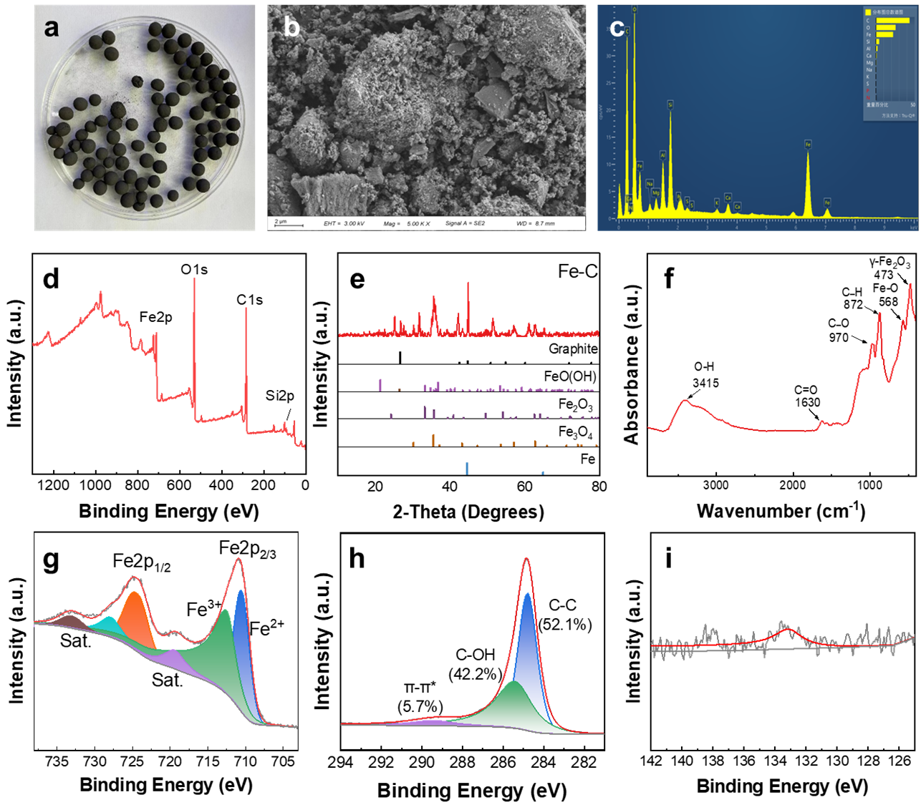
Fig. S1. Physical (a) and characterization diagrams of Fe-C particles (b) Scanning electron microscope (SEM) diagram, (c) Energy spectroscopy (EDS) analysis, (c) X-ray photoelectron spectroscopy (XPS), (d) X-ray diffraction (XRD), and (e) Fourier transform infrared spectrometer (FTIR) diagrams. (g) C1s, (h) Fe2p, and (i) P2p high-resolution spectra of Fe-C particles.

Fig. S2. Characterization of microbubbles
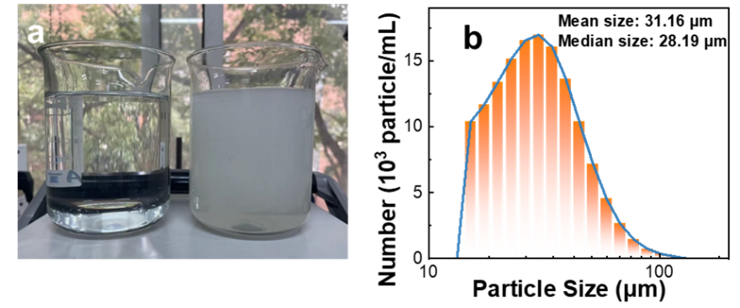
Fig. S2. (a) Photographs of microbubbles. (b) Particle size distribution of microbubbles.

Fig. S3. Changes in water quality during pretreatment
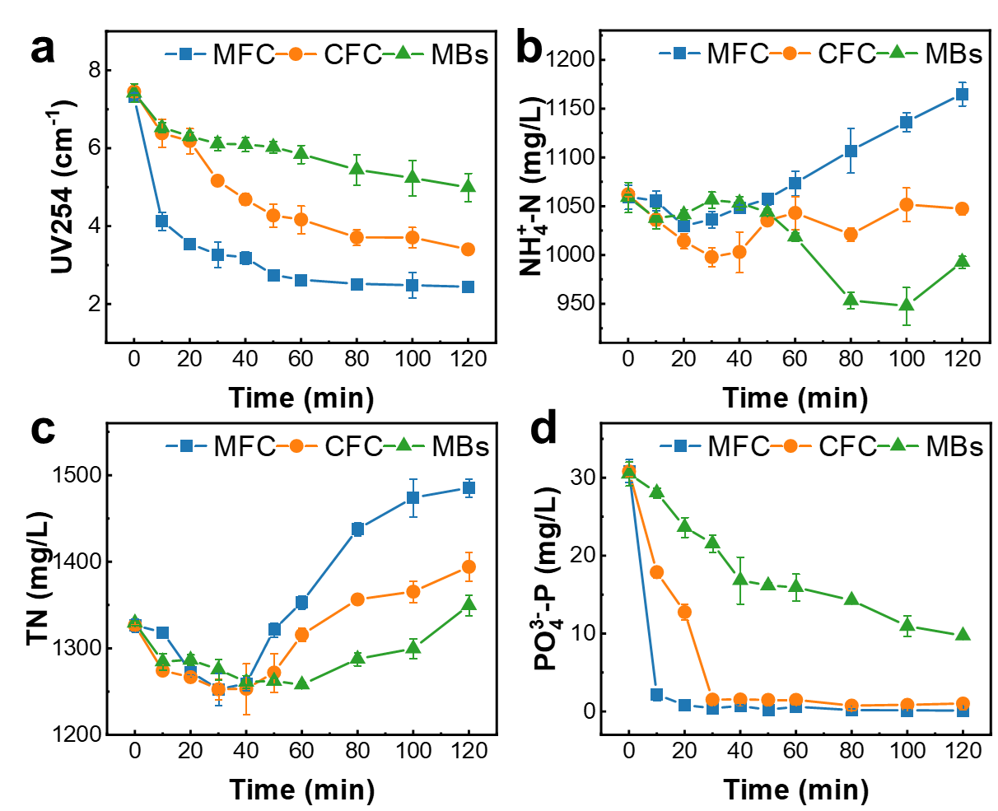
Fig. S3. Variation in (a) UV254, (b)NH₄⁺-N, (c) TN, and (d) PO₄³⁻-P of the biogas slurry with operation time.

Fig. S4. Variation of floc settlement of biogas slurry
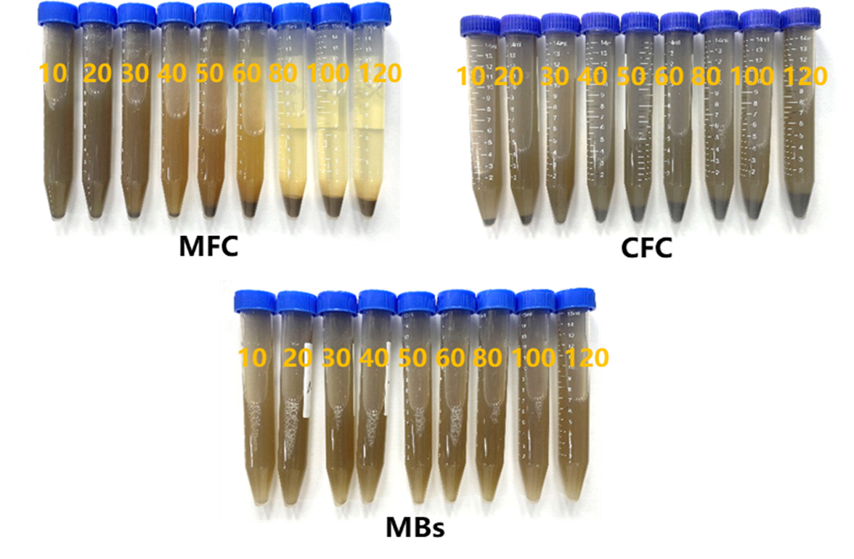
Fig. S4. Variation of floc settlement of biogas slurry with operation time in different treatment systems.

Fig. S5. EEM spectra of supernatant in RBS, and different systems
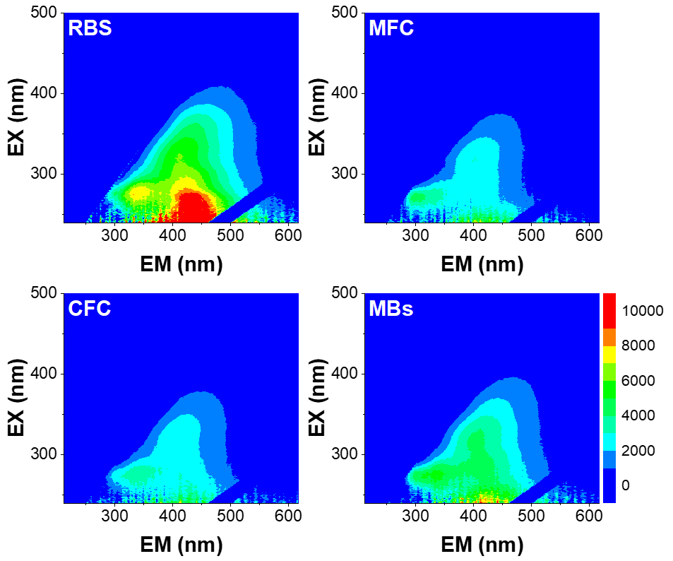
Fig. S5. EEM spectra of supernatant in RBS, MFC, CFC, and MBs systems.

Fig. S6. EEM spectra of C1 and C2
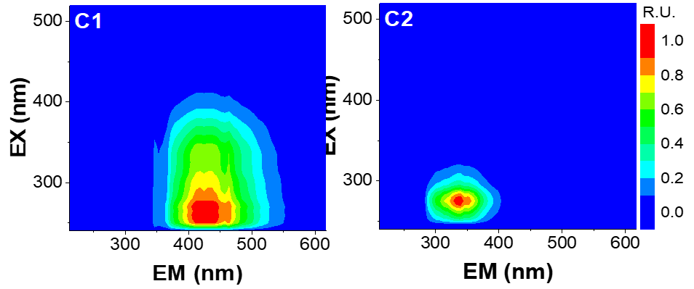
Fig. S6. EEM spectra of two fluorescence components (C1 and C2 ) identified using PARAFAC

Fig. S7. Fluorescence EEM contours of two PARAFAC components
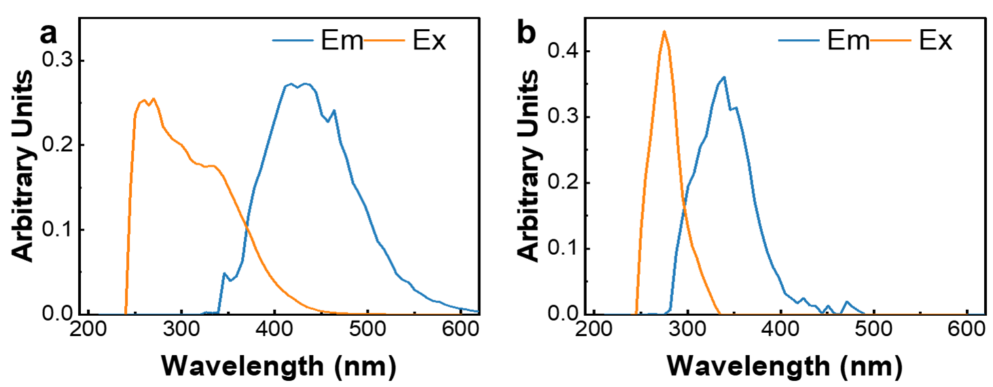

Fig. S7. Fluorescence EEM contours of three PARAFAC components identified from different systems: C1 and C2.
.

Fig. S8. The result of fluorescence regional integration (FRI)
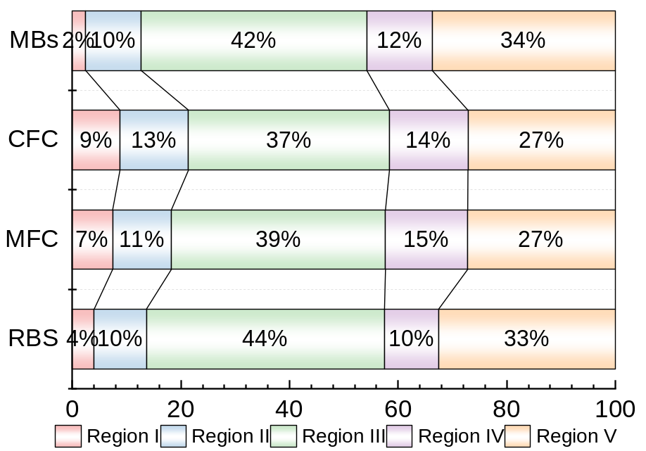
Fig. S8. The proportion of different substances in DOM is determined based on the fluorescence regional integration (FRI) (Region I, aromatic proteins I; Region II, aromatic proteins II; Region III, fulvic acid; Region IV, soluble microbial products; Region V, Humic acids).

Fig. S9. Variation in relevant spectroscopic indicators
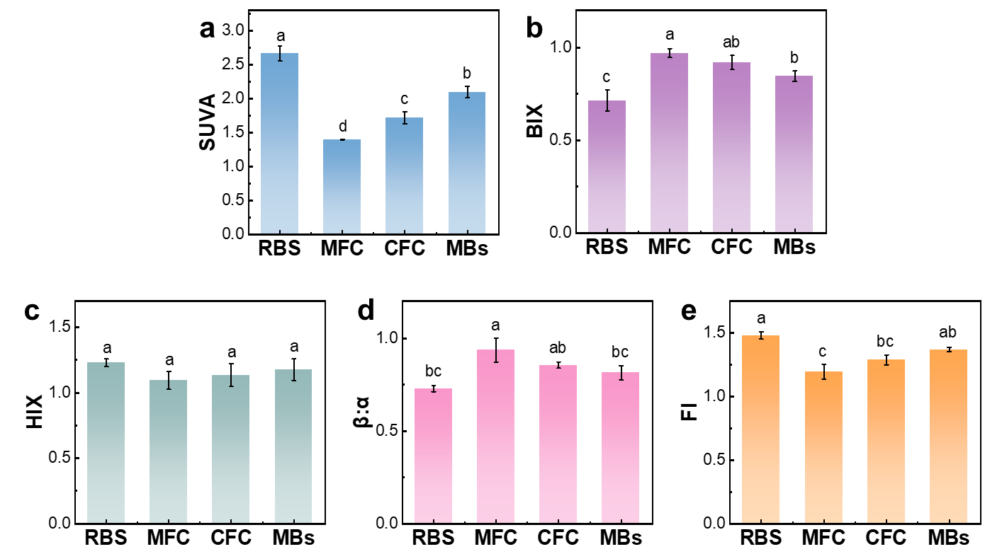
Fig. S9. Variation of specific UV absorbance (SUVA), biological index (BIX), humification index (HIX), freshness index (β:α), and (d) fluorescence index (FI) of RBS and different systems (after operation). (The error bars indicate the standard deviation. The ANOVA test was conducted between each pair of systems: the same words indicate no significant difference, p > 0.05).

Fig. S10. 2D-COS plots of the UV–Vis absorption spectrum
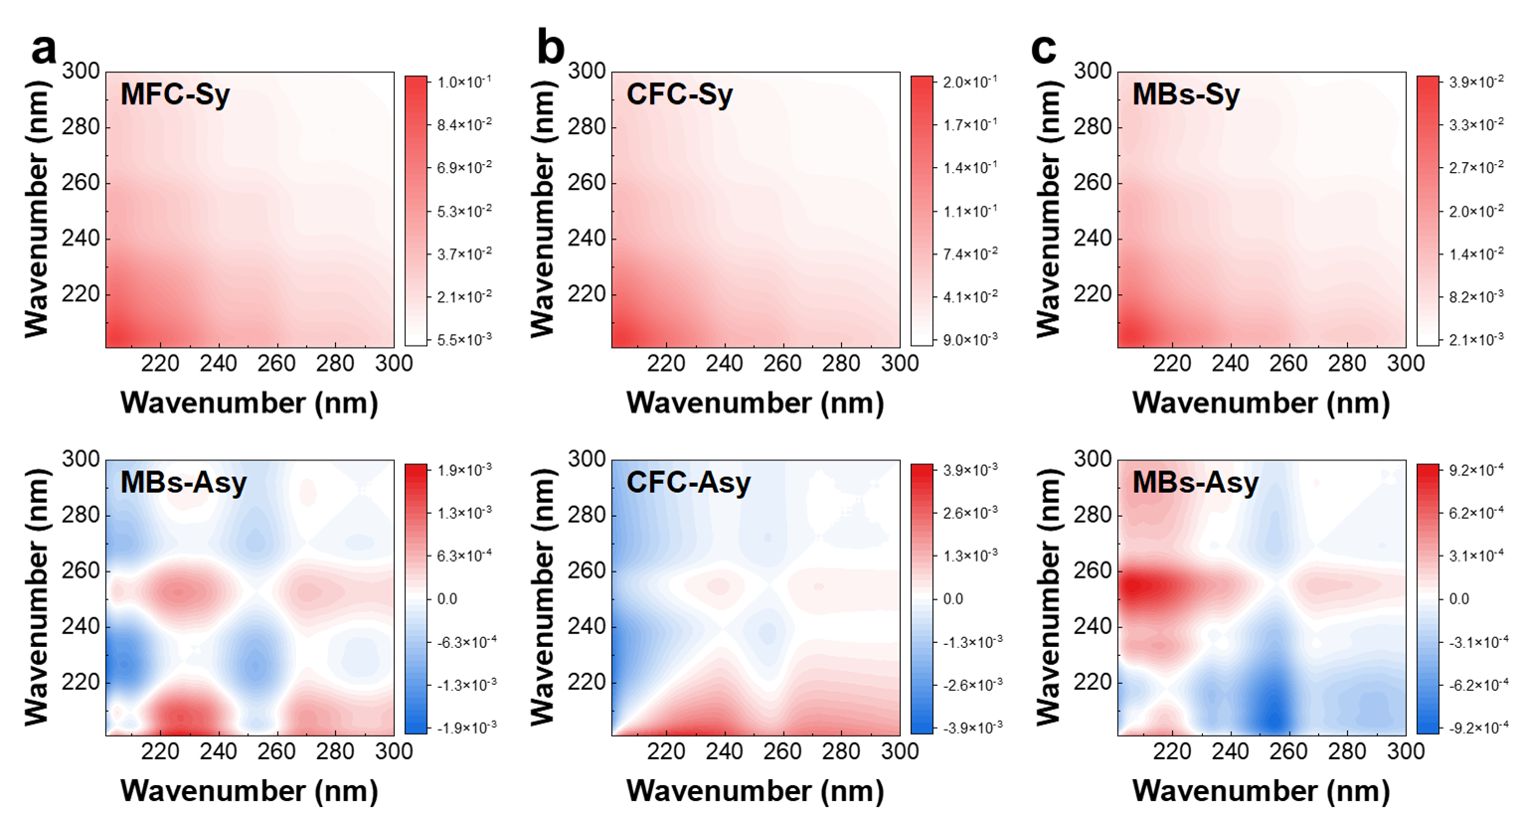
Fig. S10. 2D-COS plots of the UV–Vis absorption spectrum during operation. Synchronous and asynchronous spectra of (a)MFC, (b)CFC, and (c)MBs systems. Red represents positive correlations, and blue represents negative correlations; deeper color intensity suggests a stronger positive or negative correlation.

Fig. S11. Spearman correlation analysis between indicators in different systems
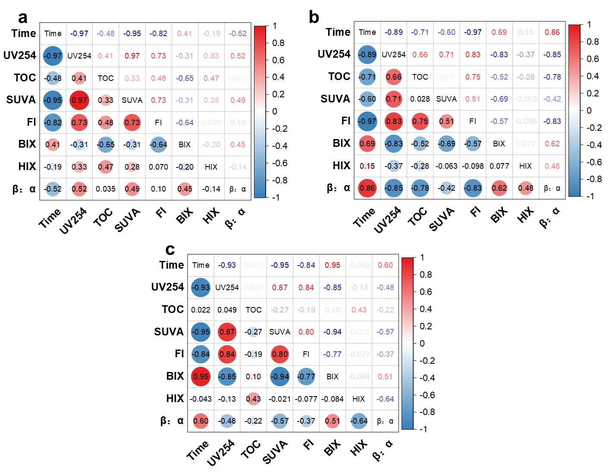
Fig. S11. Spearman correlation analysis between indicators in (a)MFC, (b)CFC, and (c)MBs systems. Blue indicates a negative correlation, red indicates a positive correlation, and the label refers to the correlation coefficient.

Fig. S12. XRD and Fe(IV) analysis
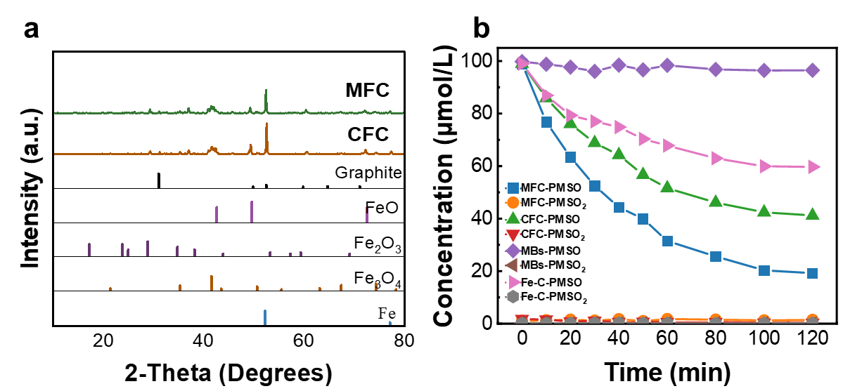
Fig. S12. (a) Changes in XRD of Fe-C particles in MFC and CFC system. (b) Identification of Fe (IV) in the pretreatment system.

Fig. S13. XPS survey spectra of flocs in MFC and CFC systems
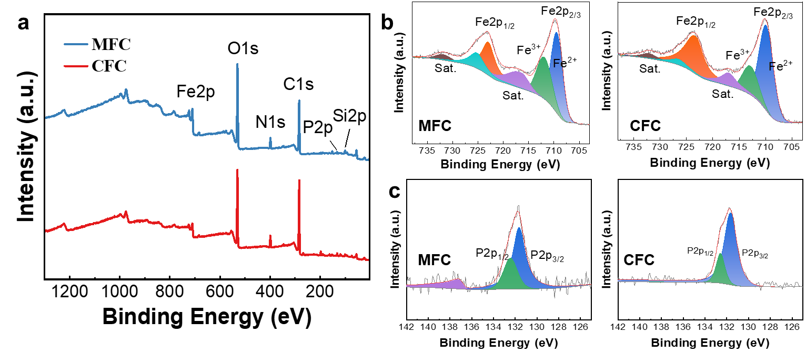
Fig. S13. (a) XPS survey spectra of flocs in MFC and CFC systems. (b) Fe2p and (c) P2p high-resolution spectra of flocs in MFC and CFC systems.

Fig. S14. Wavelet transform plots of standard mineral
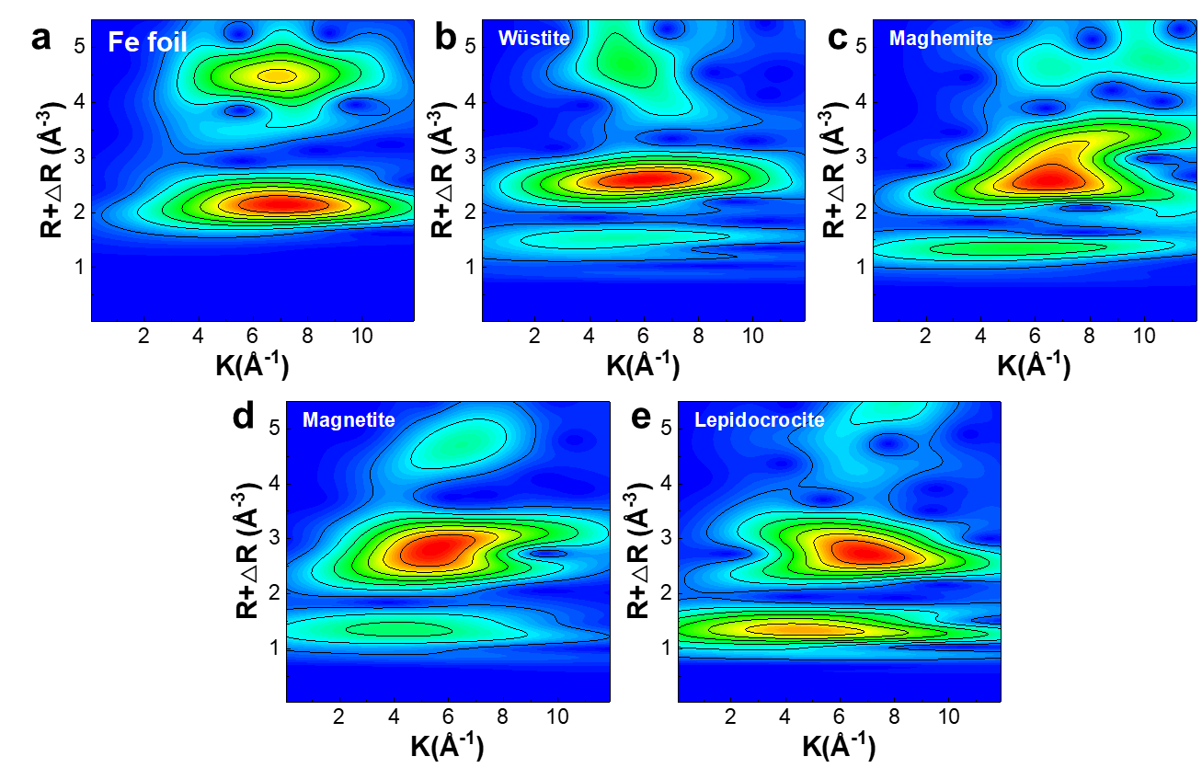
Fig. S14. Wavelet transform plots of standard mineral: (a) Fe foil, (b) Wüstite, (c) Magnetite, (d) maghemite, and (e) lepidocrocite.

Fig. S15. Effect on microalgae growth after pretreatment of biogas slurry
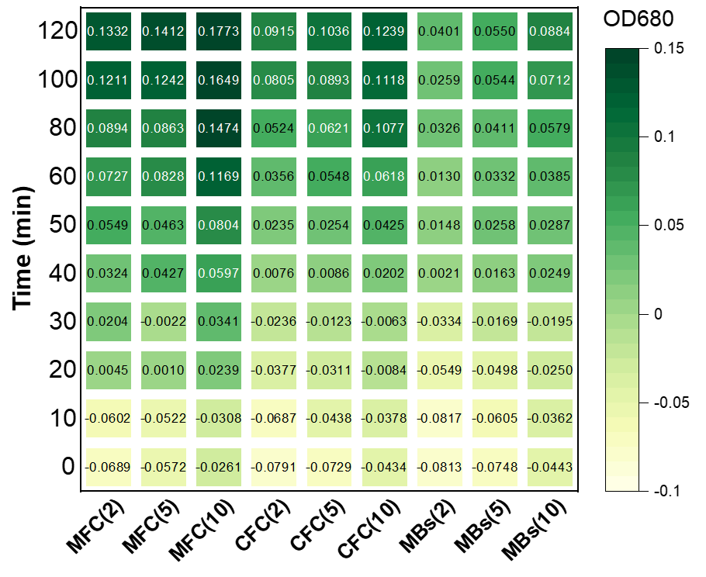
Fig. S15. Effect on microalgae growth after pre-treatment of biogas slurry with phosphorus supplementation. Values in parentheses are dilutions (2×, 5×, and 10×) of the treated biogas slurry.

Fig. S16. Effect on microalgae growth after pretreatment of biogas slurry with phosphorus supplementation
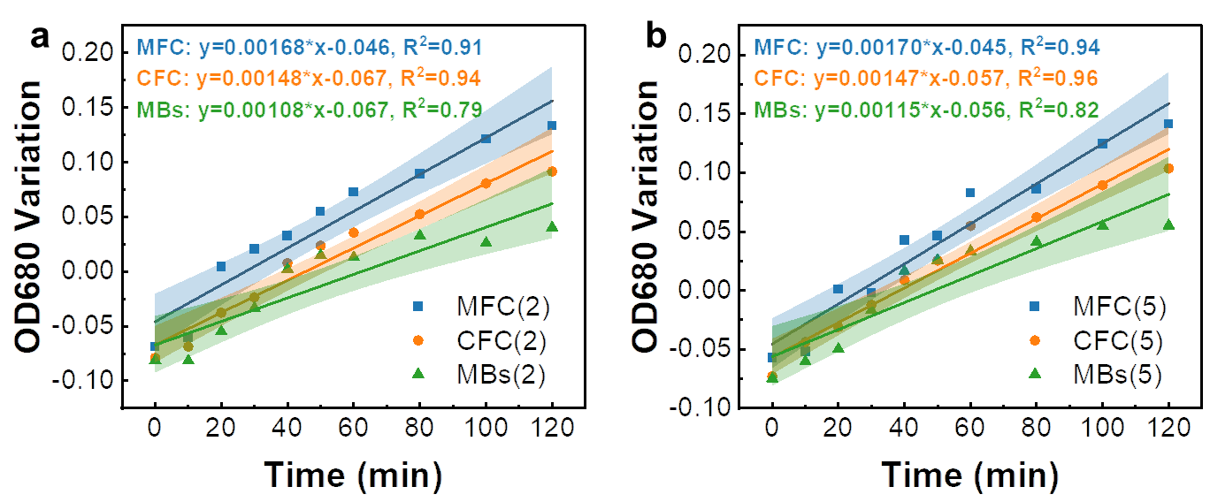
Fig. S16. Effect on microalgae growth after pre-treatment of biogas slurry with phosphorus (8.4 mg/L) supplementation. Changes in the growth of microalgae at 2× (a) and 5 × (b) dilution of the biogas slurry.

Table S1. Characteristics of the row biogas slurry
Parameters | Unit | Content
TOC | mg/L | 279.96±6.24
TN | mg/L | 1326.75±1.06
NH₄⁺-N | mg/L | 1059.57±12.21
NO³⁻-N | mg/L | 0.041±0.002
NO²⁻-N | mg/L | not detected
TP | mg/L | 35.67±2.45
PO₄³⁻-P | mg/L | 30.89±1.46
pH | — | 8.12±0.23
UV254 | cm⁻¹ | 7.45±0.14
K | mg/L | 816.5±42.65
Na | mg/L | 290.88±25.57
Mg | mg/L | 64.32±10.21
Ca | mg/L | 24.75±3.30
Al | mg/L | 4.63±1.15
Fe | mg/L | 2.70±0.34
Co | mg/L | 0.63±0.15
Zn | mg/L | 0.52±0.23
Mn | mg/L | 0.38±0.08
Cu | mg/L | 0.13±0.03

Table S2. Abbreviations for water quality indexes
Abbr | Indexes | Calculation method
R1 | Tyrosine-like aromatic protein | Ex=220~250 nm；Em=280~330 nm
R2 | Tryptophan-like aromatic protein | Ex=220~250 nm；Em=330~380 nm
R3 | Fulvic acid-like matter | Ex=220~250 nm；Em=380~500 nm
R4 | Soluble microbial byproduct-like matter | Ex=250~400 nm；Em=280~380 nm
R5 | Humic acid-like matter | Ex=250~400 nm；Em=380~500 nm
FI | fluorescence index | (Ex=370 nm; Em=450 nm)/(Ex=370 nm; Em=500 nm)
HIX | humification index | (Ex=255 nm; Em=435-480 nm)/[(Ex=255 nm; Em=300-345 nm)]
BIX | biological index | (Ex=310 nm; Em=380 nm)/(Ex=310 nm; Em=430 nm)
β：α | freshness index | (Ex=310 nm; Em=380 nm)/(Ex=310 nm; Em,max=420~435 nm)
SUVA | Specific UV absorbance | the ratio of A254 to TOC

Table S3. Signs of cross-peaks in synchronous (asynchronous) spectrum
System |  | 205 | 230 | 254 | 270 | 290
 | 290 | +(-) | +(+) | +(-) | +(+)
 | 270 | +(-) | +(-) | +(-)
MFC | 254 | +(+) | +(+)
 | 230 | +(-)
 | 205
 | 290 | +(-) | +(-) | +(-) | +(+)
 | 270 | +(-) | +(-) | +(-)
CFC | 254 | +(-) | +(+)
 | 230 | +(-)
 | 205
 | 290 | +(+) | +(+) | +(-) | +(+)
 | 270 | +(+) | +(+) | +(-)
MBs | 254 | +(+) | +(+)
 | 230 | +(+)
 | 205

Table S4. FRI of DOM in biogas slurry of different systems
 | Region I | Region II | Region III | Region VI | Region V
RBS | 149572 | 358703 | 1636323 | 371861 | 1214559
MFC | 78213 | 113641 | 414775 | 159506 | 285995
CFC | 107768 | 154933 | 453850 | 177541 | 333155
MBs | 47663 | 198768 | 809130 | 234798 | 656384

Table S5. Weight ratio of each element in EDS analysis (wt%)
Element | Fe/C | CFC | MFC
C | 43.49 | 59.21 | 51.07
N | 0.00 | 3.27 | 0.71
O | 25.45 | 25.06 | 31.36
Na | 0.44 | 0.13 | 0.07
Mg | 0.56 | 0.08 | 0.03
Al | 2.04 | 0.10 | 0.06
Si | 4.24 | 0.66 | 0.71
P | 0.16 | 1.13 | 0.47
S | 0.22 | 0.64 | 0.32
K | 0.30 | 0.25 | 0.04
Ca | 0.90 | 0.30 | 0.23
Fe | 22.21 | 9.16 | 14.91

Table S6. OpenFluor matches for PARAFAC components
This Study | References | Component # in the Reference | Ex match | Em match
Component 1  (humic-like components) | (Amaral et al., 2020) | C1 | 0.985 | 0.985
Component 1  (humic-like components) | (Amaral et al., 2021) | C1 | 0.995 | 0.992
Component 1  (humic-like components) | (Hong et al., 2021) | C1 | 0.983 | 0.984
Component 1  (humic-like components) | (Brünjes et al., 2022) | C4 | 0.9776 | 0.988
Component 1  (humic-like components) | (Gonçalves-Araujo et al., 2015) | C1 | 0.974 | 0.989
Component 2  (protein-like components) | (Yamashita et al., 2021) | C4 | 0.989 | 0.985
Component 2  (protein-like components) | (Wheeler et al., 2017) | C2 | 0.991 | 0.980
Component 2  (protein-like components) | (Kim et al., 2020) | C3 | 0.987 | 0.984
Component 2  (protein-like components) | (Wasswa et al., 2022) | C4 | 0.984 | 0.986
Component 2  (protein-like components) | (Wang et al., 2020) | C4 | 0.980 | 0.988

Table S7. EXAFS fitting parameters at the Fe K-edge for various samples
Sample | Shell | Reff(Å) | R(Å) | CN | σ²(Å²) | ΔE₀(eV) | R factor
MFC | Fe-O1 | 1.93 | 1.85(3) | 2.0(3) | 0.002 | -7.87 (2.59) | 0.0152
MFC | Fe-O2 | 2.00 | 2.01(3) | 2.4(4) | 0.002 | -7.87 (2.59) | 0.0152
MFC | Fe-Fe1 | 2.98 | 2.96(3) | 0.8(2) | 0.005 | -7.87 (2.59) | 0.0152
MFC | Fe-Fe2 | 3.42 | 3.45(4) | 0.4(1) | 0.005 | -7.87 (2.59) | 0.0152
MFC | Fe-Fe3 | 3.75 | 3.70(6) | 1.2(3) | 0.009 | -7.87 (2.59) | 0.0152
CFC | Fe-O1 | 1.93 | 1.87(3) | 2.3(4) | 0.002 | -6.94 (2.60) | 0.0139
CFC | Fe-O2 | 2.00 | 2.02(3) | 2.9(5) | 0.002 | -6.94 (2.60) | 0.0139
CFC | Fe-Fe1 | 2.98 | 2.99(3) | 0.8(2) | 0.005 | -6.94 (2.60) | 0.0139
CFC | Fe-Fe2 | 3.42 | 3.45(5) | 1.0(3) | 0.005 | -6.94 (2.60) | 0.0139
CFC | Fe-Fe3 | 3.75 | 3.68(9) | 0.8(2) | 0.009 | -6.94 (2.60) | 0.0139
Reff: half path length of reference; CN, coordination number; R, half path length to the neighboring atom; σ², the Mean Square Relative Displacement (MSRD); ΔE₀, inner potential correction; R factor indicates the goodness of the fit. S₀² was fixed to 0.870, according to the experimental EXAFS fit of Fe foil by fixing CN as the known crystallographic value. * This value was fixed during EXAFS fitting, based on the known structure of Fe. Fitting range: 3.0 ≤ k (/Å) ≤ 11.0 and 1.0 ≤ R (Å) ≤ 4.0. A reasonable range of EXAFS fitting parameters: 0.800 < Ѕ₀² < 1.000; CN > 0; σ² > 0 Å²; |ΔE₀| < 10 eV; R factor < 0.02.

References
Amaral, V., Romera-Castillo, C. and Forja, J. 2021. Submarine mud volcanoes as a source of chromophoric dissolved organic matter to the deep waters of the Gulf of Cádiz. Scientific Reports 11(1), 3200.
Amaral, V., Romera-Castillo, C., García-Delgado, M., Gómez-Parra, A. and Forja, J. 2020. Distribution of dissolved organic matter in estuaries of the southern Iberian Atlantic Basin: Sources, behavior and export to the coastal zone. Marine Chemistry 226, 103857.
Brünjes, J., Seidel, M., Dittmar, T., Niggemann, J. and Schubotz, F. 2022. Natural Asphalt Seeps Are Potential Sources for Recalcitrant Oceanic Dissolved Organic Sulfur and Dissolved Black Carbon. Environmental Science & Technology 56(12), 9092-9102.
Chen, W., Westerhoff, P., Leenheer, J.A. and Booksh, K. 2003. Fluorescence Excitation−Emission Matrix Regional Integration to Quantify Spectra for Dissolved Organic Matter. Environmental Science & Technology 37(24), 5701-5710.
Du, H., Yu, G., Guo, M. and Xu, H. 2021. Investigation of carbon dynamics in rhizosphere by synchrotron radiation-based Fourier transform infrared combined with two dimensional correlation spectroscopy. Science of The Total Environment 762, 143078.
Funke, H., Scheinost, A.C. and Chukalina, M. 2005. Wavelet analysis of extended x-ray absorption fine structure data. Physical Review B 71(9), 094110.
Gonçalves-Araujo, R., Stedmon, C.A., Heim, B., Dubinenkov, I., Kraberg, A., Moiseev, D. and Bracher, A. 2015. From Fresh to Marine Waters: Characterization and Fate of Dissolved Organic Matter in the Lena River Delta Region, Siberia. Frontiers in Marine Science 2.
He, L., Wang, D., Wu, Z., Lv, Y. and Li, S. 2022. Magnesium-modified biochar was used to adsorb phosphorus from wastewater and used as a phosphorus source to be recycled to reduce the ammonia nitrogen of piggery digestive wastewater. Journal of Cleaner Production 360, 132130.
Hong, H., Wu, S., Wang, Q., Dai, M., Qian, L., Zhu, H., Li, J., Zhang, J., Liu, J., Li, J., Lu, H. and Yan, C. 2021. Fluorescent dissolved organic matter facilitates the phytoavailability of copper in the coastal wetlands influenced by artificial topography. Science of The Total Environment 790, 147855.
Huang, H., Tu, S., Zeng, C., Zhang, T., Reshak, A.H. and Zhang, Y. 2017. Macroscopic Polarization Enhancement Promoting Photo- and Piezoelectric-Induced Charge Separation and Molecular Oxygen Activation. Angewandte Chemie International Edition 56(39), 11860-11864.
Huang, Y., Zhang, H., Liu, X., Ma, B. and Huang, T. 2022. Iron-Activated Carbon Systems to Enhance Aboriginal Aerobic Denitrifying Bacterial Consortium for Improved Treatment of Micro-Polluted Reservoir Water: Performances, Mechanisms, and Implications. Environmental Science & Technology 56(6), 3407-3418.
Hur, J., Jung, K.-Y. and Jung, Y.M. 2011. Characterization of spectral responses of humic substances upon UV irradiation using two-dimensional correlation spectroscopy. Water Research 45(9), 2965-2974.
Kim, J., Kim, Y., Kang, H.-W., Kim, S.H., Rho, T. and Kang, D.-J. 2020. Tracing water mass fractions in the deep western Indian Ocean using fluorescent dissolved organic matter. Marine Chemistry 218, 103720.
Lai, B., Zhou, Y., Qin, H., Wu, C., Pang, C., Lian, Y. and Xu, J. 2012. Pretreatment of wastewater from acrylonitrile–butadiene–styrene (ABS) resin manufacturing by microelectrolysis. Chemical Engineering Journal 179, 1-7.
Liu, T., Xiao, S., Li, N., Chen, J., Zhou, X., Qian, Y., Huang, C.-H. and Zhang, Y. 2023. Water decontamination via nonradical process by nanoconfined Fenton-like catalysts. Nature Communications 14(1), 2881.
Ma, Z., Yang, Y., Jiang, Y., Xi, B., Yang, T., Peng, X., Lian, X., Yan, K. and Liu, H. 2017. Enhanced degradation of 2,4-dinitrotoluene in groundwater by persulfate activated using iron–carbon micro-electrolysis. Chemical Engineering Journal 311, 183-190.
Murphy, K.R., Stedmon, C.A., Wenig, P. and Bro, R. 2014. OpenFluor– an online spectral library of auto-fluorescence by organic compounds in the environment. Analytical Methods 6(3), 658-661.
Noda, I. 1993. Generalized Two-Dimensional Correlation Method Applicable to Infrared, Raman, and other Types of Spectroscopy. Applied Spectroscopy 47(9), 1329-1336.
Ogata, F., Uematsu, Y., Fukuda, M., Saenjum, C., Kabayama, M., Nakamura, T. and Kawasaki, N. 2020. Changes in the mechanism of the reaction between phosphate and magnesium ions: Effect of initial concentration and contact time on removal of phosphate ions from aqueous media. Journal of Environmental Chemical Engineering 8(5), 104385.
Provolo, G., Perazzolo, F., Mattachini, G., Finzi, A., Naldi, E. and Riva, E. 2017. Nitrogen removal from digested slurries using a simplified ammonia stripping technique. Waste Management 69, 154-161.
Ravel, B. and Newville, M. 2005. ATHENA, ARTEMIS, HEPHAESTUS: data analysis for X-ray absorption spectroscopy using IFEFFIT. Journal of Synchrotron Radiation 12(4), 537-541.
SEPA 2002. Water and Wastewater Monitoring and Analysis Method. 4th edition. China Environmental Science Press, Beijing.
Stedmon, C.A. and Bro, R. 2008. Characterizing dissolved organic matter fluorescence with parallel factor analysis: a tutorial. Limnology and Oceanography: Methods 6(11), 572-579.
Tamura, H., Goto, K., Yotsuyanagi, T. and Nagayama, M. 1974. Spectrophotometric determination of iron(II) with 1,10-phenanthroline in the presence of large amounts of iron(III). Talanta 21(4), 314-318.
Wang, S., Matt, M., Murphy, B.L., Perkins, M., Matthews, D.A., Moran, S.D. and Zeng, T. 2020. Organic Micropollutants in New York Lakes: A Statewide Citizen Science Occurrence Study. Environmental Science & Technology 54(21), 13759-13770.
Wang, X., Gong, X., Zhang, Q. and Du, H. 2013. Degradation mechanism of Direct Pink 12B treated by iron-carbon micro-electrolysis and Fenton reaction. Journal of Environmental Sciences 25, S63-S68.
Wasswa, J., Driscoll, C.T. and Zeng, T. 2022. Contrasting Impacts of Photochemical and Microbial Processing on the Photoreactivity of Dissolved Organic Matter in an Adirondack Lake Watershed. Environmental Science & Technology 56(3), 1688-1701.
Wheeler, K.I., Levia, D.F. and Hudson, J.E. 2017. Tracking senescence-induced patterns in leaf litter leachate using parallel factor analysis (PARAFAC) modeling and self-organizing maps. Journal of Geophysical Research: Biogeosciences 122(9), 2233-2250.
Yamashita, Y., Kojima, D., Yoshida, N. and Shibata, H. 2021. Relationships between dissolved black carbon and dissolved organic matter in streams. Chemosphere 271, 129824.
Yang, B., Graham, N., Liu, P., Liu, M., Gregory, J. and Yu, W. 2023. Atomic-Level Structural Differences between Fe(III) Coprecipitates Generated by the Addition of Fe(III) Coagulants and by the Oxidation of Fe(II) Coagulants Determine Their Coagulation Behavior in Phosphate and DOM Removal. Environmental Science & Technology 57(33), 12489-12500.
You, X., Chen, C., Yang, L., Xia, X., Zhang, Y. and Zhou, X. 2022. Physiological and morphological responses of Chlorella pyrenoidosa to different exposure methods of graphene oxide quantum dots. Science of The Total Environment 854, 158722.
Yu, J., Xu, H., Wang, D., Sun, H., Jiao, R., Liu, Y., Jin, Z. and Zhang, S. 2022. Variations in NOM during floc aging: Effect of typical Al-based coagulants and different particle sizes. Water Research 218, 118486.
Zhao, H.D., Nie, T., Zhao, H.X., Liu, Y.H., Zhang, J., Ye, Q., Xu, H. and Shu, S.H. 2021. Enhancement of Fe-C micro-electrolysis in water by magnetic field: Mechanism, influential factors and application effectiveness. Journal of Hazardous Materials 410, 124643.
Zheng, X., Zhou, C., Wu, F., Xu, H., Zhao, Z., Han, Z., Zhang, H. and Yang, S. 2023. Enhanced removal of organic, nutrients, and PFCs in the iron-carbon micro-electrolysis constructed wetlands: Mechanism and iron cycle. Chemical Engineering Journal 457, 141174.

