Supplementary Information for
Air nanobubble simultaneously enhances hydrolysis and methane yield of sludge temperature phased-anaerobic digestion

Contents:
Fig. S1: The (a) free ammonia nitrogen and (b) soluble chemical oxygen demand during anaerobic digestion
Fig. S2: (a) Phylum-level relative abundance of bacteria, (b) genus-level relative abundance of archaea (a: day 2; b: day 41), (c) phylum-level principal component analysis of bacteria, and (d) genus-level principal component analysis of archaea on day 41
Table S1: Parameters of different seed sludge and dewatered sludge
Table S2: Alpha diversity analysis of bacteria and archaea (a: day 2; b: day 41)
Table S3: Changes in the relative abundance of bacteria and archaea under different treatments (a: day 2; b: day 41)

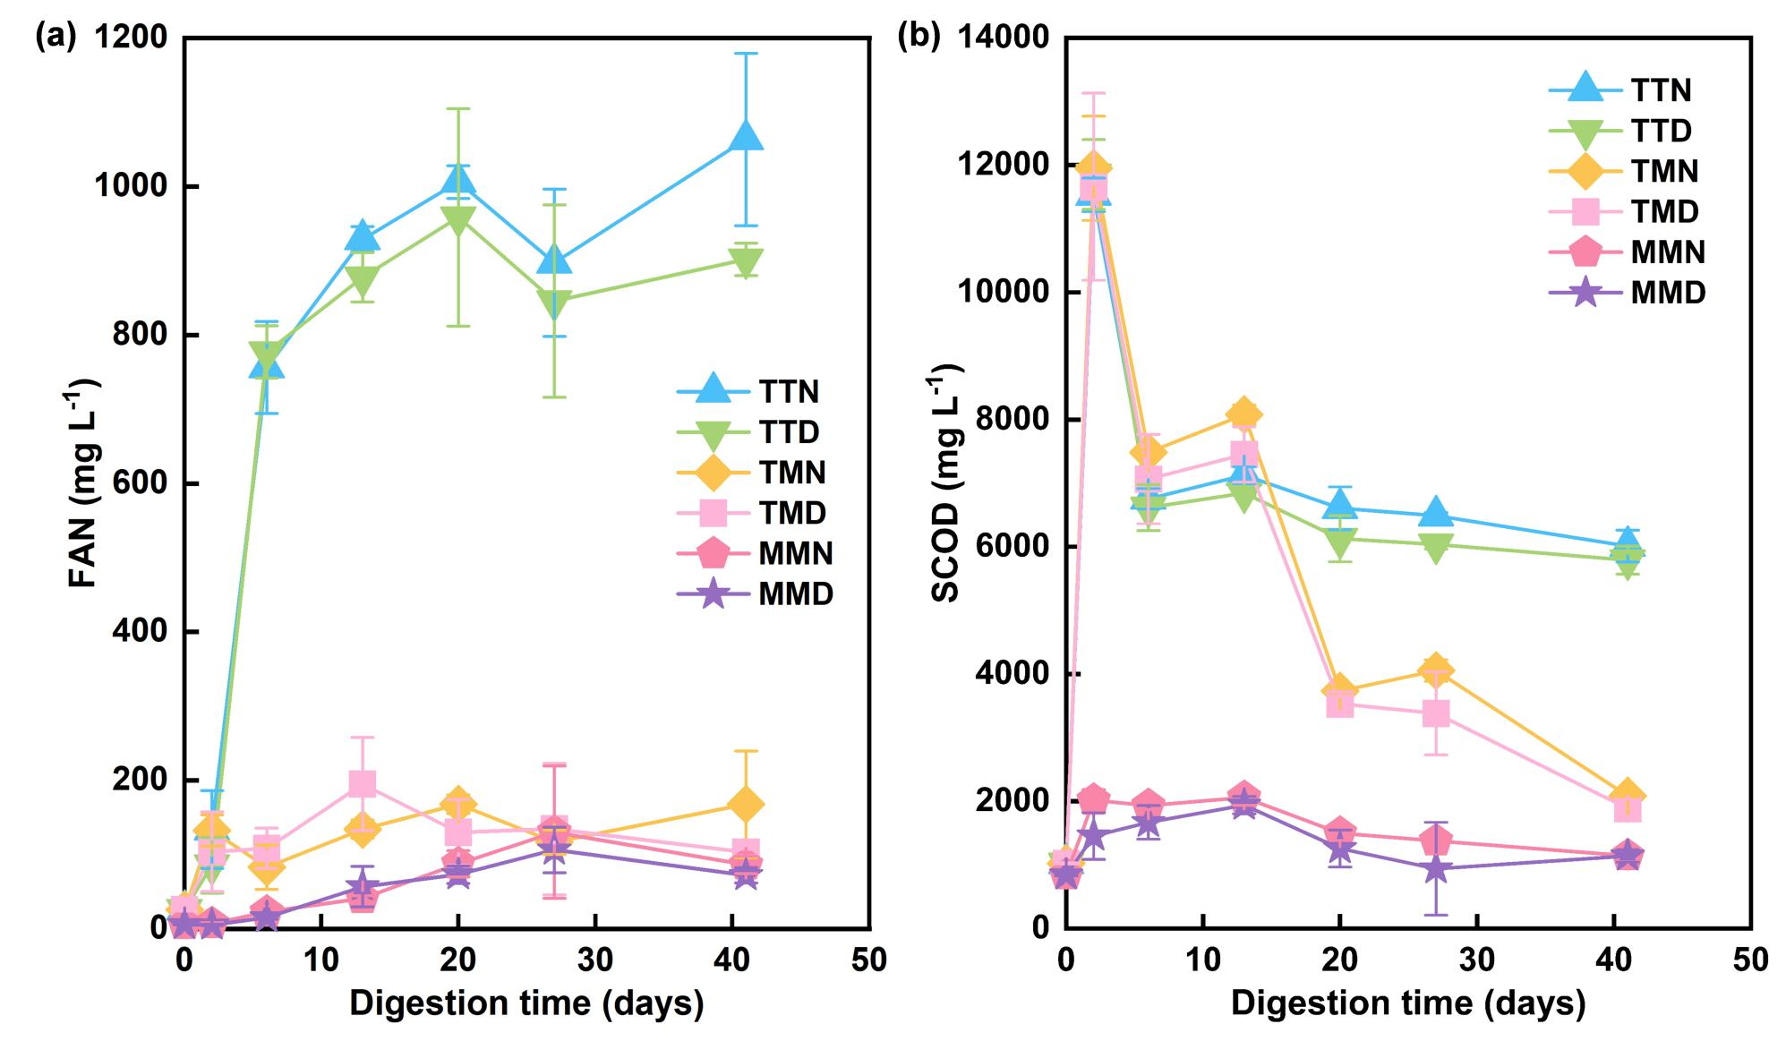
Fig. S1 The (a) free ammonia nitrogen and (b) soluble chemical oxygen demand during anaerobic digestion

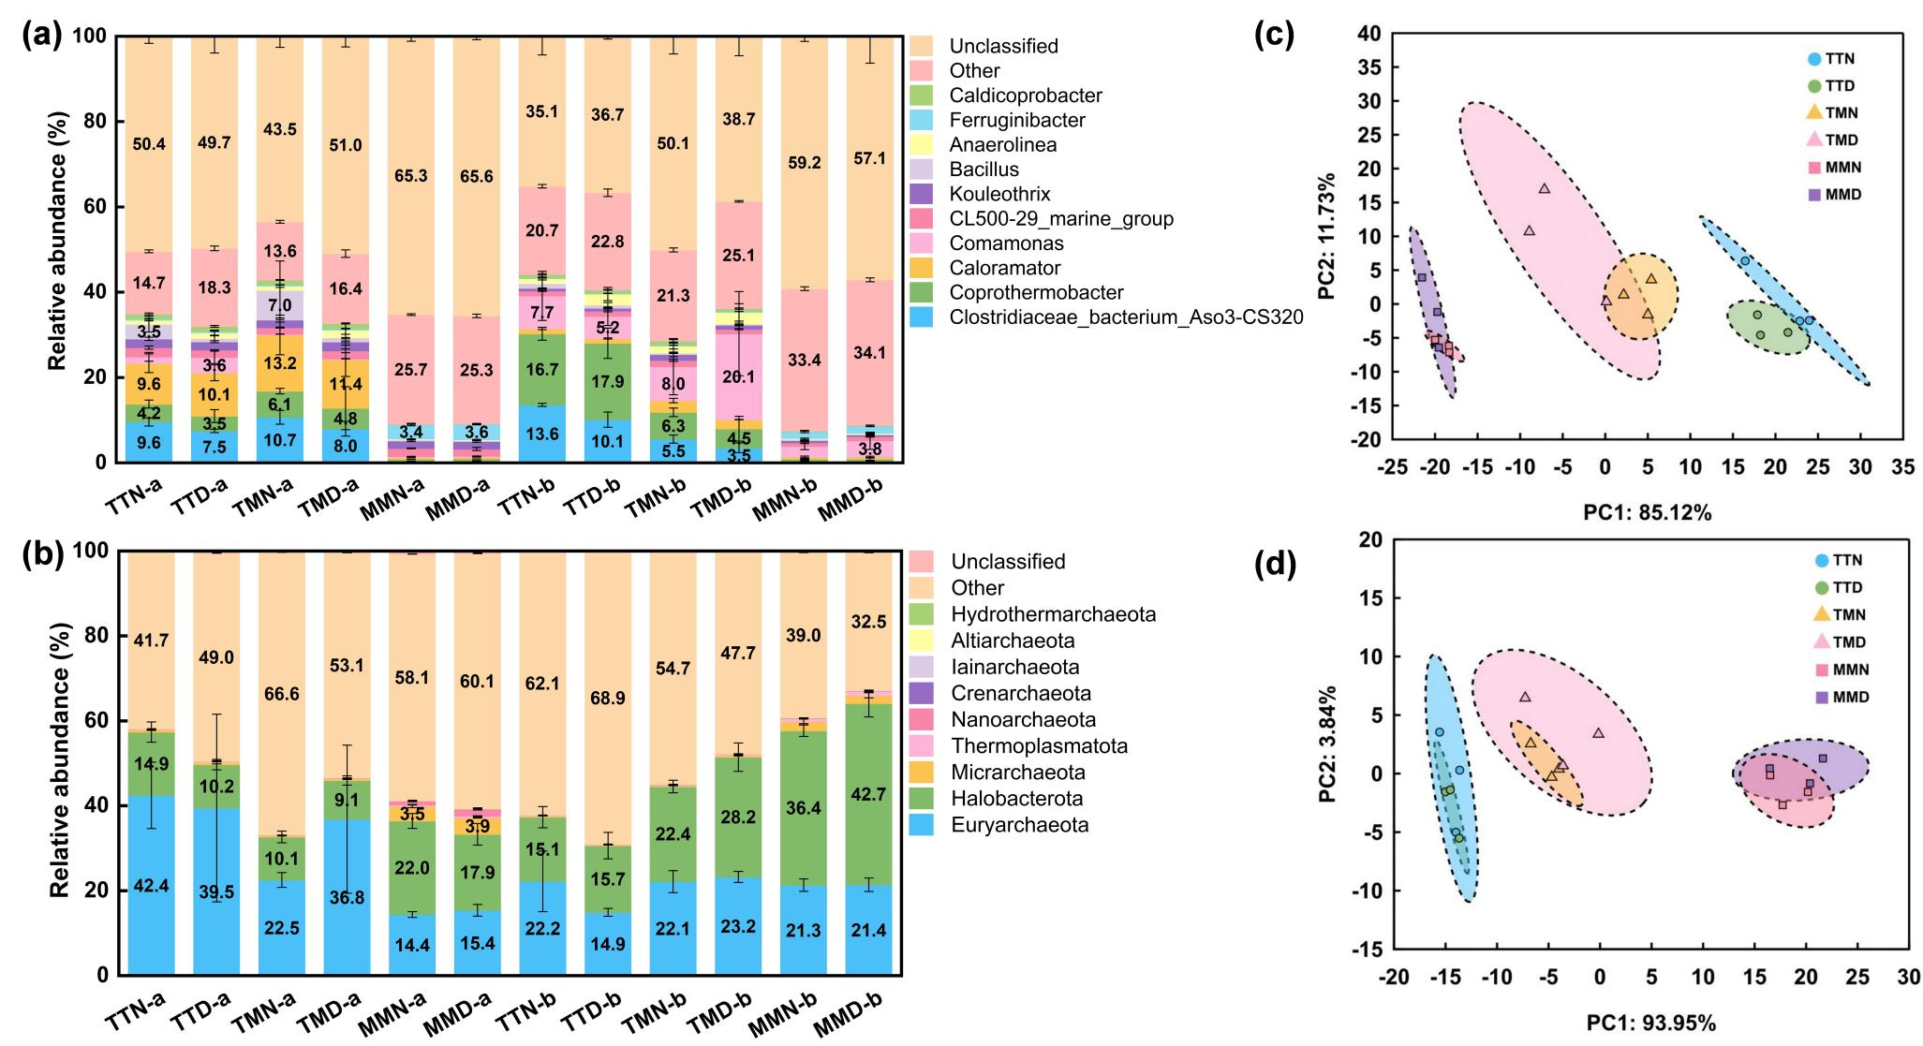
Fig. S2 (a) Phylum-level relative abundance of bacteria, (b) genus-level relative abundance of archaea (a: day 2; b: day 41), (c) phylum-level principal component analysis of bacteria, and (d) genus-level principal component analysis of archaea on day 41

Table S1 Parameters of different seed sludge and dewatered sludge
 | Thermophilic  seed sludge | Mesophilic  seed sludge | Dewatered sludge
TS (%) | 6.26 ± 0.06 | 6.19 ± 0.01 | 27.22 ± 1.74
VS (%) | 2.25 ± 0.01 | 2.46 ± 0.02 | 7.17 ± 0.50
VS/TS (%) | 36.02 ± 0.29 | 39.71 ± 0.38 | 26.35 ± 0.28
pH | 7.72 ± 0.03 | 7.68 ± 0.05 | 7.31 ± 0.02
C (%, dry solids) | 8.59 ± 0.05 | 8.95 ± 0.07 | 11.99 ± 0.13
H (%, dry solids) | 1.23 ± 0.01 | 1.27 ± 0.02 | 1.65 ± 0.03
N (%, dry solids) | 0.94 ± 0.00 | 1.11 ± 0.01 | 1.90 ± 0.04
S (%, dry solids) | 0.33 ± 0.01 | 0.36 ± 0.01 | 0.34 ± 0.00
C/N | 9.12 ± 0.08 | 8.05 ± 0.15 | 6.32 ± 0.04
Note: All values are expressed as mean ± standard deviation (n = 3). (Total solids, TS; volatile solids, VS)

Table S2 Alpha diversity analysis of bacteria and archaea (a: day 2; b: day 41)
Bacteria | Sample | OTUs | Shannon | Chao | Coverage | Sample | OTUs | Shannon | Chao | Coverage
Bacteria | TTN-a | 2089 ± 84^{abc} | 7.56 ± 0.13^{c} | 2276 ± 69^{ab} | 0.990 ± 0.001 | TTN-b | 1384 ± 93^{d} | 6.19 ± 0.29^{d} | 1573 ± 80^{d} | 0.990 ± 0.001
Bacteria | TTD-a | 2051 ± 92^{bc} | 7.49 ± 0.15^{c} | 2245 ± 84^{ab} | 0.990 ± 0.002 | TTD-b | 1467 ± 65^{d} | 6.42 ± 0.23^{d} | 1622 ± 67^{d} | 0.990 ± 0.001
Bacteria | TMN-a | 2080 ± 182^{abc} | 7.86 ± 0.20^{b} | 2255 ± 154^{ab} | 0.990 ± 0.002 | TMN-b | 2224 ± 74^{b} | 7.88 ± 0.19^{b} | 2348 ± 52^{b} | 0.990 ± 0.001
Bacteria | TMD-a | 1987 ± 139^{c} | 7.17 ± 0.19^{d} | 2157 ± 34^{b} | 0.990 ± 0.001 | TMD-b | 2065 ± 65^{c} | 7.26 ± 0.42^{c} | 2211 ± 78^{c} | 0.990 ± 0.001
Bacteria | MMN-a | 2270 ± 115ª | 8.80 ± 0.03ª | 2386 ± 120ª | 0.990 ± 0.000 | MMN-b | 2459 ± 62ª | 8.83 ± 0.03ª | 2557 ± 67ª | 0.990 ± 0.000
Bacteria | MMD-a | 2237 ± 69^{ab} | 8.77 ± 0.01ª | 2338 ± 60^{ab} | 0.990 ± 0.002 | MMD-b | 2419 ± 53ª | 8.77 ± 0.30ª | 2513 ± 61ª | 0.990 ± 0.001
Archaea | Sample | OTUs | Shannon | Chao | Coverage | Sample | OTUs | Shannon | Chao | Coverage
Archaea | TTN-a | 521 ± 50ª | 2.51 ± 0.16^{b} | 642 ± 49ª | 0.999 ± 0.000 | TTN-b | 308 ± 71e | 1.78 ± 0.25^{c} | 412 ± 84^{c} | 0.999 ± 0.000
Archaea | TTD-a | 478 ± 27ª | 2.46 ± 0.18^{b} | 593 ± 58ª | 0.999 ± 0.000 | TTD-b | 319 ± 36de | 1.86 ± 0.08^{c} | 420 ± 72^{c} | 0.999 ± 0.000
Archaea | TMN-a | 563 ± 19ª | 2.53 ± 0.10^{b} | 670 ± 32ª | 0.999 ± 0.000 | TMN-b | 422 ± 38^{bc} | 2.50 ± 0.12^{b} | 555 ± 11^{b} | 0.999 ± 0.000
Archaea | TMD-a | 513 ± 88ª | 2.48 ± 0.44^{b} | 624 ± 69ª | 0.999 ± 0.000 | TMD-b | 396 ± 53^{cd} | 2.46 ± 0.19^{b} | 513 ± 72^{bc} | 0.999 ± 0.000
Archaea | MMN-a | 577 ± 47ª | 3.85 ± 0.00ª | 693 ± 62ª | 0.999 ± 0.000 | MMN-b | 555 ± 49ª | 3.50 ± 0.02ª | 668 ± 54ª | 0.999 ± 0.000
Archaea | MMD-a | 532 ± 35ª | 3.75 ± 0.07ª | 655 ± 38ª | 0.999 ± 0.000 | MMD-b | 479 ± 12^{ab} | 3.45 ± 0.04ª | 605 ± 15^{ab} | 0.999 ± 0.000
Note: All values are expressed as mean ± standard deviation (n =3); a, b, c, d, and e were labeled according to Duncan's test. When there were no duplicate labeling symbols between the two groups, they were considered to be significantly different at the p<0.05 level.

Table S3: Changes in the relative abundance of bacteria and archaea under different treatments (a: day 2; b: day 41)
Bacteria | Role of different treatments | Test | Control | Firmicutes | Proteobacteria | Actinobacteriota | Chloroflexi | Bacteroidota | Patescibacteria | Coprothermobacterota | Planctomycetota | Acidobacteriota | Synergistota
Bacteria | Hydrolysis difference | TMN-a | MMN-a | 46.0% | -11.1% | 0.9% | -6.4% | -15.8% | -4.8% | 5.7% | -3.1% | -4.8% | -0.9%
Bacteria | Hydrolysis difference | TMD-a | MMD-a | 39.1% | -10.5% | 4.0% | -4.1% | -16.7% | -3.3% | 4.4% | -1.6% | -4.7% | -0.5%
Bacteria | Methanogenesis difference | TTN-b | TMN-b | 6.5% | -1.8% | 1.2% | -3.3% | -3.9% | -4.0% | 10.4% | -3.0% | -0.3% | -0.8%
Bacteria | Methanogenesis difference | TTD-b | TMD-b | 10.6% | -14.8% | 4.0% | -1.4% | -6.1% | -2.5% | 13.4% | -1.7% | -0.2% | -0.7%
Bacteria | NBW difference | TTN-a | TTD-a | 0.4% | -2.8% | 1.0% | 0.3% | 0.1% | 0.5% | 0.7% | 0.0% | -0.1% | -0.1%
Bacteria | NBW difference | TMN-a | TMD-a | 6.9% | -0.8% | -2.7% | -1.8% | -0.6% | -1.5% | 1.3% | -1.0% | -0.3% | -0.1%
Bacteria | NBW difference | MMN-a | MMD-a | 0.0% | -0.2% | 0.4% | 0.5% | -1.5% | 0.0% | 0.0% | 0.4% | -0.1% | 0.3%
Bacteria | NBW difference | TTN-b | TTD-b | 4.6% | -0.1% | -0.1% | -1.8% | -0.1% | -0.3% | -1.3% | -0.4% | 0.0% | 0.0%
Bacteria | NBW difference | TMN-b | TMD-b | 8.7% | -13.1% | 2.7% | 0.1% | -2.3% | 1.2% | 1.8% | 0.9% | 0.1% | 0.1%
Bacteria | NBW difference | MMN-b | MMD-b | 0.7% | -5.2% | 0.0% | -0.2% | 2.3% | 0.9% | 0.0% | -1.1% | 0.0% | 0.0%
Archaea | Role of different treatments | Test | Control | Methanothermobacter | Methanosaeta | Methanosarcina | Methanobacterium | Methanospirillum | Methanobrevibacter | Methanomassillicoccus | Methanocorpusculum | Methanomethylovorans | Methanosphaerula
Archaea | Hydrolysis difference | TMN-a | MMN-a | 17.9% | -14.8% | 4.2% | -7.9% | -1.2% | -1.8% | -0.2% | -0.2% | 0.0% | 0.0%
Archaea | Hydrolysis difference | TMD-a | MMD-a | 31.6% | -11.3% | 3.0% | -8.6% | -0.5% | -1.4% | -0.3% | -0.2% | 0.0% | 0.0%
Archaea | Methanogenesis difference | TTN-b | TMN-b | 4.5% | -7.9% | 1.6% | -4.2% | -0.8% | -0.3% | -0.1% | 0.0% | 0.0% | 0.0%
Archaea | Methanogenesis difference | TTD-b | TMD-b | 0.1% | -10.7% | 0.1% | -6.1% | -1.2% | -0.6% | -0.2% | 0.0% | -0.1% | 0.0%
Archaea | NBW difference | TTN-a | TTD-a | 2.6% | 0.2% | 4.4% | 0.4% | 0.0% | 0.0% | 0.0% | 0.0% | 0.0% | -0.1%
Archaea | NBW difference | TMN-a | TMD-a | -13.4% | -0.3% | 1.4% | -0.5% | 0.0% | -0.5% | 0.0% | 0.0% | 0.0% | 0.0%
Archaea | NBW difference | MMN-a | MMD-a | 0.3% | 3.2% | 0.2% | -1.1% | 0.6% | -0.1% | -0.1% | 0.0% | 0.0% | 0.0%
Archaea | NBW difference | TTN-b | TTD-b | 4.6% | 0.9% | -2.0% | 0.8% | 0.0% | 0.2% | 0.0% | 0.0% | 0.0% | 0.0%
Archaea | NBW difference | TMN-b | TMD-b | 0.2% | -1.9% | -3.5% | -1.1% | -0.4% | -0.1% | -0.1% | 0.0% | 0.0% | 0.0%
Archaea | NBW difference | MMN-b | MMD-b | -0.2% | -3.1% | -1.8% | 0.3% | -1.1% | -0.3% | -0.1% | -0.1% | 0.0% | 0.0%

