Table S1 The economic assessment in this work
Groups | CH₄ production (L) | Heating value of CH₄ (kJ) Electricity generation (kWh)
Control-0 | 40,713 | 1,629,741 452.71
MNBW-0 | 48,207 | 1,929,726 536.04
Control-1.25  MNBW-1.25  Control-2.5  MNBW-2.5 | 48,118  56,932  56,999  64,716 | 1,926,164 535.05  2,278,988 633.05  2,281,670 633.80  2,590,581 719.61
This economic assessment is based on the disposal of 1 ton of swine manure, and the unit conversion from kJ to kWh is 1/3600.

Indices |  | Control-0 | MNBW-0 |  | Control-1.25 | MNBW-1.25 | Control-2.5 | MNBW-2.5
Feature  ACE  Chao1  Simpson  Shannon  Coverage |  | 1518  1530.3604  1519.4212  0.9654  7.868  0.9994 | 1812  1818.7484  1812.3142  0.9795  8.294  0.9996 |  | 1519  1527.9745  1519.5789  0.9872  7.9889  0.9996 | 2111  2118.6372  2111.2503  0.9832  8.0072  0.9996 | 1402  1409.1829  1402.4222  0.9662  7.0423  0.9997 | 1642  1652.5929  1642.8147  0.9664  7.0885  0.9995
Table S2 Analysis results of bacterial diversity in this work

Indices |  | Control-0 | MNBW-0 |  | Control-1.25 | MNBW-1.25 | Control-2.5 | MNBW-2.5
Feature  ACE  Chao1  Simpson  Shannon  Coverage |  | 2107  2163.8174  2119.0586  0.9808  7.4568  0.9976 | 1666  1748.4079  1691.03  0.9748  6.8483  0.997 |  | 1279  1352.6105  1303.4149  0.9477  6.1055  0.9975 | 1372  1458.1822  1401.0092  0.9578  6.3081  0.9966 | 1012  1080.0246  1038.3896  0.9082  5.2018  0.9975 | 1187  1215.6035  1193.8  0.9635  6.2159  0.9987
Table S3 Analysis results of archaea diversity in this work

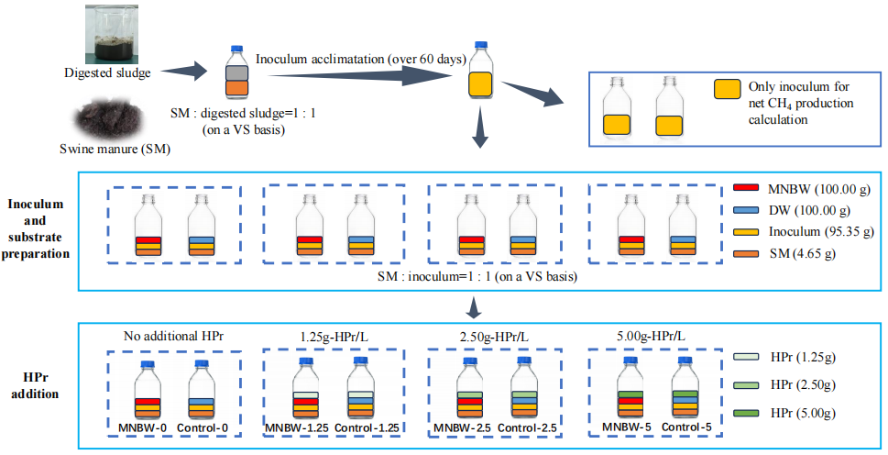
Fig. S1. Schematic diagram of AD system setup in this work

