Table S1. Alpha diversity indexes of bacteria
 | OTUs | Shannon | Chao1 | Simpson
Control-3days | 1811.67±50.85ª | 1.53±0.02ª | 1812.67±50.81ª | 0.138±0.013ª
Air-3days | 1906.33±129.67ª | 1.66±0.26ª | 1907.27±129.5ª | 0.117±0.047ª
CO₂-3days | 1993.33±120.80ª | 1.75±0.12ª | 1994.30±120.84ª | 0.098±0.02ª
Air+CO₂-3days | 1998.00±112.69ª | 1.80±0.06ª | 1998.80±112.69ª | 0.088±0.005ª
Control-21days | 1641.00±22.54^{b} | 1.79±0.02^{b} | 1641.93±22.48^{b} | 0.063±0.003^{b}
Air-21days | 1791.33±101.32^{c} | 1.92±0.05^{d} | 1792.20±101.21^{c} | 0.048±0.008^{b}
CO₂-21days | 1717.33±47.00^{b, c} | 1.83±0.04^{b, c} | 1718.13±47.05^{b, c} | 0.060±0.008^{b}
Air+CO₂-21days | 1782.00±42.72^{c} | 1.88±0.06^{c, d} | 1782.97±42.64^{c} | 0.052±0.011^{b}
Note: a, b, c, and d are labeled according to the Duncan test, and differences between the two groups are considered significant at the p<0.05 level when the symbols labeled between the two groups do not have repeated letters. Separate letters for each column.
Table S2. Alpha diversity indexes of archaea
 | OTUs | Shannon | Chao1 | Simpson
Control-3days | 19.67±4.04ª | 0.96±0.09ª | 21.70±6.56ª | 0.176±0.032ª
Air-3days | 32.33±11.93ª | 1.03±0.09ª | 33.01±12.01ª | 0.165±0.042ª
CO₂-3days | 28.67±6.51ª | 1.03±0.08ª | 33.01±8.42ª | 0.158±0.031ª
Air+CO₂-3days | 25.33±5.03ª | 0.97±0.03ª | 51.67±27.77ª | 0.171±0.020ª
Control-21days | 27.00±7.00^{b} | 0.51±0.03^{b} | 28.10±6.93^{b} | 0.451±0.013^{b}
Air-21days | 31.00±5.20^{b} | 0.42±0.02^{c} | 31.43±4.88^{b} | 0.516±0.014^{c}
CO₂-21days | 23.33±3.06^{b} | 0.42±0.03^{c} | 32.00±6.00^{b} | 0.530±0.023^{c}
Air+CO₂-21days | 31.00±13.11^{b} | 0.46±0.05^{b, c} | 31.73±14.17^{b} | 0.514±0.043^{c}
Note: a, b, and other letters are labeled according to the Duncan test, and differences between the two groups are considered significant at the p<0.05 level when the symbols labeled between the two groups do not have repeated letters. Separate letters for each column.
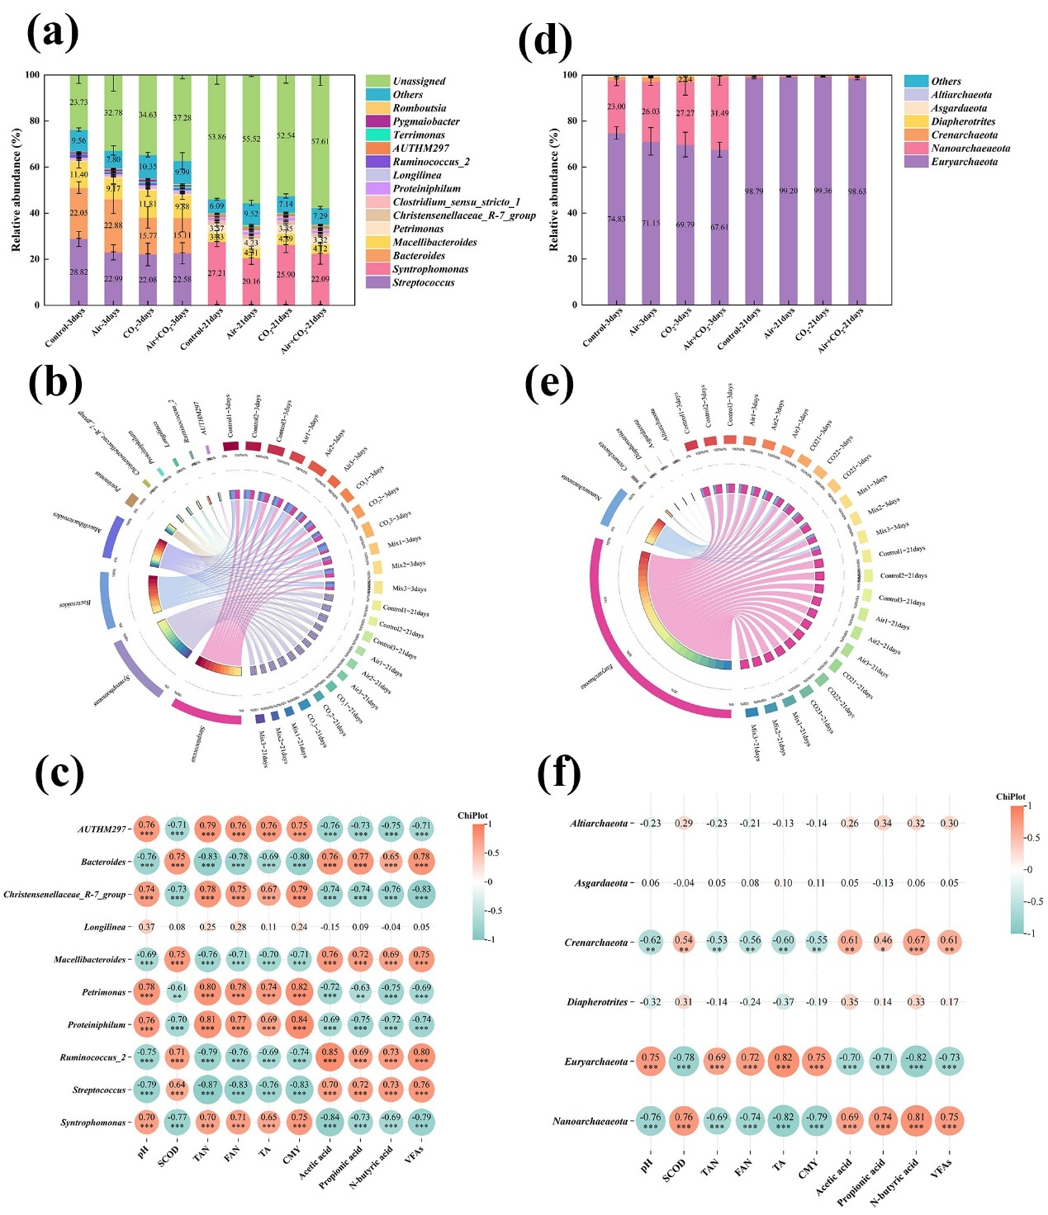Fig.S Distribution of bacterial sequences at the genus level (RA (a), Circos plot (b), Correlation analysis plots of environmental factors (c)) and distribution of archaea sequences at the phylum level (RA (d), Circos plot (e), Correlation analysis plots of environmental factors (f)).

