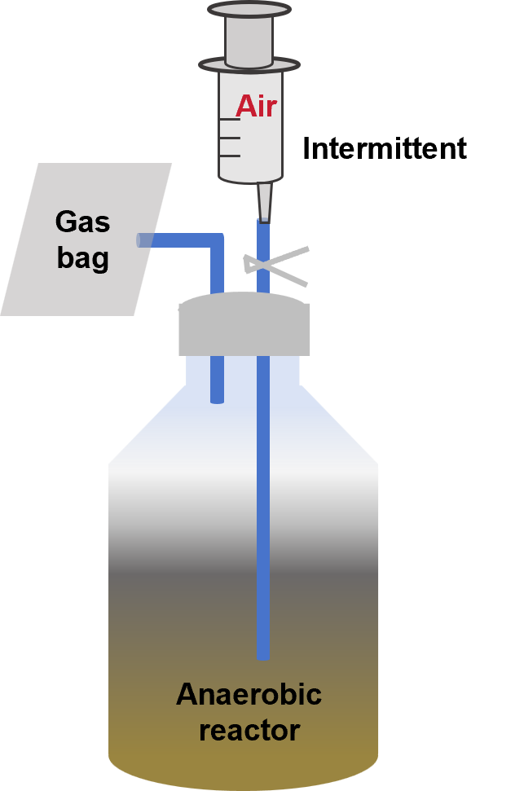
Figure S1. Schematic diagram of the reactor.

Table S1. Relative abundance of genes related to HA formation: modules related to intracellular polyphenols formation and ubiquinone oxidoreductase contributed to extracellular HA condensation.
 | Module/EC | R1 | R4
Intracellular | M00004 | 1.90E-03 | 1.83E-03
 | M00022 | 1.21E-03 | 1.19E-03
 | M00024 | 3.19E-04 | 3.43E-04
 | M00025 | 3.73E-04 | 3.91E-04
Extracellular | EC.1.3.5.1 | 3.04E-04 | 3.13E-04
 | EC7.2.1.1 | 5.19E-04 | 6.00E-04

