Enhancing anaerobic co-digestion of poultry litter and wheat straw via integrated microaeration, biochar, and nanoparticle strategies: Kinetic, microbial, and economic insights

Yuanhang Zhan¹, Yiting Xiao¹, Sarah Wu², Zhiwu Wang³, Jun Zhu^{1*}

¹Department of Biological and Agricultural Engineering, University of Arkansas, Fayetteville, AR 72701, USA
²Department of Chemical and Biological Engineering, University of Idaho, Moscow, ID 83844, USA
³Department of Biological Systems Engineering, Virginia Tech, Blacksburg, VA 24060, USA

*Correspondence: yz062@uark.edu; Tel.: +1-479-575-2688.

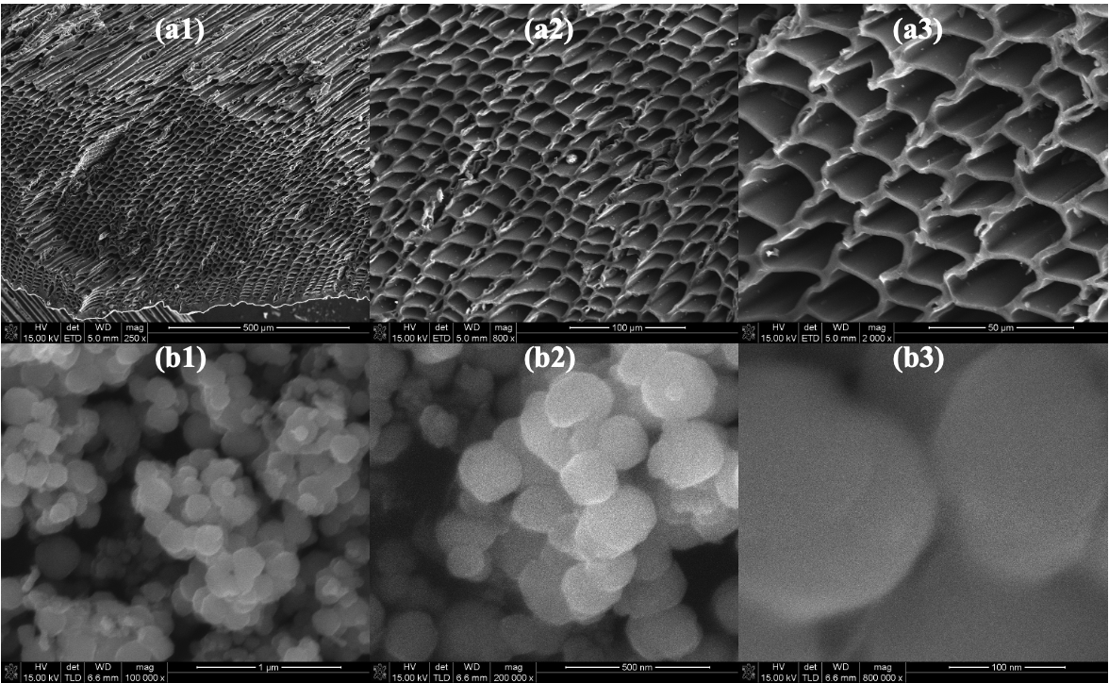
Fig. S1. The scanning electron microscope (SEM) images of the (a1-a3) biochar and (b1-b3) magnetite nanoparticles at different magnitudes

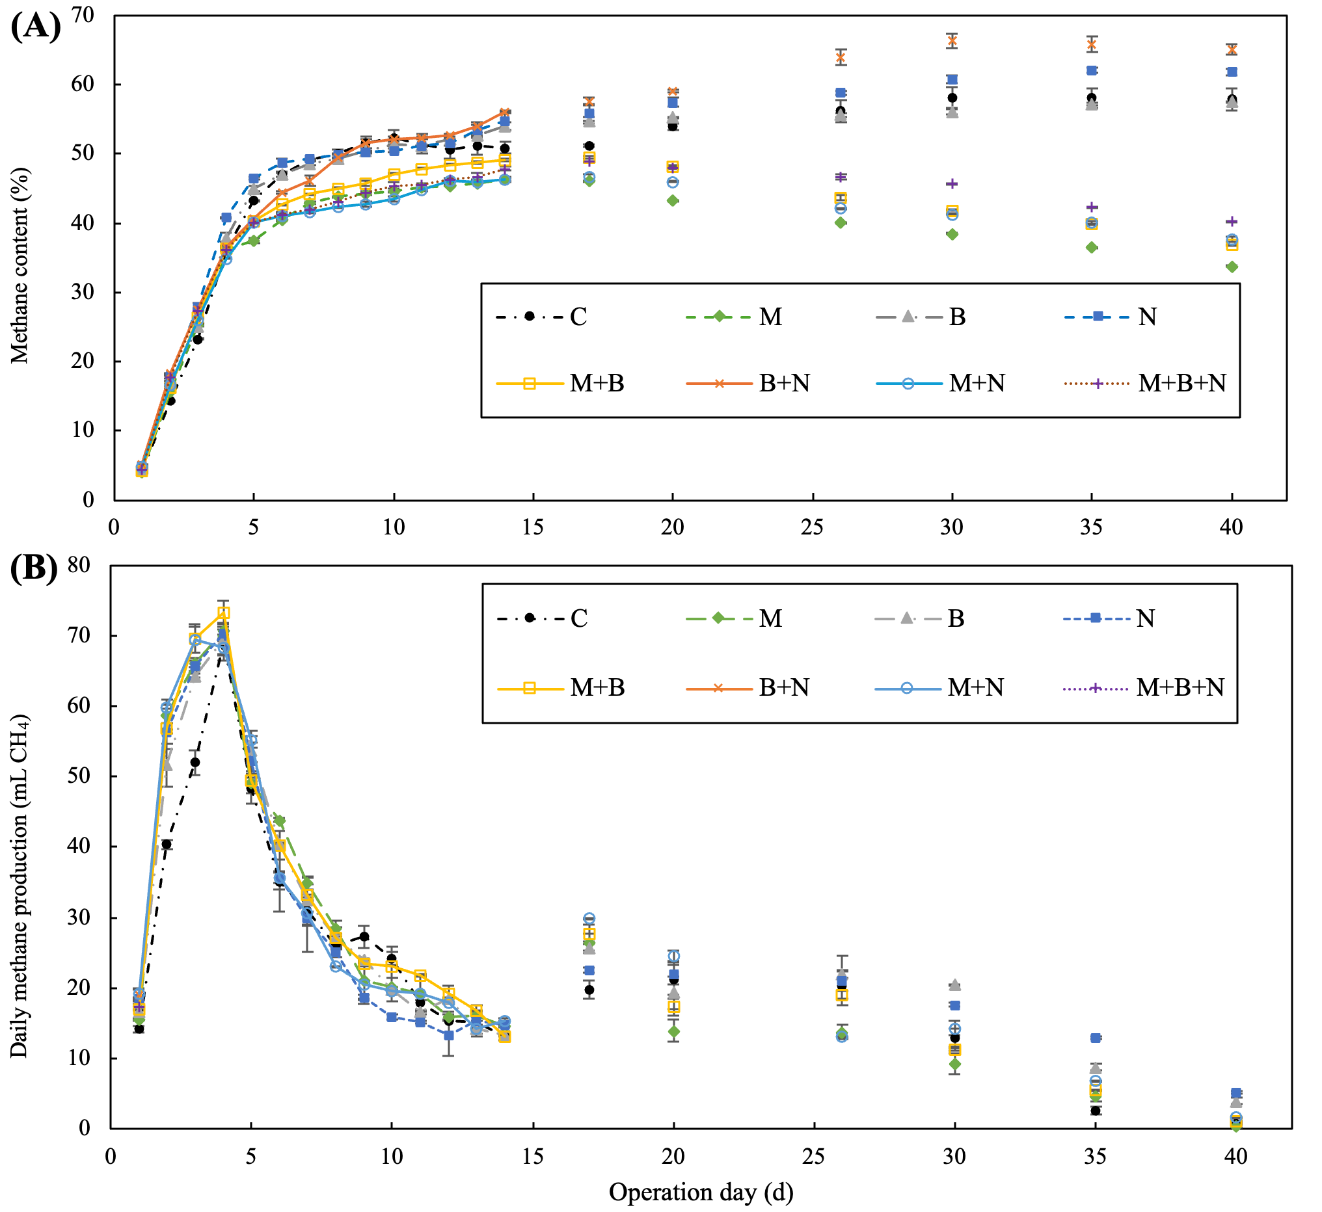
Fig. S2. The variation of (a) methane content (%) and (b) daily methane production (mL CH₄) of the Co-AD process under different conditions (C, the control; M, microaeration; B, biochar addition; N, nanoparticles; and their combinations)
Table S1 Summary of the kinetic parameters using the first-order kinetic model (FM), the modified Gompertz model (MGM) for the Co-AD process under different conditions (C, the control; M, microaeration; B, biochar addition; N, nanoparticles; and their combinations).
Groups |  | C | M | B | N | M+B | B+N | M+N | M+B+N
Experimental CMY_{o} (NmL/g VS_{added}) |  | 274.43 ± 0.87 | 293.92 ± 1.12 | 304.66 ± 0.43 | 296.88 ± 0.68 | 306.61 ± 1.15 | 324.83 ± 3.78 | 302.58 ± 2.05 | 305.28 ± 0.33
FM | Y_{m} (NmL/g VS_{added}) | 281.80 | 301.75 | 308.45 | 295.93 | 314.29 | 307.31 | 326.82 | 310.83
FM | Dif (%) | 2.69 | 2.67 | 1.24 | -0.32 | 2.51 | 1.56 | 0.61 | 1.82
FM | k (day⁻¹) | 0.112 | 0.127 | 0.116 | 0.121 | 0.121 | 0.122 | 0.116 | 0.118
FM | R² | 0.9822 | 0.9841 | 0.9865 | 0.9872 | 0.9867 | 0.9890 | 0.9890 | 0.9910
FM | RMSE | 10.79 | 10.67 | 10.00 | 9.20 | 10.14 | 8.88 | 9.45 | 8.14
FM | AIC | 102.63 | 102.20 | 99.61 | 96.28 | 100.14 | 94.85 | 97.36 | 91.37
MGM | Y_{m} (NmL/g VS_{added}) | 265.08 | 285.12 | 290.03 | 278.45 | 297.01 | 290.34 | 307.11 | 293.42
MGM | Dif (%) | -3.41 | -3.00 | -4.80 | -6.21 | -3.13 | -4.04 | -5.45 | -3.89
MGM | R_{m} (NmL/g VS_{added}/day) | 23.56 | 26.83 | 24.62 | 24.68 | 26.06 | 25.56 | 26.18 | 24.93
MGM | λ (day) | 0.44 | 0.19 | 0.00 | 0.00 | 0.04 | 0.00 | 0.00 | 0.00
MGM | R² | 0.9891 | 0.9885 | 0.9833 | 0.9762 | 0.9870 | 0.9818 | 0.9810 | 0.9842
MGM | RMSE | 8.42 | 9.09 | 11.14 | 12.55 | 10.00 | 11.42 | 12.45 | 10.77
MGM | AIC | 95.91 | 98.96 | 107.09 | 111.87 | 102.75 | 108.10 | 111.52 | 105.74
Note: CMY_{o} = the actual observed cumulative methane yield (NmL CH₄/g VS_{added}); Y_{m} = Specific methane yield of substrates (NmL CH₄/g VS_{added}); e = 2.718; k = Hydrolytic rate constant (day⁻¹); t = Digestion time (days); R_{m} = Maximum methane production rate (NmL CH₄/g VS_{added}/day); λ = Lag phase (days).

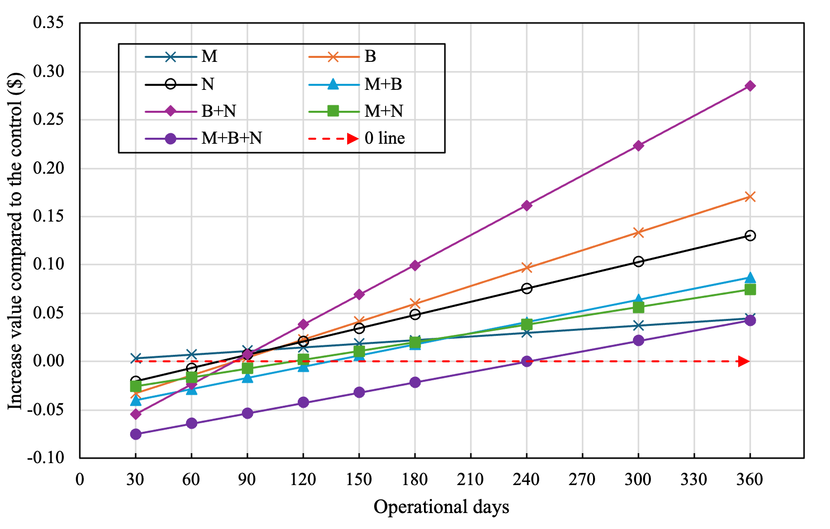
Fig. S3. The calculated increased value of the Co-AD process (M, microaeration; B, biochar addition; N, nanoparticles; and their combinations) in the enhanced treatments grouped by different technologies compared to the control (0 line) without enhancing technologies, variation with the proposed operational time (solid retention time, days)

