Supplementary Material for:
Hydrodynamic regulation drives azo dye transformation and hydrolysis acidification by reshaping microbial metabolism in the micro-aerobic hydrolysis acidification reactor

Fig. S1. Schematic diagram of the MHAH reactor.

Fig. S2. Simplification of the physical model (a), grid independence simulation (b), and verification of the CFD-PBM coupling model (c).

Fig. S3. DO, ORP, and pH under different flow characteristics.

Fig. S4. Three-dimensional fluorescence spectra of influent and effluent DOM. (a) Influent, (b) Effluent of R1, (c) Effluent of R2, (d) Effluent of R3, (e) Effluent of R4.

Fig. S5. The Fourier infrared transformation spectrum of EPS in MAHA reactors.

Fig. S6. Functional pathways at KEGG Level 1 and Level 2.

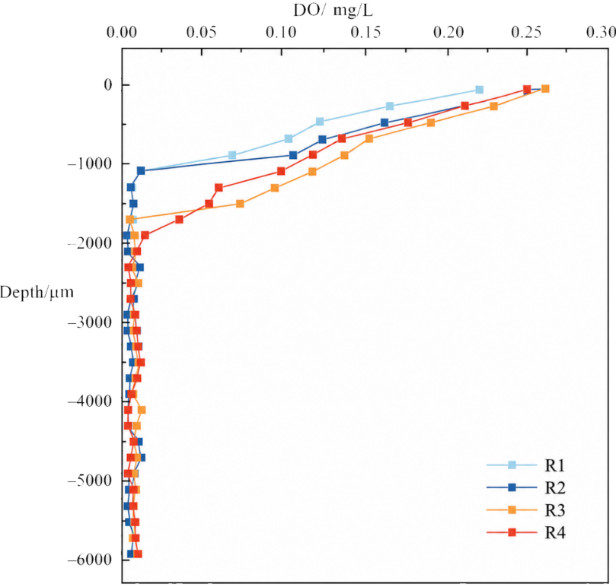
Fig. S7. Microscale DO profiles along the depth of carrier-associated biofilms in R1-R4.

Fig. S8. The top ten genera contributing to key enzymes.

Table S1. The theoretical equations of the CFD-PBM coupling model.
Theoretical model | Formulas | N_{O}.
Mass balance equation | 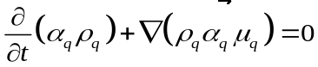 | S1
Momentum equation | 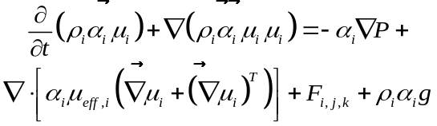 | S2
PBM model | 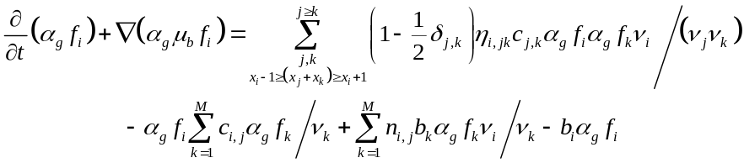 | S3

Table S2. Signs of cross peaks in synchronous and asynchronous (in parentheses) 2D correlation spectra (2D-COS) under different stirring speeds.
cm⁻¹ | 670 | 1023 | 1186 | 1360 | 1456 | 1624 | 2853 | 2922 | 3414
670 | + |  |  | -(+) | -(+) | -(-) | -(+) | -(+) | -(-)
1023 |  | + |  | +(+) | +(+) | +(-) | -(+) | +(+) | +(+)
1186 |  |  | + | -(-) | -(-) | +(-) | -(+) | -(+) | +(+)
1360 |  |  |  | + | -(+) | +(-) | -(+) | -(+) | -(+)
1456 |  |  |  |  | + | +(-) | -(+) | -(+) | +(+)
1624 |  |  |  |  |  | + | -(+) | -(+) | +(+)
2853 |  |  |  |  |  |  | + |  | -(-)
2922 |  |  |  |  |  |  |  | + | -(-)
3414 |  |  |  |  |  |  |  |  | +
Note. “+” and “−” indicate positive and negative cross peaks, respectively. The signs outside parentheses represent synchronous correlation peaks, whereas those inside parentheses represent asynchronous correlation peaks. According to Noda’s rules, for a cross peak at (ν₁, ν₂), if the synchronous and asynchronous signs are the same, the functional group at ν₁ responds earlier than that at ν₂. If the signs are opposite, the functional group at ν₂ responds earlier than that at ν₁.

Table S3. LC-MS identification of key intermediates associated with the proposed transformation pathway of Acid Red GR.
Pathway | Compound | m/z | RT (min) | exact mass | Mass error (ppm) | Molecular formula | Precursor type | KEGG ID | library | Identification level
Azo reduction products | para-Phenylenediamine | 108.069 | 0.867 | 108.0687 | 0.92533817 | C6H8N2 | [M]+ | C19499 | BioDeepDB | 1
Azo reduction products | 4-Aminophenol | 110.06 | 0.915 | 109.0528 | 0.69053244 | C6H7NO | [M+H]+ | C02372 | BioDeepDB | 1
Sulfonated aromatic intermediates | 2,7-Naphthalenedisulfonic acid | 286.976 | 5.637 | 288.2989 | 23.1588470 | C10H8O6S2 | [M-H]- | NA | MoNA | 1
Sulfonated aromatic intermediates | 1-Naphthol-5-sulfonic acid | 223.010 | 10.105 | 224.0143 | 13.6597580 | C10H8O4S | [M-H]- | NA | MoNA | 1
Sulfonated aromatic intermediates | 2-Naphthalenesulfonic acid | 208.019 | 0.813 | 208.0194 | 0.48072463 | C10H8O3S | [M]+ | C16202 | mzCloud | 1
Desulfonated/aromatic intermediates | 2-Naphthylamine | 144.081 | 11.382 | 143.0735 | 1.91559580 | C10H9N | [M+H]+ | C02227 | mzCloud | 1
Desulfonated/aromatic intermediates | 1-Naphthol | 144.056 | 0.733 | 144.0575 | 12.4951668 | C10H8O | [M]+ | C11714 | BioDeepDB | 1
Desulfonated/aromatic intermediates | 1,2-Dihydronaphthalene-1,2-diol | 162.066 | 11.460 | 162.0681 | 12.3406437 | C10H10O2 | [M]- | C06205 | MoNA | 1
Further aromatic transformation | Hydroquinone | 111.040 | 0.733 | 110.0368 | 0.00398429 | C6H6O2 | [M+H]+ | C00530 | BioDeepDB | 1
Further aromatic transformation | Catechol | 111.092 | 8.690 | 110.0368 | 0.03318445 | C6H6O2 | [M+H]+ | C00090 | BioDeepDB | 1
Ring-cleavage product | trans-trans-Muconic acid | 141.019 | 9.535 | 142.0266 | 2.29756274 | C6H6O4 | [M-H]- | C02480 | MoNA | 1
Note. “NA” indicates that the substance does not have a KEGG ID.

