Supplementary Material

Synergistic promotion of straw anaerobic digestion by a composite microbial consortium and micro-aeration: Enhancing lignocellulose decomposition and methanogenesis

Junyi Zhengª, Xuepeng Wangª, Yaobin Zhang^{a*}

Affiliations:
ª Dalian University of Technology School of Environmental Science and Technology No.2 Linggong Road, Ganjingzi District. Dalian, Liaoning, 116024, China.
* Correspondence: Tel: +86 411 8470 6460, Fax: +86 411 8470 6263;
E-mail address: qilin_yu@dlut.edu.cn

Table S1. Basic information of corn straw.

 | Corn straw | Sludge
TSS (%) | 93.8 ± 0.1 | 4.0 ± 0.2
VSS (% of TS) | 72.2 ± 0.1 | 82.6 ± 2.3
C (% of TS) | 33.7 ± 0.0
N (% of TS) | 0.9 ± 0.0
H (% of TS) | 3.9 ± 0.7

FTIR analysis.
Table S2. Band assignments of the spectra

Number | Wave number (cm⁻¹) | Band assignment
1 | 3400-3420 | O-H stretching
2 | 2840-2980 | C-H vibrations
3 | 1650-1655 | C-O stretch in conjugated  p-substituted aryl ketones
4 | 1500-1690 | C=C stretching vibration peak in benzene ring
5 | 1000-1050 | C-O in guaiacyl group

Text S1 ROS measurement
The parameters of electron paramagnetic resonance (EPR) spectrometer
EPR instrument (Bruker, Elexsys II E500-CW-EPR) operating parameters were center field 3500 G; microwave frequency 9.8 GHz; microwave power 2.0 mW; modulation frequency 4.0 G; modulation amplitude 4.0 G; sweep width 200 G; receiver gain 3.54 × 10⁴; time constant 41.0 ms; sweep time 15 s; 15 scans.
Quantitative analysis of •O₂⁻ and •OH
The formation of •OH and •O₂⁻ were determined using a fluorescence probe method with dimethyl sulfoxide and 2,3-bis(2-methoxy-4-nitro-5-sulfophenyl)-5-carboxypyridine tetrazolium [XTT][1]. Briefly, 0.05 g of sludge sample was mixed with 5 mL of 0.05 mM XTT solution and shaken under dark conditions for 24 h. Subsequently, the mixture was centrifuged at 7000 × g for 5 min, and the resulting supernatant was collected and filtered through a syringe fitted with a 0.45 μm nylon organophilic membrane. Finally, XTT formazan in the filtrate was determined using an Evolution 201 UV-visible spectrophotometer (Thermo Scientific, USA) at a wavelength of 475 nm (= 23800 M⁻¹cm⁻¹).
C = A × v /( r × l × m × 2) (s1)
where C is the concentration of •O₂⁻ produced, A is the absorbance of XTT formaldehyde, v is the volume of XTT added (40 mL), r is the extinction coefficient of XTT formaldehyde (23,800 m- 1cm-1), l is the optical range length (1 cm), m is the mass of fresh soil (5.0 g), 2 is the conversion factor for the reaction between •O₂⁻ and XTT.
•OH was quantificationally detected after being captured by dimethyl sulfoxide (DMSO) to form formaldehyde (HCHO), which was reacted with 2,4- Dinitrophenylhydrazine (DNPH) to HCHO-DNPH (Tai et al., 2004). Briefly, 5 mL of the sample was mixed with 5 mL DMSO (100 mM) immediately after collection, and a 10-minute vortex was conducted to ensure full reaction. After that, 1 mL of the solution was collected and mixed with 5 mL of H₃PO₄-NaH₂PO₄ buffer solution (pH = 4) and 2.7 mL of 2,4-DNPH solution (1 mM). After 30 minutes in a water bath at 50℃, the mixture was filtered (0.22 μm) before the determination. The contents of HCHO- DNPH were quantified by high-performance liquid chromatography (HPLC, LC- 2050C, Shimadzu, Japan) equipped with a C18 column (5 μm, 250 × 4.6 mm).
Text S2 Characterization and analysis
Electrochemical measurement
After washing three times with 0.01 M phosphate buffer solution (PBS), 20 μL of the sediment suspensions were coated on a glassy carbon electrode (Φ3 mm, working area: 0.07 mm2) and dried in an infrared oven. Electrochemical tests were performed with an electrochemical workstation (Chenhua, CHI 660). The coated glassy carbon electrode, Ag/AgCl electrode, and Pt electrode were selected as the working electrode, reference electrode, and counter electrode, respectively. The capacitance and resistance of the sediment were assessed with cyclic voltammetry (CV) and electrochemical impedance spectroscopy (EIS), respectively.
Cyclic voltammetry was performed in the range of -0.8 to 0.8 V (vs Ag/AgCl) at scan rates of 50 mV/s, with 30 mL of 0.01 M PBS as the electrolyte. Electrochemical impedance spectroscopy was conducted over a frequency range of 1000 kHz to 0.01 Hz, with a sinusoidal perturbation of 10 mV amplitude to analyze the internal impedances of the sediments. Before the electrochemical tests, the electrolyte in the same concentration was aerated for 40 min with N₂ to maintain an anaerobic condition.
Analytical methods
COD were determined by the Standard Methods for the Examination of Water and Wastewater. The volume and content of biogas were measured using a 100 mL glass syringe and a gas chromatograph (Tianmei, GC-7900, China) with a thermal conductivity detector (TCD), respectively[2].
Measurement of enzyme activity
Laccase (Lac), a copper-containing polyphenol oxidase, decomposes the substrate ABTS to produce ABTS radicals, exhibiting a significantly greater absorbance coefficient at 420 nm compared to the substrate (ml076971, 100T/48S). The rate of increase in these radicals is used to determine laccase activity. In contrast, lignin peroxidase (LiP), a ferrous heme-containing peroxidase, catalyzes the demethylation of asphaltene, resulting in a decrease in absorbance value measured at 651 nm (ml092790, 100T/96S). Likewise, manganese peroxidase (MnP), another ferrous heme-containing enzyme, performs the oxidation of guaiacol to tetra-o-methoxylenol, displaying a distinct absorption peak at 465 nm (ml076964, 100T/96S)[3]. Carboxymethyl cellulase activity (CMCase) was determined by measuring the glucose formed from carboxymethyl cellulose (CMC) [4].

Text S3 Supplementary batch experiment
The experiment was designed based on the batch protocol described in Section 2.2 and consisted of five groups (n=3):(1) Control-AN (100 mL sludge, 6 g straw, 20 mL sterile water, no aeration) (2) Fungi-AN (100 mL sludge, 6 g straw, 20 mL spore suspension, no aeration) (3) Control-MA (100 mL sludge, 6 g straw, 20 mL sterile water, 4% air/day) (4) Fungi-MA (100 mL sludge, 6 g straw, 20 mL spore suspension, 4% air/day) (5) Fungi-MA-6% (100 mL sludge, 6 g straw, 20 mL spore suspension, 6% air/day) All reactors were operated at 37.0°C. At the termination of the experiment, liquid samples were immediately collected and analyzed for Volatile Fatty Acids (VFAs), Reactive Oxygen Species (ROS), and key enzyme activities (LiP, MnP, Lac), following the procedures detailed in Section 2.3.

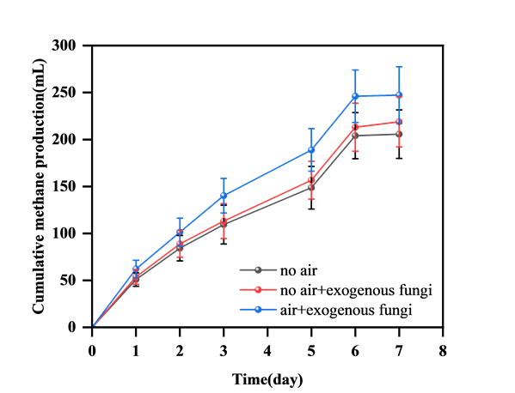
Fig. S1 Methane production batch experiments.
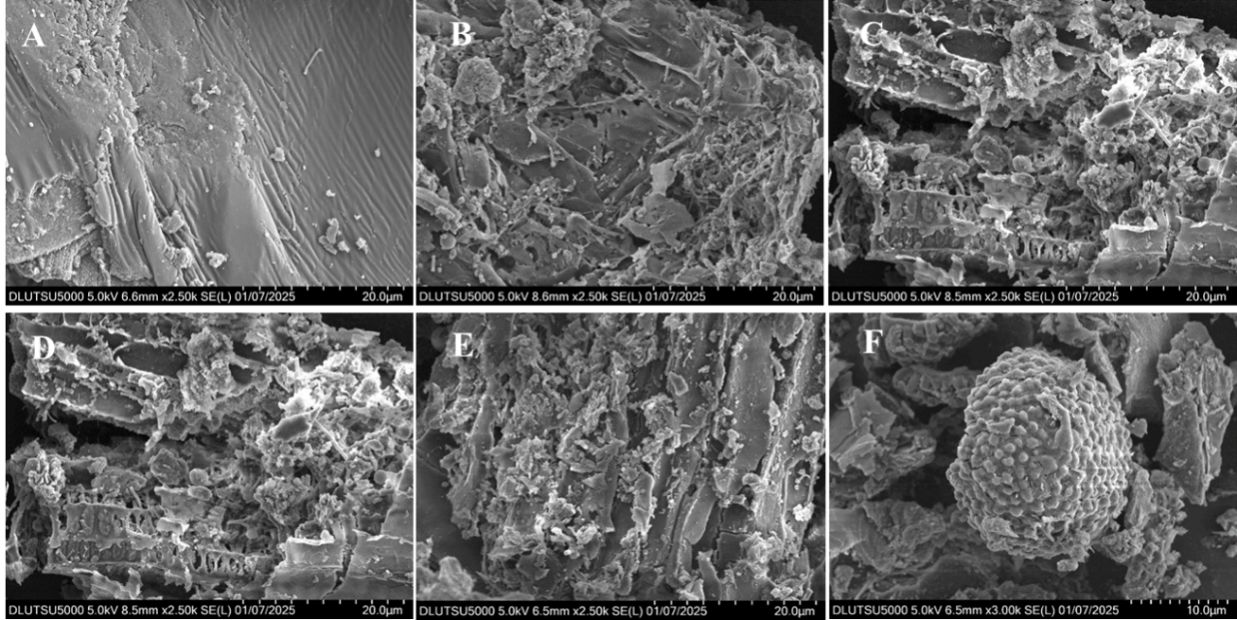
Fig. S2 Morphological characterization of straw digestate. (A) The residue of anaerobic control group; (B,C,D,E) The residue of aeration group; (F) Agglomerated microbial community in aeration group
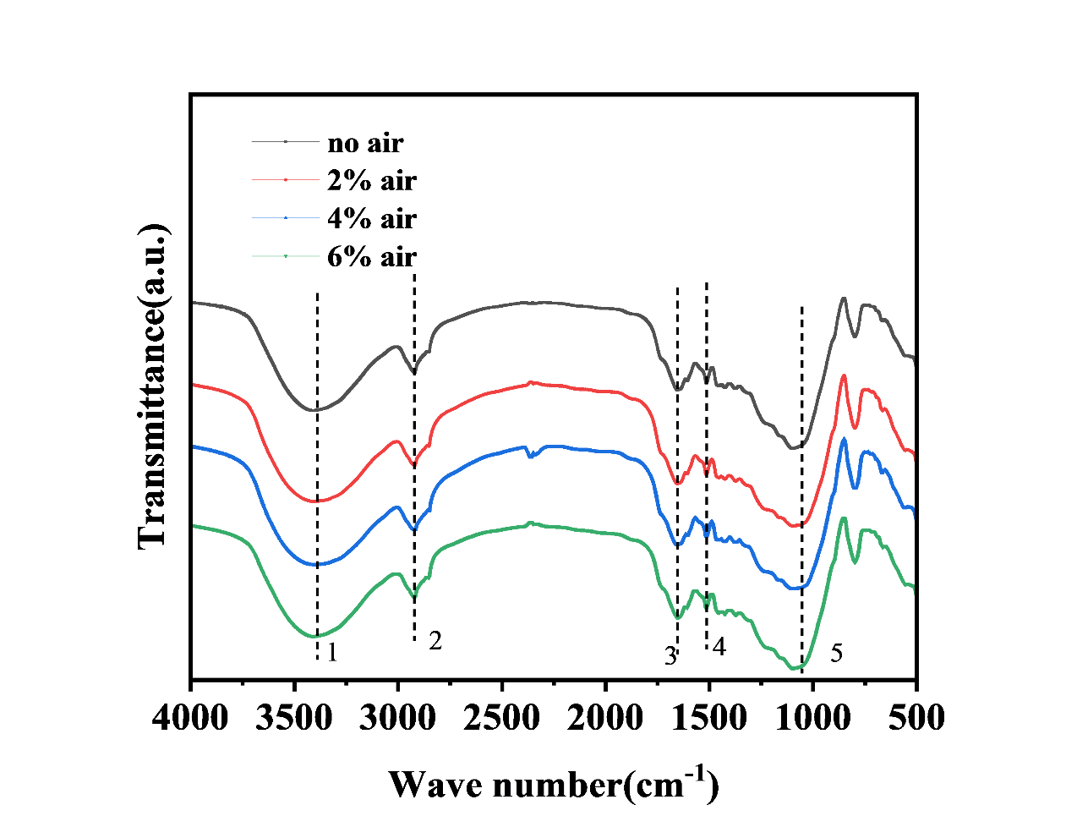
Fig. S3 FTIR pattern of lyophilized digestate

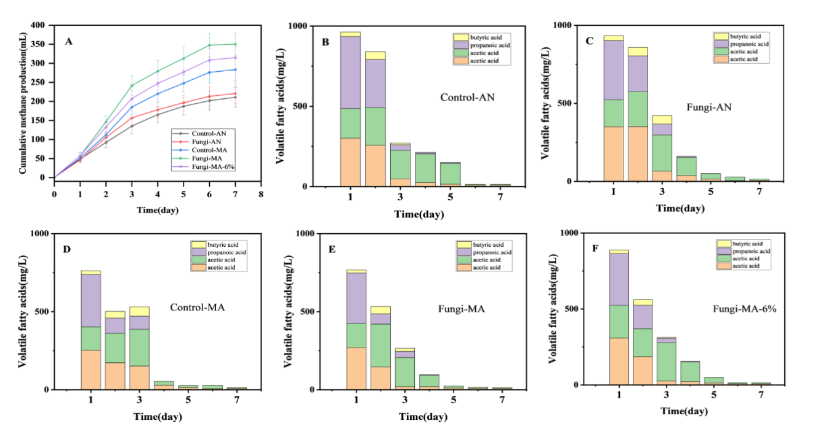

Fig. S4 Supplementary batch experiment (A) Methane production; (B,C,D,E,F) VFA of effluent from each experiment group

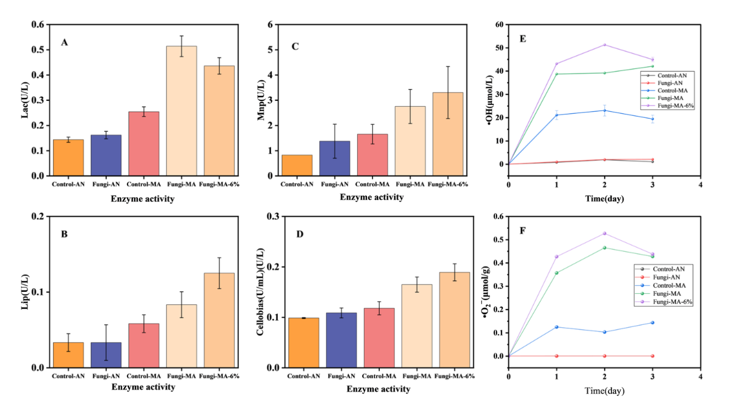
Fig. S5 Enzyme activity and ROS generation (A) laccase activity; (B) lignin peroxidase activity; (C) manganese peroxidase activity; laccase activity; (D) β-glucosidase enzyme activity; (E) quantitative analysis of •OH; (F) •O²⁻ quantitative analysis

Reference
[1] G. Zhao, B. Wu, X. Zheng, B. Chen, A. Kappler, C. Chu, Tide-triggered production of reactive oxygen species in coastal soils, Environ. Sci. Technol. 56 (2022) 11888-11896. https://doi.org/10.1021/acs.est.2c03142.
[2] Z. Zhao, Y. Zhang, L. Wang, X. Quan, Potential for direct interspecies electron transfer in an electric-anaerobic system to increase methane production from sludge digestion, Sci. Rep. 5 (2015) 11094. https://doi.org/10.1038/srep11094.
[3] Y. Gong, Z. Jin, X. Wang, Y. Zhang, Improving methane production and 4-chlorophenol removal in anaerobic digestion of corn straw by adding phanerochaete chrysosporium and biochar under microaerobic conditions, Water Res. 270 (2025) 122845. https://doi.org/10.1016/j.watres.2024.122845.
[4] C. Yan, Y. Liu, X. Cui, L. Cao, J. Xiong, Q. Zhang, Y. Wang, R. Ruan, Improving the efficiency of anaerobic digestion: domesticated paddy soil microbes enhance the hydrolytic acidification of rice straw and pig manure, Bioresour. Technol. 345 (2022) 126570. https://doi.org/10.1016/j.biortech.2021.126570.

