Supplementary material

Can microaeration and hydraulic retention time steer anaerobic microbiomes toward efficient LAS degradation?

Maurício Guimarães de Oliveiraª, Vicente Elício Porfiro Sales Gonçalves da Silvaª, Steven Renato Ferreira Vasconcelosª, Paulo Igor Milen Firminoª, André Bezerra dos Santos ^{a,*}

ª Department of Hydraulic and Environmental Engineering, Federal University of Ceará, Fortaleza, Ceará, Brazil

* Corresponding author: Department of Hydraulic and Environmental Engineering. Campus do Pici, Bloco 713. Pici. CEP: 60455-900. Fortaleza – Ceará – Brazil.
E-mail: andre23@ufc.br

Table S1 – Valid sequences and alpha-diversity indices of each sample.
Samples | Valid Sequences | Chao1 | ACE | Shannon | Inv_Simpson
Inoculum | 87014 | 589.6 | 591.8 | 4.1 | 26.5
R1 | 72655 | 396.1 | 397.4 | 3.5 | 13.4
R2 | 75642 | 719.6 | 722.9 | 4.2 | 28.3
R3 | 89748 | 426.1 | 427.2 | 3.6 | 15.6
R4 | 76789 | 533.4 | 536.2 | 4.1 | 30.1

Figure S1 – Box plot of pH and acidity/alkalinity ratio.
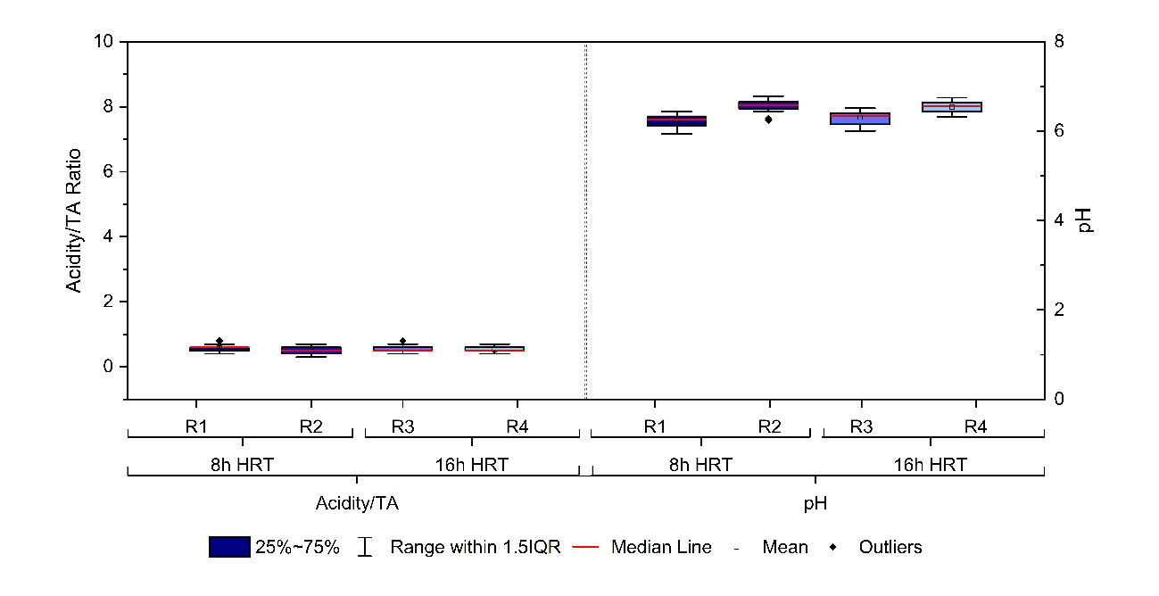

Figure S2 – Venn diagram for each system operated, including the starting inoculum.

Figure S3 – Contribution of the most significant genus in methanogenic pathways: a) Hydrogenotrophic, b) Methylotrophic and c) Acetoclastic.
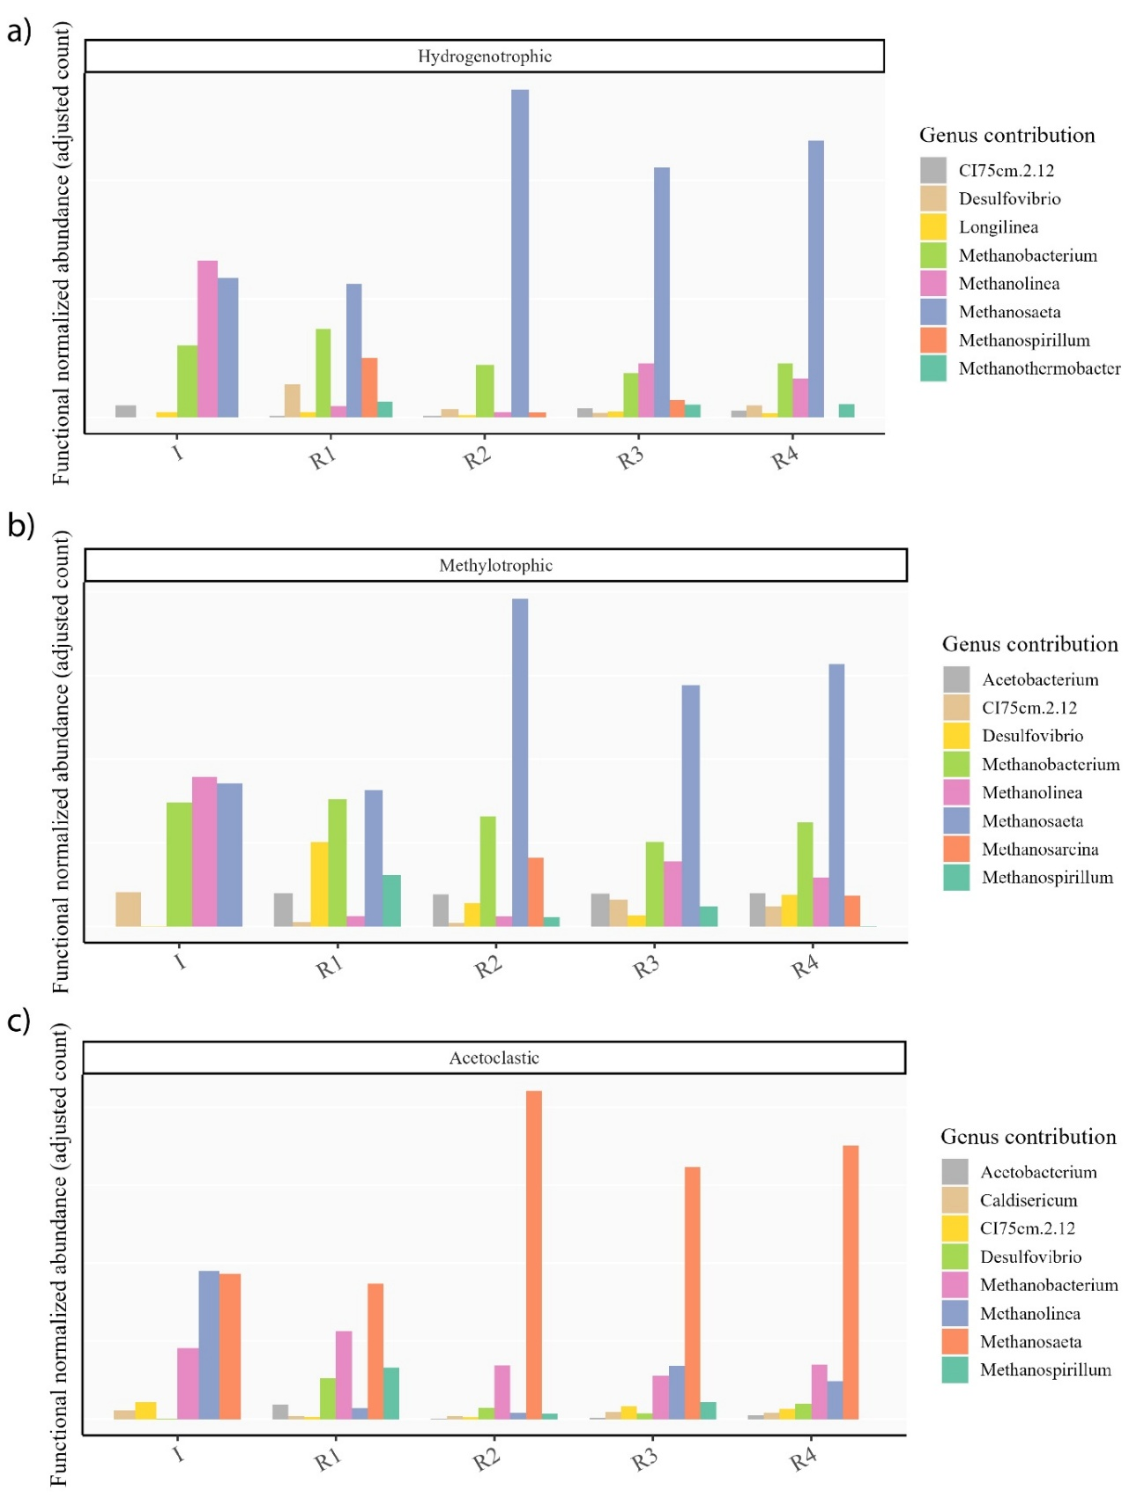

Figure S4 – Contribution of the most significant genus to the a) ω-oxidation, b) β-oxidation and c) benzene ring cleavage metabolism pathways.
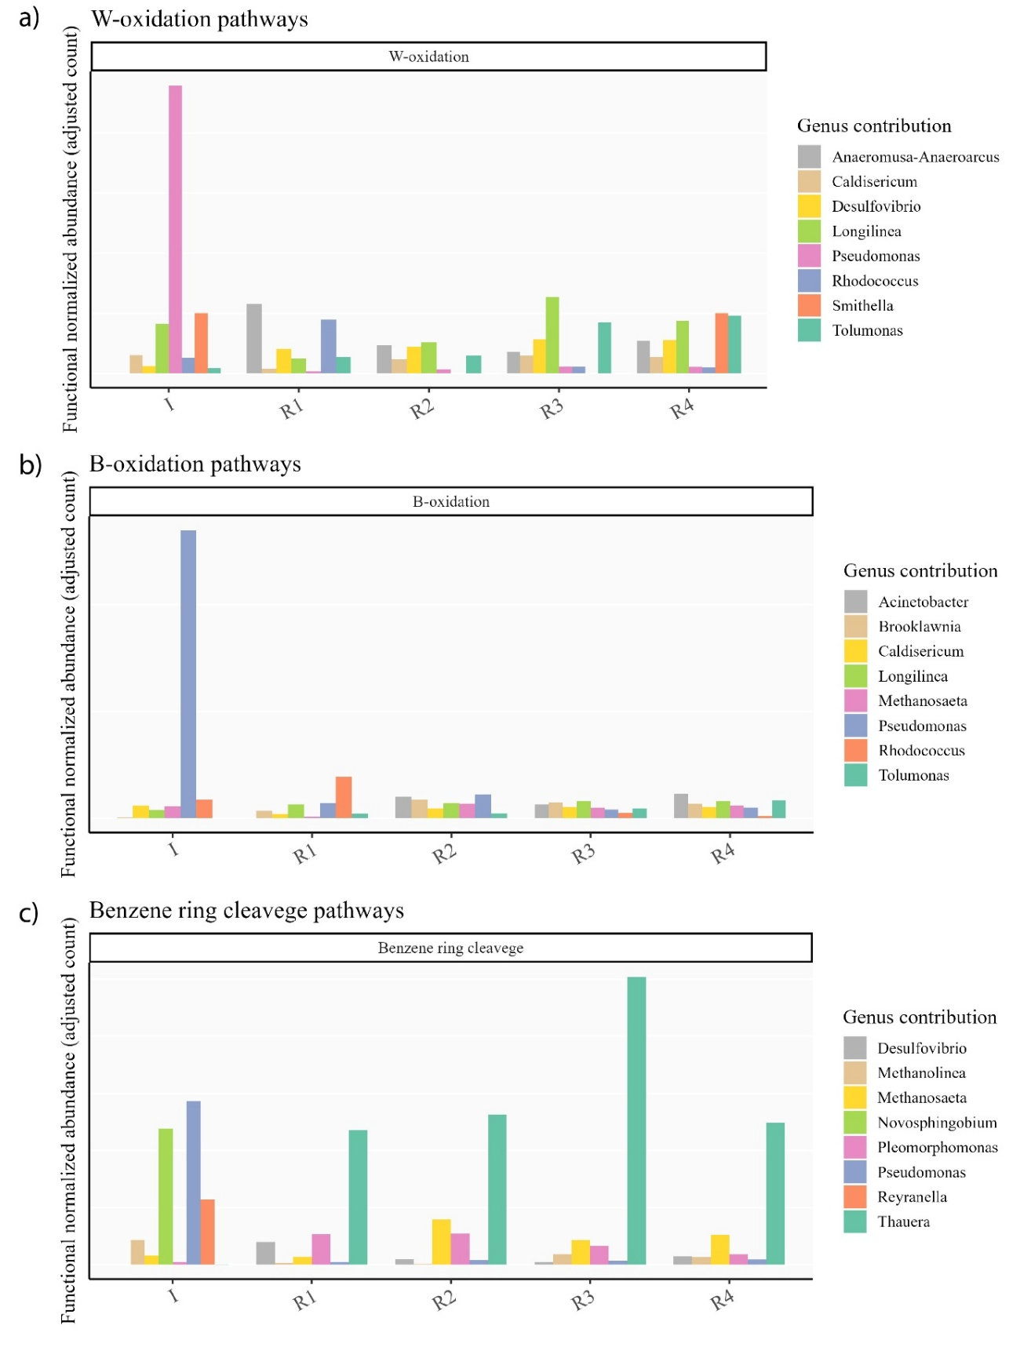

Figure S5 – Contribution of the most significant genus to desulfur metabolism.

Figure S6 – Temporal profiles of off-gas O₂ concentration and O₂/N₂ ratio in the microaerated reactors.
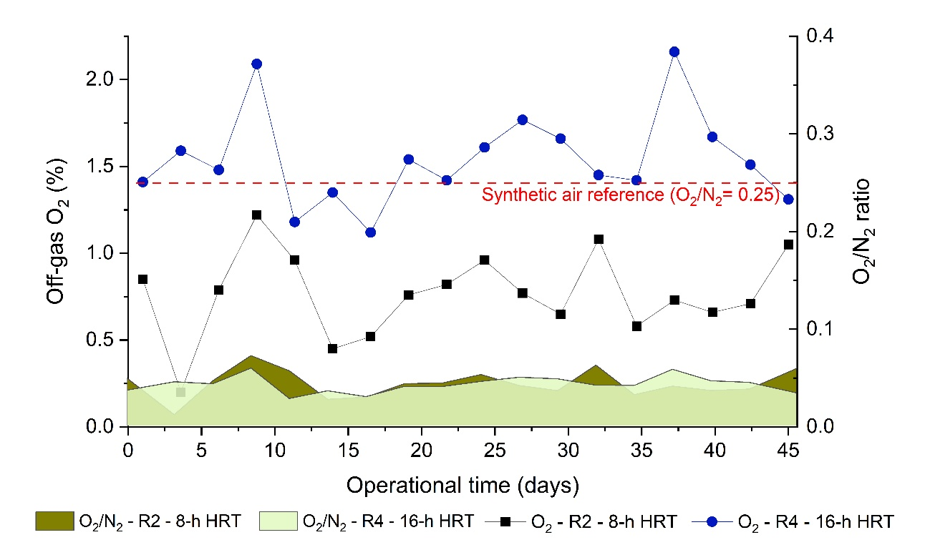

Figure S7 – Apparent gas-phase O₂ depletion in the microaerated reactors.
