Supplementary material

Investigation of hydrolysis acidification process during anaerobic treatment of coal gasification wastewater (CGW): Evolution of dissolved organic matter and biotoxicity

Zhiqiang Chen^{a,b}, Da Liª, Qinxue Wen^{a *}
ª State Key Laboratory of Urban Water Resource and Environment, School of Environment, Harbin Institute of Technology, Harbin 150090, China
^{b} School of Civil Engineering, Lanzhou University of Technology，Lanzhou 730070, China.

Table S1 The signs of typical peaks in 2D-COS maps.
The coupled process | Wavelength  (nm) | 210 | 220 | 225 | 240 | 254 | 270 | 285 | 295
HA-1-UASB | 205 | +(-) | +(-) |  | +(-) | +(-) | +(-) |  | +(-)
HA-1-UASB | 210 |  | +(+) |  | +(-) | +(-) | +(-) |  | +(-)
HA-1-UASB | 220 |  |  |  | +(-) | +(-) | +(-) |  | +(-)
HA-1-UASB | 240 |  |  |  |  | +(+) | +(+) |  | +(-)
HA-1-UASB | 254 |  |  |  |  |  | +(+) |  | +(-)
HA-1-UASB | 270 |  |  |  |  |  |  |  | +(-)
HA-2-UASB | 205 | +(-) |  | +(+) |  | +(+) | +(-) | +(+)
HA-2-UASB | 210 |  |  | +(+) |  | +(+) | +(-) | +(+)
HA-2-UASB | 225 |  |  |  |  | +(+) | +(-) | +(+)
HA-2-UASB | 254 |  |  |  |  |  | +(-) | +(+)
HA-2-UASB | 270 |  |  |  |  |  |  | +(+)
Note: “+”, “-” means positive sign and negative sign, respectively.

Table S2 Pearson correlation matrix of the regular parameters, spectral indicators, and acute toxicity.
 |  | TPh | DOC | UV₂₅₄ | SUVA | GPC-A | GPC-B | Φ_{Ⅰ,n} | Φ_{Ⅱ,n} | Φ_{Ⅳ,n} | Φ_{T,n} | TU
COD | R | 0.974 | 0.950 | 0.938 | -0.366 | 0.804 | 0.081 | 0.935 | 0.811 | 0.935 | 0.899 | 0.882
COD | P | 0.005 | 0.013 | 0.018 | 0.545 | 0.101 | 0.897 | 0.020 | 0.096 | 0.020 | 0.038 | 0.047
TPh | R |  | 0.946 | 0.893 | -0.431 | 0.800 | 0.071 | 0.890 | 0.796 | 0.905 | 0.871 | 0.874
TPh | P |  | 0.015 | 0.042 | 0.469 | 0.104 | 0.910 | 0.043 | 0.107 | 0.035 | 0.055 | 0.052
DOC | R |  |  | 0.872 | -0.581 | 0.794 | 0.094 | 0.868 | 0.767 | 0.868 | 0.840 | 0.852
DOC | P |  |  | 0.054 | 0.304 | 0.109 | 0.880 | 0.057 | 0.130 | 0.057 | 0.075 | 0.067
UV₂₅₄ | R |  |  |  | -0.108 | 0.939 | -0.255 | 1.000 | 0.953 | 0.998 | 0.992 | 0.976
UV₂₅₄ | P |  |  |  | 0.863 | 0.018 | 0.679 | 0.000 | 0.012 | 0.000 | 0.001 | 0.004
SUVA | R |  |  |  |  | -0.058 | -0.600 | -0.100 | 0.022 | -0.104 | -0.059 | -0.110
SUVA | P |  |  |  |  | 0.926 | 0.285 | 0.873 | 0.972 | 0.868 | 0.925 | 0.860
GPC-A | R |  |  |  |  |  | -0.513 | 0.941 | 0.994 | 0.948 | 0.972 | 0.988
GPC-A | P |  |  |  |  |  | 0.376 | 0.017 | 0.001 | 0.014 | 0.006 | 0.002
GPC-B | R |  |  |  |  |  |  | -0.263 | -0.517 | -0.273 | -0.361 | -0.391
GPC-B | P |  |  |  |  |  |  | 0.669 | 0.372 | 0.656 | 0.551 | 0.515
Φ_{Ⅰ,n} | R |  |  |  |  |  |  |  | 0.955 | 0.998 | 0.993 | 0.977
Φ_{Ⅰ,n} | P |  |  |  |  |  |  |  | 0.011 | 0.000 | 0.001 | 0.004
Φ_{Ⅱ,n} | R |  |  |  |  |  |  |  |  | 0.962 | 0.983 | 0.989
Φ_{Ⅱ,n} | P |  |  |  |  |  |  |  |  | 0.009 | 0.003 | 0.001
Φ_{Ⅳ,n} | R |  |  |  |  |  |  |  |  |  | 0.995 | 0.984
Φ_{Ⅳ,n} | P |  |  |  |  |  |  |  |  |  | 0.000 | 0.002
Φ_{T,n} | R |  |  |  |  |  |  |  |  |  |  | 0.993
Φ_{T,n} | P |  |  |  |  |  |  |  |  |  |  | 0.001
Note: R values were the Pearson's correlation coefficient, and P values were also given correspondingly with Sig.(2-tailed). GPC-A: Chromatogram area of fitted peak A. GPC-B: Chromatogram area of fitted peak B.

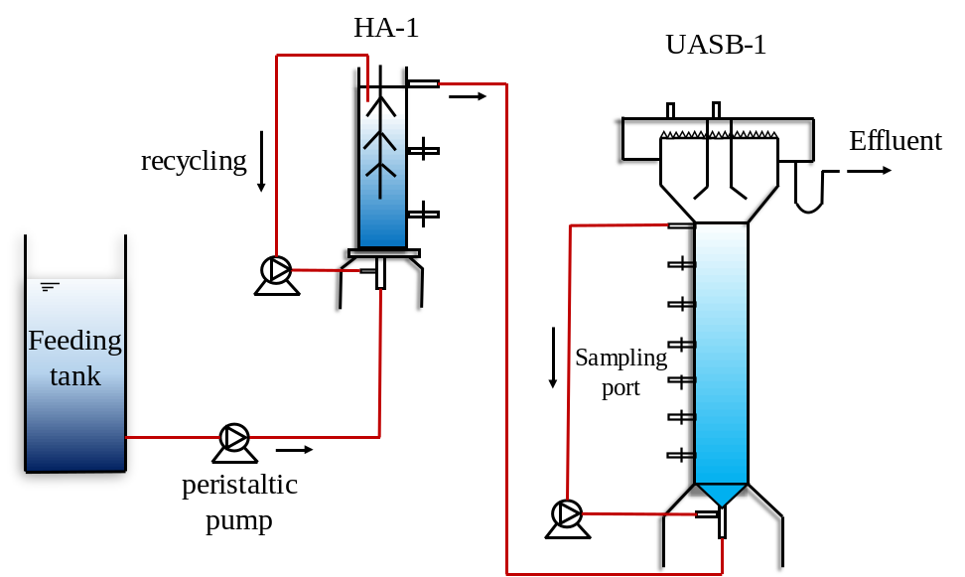
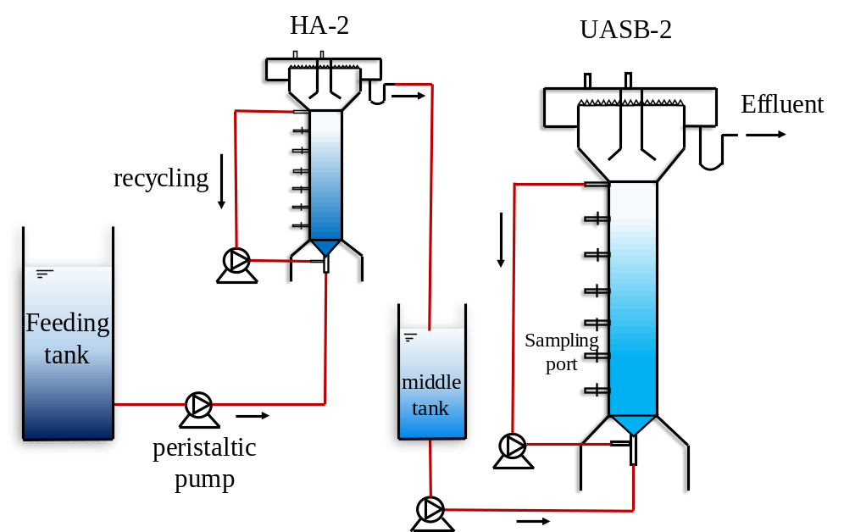
Fig.S1. The schematic diagram of the reactors.

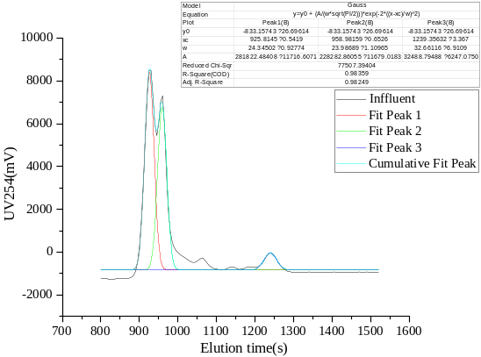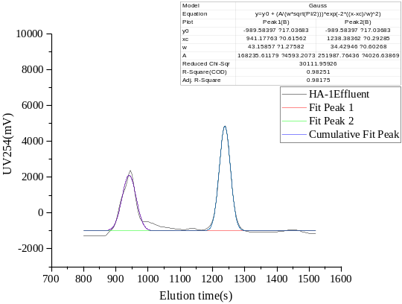
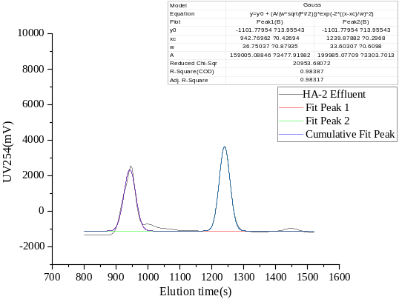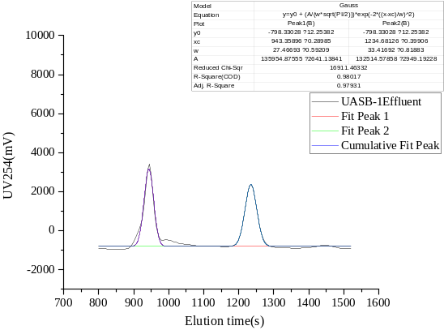
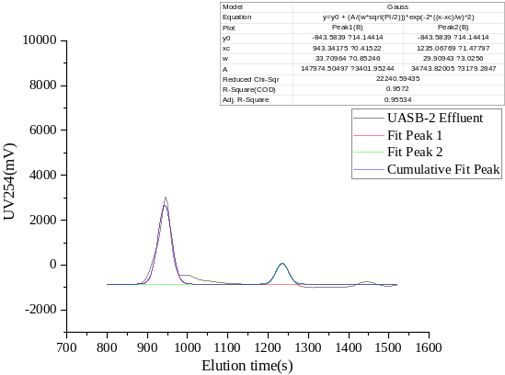
Fig. S2. The multi-peak Gaussian fitting maps of influent and 4 treated effluent.

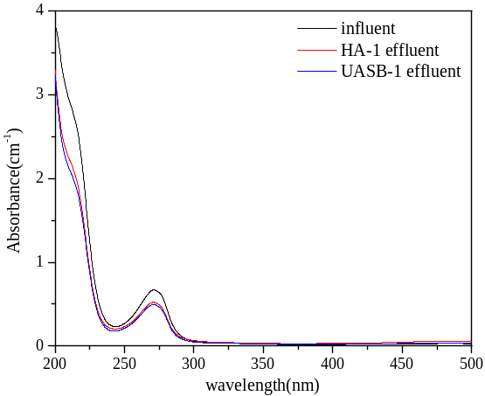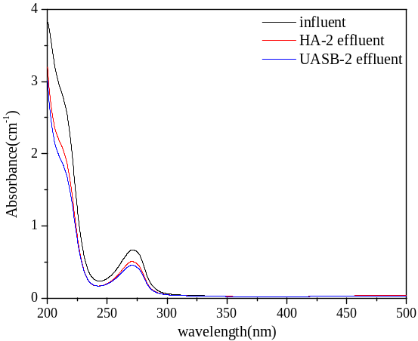
Fig. S3. UV-Vis spectroscopic characteristics of samples.

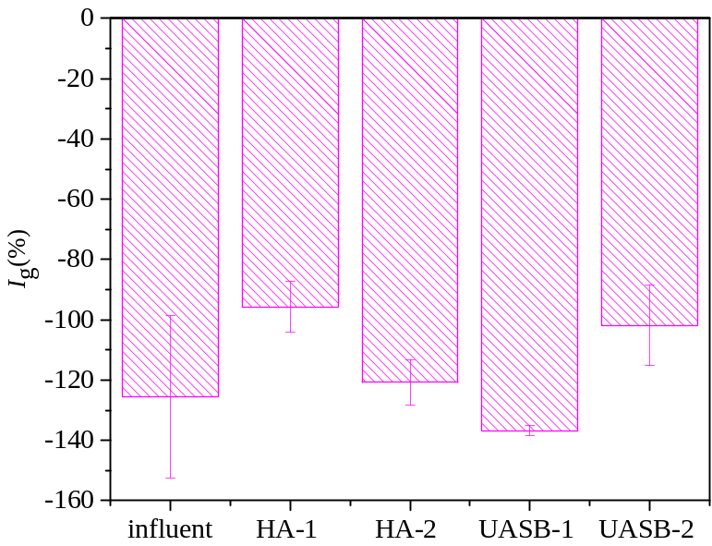
Fig. S4. Evolution of I_{g} for influent and treated effluent.

