Supporting Information
Effect of air mixing on high-solids anaerobic digestion of cow manure: Performance and mechanism

Xinwei Li ª, Liangwei Deng ^{b,c}, Fucheng Li ^{a,c}, Dan Zheng ^{b,c}, Hongnan Yang ^{b,c*}
ª Department of Environment and Resources, Southwest University of Science and Technology, Mianyang 621010, P. R. China
^{b} Biogas Institute of Ministry of Agriculture and Rural Affairs, Chengdu 610041, P. R. China
^{c} Key Laboratory of Development and Application of Rural Renewable Energy, Ministry of Agriculture and Rural Affairs, Chengdu 610041, P. R. China

*Corresponding author:
E-mail: yanghongnan@caas.cn

Table：S1-S2
Figure：S1-S3
Table S1 Characteristics of both substrate and inoculum sludge.
 | Unit | Cow manure | Inoculum sludge
TS | % wet weight | 21.8±0.1 | 10.2±0.2
VS | % wet weight | 16.6±0.1 | 5.0±0.03
VS/TS | % | 76.2±0.4 | 48.7±0.5
SCOD | mg/L | 5026.0±90.0 | 3980.0±158.0
TVFA | mg/L | 8006.5±59.4 | 325.2±103.2
TS : total solids; VS: volatile solids; SCOD: soluble chemical oxygen demand; TVFA: total volatile fatty acids, which was equal to the sum of acetic acid, propionic acid and butyric acid; The data were tested in duplicate and given as mean value ± standard deviation (n=2).

Table S2 Biogas production performance of anaerobic digestion of cow manure under different air mixing intensities
Experimental group | P_{max}  (mL/gTS) | Improve efficiency  (%) | P_{max-CH4}  (mL_{CH4}/gTS) | Improve efficiency  (%) | CH₄  (%)
R-ck | 282 ±4 |  | 175 ±3 |  | 62±1
R-12.5 | 294 ±4 | 4 ±1 | 185 ±3 | 6 ±1 | 59±3
R-37.5 | 316 ±6 | 12 ±2 | 198 ±3 | 13 ±1 | 53±2
R-62.5 | 299 ±5 | 6 ±2 | 186 ±2 | 6 ±1 | 50±3
P_{max}: the maximum cumulative biogas production; P_{max-CH4}: the maximum cumulative methane production; the data were tested in duplicate and given as mean value ± standard deviation (n = 2); R-ck represents the control group without mixing; R-12.5, R-37.5 and R-62.5 represent the experimental groups with air mixing intensity of 12.5, 37.5 and 62.5 mL/(L‧min), respectively.

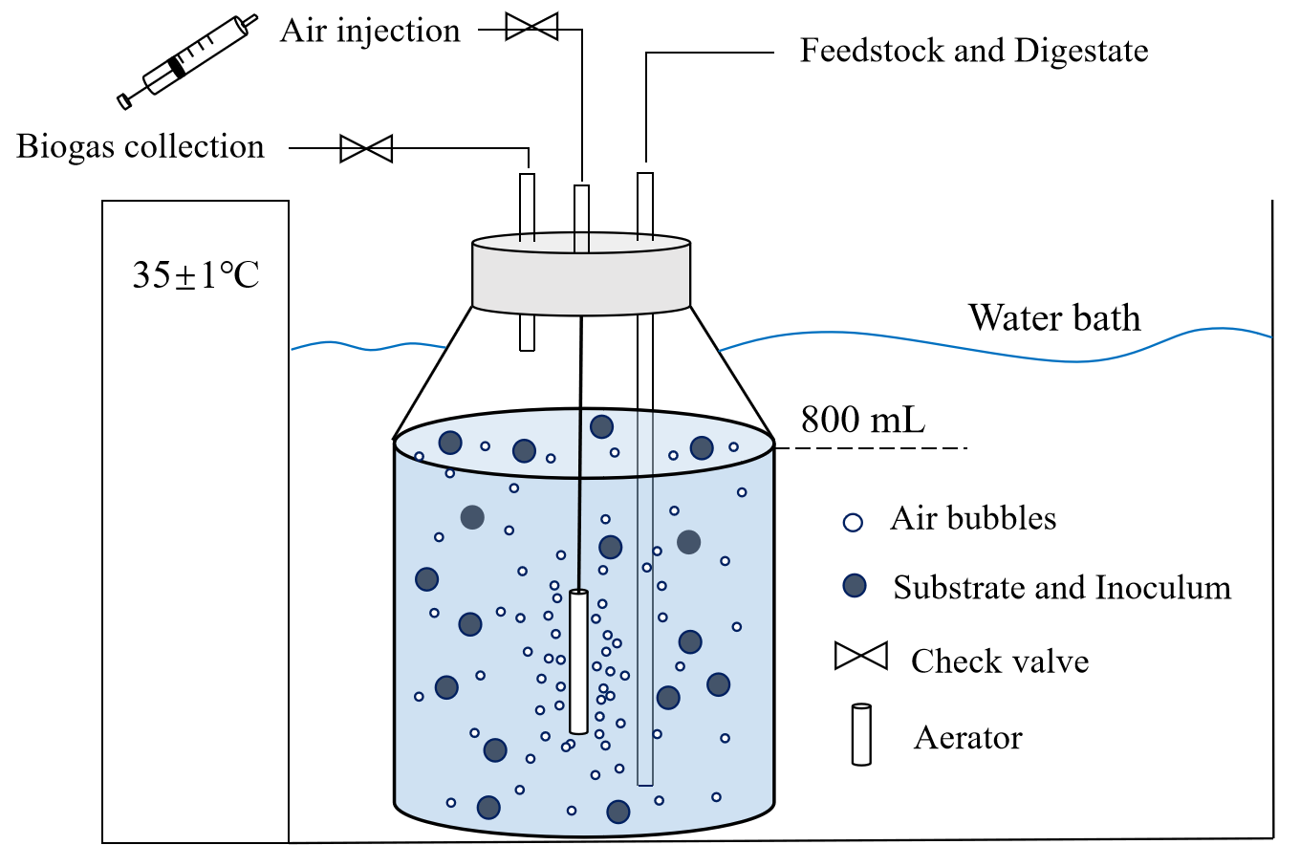
Fig. S1. Schematic diagram showing components of air mixed reactor.

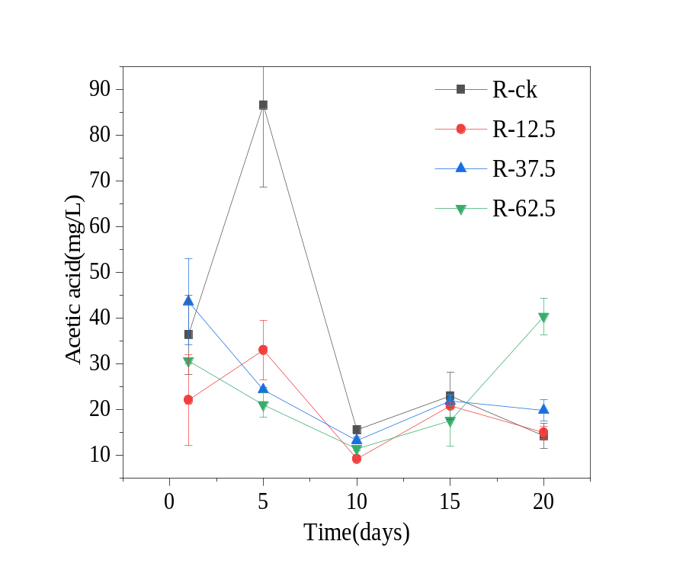
Fig. S2. Variation in concentrations of acetate in the process of experiment under different air mixing intensities. Error bars represent standard deviations of duplicate tests (n= 2). R-ck represents the control group without mixing; R-12.5, R-37.5 and R-62.5 represent the experimental groups with air mixing intensity of 12.5, 37.5 and 62.5 mL/(L‧min), respectively.

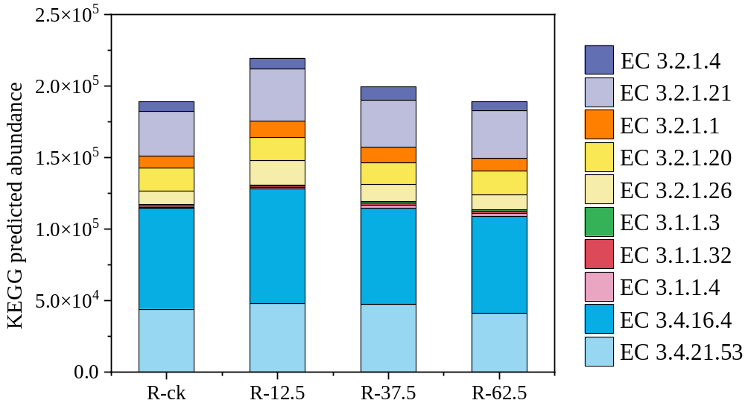

Fig. S3. Total abundance of predicted hydrolytic enzymes. R-ck represents the control group without mixing; R-12.5, R-37.5 and R-62.5 represent the experimental groups with air mixing intensity of 12.5, 37.5 and 62.5 mL/(L‧min), respectively.

