Effect of different aerobic hydrolysis time on the anaerobic digestion characteristics and energy consumption analysis
Jingbo Qu^{a,b,c}, Yong Sun^{a,c}, Mukesh Kumar Awasthi ^{d},Yuyingnan Liu^{a,c}, Xinrui Xu^{a,c}, Xianghui Meng^{a,c}, Hongqiong Zhang^{a,c,e*}
ªCollege of Engineering, Northeast Agriculture University, Harbin 150030, PR China
^{b}Guangdong Provincial Key Laboratory of New and Renewable Energy Research and Development, Guangzhou 510640, PR China
^{c}Key Laboratory of Agricultural Renewable Resources Utilization Technology and Equipment in Cold Areas of Heilongjiang Province, Harbin 150030, PR China
^{d}College of Natural Resources and Environment, Northwest A&F University, Taicheng Road 3#, Yangling, Shaanxi 712100, PR China
^{e}Key Laboratory of New Materials and Facilities for Rural Renewable Energy of Ministry of Agriculture and Rural Affairs, Henan Agricultural University, Zhengzhou 450002, PR China
*Corresponding author:
Prof. Hongqiong Zhang
College of Engineering, Northeast Agricultural University,
Harbin, 150030, P. R. China
E-mail address: zhhqiong@163.com

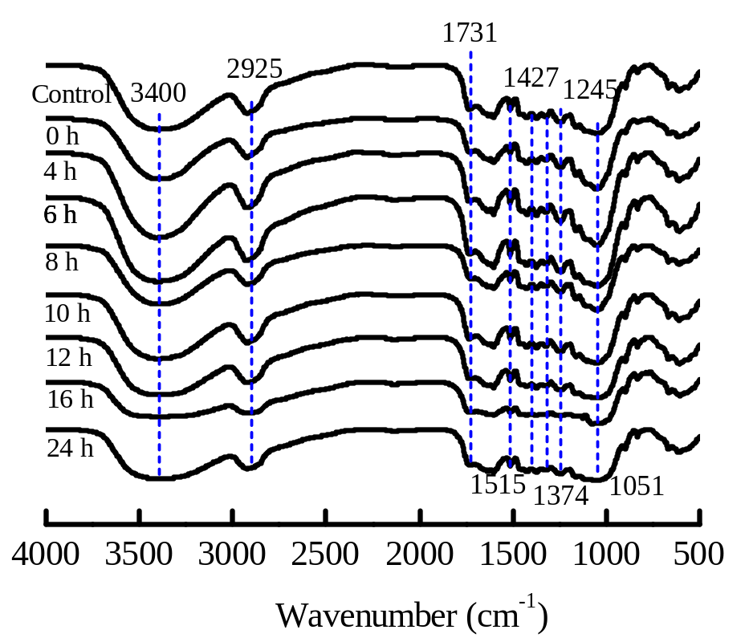
Fig. 1. Changes of FT-IR of corn stover during aerobic hydrolytic phase

Table 3. Analysis of variance for the methane yield
Source | Sum of Squares | Df | Mean Square | F Value | - value  Prob ＞ F
Between Groups | 626.16 | 3 | 208.72 | 35.58 | 0.0001
Within Groups | 46.94 | 8 | 5.867
Total | 673.10 | 11

Table 4. Temperature and heating energy of fermentation feed solution after mixing
Hydrolysis time  (h) | m_{y}  (kg) | m_{L}  (kg) | t_{H}  (℃) | Q_{H}  ×10⁵(kJ)
8 | 2917.04 | 30811.29 | 29.47 | 18.25
16 | 2977.58 | 31450.71 | 29.47 | 18.63
24 | 3068.46 | 32410.63 | 29.47 | 19.20

Table 5. Heat consumption of envelope structure of aerobic hydrolysis reactor in each month
Month | t_{W}  (℃) | Top  ×10⁵(kJ) | Side wall  ×10⁵(kJ) | Bottom  ×10⁵(kJ) | Total  ×10⁵(kJ)
January | -18.3 | 3.71 | 23.80 | 9.28 | 36.79
February | -13.6 | 3.09 | 19.85 | 7.74 | 30.68
March | -3.4 | 2.81 | 18.02 | 7.02 | 27.85
April | 7.1 | 2.10 | 13.49 | 5.26 | 20.85
May | 14.7 | 1.71 | 10.99 | 4.28 | 19.98
Jun | 20.4 | 1.32 | 8.49 | 3.31 | 13.12
July | 28 | 0.91 | 5.82 | 2.27 | 9.00
August | 21.1 | 1.33 | 8.50 | 3.31 | 13.14
September | 14.5 | 1.67 | 10.71 | 4.17 | 16.55
October | 5.6 | 2.26 | 14.52 | 5.66 | 22.44
November | -5.3 | 2.83 | 18.15 | 7.07 | 28.05
December | -14.8 | 3.50 | 22.44 | 8.75 | 34.69

Table 6. Heat consumption of anaerobic digestion reactor in each month
Month | t_{W}  (℃) | Q_{f1}  ×10⁵(kJ) | Q_{f2}  ×10⁵(kJ) | Q_{f3}  ×10⁵(kJ) | Q_{f}  ×10⁵(kJ) | Q_{w}  ×10⁵(kJ) | Q_{g}  ×10⁵(kJ) | Q_{hf}  ×10⁵(kJ)
January | -18.3 | 5.07 | 35.29 | 11.95 | 52.31 | 1.25 | 2.83 | 56.39
February | -13.6 | 4.13 | 28.90 | 9.84 | 42.87 | 1.12 | 2.33 | 46.32
March | -3.4 | 3.51 | 25.16 | 8.61 | 37.28 | 1.23 | 2.04 | 40.55
April | 7.1 | 2.32 | 17.51 | 6.05 | 25.88 | 1.19 | 1.43 | 28.50
May | 14.7 | 1.61 | 12.99 | 4.55 | 19.15 | 1.22 | 1.08 | 21.45
Jun | 20.4 | 0.98 | 8.86 | 3.17 | 13.01 | 1.13 | 0.77 | 14.91
July | 28 | 0.21 | 4.04 | 1.57 | 5.82 | 1.21 | 0.38 | 7.41
August | 21.1 | 0.93 | 8.68 | 3.12 | 12.73 | 1.21 | 0.76 | 14.70
September | 14.5 | 1.57 | 12.70 | 4.45 | 18.72 | 1.18 | 1.08 | 20.98
October | 5.6 | 2.56 | 19.11 | 6.59 | 28.26 | 1.23 | 1.59 | 31.08
November | -5.3 | 3.59 | 25.59 | 8.74 | 37.92 | 1.20 | 2.12 | 41.24
December | -14.8 | 4.70 | 27.19 | 11.16 | 43.05 | 1.25 | 2.70 | 46.95

