Supplementary Interactive Plot Data
Figure S1 Changes of pH values obtained before extruding.
Figure S2 Changes of pH values obtained after extruding.

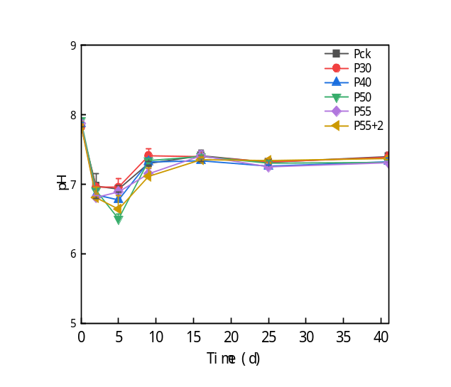
Figure S1 Changes of pH values obtained before extruding.

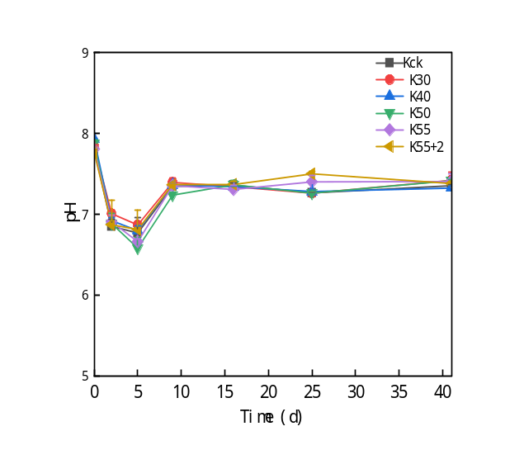
Figure S2 Changes of pH values obtained after extruding.

