Supplementary materials

Nanobubbles drive advanced anaerobic treatment of swine wastewater for efficient methane recovery: Performance gains and multi-pathway enhancement

Text S1 COD balance Estimation
The COD balance was calculated using the following assumptions and conversions:
- COD Input Estimation:
The total COD input in each reactor was estimated from the volatile solids content of the inoculum and substrate using the empirical conversion factor of 1 g VS ≈ 1.42 g COD (based on the typical oxidation state of organic matter in anaerobic systems)

- COD Output Distribution:
The output COD was partitioned into three fractions:
Methane COD (COD_{CH4}): Converted from cumulative methane production using the stoichiometric equivalence of 1 L CH₄ = 2.86 g COD at standard temperature and pressure (0℃, 1 atm):
$${COD}_{{CH}_{4}}=V_{{CH}_{4}}(L)×2.86(g COD/L)$$
Residual Soluble COD (SCOD_{final}): Measured directly as the final SCOD concentration in the liquid phase at the end of the 28-day experiment.
Residual Biomass COD (COD_{residual}): Estimated as the difference between total COD input and the sum of methane COD and residual SCOD, representing the COD remaining in particulate biomass and undegraded solids:
$${COD}_{residual}={COD}_{input}-({COD}_{{CH}_{4}}+{SCOD}_{final})$$

- COD Conversion Rate:
The fraction of input COD converted to methane and soluble intermediates was calculated as:
$$COD conversion rate=\frac{{COD}_{{CH}_{4}}+{SCOD}_{final}}{{COD}_{input}}×100\%$$

Text S2 Calculation of Free Ammonia Nitrogen (FAN)
The concentration of Free Ammonia Nitrogen (FAN) was calculated based on the measured Total Ammonia Nitrogen (TAN), pH, and digestion temperature (T) using the following equations (Cai, 2021; Hansen et al., 1998):
$$FNA= \frac{0.9441×TAN}{1+{10}^{(pKa-pH)}}$$
$$pKa=0.0925+\frac{2728.795}{T+273.15}$$
Where:
- TAN is the total ammonia nitrogen concentration (mg-N/L),
- pKa is the negative natural logarithm of the acid dissociation constant Ka,
- T is the temperature (°C),
- pH is the measured value in the anaerobic digestion reactor.
Table S1 The characteristics of substrate and inoculum used in this study.
Parameters | Unit | Substrate | Inoculum
Total solids (TS) | g/L | 4.01±0.18 | 17.69±0.85
Volatile solids (VS) | g/L | 1.74±0.03 | 7.33±0.37
VS/TS | % | 43.38±2.48 | 41.44±0.12
Total nitrogen (TN) | mg/L | 533.33±11.55 | 50.00±20.00
Total ammonia nitrogen (TAN) | mg-N/L | 453.70±9.28 | 41.25±0.27
Soluble chemical oxygen demand (SCOD) | mg/L | 3306.67±244.93 | 832.00±124.96
pH |  | 8.22±0.02 | 8.48±0.01
ª Data are expressed in the mean ± standard deviation (SD) (n=3).

Table S2 Experimental conditions of each group in this study.
Treatment | Substrate (mL) | Inoculum (mL) | NBW (mL) | DW (mL)
DW | 242 | 58 | 0 | 100
Air-NBW | 242 | 58 | 100(Air-NBW) | 0
O₂-NBW | 242 | 58 | 100(O₂-NBW) | 0
O₃-NBW | 242 | 58 | 100(O₃-NBW) | 0

Table S3 COD Balance Analysis
Treatment | COD_{input} (mg) | COD_{CH4} (mg) | SCOD_{final} (mg) | COD_{residual} (mg) | COD conversion rate (%) | CH₄ recovery (%)
DW | 1201.63 | 184.36 | 115.68 | 901.59 | 15.34 | 15.34
Air-NBW | 1201.63 | 263.61 | 123.60 | 814.42 | 21.94 | 21.94
O₂-NBW | 1201.63 | 227.42 | 115.88 | 858.61 | 18.93 | 18.93
O₃-NBW | 1201.63 | 345.74 | 139.30 | 716.59 | 28.77 | 28.77

Table S4 Conversion of VFA concentrations from mg/L to mmol/L used in this study.
Time (day) | Treatment | Hac (mmol/L) | HPr (mmol/L) | iso-HBu (mmol/L) | n-HBu (mmol/L) | iso-HVa (mmol/L) | n-HVa (mmol/L)
0 | DW | 1.34±0.24 | 1.33±0.15 | 0.9±0.06 | 1.16±0.10 | 0.93±0.24 | 0.50±0.11
0 | Air-NBW | 1.28±0.04 | 1.00±0.26 | 0.83±0.08 | 1.12±0.14 | 1.06±0.13 | 0.68±0.15
0 | O₂-NBW | 1.55±0.04 | 1.08±0.04 | 1.00±0.26 | 1.17±0.09 | 0.55±0.21 | 0.81±0.20
0 | O₃-NBW | 1.45±0.12 | 1.08±0.15 | 0.96±0.01 | 1.10±0.10 | 0.68±0.12 | 0.53±0.02
7 | DW | 2.31±0.25 | 1.12±0.07 | 0.43±0.09 | 0.95±0.05 | 0.91±0.13 | 0.97±0.19
7 | Air-NBW | 2.17±0.04 | 1.23±0.05 | 0.56±0.05 | 1.00±0.04 | 1.07±0.06 | 0.92±0.08
7 | O₂-NBW | 2.18±0.03 | 1.18±0.07 | 0.61±0.04 | 0.93±0.04 | 0.95±0.10 | 1.13±0.06
7 | O₃-NBW | 1.95±0.15 | 1.11±0.03 | 0.49±0.08 | 0.92±0.04 | 1.04±0.19 | 1.50±0.29
14 | DW | 0.29±0.01 | 0.34±0.07 | 0.31±0.01 | 0.78±0.09 | 0.00±0.00 | 0.00±0.00
14 | Air-NBW | 0.27±0.08 | 0.33±0.02 | 0.29±0.01 | 0.71±0.04 | 0.00±0.00 | 0.00±0.00
14 | O₂-NBW | 0.24±0.01 | 0.33±0.01 | 0.29±0.01 | 0.00±0.00 | 0.00±0.00 | 0.00±0.00
14 | O₃-NBW | 0.28±0.01 | 0.37±0.00 | 0.30±0.01 | 0.00±0.00 | 0.00±0.00 | 0.00±0.00
21 | DW | 0.27±0.04 | 0.07±0.13 | 0.00±0.00 | 0.00±0.00 | 0.00±0.00 | 0.00±0.00
21 | Air-NBW | 0.25±0.08 | 0.05±0.10 | 0.00±0.00 | 0.00±0.00 | 0.00±0.00 | 0.00±0.00
21 | O₂-NBW | 0.21±0.09 | 0.14±0.13 | 0.00±0.00 | 0.00±0.00 | 0.00±0.00 | 0.00±0.00
21 | O₃-NBW | 0.30±0.00 | 0.00±0.00 | 0.00±0.00 | 0.00±0.00 | 0.00±0.00 | 0.00±0.00
28 | DW | 0.15±0.08 | 0.00±0.00 | 0.00±0.00 | 0.00±0.00 | 0.00±0.00 | 0.00±0.00
28 | Air-NBW | 0.09±0.02 | 0.00±0.00 | 0.00±0.00 | 0.00±0.00 | 0.00±0.00 | 0.00±0.00
28 | O₂-NBW | 0.10±0.01 | 0.00±0.00 | 0.00±0.00 | 0.00±0.00 | 0.00±0.00 | 0.00±0.00
28 | O₃-NBW | 0.09±0.01 | 0.00±0.00 | 0.00±0.00 | 0.00±0.00 | 0.00±0.00 | 0.00±0.00
ª Data are expressed in the mean ± standard deviation (SD) (n=3).

Table S5 Temporal variations of Free Ammonia Nitrogen concentrations (mg-N/L).
Days | DW | Air-NBW | O₂-NBW | O₃-NBW
0 | 65.55±1.55 | 70.71±0.29 | 84.81±2.16 | 64.57±1.92
7 | 38.26±1.17 | 42.74±2.80 | 45.74±1.24 | 42.80±1.60
14 | 59.08±1.5 | 60.63±0.40 | 64.32±1.31 | 65.73±1.66
21 | 73.83±4.9 | 72.43±1.05 | 72.04±0.32 | 73.88±1.91
28 | 55.93±4.3 | 69.60±5.27 | 65.77±4.62 | 79.44±2.05
ª Data are expressed in the mean ± standard deviation (SD) (n=3).

Table S6 KEGG modules and key genes involved in methanogenesis pathways used in this study.
Pathway | KEGG module | Key genes
Acetoclastic | M00357 | ackA, pta, acs, ACDS
Hydrogenotrophic | M00567 | fmdA, ftr, mch, hmd, mtd, mer
Methylotrophic | M00356 | MtaA, MtaB
Methylotrophic | M00563 | MtbA, MtbB, MtmB, MttB

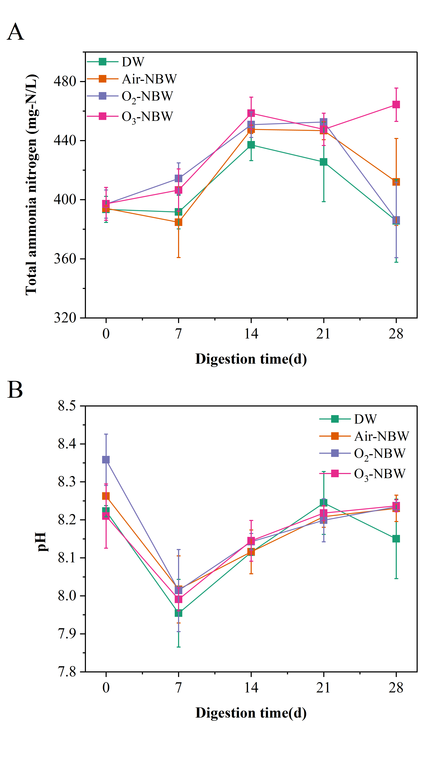
Fig. S1 Changes in total ammonia nitrogen (A) and pH (B) during anaerobic digestion.
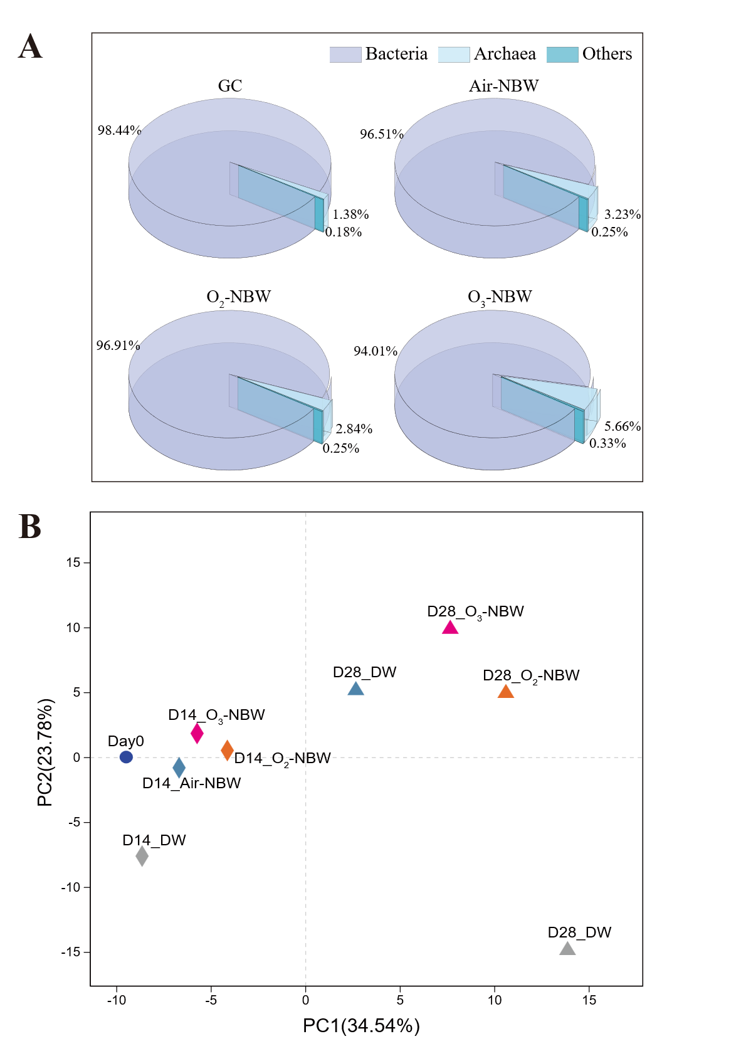
Fig. S2 Distribution of archaea and bacteria in all groups on day 28 of anaerobic digestion (A). The principal component analysis (PCA) of microbial community at phylum level (B).

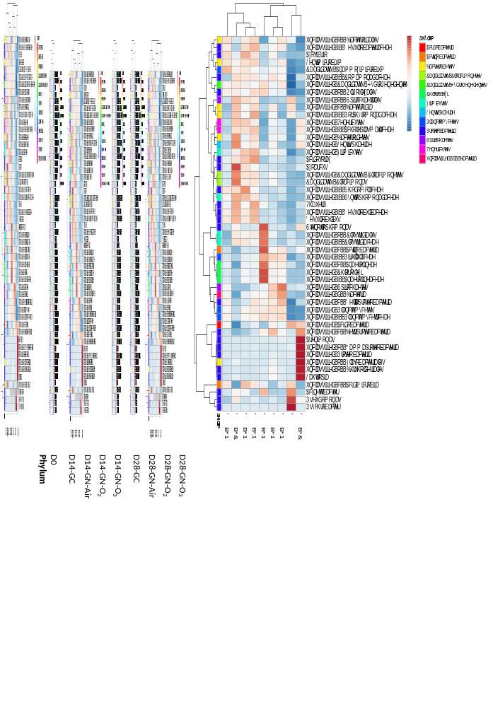

Fig. S3 Heatmap for the relative abundance (RA) of bacterial genera in all samples.

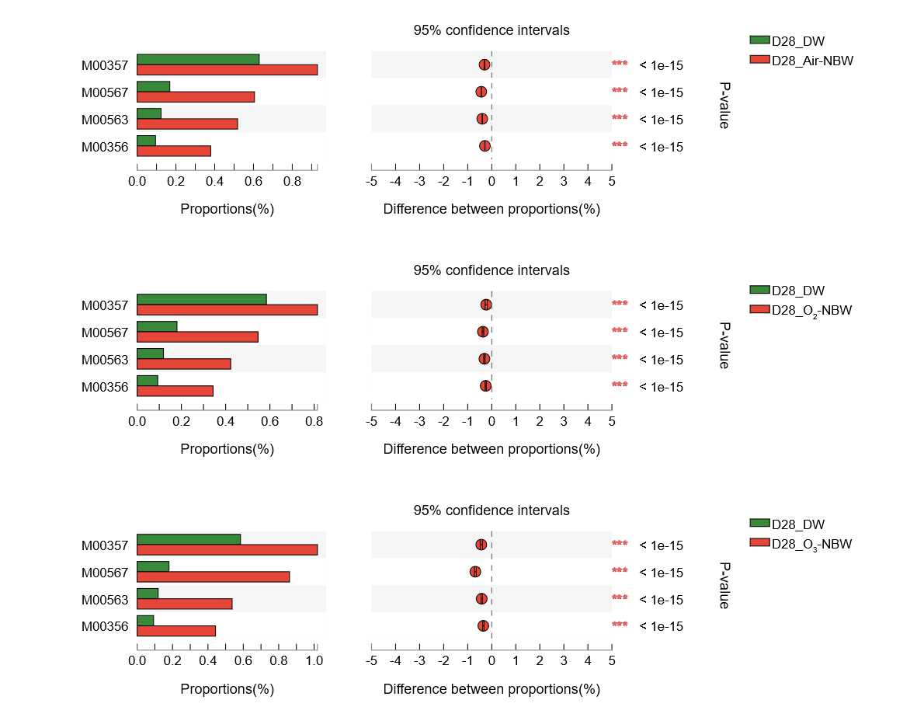

Fig. S4 Differences in methanogenic pathways between GC and GN on the 28th day. Chi-square test t was used and a significant difference was considered when P value was below 0.05. (***, P<0.001).

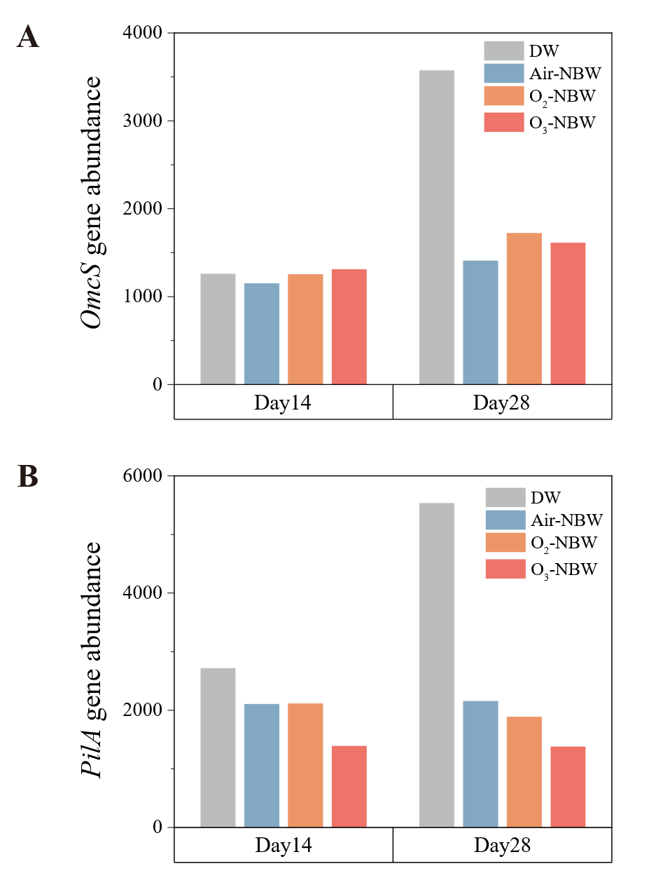
Fig. S5 The abundance of genes that encoded OmcS (A) and pilA (B) during anaerobic digestion.

Reference:
Cai, Y., 2021. Exploring the combined effect of total ammonia nitrogen, pH and temperature on anaerobic digestion of chicken manure using response surface methodology and two kinetic models. Bioresource Technology.
Hansen, K.H., Angelidaki, I., Ahring, B.K., 1998. ANAEROBIC DIGESTION OF SWINE MANURE: INHIBITION BY AMMONIA. Water Research 32, 5–12. https://doi.org/10.1016/S0043-1354(97)00201-7

