Supplementary Information
Treatment of fresh leachate by microaeration pretreatment combined with IC-AO² process: performance and mechanistic insight

Mengqi Wei ª, Ruina Zhang ^{c,d}, Mingjian Zhou ª, Zhiqiang Yuan ª, Haiping Yuan ª, Nanwen Zhu^{a,b}*

ª School of Environmental Science & Engineering, Shanghai Jiao Tong University, Shanghai, 200240, China
^{b} Shanghai Engineering Research Center of Solid Waste Treatment and Resource Recovery, Shanghai, 200240, China
^{c} Shanghai Institute for Design & Research on Environmental Engineering Co., Ltd, Shanghai, 200040, China
^{d} Shanghai Environmental Sanitation Engineering Design Institute Co., Ltd, Shanghai, 200001, China

*Corresponding Author: E-mail: nwzhu@sjtu.edu.cn; Fax: +86 21 54742817.

Content:
2 texts
7 tables
1 figure

Text S1. Sample pretreatment and SPE method for quantification of antibiotics
Filtered samples（200ml）were acidified with hydrochloric acid to pH 3. 0.2 g Na₂EDTA chelating agent and internal standard (50 ng for each sample) were added to samples. HLB cartridges (500 mg, 6 mL, Waters) were firstly activated with 10 mL methanol (MS grade), 10 mL ultra-pure water and 10 mL acid (pH=3); Leachate samples were add to cartridges at a flow rate of 2 mL/min, then rinse the cartridges with 20 mL HCl (pH=3) to remove the salts; After that, cartridges were dried with a stream of N₂ and eluted with 1 mL of methanol and kept at 4 ℃ in dark until tested.

Text S2. Analysis of the antibiotics
For analysis of the antibiotics, 18 target compounds were quantified by the external standard method, and the correlation coefficients (r²) of calibration curves for all the target antibiotics were typically above 0.99. Mass spectrometry conditions: ESI positive/negative ion mode, curtain gas of 35 psi, ionization voltage was 5500V-4500V, desolventizing temperature was 500 ℃, atomizing gas of 55 psi, auxiliary heating gas of 55 psi, multiple reaction monitoring (MRM) was used to analyze the sample. Liquid chromatography conditions: methanol solvent, column was ACQUITY BEH C18 2.1*100 mm 1.7 um, temperature was 40 ℃, mobile phase A was 0.1% formic acid + pure water, mobile phase B was 0.1% formic acid + acetonitrile.
Table S1. The physicochemical properties of target antibiotics in this study.
Compound | Abbreviation | Molecular formula | Molecular weight | Structure
Sulfadiazine | SDZ | C₁₀H₁₀N₄O₂S | 250.28 | 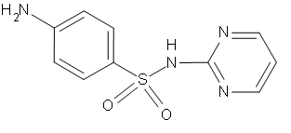
Sulfathiazole | STZ | C₉H₉N₃O₂S₂ | 255.32 | 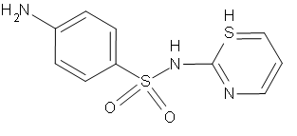
Sulfapyridine | SPZ | C₁₁H₁₁N₃O₂S | 249.29 | 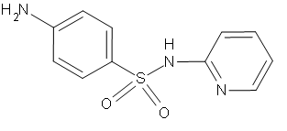
Sulfamerazine | SMZ | C₁₁H₁₂N₄O₂S | 264.30 | 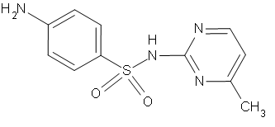
Sulfamethazine | SMT | C₁₂H₁₄N₄O₂S | 278.34 | 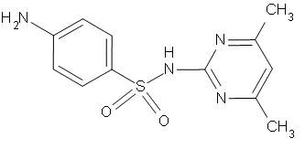
Sulfaquinoxaline | SQ | C₁₄H₁₂N₄O₂S | 300.34 | 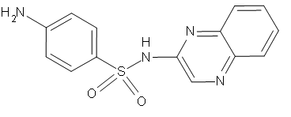
Oxytetracycline | OTC | C₂₂H₂₄N₂O₉ | 460.15 | 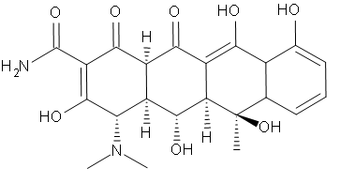
Tetracycline | TC | C₂₂H₂₄N₂O₈ | 444.15 | 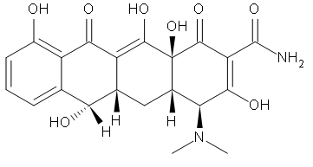
Doxycycline | DOC | C₂₂H₂₄N₂O₈ | 444.43 | 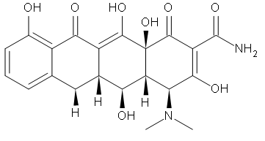
Chlortetracycline | CTC | C₂₂H₂₃ClN₂O₈ | 478.11 | 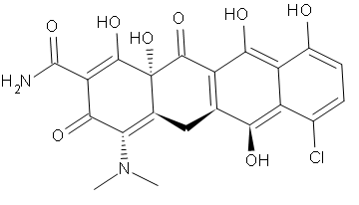
Erythromycin | ETM | C₃₇H₆₇NO₁₃ | 733.93 | 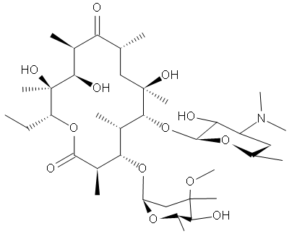
Roxithromycin | RTM | C₄₁H₇₆N₂O₁₅ | 837.05 | 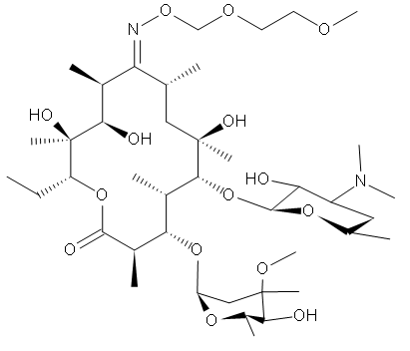
Ofloxacin | OFX | C₁₈H₂₀FN₃O₄ | 329.34 | 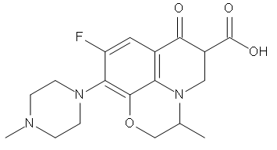
Norfloxacin | NFX | C₁₆H₁₈FN₃O₃ | 319.33 | 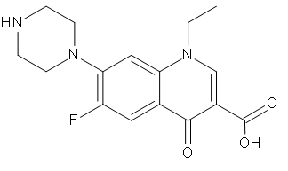
Ciprofloxacin | CFX | C₁₇H₁₈FN₃O₃ | 331.34 | 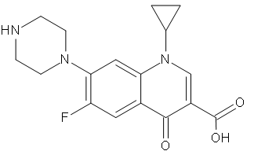
Enrofloxacin | EFX | C₁₉H₂₂FN₃O₃ | 359.40 | 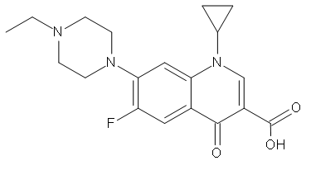
Chloramphenicol | CAP | C₁₁H₁₂Cl₂N₂O₅ | 323.13 | 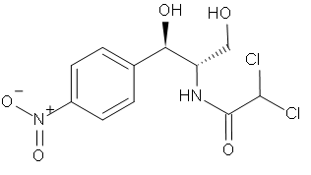
Thiamphenicol | TAP | C₁₂H₁₅Cl₂NO₅S | 356.22 | 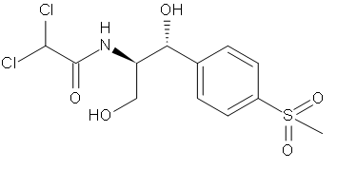

Table S2. Elution gradient of liquid chromatography.
Time (min) | A(%) | B(%) | Flow rate (mL/min)
0.0 | 90 | 10 | 0.4
0.5 | 90 | 10 | 0.4
3.0 | 50 | 50 | 0.4
6.0 | 0 | 100 | 0.4
8.0 | 0 | 100 | 0.4
8.1 | 90 | 10 | 0.4
10.0 | 90 | 10 | 0.4
A and B was mobile phase
A: 0.1% formic acid + pure water
B: 0.1% formic acid + acetonitrile
Table S3. Tests of Between-Subjects Effects (COD)
Dependent Variable: COD
Source | Type III Sum of Squares | df | Mean Square | F | Sig.
Corrected Model | 4000036.833a | 8 | 500004.604 | 149.438 | .000
Intercept | 76842756.000 | 1 | 76842756.000 | 22966.302 | .000
R | 1196126.042 | 2 | 598063.021 | 178.745 | .000
RD | 69666.833 | 2 | 34833.417 | 10.411 | .000
HRT | 616295.250 | 2 | 308147.625 | 92.097 | .000
SRT | 1544270.458 | 2 | 772135.229 | 230.771 | .000
R * RD | .000 | 0 | . | . | .
R * HRT | .000 | 0 | . | . | .
R * SRT | .000 | 0 | . | . | .
RD * HRT | .000 | 0 | . | . | .
RD * SRT | .000 | 0 | . | . | .
HRT * SRT | .000 | 0 | . | . | .
R * RD * HRT | .000 | 0 | . | . | .
R * RD * SRT | .000 | 0 | . | . | .
R * HRT * SRT | .000 | 0 | . | . | .
RD * HRT * SRT | .000 | 0 | . | . | .
R * RD * HRT * SRT | .000 | 0 | . | . | .
Error | 210791.167 | 63 | 3345.892
Total | 130743060.000 | 72
Corrected Total | 4210828.000 | 71
a. R Squared = .950 (Adjusted R Squared = .944)

Table S4. Tests of Between-Subjects Effects (TN)
Dependent Variable: TN
Source | Type III Sum of Squares | df | Mean Square | F | Sig.
Corrected Model | 326881.270a | 8 | 40860.159 | 143.419 | .000
Intercept | 4225217.284 | 1 | 4225217.284 | 14830.535 | .000
R | 71399.763 | 2 | 35699.881 | 125.307 | .000
RD | 41153.490 | 2 | 20576.745 | 72.224 | .000
HRT | 10359.317 | 2 | 5179.658 | 18.181 | .000
SRT | 55900.893 | 2 | 27950.446 | 98.106 | .000
R * RD | .000 | 0 | . | . | .
R * HRT | .000 | 0 | . | . | .
R * SRT | .000 | 0 | . | . | .
RD * HRT | .000 | 0 | . | . | .
RD * SRT | .000 | 0 | . | . | .
HRT * SRT | .000 | 0 | . | . | .
R * RD * HRT | .000 | 0 | . | . | .
R * RD * SRT | .000 | 0 | . | . | .
R * HRT * SRT | .000 | 0 | . | . | .
RD * HRT * SRT | .000 | 0 | . | . | .
R * RD * HRT * SRT | .000 | 0 | . | . | .
Error | 17948.691 | 63 | 284.900
Total | 7030929.176 | 72
Corrected Total | 344829.961 | 71
a. R Squared = .948 (Adjusted R Squared = .941)

Table S5. Tests of Between-Subjects Effects (NH₄⁺-N)
Dependent Variable: Ammonia
Source | Type III Sum of Squares | df | Mean Square | F | Sig.
Corrected Model | 201236.256a | 8 | 25154.532 | 61.098 | .000
Intercept | 3246176.941 | 1 | 3246176.941 | 7884.600 | .000
R | 46796.358 | 2 | 23398.179 | 56.832 | .000
RD | 19982.066 | 2 | 9991.033 | 24.267 | .000
HRT | 2910.809 | 2 | 1455.405 | 3.535 | .035
SRT | 2929.775 | 2 | 1464.888 | 3.558 | .034
R * RD | .000 | 0 | . | . | .
R * HRT | .000 | 0 | . | . | .
R * SRT | .000 | 0 | . | . | .
RD * HRT | .000 | 0 | . | . | .
RD * SRT | .000 | 0 | . | . | .
HRT * SRT | .000 | 0 | . | . | .
R * RD * HRT | .000 | 0 | . | . | .
R * RD * SRT | .000 | 0 | . | . | .
R * HRT * SRT | .000 | 0 | . | . | .
RD * HRT * SRT | .000 | 0 | . | . | .
R * RD * HRT * SRT | .000 | 0 | . | . | .
Error | 25937.795 | 63 | 411.711
Total | 5819055.460 | 72
Corrected Total | 227174.051 | 71
a. R Squared = .886 (Adjusted R Squared = .871)

Table S6. Tests of Between-Subjects Effects (NO₃⁻-N)
Dependent Variable: Nitrate
Source | Type III Sum of Squares | df | Mean Square | F | Sig.
Corrected Model | 2398.471a | 8 | 299.809 | 6.848 | .000
Intercept | 30245.848 | 1 | 30245.848 | 690.847 | .000
R | 132.421 | 2 | 66.210 | 1.512 | .228
RD | 942.803 | 2 | 471.401 | 10.767 | .000
HRT | .489 | 2 | .244 | .006 | .994
SRT | 88.733 | 2 | 44.367 | 1.013 | .369
R * RD | .000 | 0 | . | . | .
R * HRT | .000 | 0 | . | . | .
R * SRT | .000 | 0 | . | . | .
RD * HRT | .000 | 0 | . | . | .
RD * SRT | .000 | 0 | . | . | .
HRT * SRT | .000 | 0 | . | . | .
R * RD * HRT | .000 | 0 | . | . | .
R * RD * SRT | .000 | 0 | . | . | .
R * HRT * SRT | .000 | 0 | . | . | .
RD * HRT * SRT | .000 | 0 | . | . | .
R * RD * HRT * SRT | .000 | 0 | . | . | .
Error | 2758.190 | 63 | 43.781
Total | 59109.501 | 72
Corrected Total | 5156.661 | 71
a. R Squared = .465 (Adjusted R Squared = .397)

Table S7. Molecular parameters of leachate samples derived from assigned molecular formulae (Raw: raw leachate; MA: MA effluent; IC: IC effluent; Effluent: AO² effluent).
Sample | C_{avg} | H_{avg} | O_{avg} | N_{avg} | S_{avg} | DBE_{avg} | H/C_{avg} | O/C_{avg} | m/z_{avg}
Raw | 19.9 | 30.8 | 5.5 | 0.7 | 0.7 | 6.1 | 1.5 | 0.3 | 399.7
MA | 17.5 | 24.2 | 6.7 | 0.7 | 0.7 | 7.0 | 1.4 | 0.4 | 383.5
IC | 16.7 | 23.2 | 7.2 | 0.7 | 0.7 | 6.7 | 1.4 | 0.4 | 378.8
Effluent | 17.8 | 23.5 | 7.6 | 0.9 | 0.6 | 7.7 | 1.3 | 0.5 | 396.2

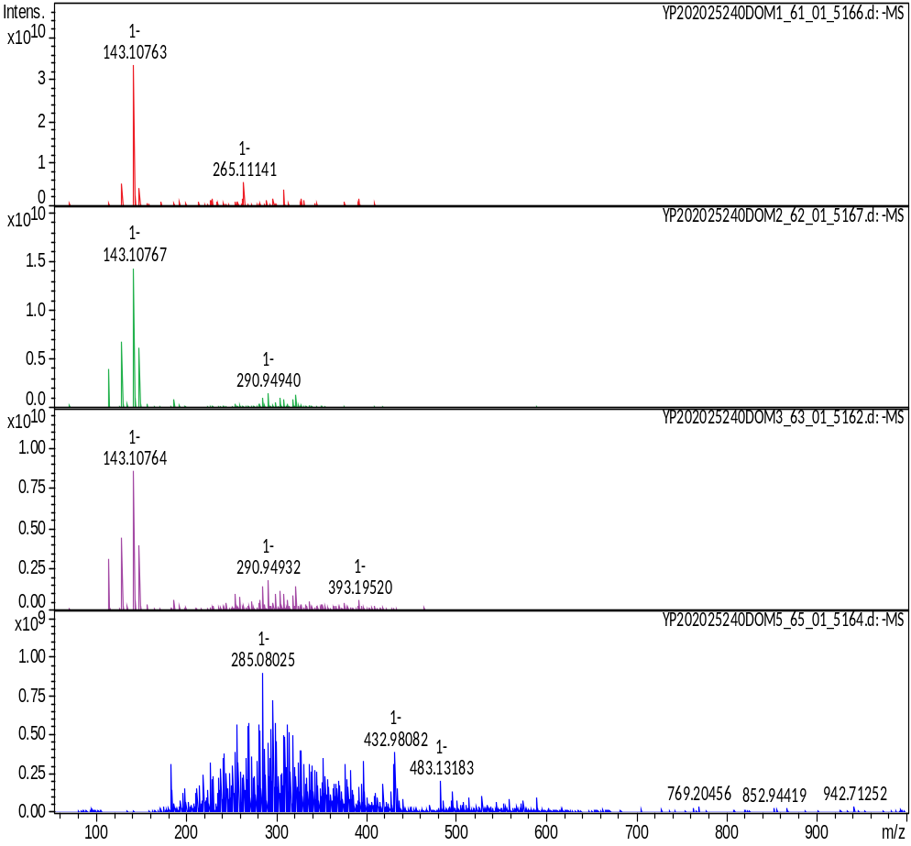
Fig. S1. Broad-band mass spectra of the C18 extracted leachate samples using negative-ion ESI FT-ICR MS.

