Supplementary material

The thermophilic (55°C) microaerobic pretreatment of corn straw for anaerobic digestion

Authors:

Shan-Fei Fu^{1,2}, Wang Fei^{1,2}, Xian-Zheng Yuan¹,Zhi-Man Yang¹, Sheng-Jun Luo¹ , Chuan-Shui Wang¹,Rong-Bo Guo^{1*}

Addresses:
- Qingdao Institute of Bioenergy and Bioprocess Technology, Chinese Academy of Sciences, Qingdao, Shandong Province 266101, P.R. China
- University of Chinese Academy of Sciences, Beijing 100049, P. R. China

Corresponding author:
Rong-Bo Guo, Ph. D
Qingdao Institute of Bioenergy and Bioprocess Technology, Chinese Academy of Sciences
No.189 Songling Road, Qingdao, Shandong Province 266101, P. R. China
Phone: +860532-80662708 Fax: +860532-80662708
E-mail: guorb@qibebt.ac.cn

This supplementary material contains 3 figures

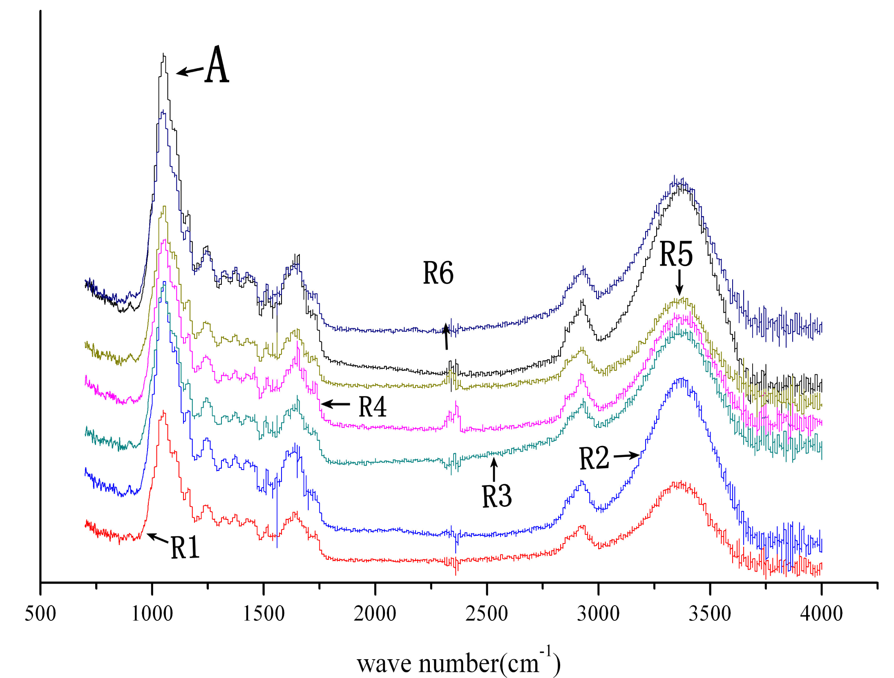
Fig. S1 FTIR-ATR patterns of untreated and pretreated corn straw

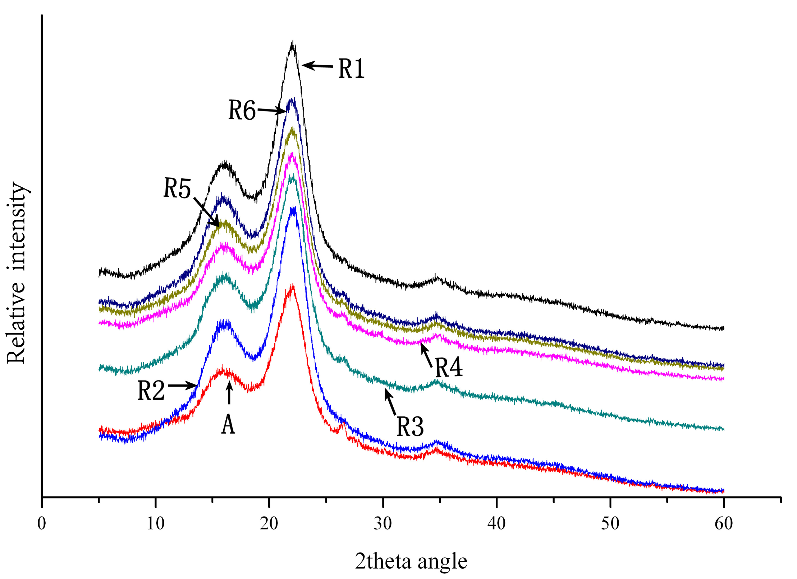
Fig. S2 XRD patterns of untreated and pretreated corn straw
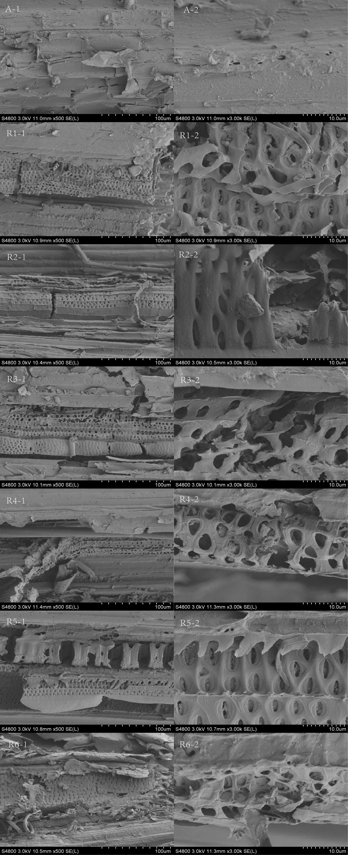
Fig. S3 SEM images of untreated and pretreated corn straw (1at 500×, 2 at 3000×)

