Supporting Information
Study on synergistic effect of carrier combined with micro-aeration on anaerobic digestion of food waste
Keke Dingª, Baocun Wuª, Yi Wangª, Linji Xuª, Miao Liu^{b}, Jinjing Xiangª, Yongdong Chenª, Li Gu^{a*}, Jinze Li^{a∗}, Lin Liª, Qiang Heª and Shaowu Liu^{c}

a. Key laboratory of the Three Gorges Reservoir Region’s Eco-environments, Ministry of Education, Institute of Environment and Ecology, Chongqing University, 174 Shapingba Road, Chongqing, 400045, P.R. China
b. Gastrointestinal Cancer Center, Chongqing University Cancer Hospital, 174 Shapingba Road, 400045, P.R. China
c. Chongqing Water Group Co., Ltd, No.1 Longjiawan, Yuzhong District, Chongqing, 400043, P.R. China

Supporting Information
Text S1 ESI FT-ICR MS analysis
Text S2 Van Krevelen diagrams boundary regions
Text S3 Calculation of molecular parameters
Table S1 Details of the used polyurethane foam carrier
Table S2 Classification standard of unsaturated degree and redox state
Table S3 Relative abundance of key KEGG pathway genes before and after micro-aeration treatment
Table S4 Relative abundance of key genes in oxidative phosphorylation metabolic pathway before and after micro-aeration treatment (RPKM)
Table S5 Relative abundance of genes related to organic matter transformation and methanogenesis before and after micro-aeration treatment
Fig. S1 Schematic diagram of the reactor structure
Fig. S2 Pictures of Polyurethane sponge carriers: (a) the original state; (b) after anaerobic hanging membrane
Fig. S3 The proportion of DOM molecular weight (a); The distribution of (b) DBE and (c) NOSC molecules in D0 and D20 under different operating conditions
Fig. S4 Van Krevelen plots of different compositions
Fig. S5 Changes of bacterial (a) and archaeal (b) community structure before and after
micro-aeration treatment
Fig. S6 Relative abundance of the top 50 metabolism at pathway level 3

Text S1 ESI FT-ICR MS analysis
PPL /C18-Solid phase extraction procedure. All DOM samples were desalted by an established SPE procedure using Agilent Bond Elut-PPL cartridges (500 mg per 6 mL). Specifically, samples were first acidified by hydrochloric acid (HCl, 1 mol/L) to pH 2.0 to improve the recovery of phenolic and carboxylic substances [1]. Notably, the solution was diluted to ~2–3 mg-(dissolved organic carbon (DOC))/L to avoid protein precipitation in DOM [2, 3]. The acidified samples were pumped at ~2 mL/min through the cartridges, which had been pre-activated with 12 mL methanol (LC-MS grade) and 12mL acidified ultrapure water (pH 2.0).Next, the cartridges were rinsed with 18 mL acidified ultrapure water to remove the residual salts, dried with a stream of N₂, and immediately eluted by 12 mL methanol to recover DOM. The eluted samples were blow-dried with N₂ and the eluate was stored at -20 ℃ after freeze-drying. Before FT-ICR MS analysis, the dried eluate was solubilized by 1:1 methanol/water (v/v) solution. After the sample testing was completed, the internal standard calibration was then performed using small molecule standards. The resulting data were assigned an in-house MATLAB algorithm named NOMDBP created by Fu et al.[4].The performance criteria for automatic molecular formula matching were set as follows: the relative error between the measured value and the matching value for any mass-to-charge ratio was less than 1 ppm, and the peak height signal-to-noise ratio S/N was ≥ 4.

Text S2 Van Krevelen diagrams boundary regions
Dividing the Van Krevelen diagram into regions corresponding to seven compound classes based on of O/C and H/C ratios. The stoichiometric ranges used to establish the classification boundaries follow: lipids for H/C = 1.5-2.0, O/C = 0-0.3; aliphatic/proteins for H/C = 1.5-2.2, O/C = 0.3-0.67; lignin/CRAM-like for H/C = 0.7-1.5, O/C = 0.1-0.67; carbohydrates for H/C = 1.5-2.4, O/C = 0.67-1.2; unsaturated hydrocarbons for H/C = 0.7-1.5, O/C = 0-0.1; aromatic structures for H/C = 0.2-0.7, O/C = 0-0.67; and tannin for H/C = 0.6-1.5, O/C = 0.67-1.0 [5].
Text S3 Calculation of molecular parameters
After obtaining the molecular formulas of DOM in the digested sludge, it can be classified into organic compounds of CHO, CHON, CHOS, and CHONS types according to the stoichiometric number of molecular elements. Molecular parameters such as H/C, O/C, DBE, X_{c}, NOSC, and AI_{mod} were then calculated based on the atomic numbers of C, H, O, and N in the molecular formulas. The magnitude-averaged C_{w}, H_{w}, O_{w}, N_{w}, O/C_{w}, H/C_{w}, DBE_{w}, NOSC_{w} and AI_{modw} values were used to estimate the averaged molecular characteristics of DOM, where the value of the peak intensity was the average of all the test results [6-8].
$DBE=1+{\left(2C-H+N\right)}/2$
$$NOSC=4-\left[{\left(4C+H-3N-2O\right)}/C\right]$$
$${AI}_{mod}={\left(1+C-O/2-H/2\right)}/{\left(C-O/2-N\right)}$$
$$X_{C}=\left(2C-H\right)/DBE+1$$
${\left(M\right)}_{w}={\left[\sum_{i}{\left(I_{i}×M_{i}\right)}\right]}/{\sum_{i}{I_{i}}}$
where C, H, O and N represent the number of carbon, hydrogen, oxygen and nitrogen atoms per molecular formula, respectively; M represents parameters of C, H, O, N, O/C, H/C, DBE, NOSC and AI_{mod}, respectively; w signifies a magnitude-weighted calculation, and I_{i} and M_{i} are the peak intensity and M value of peak i, respectively.

Material | Shape | Size | Specific surface area  (m²/m) | Hanging membrane time (d) | Porosity  (%) | Applicable pH
polymer synthetic hydrophilic biological filler | Cube | 2cm×2cm×2cm | > 4500 | 3-10 | ≥ 98% | 6-10
Table S1 Details of the used polyurethane foam carrier

Table S2 Classification standard of unsaturated degree and redox state
Substance species | (DBE-O)/C | NOSC
Unsaturated oxidized compounds | (DBE-O)/C >0 | NOSC >0
Unsaturated reduced compounds | (DBE-O)/C >0 | NOSC <0
Saturated reduced compounds | (DBE-O)/C <0 | NOSC <0
Saturated oxidized compounds | (DBE-O)/C <0 | NOSC >0

Table S3 Relative abundance of key KEGG pathway genes before and after micro-aeration treatment
Pathway Level1 | Pathway Level2 | Pathway Level3 | Pathway ID | Stage Ⅰ |  | Stage Ⅱ
 |  |  |  | D0 | D20 | D0 | D20
Metabolism  Metabolism | Global and overview maps | Metabolic pathways | ko01100 | 182787 | 184365 | 187060 | 178968
Metabolism  Metabolism | Global and overview maps | Biosynthesis of secondary metabolites | ko01110 | 80309 | 80812 | 82551 | 78359
Metabolism  Metabolism | Global and overview maps | Microbial metabolism in diverse environments | ko01120 | 43629 | 43561 | 43544 | 40324
Metabolism  Metabolism | Global and overview maps | Biosynthesis of cofactors | ko01240 | 35392 | 33618 | 36315 | 33676
Metabolism  Metabolism | Global and overview maps | Biosynthesis of amino acids | ko01230 | 31429 | 33346 | 32028 | 32122
Metabolism  Metabolism | Global and overview maps | Carbon metabolism | ko01200 | 28543 | 28093 | 28767 | 27193
Metabolism  Metabolism | Global and overview maps | Nucleotide metabolism | ko01232 | 15820 | 15947 | 16298 | 16110
Metabolism  Metabolism | Nucleotide metabolism | Purine metabolism | ko00230 | 15714 | 15316 | 16159 | 15255
Metabolism  Metabolism | Global and overview maps | Biosynthesis of nucleotide sugars | ko01250 | 15659 | 15424 | 16058 | 14195
Metabolism  Metabolism | Carbohydrate metabolism | Amino sugar and nucleotide sugar metabolism | ko00520 | 14815 | 15748 | 14941 | 15282
Metabolism  Metabolism | Nucleotide metabolism | Pyrimidine metabolism | ko00240 | 13297 | 13474 | 13354 | 13718
Metabolism  Metabolism | Carbohydrate metabolism | Glycolysis / Gluconeogenesis | ko00010 | 12154 | 13345 | 12033 | 12393
Metabolism  Metabolism | Energy metabolism | Carbon fixation pathways in prokaryotes | ko00720 | 9034 | 8920 | 9387 | 9219
Metabolism  Metabolism | Carbohydrate metabolism | Pyruvate metabolism | ko00620 | 9059 | 9006 | 9142 | 9105
Metabolism  Metabolism | Amino acid metabolism | Cysteine and methionine metabolism | ko00270 | 8745 | 9315 | 8995 | 8745
Metabolism  Metabolism | Energy metabolism | Oxidative phosphorylation | ko00190 | 8488 | 8838 | 8920 | 9191
Metabolism  Metabolism | Energy metabolism | Methane metabolism | ko00680 | 8992 | 9315 | 8161 | 8837
Metabolism  Metabolism | Glycan biosynthesis and metabolism | O-Antigen nucleotide sugar biosynthesis | ko00541 | 8917 | 8526 | 9065 | 8593
Metabolism  Metabolism | Carbohydrate metabolism | Pentose phosphate pathway | ko00030 | 8184 | 9871 | 8102 | 8190
Metabolism  Metabolism | Amino acid metabolism | Glycine, serine and threonine metabolism | ko00260 | 8555 | 7852 | 8724 | 8671
Metabolism  Metabolism | Carbohydrate metabolism | Starch and sucrose metabolism | ko00500 | 7992 | 9887 | 7626 | 7658
Metabolism  Metabolism | Carbohydrate metabolism | Fructose and mannose metabolism | ko00051 | 7788 | 9346 | 7499 | 8194
Metabolism  Metabolism | Glycan biosynthesis and metabolism | Peptidoglycan biosynthesis | ko00550 | 7763 | 7669 | 8090 | 8261
Metabolism  Metabolism | Amino acid metabolism | Alanine, aspartate and glutamate metabolism | ko00250 | 7527 | 7154 | 7791 | 6866
Metabolism  Metabolism | Carbohydrate metabolism | Butanoate metabolism | ko00650 | 5780 | 6605 | 6472 | 7205
Metabolism  Metabolism | Energy metabolism | Carbon fixation in photosynthetic organisms | ko00710 | 6109 | 6837 | 6096 | 5742
Metabolism  Metabolism | Metabolism of cofactors and vitamins | Nicotinate and nicotinamide metabolism | ko00760 | 5896 | 6163 | 6101 | 6055
Metabolism  Metabolism | Carbohydrate metabolism | Glyoxylate and dicarboxylate metabolism | ko00630 | 6079 | 5878 | 6133 | 6114
Metabolism  Metabolism | Carbohydrate metabolism | Galactose metabolism | ko00052 | 5448 | 6938 | 5290 | 6267
Metabolism  Metabolism | Carbohydrate metabolism | Citrate cycle TCA cycle | ko00020 | 6168 | 5417 | 6452 | 5674
Metabolism  Metabolism | Metabolism of terpenoids and polyketides | Terpenoid backbone biosynthesis | ko00900 | 5578 | 6046 | 5932 | 5632
Metabolism  Metabolism | Global and overview maps | 2-Oxocarboxylic acid metabolism | ko01210 | 5734 | 5551 | 5925 | 5662
Metabolism  Metabolism | Metabolism of cofactors and vitamins | One carbon pool by folate | ko00670 | 5016 | 5418 | 5372 | 5773
Metabolism  Metabolism | Metabolism of cofactors and vitamins | Folate biosynthesis | ko00790 | 4999 | 5567 | 5133 | 5818
Metabolism  Metabolism | Amino acid metabolism | Phenylalanine, tyrosine and tryptophan biosynthesis | ko00400 | 5440 | 5439 | 5529 | 4844
Metabolism  Metabolism | Metabolism of cofactors and vitamins | Pantothenate and CoA biosynthesis | ko00770 | 5188 | 5340 | 5387 | 5203
Metabolism  Metabolism | Global and overview maps | Fatty acid metabolism | ko01212 | 5122 | 4800 | 5501 | 5131
Metabolism  Metabolism | Xenobiotics biodegradation and metabolism | Drug metabolism - other enzymes | ko00983 | 4990 | 4783 | 5197 | 5209
Metabolism  Metabolism | Amino acid metabolism | Lysine biosynthesis | ko00300 | 4914 | 4855 | 5048 | 5110
Genetic Information Processing | Translation | Ribosome | ko03010 | 23893 | 28948 | 25059 | 25892
Genetic Information Processing | Replication and repair | Homologous recombination | ko03440 | 9659 | 11392 | 9796 | 10407
Genetic Information Processing | Translation | Aminoacyl-tRNA biosynthesis | ko00970 | 9480 | 11107 | 9687 | 10785
Genetic Information Processing | Replication and repair | Mismatch repair | ko03430 | 7399 | 8577 | 7427 | 7779
Genetic Information Processing | Replication and repair | DNA replication | ko03030 | 6757 | 7932 | 6817 | 7195
Genetic Information Processing | Folding, sorting and degradation | Protein export | ko03060 | 5570 | 6219 | 5683 | 5542
Cellular Processes | Cellular community - prokaryotes | Quorum sensing | ko02024 | 11711 | 11839 | 11618 | 10140
Cellular Processes | Cell growth and death | Cell cycle - Caulobacter | ko04112 | 5249 | 5632 | 5406 | 5958
Environmental Information Processing | Membrane transport | ABC transporters | ko02010 | 20088 | 22631 | 20645 | 20927
Environmental Information Processing | Signal transduction | Two-component system | ko02020 | 12688 | 10916 | 13295 | 11216
Environmental Information Processing | Membrane transport | Bacterial secretion system | ko03070 | 5554 | 5662 | 5604 | 5163

Table S4 Relative abundance of key genes in oxidative phosphorylation metabolic pathway before and after micro-aeration treatment (RPKM)
Enzyme ID | Enzyme Description | Stage Ⅰ |  | Stage Ⅱ |  | KEGG  Name
Enzyme ID | Enzyme Description | D0 | D20 | D0 | D20 | KEGG  Name
7.1.1.2 | Translocases,Catalysing the translocation of hydrons,Linked to oxidoreductase reactions,NADH:ubiquinone oxidoreductase | 1598 | 975 | 1492 | 2139 | nuoEFHJ
7.1.1.2 |  | 15 | 17 | 21 | 14 | nuoCD
1.6.5.9 | Oxidoreductases,Acting on NADH or NADPH,With a quinone or similar compound as acceptor,NADH:quinone oxidoreductase | 86 | 42 | 83 | 149 | ndh
1.3.5.1 | Oxidoreductases,Acting on the CH-CH group of donors,With a quinone or related compound as acceptor,succinate:quinone oxidoreductase | 484 | 526 | 529 | 621 | sdhABCD  frdABCD
7.1.1.8 | Translocases,Catalysing the translocation of hydrons,Linked to oxidoreductase reactions,quinol:ferricytochrome-c oxidoreductase | 13 | 19 | 22 | 35 | UQCRFS1
7.1.1.9 | Translocases,Catalysing the translocation of hydrons,Linked to oxidoreductase reactions,ferrocytochrome-c:oxygen oxidoreductase | 76 | 8 | 72 | 19 | COX15
7.1.1.9 |  | 68 | 8 | 64 | 15 | coxB
7.2.2.1  7.1.2.2 | Translocases,Catalysing the translocation of inorganic cations,Linked to the hydrolysis of a nucleoside triphosphate,ATP phosphohydrolase (two-sector, Na+-transporting); Translocases,Catalysing the translocation of hydrons, Linked to the hydrolysis of a nucleoside triphosphate,ATP phosphohydrolase (two-sector, H+-transporting) | 308 | 204 | 323 | 330 | ATPF1ABEDG
7.2.2.1  7.1.2.2 |  | 270 | 284 | 329 | 318 | ATPF0ABC
3.6.1.1 | Hydrolases,Acting on acid anhydrides,In phosphorus-containing anhydrides, diphosphate phosphohydrolase | 158 | 372 | 212 | 454 | ppa
3.6.1.1 |  | 13 | 86 | 20 | 211 | ppaX
2.7.4.1 | Transferases,Transferring phosphorus-containing groups,Phosphotransferases with a phosphate group as acceptor,ATP:polyphosphate phosphotransferase | 134 | 96 | 128 | 161 | ppk1
2.7.4.34 | Transferases,Transferring phosphorus-containing groups,Phosphotransferases with a phosphate group as acceptor,GTP:polyphosphate phosphotransferase | 120 | 39 | 128 | 45 | ppk2

Table S5 Relative abundance of genes related to organic matter transformation and methanogenesis before and after micro-aeration treatment
Metabolic pathway | Enzyme  ID | Enzyme Description | Stage Ⅰ |  | Stage Ⅱ |  | KEGG  Name
Metabolic pathway | Enzyme  ID | Enzyme Description | D0 | D20 | D0 | D20 | KEGG  Name
Pyruvate metabolism  Pyruvate metabolism | 2.7.1.40 | Transferases,Transferring phosphorus-containing groups,Phosphotransferases with an alcohol group as acceptor,ATP:pyruvate 2-O-phosphotransferase | 292 | 273 | 331 | 419 | PK,  pyk
Pyruvate metabolism  Pyruvate metabolism | 1.2.4.1 | Oxidoreductases,Acting on the aldehyde or oxo group of donors, With a disulfide as acceptor,pyruvate:[dihydrolipoyllysine-residue acetyltransferase]-lipoyllysine 2-oxidoreductase (decarboxylating, acceptor-acetylating) | 24 | 30 | 46 | 49 | aceE
Pyruvate metabolism  Pyruvate metabolism | 2.3.1.12 | Transferases,Acyltransferases,Transferring groups other than aminoacyl groups,acetyl-CoA:enzyme N6-(dihydrolipoyl)lysine S-acetyltransferase | 117 | 107 | 115 | 96 | DLAT
Pyruvate metabolism  Pyruvate metabolism | 1.2.7.11 | Oxidoreductases,Acting on the aldehyde or oxo group of donors,With an iron-sulfur protein as acceptor,2-oxocarboxylate:ferredoxin 2-oxidoreductase (decarboxylating, CoA-acylating); Oxidoreductases, Acting on the aldehyde or oxo group of donors,With an iron-sulfur protein as acceptor,2-oxoglutarate:ferredoxin oxidoreductase (decarboxylating) | 1489 | 1553 | 1369 | 1631 | kor
Pyruvate metabolism  Pyruvate metabolism | 1.2.7.1 | Oxidoreductases,Acting on the aldehyde or oxo group of donors,With an iron-sulfur protein as acceptor,pyruvate:ferredoxin 2-oxidoreductase (CoA-acetylating) | 576 | 579 | 496 | 455 | PorA  PorB
Pyruvate metabolism  Pyruvate metabolism | 1.2.7.- | Oxidoreductases,Acting on the aldehyde or oxo group of donors,With an iron-sulfur protein as acceptor,pyruvate:ferredoxin 2-oxidoreductase (CoA-acetylating) | 2103 | 2220 | 1980 | 2267 | por
Pyruvate metabolism  Pyruvate metabolism | 6.2.1.1 | Ligases,Forming carbon-sulfur bonds,Acid-thiol ligases,acetate:CoA ligase (AMP-forming) | 273 | 232 | 244 | 271 | ACSS1_2
Pyruvate metabolism  Pyruvate metabolism | 3.1.2.1 | Hydrolases,Acting on ester bonds,Thioester hydrolases,acetyl-CoA hydrolase | 61 | 106 | 29 | 153 | E3.1.2.1
Pyruvate metabolism  Pyruvate metabolism | 1.2.1.10 | Oxidoreductases,Acting on the aldehyde or oxo group of donors,With NAD+ or NADP+ as acceptor,acetaldehyde:NAD+ oxidoreductase (CoA-acetylating) | 72 | 62 | 112 | 71 | mhpF,  E1.2.1.10
Pyruvate metabolism  Pyruvate metabolism | 1.2.1.3 | Oxidoreductases,Acting on the aldehyde or oxo group of donors,With NAD+ or NADP+ as acceptor,aldehyde:NAD+ oxidoreductase | 197 | 211 | 505 | 280 | ALDH
Pyruvate metabolism  Pyruvate metabolism | 2.7.2.1 | Transferases,Transferring phosphorus-containing groups,Phosphotransferases with a carboxy group as acceptor,ATP:acetate phosphotransferase | 337 | 348 | 495 | 456 | ackA
Pyruvate metabolism  Pyruvate metabolism | 3.6.1.7 | Hydrolases,Acting on acid anhydrides, In phosphorus-containing anhydrides, acylphosphate phosphohydrolase | 200 | 173 | 163 | 129 | acyP
Pyruvate metabolism  Pyruvate metabolism | 2.8.3.1 | Transferases, Transferring sulfur-containing groups, CoA-transferases,acetyl-  CoA:propanoate CoA-transferase | 103 | 114 | 221 | 268 | pct
Butanoate metabolism | 2.7.2.7 | Transferases,Transferring phosphorus-containing groups,Phosphotransferases with a carboxy group as acceptor,ATP:butanoate 1-phosphotransferase | 288 | 292 | 268 | 340 | buk
Butanoate metabolism | 2.3.1.19 | Transferases,Acyltransferases,Transferring groups other than aminoacyl groups, butanoyl-CoA:phosphate butanoyltransferase | 76 | 70 | 68 | 245 | ptb
Butanoate metabolism | 6.2.1.2 | Ligases,Forming carbon-sulfur bonds,Acid-thiol ligases,medium-chain fatty acid:CoA ligase (AMP-forming) | 100 | 126 | 88 | 138 | ACSM
Butanoate metabolism | 2.8.3.8 | Transferases,Transferring sulfur-containing groups, CoA-transferases, acyl-CoA:acetate CoA-transferase; Transferases, Transferring sulfur-containing groups, CoA-transferases,butanoyl-CoA:acetoacetate CoA-transferase | 342 | 404 | 262 | 308 | ato
Butanoate metabolism | 1.3.8.1 | Oxidoreductases,Acting on the CH-CH group of donors,With a flavin as acceptor,short-chain acyl-CoA:electron-transfer flavoprotein 2,3-oxidoreductase | 72 | 100 | 74 | 75 | ACADS
Butanoate metabolism | 4.2.1.17 | Lyases,Carbon-oxygen lyases,Hydro-lyases,(3S)-3-hydroxyacyl-CoA hydro-lyase | 132 | 162 | 121 | 85 | crt
Butanoate metabolism | 1.1.1.157 | Oxidoreductases,Acting on the CH-OH group of donors,With NAD+ or NADP+ as acceptor,(S)-3-hydroxybutanoyl-CoA:NADP+ oxidoreductase | 168 | 198 | 160 | 271 | paaH
Butanoate metabolism | 1.1.1.35 | Oxidoreductases,Acting on the CH-OH group of donors,With NAD+ or NADP+ as acceptor,(S)-3-hydroxyacyl-CoA:NAD+ oxidoreductase | 18 | 20 | 9 | 12 | HADH
Butanoate metabolism | 1.1.1.36 | Oxidoreductases,Acting on the CH-OH group of donors,With NAD+ or NADP+ as acceptor,(R)-3-hydroxyacyl-CoA:NADP+ oxidoreductase | 32 | 85 | 76 | 179 | phbB
Butanoate metabolism | 5.1.2.3 | Oxidoreductases,Acting on the CH-OH group of donors,With NAD+ or NADP+ as acceptor,(S)-3-hydroxyacyl-CoA:NAD+ oxidoreductase; Lyases, Carbon-oxygen lyases,Hydro-lyases,(3S)-3-hydroxyacyl-CoA hydro-lyase; Isomerases,Racemases and epimerases,Acting on hydroxy acids and derivatives,3-hydroxybutanoyl-CoA 3-epimerase | 28 | 29 | 61 | 116 | fadJ
Butanoate metabolism | 4.2.1.55 | Lyases,Carbon-oxygen lyases,Hydro-lyases,(3R)-3-hydroxybutanoyl-CoA hydro-lyase (crotonoyl-CoA-forming) | 91 | 122 | 48 | 97 | croR
Butanoate metabolism | 2.3.1.9 | Transferases,Acyltransferases,Transferring groups other than aminoacyl groups,acetyl-CoA:acetyl-CoA C-acetyltransferase | 216 | 252 | 346 | 362 | ACAT
Methane metabolism | 2.3.1.8 | Transferases,Acyltransferases,Transferring groups other than aminoacyl groups,acetyl-CoA:phosphate acetyltransferase | 254 | 258 | 547 | 526 | pta
Methane metabolism | 2.1.1.86 | Transferases,Transferring one-carbon groups, Methyltransferases, 5-methyl-5,6,7,8-tetrahydromethanopterin:CoM 2-methyltransferase (Na+-transporting) | 57 | 53 | 149 | 190 | mtr
Methane metabolism | 2.8.4.1 | Transferases,Transferring sulfur-containing groups,Transferring alkylthio groups,methyl-CoM:CoB S-(2-sulfoethyl)thiotransferase | 18 | 18 | 56 | 71 | mcr
Methane metabolism | 1.8.7.3 | Oxidoreductases,Acting on a sulfur group of donors,With an iron-sulfur protein as acceptor,CoB,CoM:ferredoxin oxidoreductas | 767 | 740 | 433 | 305 | hdr
Methane metabolism | 1.8.98.5 | Oxidoreductases,Acting on a sulfur group of donors,With other, known, physiological acceptors,CoB,CoM,ferredoxin:H2 oxidoreductase | 494 | 350 | 888 | 946 | mvh

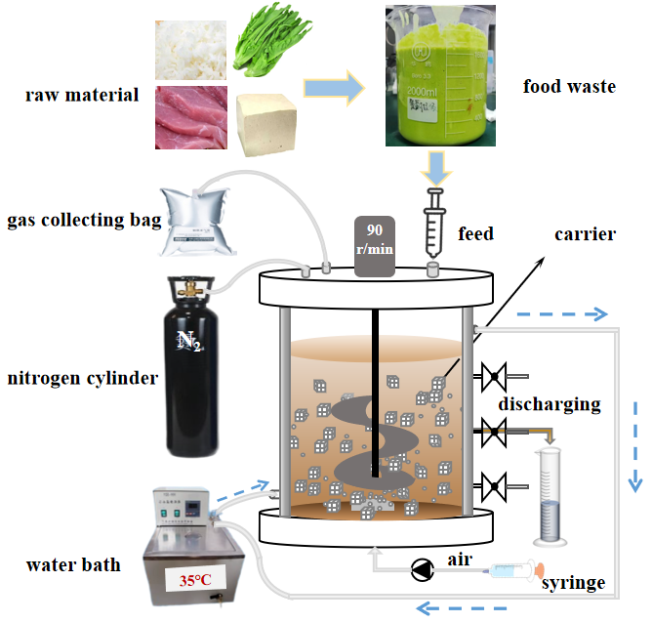

Fig. S1 Schematic diagram of the reactor structure

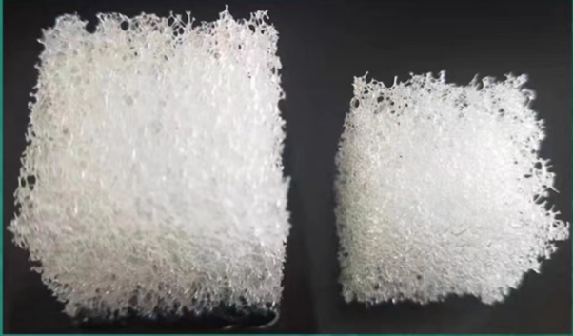
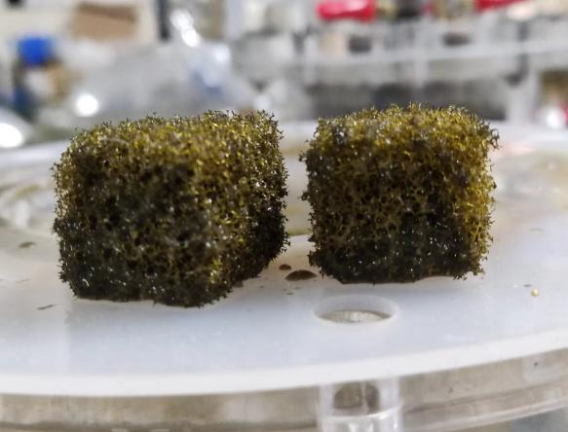
(a)
(b)
dry state
water swelling
anaerobic hanging membrane

Fig. S2 Pictures of Polyurethane sponge carriers: (a) the original state; (b) after anaerobic hanging membrane.

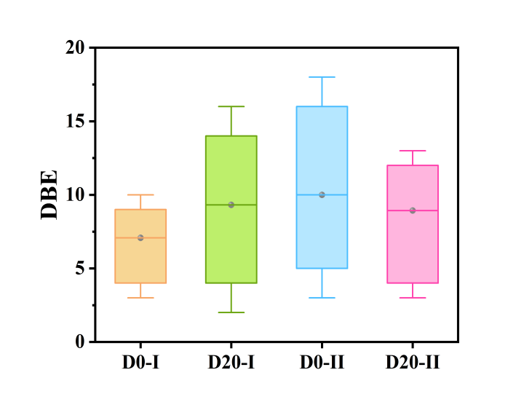
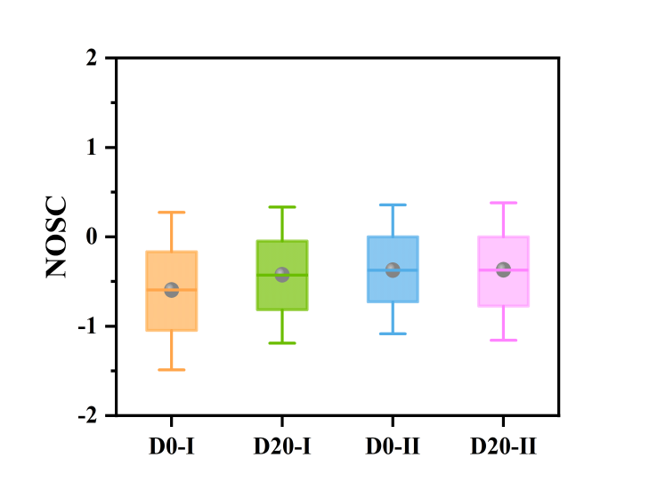
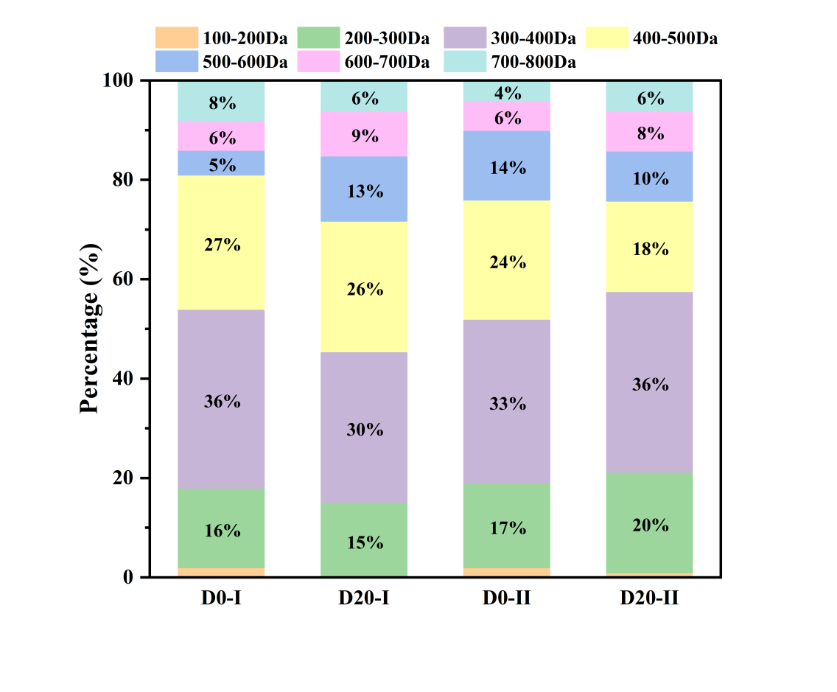
(c)
(a)
(b)

Fig. S3 The proportion of DOM molecular weight (a); The distribution of (b) DBE and (c) NOSC molecules in D0 and D20 under different operating conditions.
Fig. S4 Van Krevelen plots of different compositions

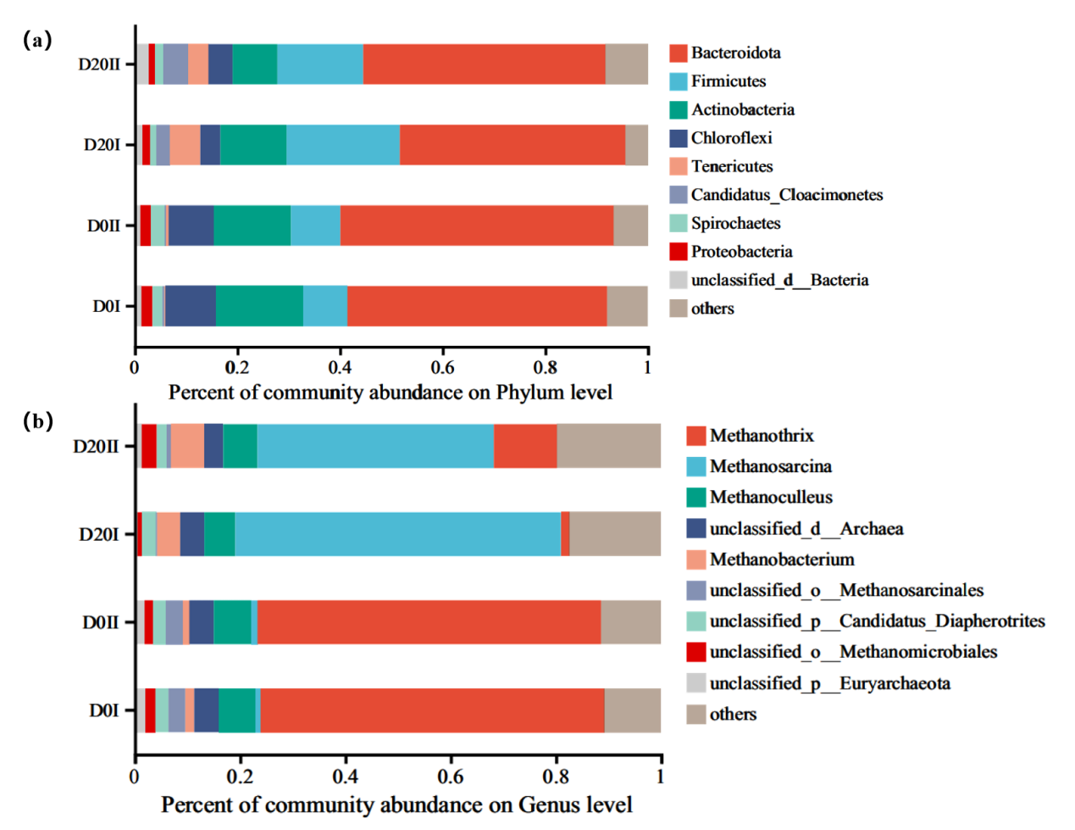
Fig. S5 Changes of bacterial (a) and archaeal (b) community structure before and after
micro-aeration treatment
Fig. S6 Relative abundance of the top 50 metabolism at pathway level 3

References:
[1] Han, H.,Feng, Y.,Chen, J.,Xie, Q.,Chen, S.,Sheng, M.,Zhong, S.,Wei, W.,Su, S.,Fu, P. Acidification impacts on the molecular composition of dissolved organic matter revealed by FT-ICR MS. Sci Total Environ.2022, 805: 150284.
[2] Zhang, B.,Shan, C.,Hao, Z.,Liu, J.,Wu, B.,Pan, B. Transformation of dissolved organic matter during full-scale treatment of integrated chemical wastewater: Molecular composition correlated with spectral indexes and acute toxicity. Water Res.2019, 157: 472-482.
[3] Stücheli, P. E.,Niggemann, J.,Schubert, C. J. Comparison of different solid phase extraction sorbents for the qualitative assessment of dissolved organic nitrogen in freshwater samples using FT-ICR-MS. Journal of Limnology.2018.
[4] Fu, Q. L.,Fujii, M.,Kwon, E. Development and Application of a High-Precision Algorithm for Nontarget Identification of Organohalogens Based on Ultrahigh-Resolution Mass Spectrometry. Anal Chem.2020, 92 (20): 13989-13996.
[5] Liu, X.,Hou, Y.,Yu, Z.,Wang, Y.,Zhou, S.,Jiang, B.,Liao, Y. Comparison of molecular transformation of dissolved organic matter in vermicomposting and thermophilic composting by ESI-FT-ICR-MS. Environ Sci Pollut Res Int.2020, 27 (35): 43480-43492.
[6] Lv, J.,Miao, Y.,Huang, Z.,Han, R.,Zhang, S. Facet-Mediated Adsorption and Molecular Fractionation of Humic Substances on Hematite Surfaces. Environmental Science & Technology.2018, 52 (20): 11660-11669.
[7] Miao, Y.,Lv, J.,Huang, H.,Cao, D.,Zhang, S. Molecular characterization of root exudates using Fourier transform ion cyclotron resonance mass spectrometry. Journal of Environmental Sciences.2020, 98: 22-30.
[8] Yassine, M. M.,Harir, M.,Dabek-Zlotorzynska, E.,Schmitt-Kopplin, P. Structural characterization of organic aerosol using Fourier transform ion cyclotron resonance mass spectrometry: Aromaticity equivalent approach. Rapid Communications in Mass Spectrometry.2014, 28 (22): 2445-2454.

∗Corresponding author: Key Laboratory of the Three Gorges Reservoir Region’s Eco-Environment, Ministry of Education, Chongqing University, Chongqing, PR China. Email address: guli@cqu.edu.cn (Li Gu) & Lijinze@cqu.edu.cn (Jinze Li)

