**2. APPROACH**

The Wireless Roadside Emergency Collision Kinetic Sensor (WRECKS) is a device that attaches to the terminal end section of a guardrail, alerting customers whenever their assets such as guardrails are hit. This device is important as there is currently no way for customers to track the status of their roadside infrastructure. Thus, WRECKS allows for a much faster response time to repair damaged guardrails. The design team’s sponsor, Atwood Fence Company, is a guardrail manufacturing company. They approached the team with the idea for WRECKS and provided some of the approaches discussed in this document. The general architecture of the device is outlined in Figure 2.1.

Figure 2.1 - WRECKS System Diagram

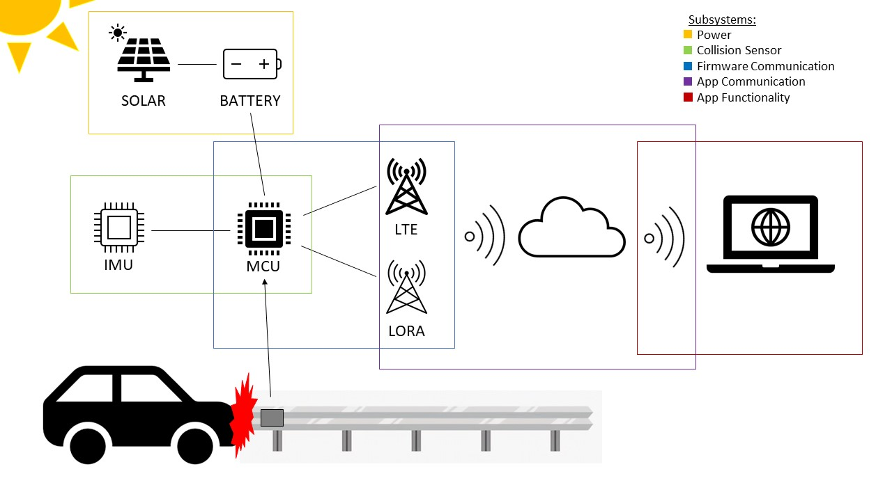

As shown in Figure 2.1, the WRECKS device is divided into 5 technical subsystems. The power subsystem is responsible for keeping the device running. It accomplishes this task by using a main battery, with solar power as an auxiliary power source. Next, the collision sensor subsystem is in charge of sensing when and where a crash has occurred and collecting the crash data. The firmware communication subsystem is responsible for sending crash data using established communication protocols. On the software side, the app communication subsystem receives and processes crash data from the sensor. Finally, the app functionality subsystem oversees the utilization of the data, and the interface by which the customer interacts with the device.

**2.1. Hardware**

As discussed above, WRECKS’ hardware is divided into three subsystems: the power supply, the collision sensor, and the firmware communication. The power supply consists of a solar panel, a charging circuit, and a battery. In the collision sensor subsystem, WRECKS uses a GPS and an inertial measurement unit (IMU). A LoRa module, an LTE module, and a microcontroller are all utilized in the firmware communication subsystem.

**2.1.1. Battery**

WRECKS is designed to be battery powered, with the battery that lasts at least two weeks on a charge. The battery has to be constantly charged via solar power. Additionally, the battery has a slightly higher voltage than required so that the voltage is regulated at a seamless, constant value.

Table 2.1 - Comparison of Power Sources/Batteries

| **Product** | **Output Voltage (Volts DC)** | **Capacity (mAh)** | **Dimensions (mm)** | **Cost (USD)** |
| --- | --- | --- | --- | --- |
| Liter 406080 Lipo [9] | 3.7 | 3000 | 80 x 60 x 4 | $10.99 |
| VIDAR Lithium-ion [10] | 3.7 | 4400 | 68 x 37 x 19 | $24.99 |
| Liter 104050 Lipo [11] | 3.7 | 2400 | 50 x 40 x 10 | $10.99 |
| Liter 123464 Lipo [12] | 3.7 | 2800 | 64 x 34 x 12 | $11.99 |

The Liter 406080 3000 mAh is the battery chosen to power WRECKS. This battery is an excellent choice as it is similar in dimensions to the RakWireless board. Its dimensions allow for a small form factor and the 4 millimeter thickness is a suitable fit for a compact design. 3000 mAh is enough to exceed WRECKS’ two week battery charge constraint. The cost is $10.99, which is the highest capacity for its cost of the batteries compared.

**2.1.2. Battery Charging Circuit**

The battery charging circuit takes the power generated by the solar panel and charges the battery at a constant voltage. This device serves as the intermediary between WRECKS’ solar panel and battery sources. The charging circuit’s ratings match the solar panel’s voltage for its input and the battery’s voltage for its output.

Table 2.2 - Comparison of Battery Charging Circuits

|  |  |  |  |  |
| --- | --- | --- | --- | --- |
| **Product** | **Input Voltage (Volts DC)** | **Output Voltage (Volts DC)** | **Dimensions (mm)** | **Cost (USD)** |
| RakWireless RAK5005-O [13] | 4.5 - 5.5 | 3.3 - 4.3 | 30 x 60 | $9.99 |
| MAX2074ATDA [14] | 3 - 5.5 | 6 - 18 | 3 x 3.5 | $2.50 |
| XL6009  [15] | 3.8 - 32 | 1.25 - 35 | 48 x 24 | $2.80 |

The Rak Wireless RAK5005-O is the battery charging circuit of choice for this project. While it is bigger and more expensive than other options, it is ideal because it comes built into an expansion board. Thus, it is unnecessary to purchase any extra parts and keeps the overall device cheaper and more compact. Whenever the choice arises, the design team has picked options that combine multiple systems into one module.

**2.1.3. Solar Panel**

WRECKS’ battery maintains its charge using a solar panel. The solar panel has dimensions that fit atop the enclosure with no overlay and ensures that the battery has enough charge at all times. As stated in 2.1.1, the power supply system is prepared for a worst case scenario of two weeks without charging

.

Table 2.3 - Comparison of Solar Panels

|  |  |  |  |  |
| --- | --- | --- | --- | --- |
| **Product** | **Output Voltage (Volts DC)** | **Output Current (mA)** | **Dimensions (mm)** | **Cost (USD)** |
| SUNYIMA [16] | 5 | 60 | 68 x 37 | $1.60 |
| AOSHIKE [17] | 5 | 30 | 53 x 30 | $1.60 |
| Panasonic AM-5907CAR-DGK-T [18] | 5 | 45.7 | 75 x 55 x 2 | $14.36 |

To utilize the RAK5005-O’s charging circuit with a solar source, a 5V solar panel is required. SUNYIMA’s panel is the best selection for WRECKS’ power supply as the product fits the 5V requirement set by the RAK5005-O, the cost is tied for lowest, and the output current is the highest. This panel also fits within the confines of WRECKS’ enclosure.

**2.1.4. LoRa Module**

A LoRa module is necessary to the WRECKS device as it allows for connection to the open-source LoRaWAN network. This network is free to use, and is the main form of communication for the WRECKS device. Table 2.4 lays out some options for different LoRa modules to be used in the project.

Table 2.4 - Comparison of LoRa Modules

|  |  |  |  |  |  |
| --- | --- | --- | --- | --- | --- |
| **Product** | **Input Voltage**  **(V)** | **Max Current** | **Dimensions (mm)** | **US Band** | **Cost (USD)** |
| REYAX RYLR896 Lora Module SX1276 UART [19] | 3.3 | 43 mA | 21.5 x 22.75 | YES | $19.50 |
| Gowoops SX1276 LoRa Radio Wireless [20] | 3.3 or 5 | 120 mA | 21 x 36 | YES | $21.99 |
| RakWireless  RAK4631 [21] | 3.3 | 125 mA | 20 x 30 | YES | $17.99 |
| Seeeduino LoRaWAN [22] | 3.3 | 200 mA | 23 x 28 | YES | $39.99 |

The design team selected the RakWireless RAK4631 as the LoRa module to be used by the WRECKS device. It has a standard input voltage of 3.3V and a standard current draw of 125 mA. Some of the other options have slightly better current draws, but the RAK4361 is small and cheap, making it preferred. The main appeal of the RAK4361 is the fact that it comes with an onboard microcontroller (see Section 2.1.9). This saves space and money by combining two components into one and makes this LoRa module the ideal candidate.

**2.1.5. Cellular Module**

The WRECKS device uses a cellular module to remain connected in situations where the LoRaWAN network is not reliable. The 4G/LTE network has more consistent coverage than LoRa, making it a sufficient back-up option for communication. Table 2.5 compares different cellular network modules for the design team’s consideration.

Table 2.5 - Comparison of Cellular Modules

|  |  |  |  |  |
| --- | --- | --- | --- | --- |
| **Product** | **Input Voltage (V)** | **Dimensions (mm)** | **4G/LTE** | **Cost (USD)** |
| HiLetgo Smallest SIM800L [23] | 3.5 - 4.2 | 25 x 23 | NO | $8.99 |
| SIM7080G with LTE GPS External Antenna [24] | 5 | 30.2 x 65 | YES | $42.99 |
| NB IoT 5 Click [25] | 3.3 or 5 | 57.2 x 25.4 | YES | $49.99 |
| RAK5860 [26] | 4.2 | 35 x 25 | YES | $30.00 |

The RAKWireless RAK5860 is the clear candidate for the WRECKS device. It is the cheapest module to include 4G/LTE coverage, and comes in a compact size. The input voltage of 4.2V is standard and comparable to the other options. Additionally, the RAK5860 includes a GPS module on the same board. Similar to the RAK4631, this means that size and cost are saved as two separate modules are combined.

**2.1.6. Cellular Antenna**

WRECKS uses various communication modules to send the collision information to the customers’ mobile devices. In order for these modules to send data to the gateway, each module requires an antenna. In order for the LoRa and 4G/LTE modules to function properly, they need an antenna that meets the specifications for their respective protocols. Table 2.6 lays out some antenna options to be considered for the WRECKS device.

Table 2.6 - Comparison of Cellular Antennas

|  |  |  |  |  |
| --- | --- | --- | --- | --- |
| **Product** | **Frequency Range**  **(Hz)** | **Gain**  **(dB)** | **Connector** | **Cost (USD)** |
| PulseLarson W1096X [27] | 698MHz ~ 960MHz, 1.71GHz ~ 2.69GHz, 3.4GHz ~ 3.8GHz | -3dBi, 1.5dBi, -0.5dBi | RP SMA Male | $11.72 |
| PulseLarson W5150 [28] | 617MHz ~ 960MHz, 1.43GHz ~ 3.5GHz, 3.5GHz ~ 6GHz | 1.2dBi, 2.5dBi, 5.5dBi | SMA Male | $14.34 |
| PulseLarson W3907B0127 [29] | 698MHz ~ 960MHz, 1.4279GHz ~ 1.5109GHz, 1.559GHz ~ 1.61GHz,  1.695GHz ~ 2.2GHz,  2.3GHz ~ 2.7GHz,  3.4GHz ~ 3.6GHz | 2.9dBi, 1.7dBi, 1.8dBi, 3.4dBi, 3.8dBi, 4.2dBi | IPEX MHF | $4.58 |
| Bingfu 4G LTE Antenna 9dBi SMA Male Cellular Antenna [30] | 698-960 MHz, 1710-2170 MHz, 2300-2700 MHz | 9dBi | SMA Male | $6.99 |

The PulseLarson W5150 is the best fit for this design since it has a wide frequency coverage that covers both the LoRa and 4G/LTE networks. While the price is higher than the competitors, this antenna will allow use on multiple frequencies, meaning that WRECKS requires less antennas to function. This cuts the device’s cost in the long run.

**2.1.7. GPS Module**

WRECKS is designed to attach to guardrails. In order to be able to tell which guardrail was hit, WRECKS uses GPS to show the location of the WRECKS device that sent the alert. Table 2.7 shows a list of GPS modules considered by the design team.

Table 2.7 - Comparison of GPS Modules

|  |  |  |  |  |
| --- | --- | --- | --- | --- |
| **Product** | **Accuracy**  **(m)** | **Update Rate**  **(Hz)** | **Dimensions (mm)** | **Cost**  **(USD)** |
| DFRobot TEL0137 USB GPS Receiver [31] | 2.5 m | 1 Hz | 60 x 24 x 9 | $9.70 |
| RAK5860 [26] | 2 m | 10 Hz | 25 x 35 | $30.00 |
| XA1110_1103891 [32] | 3 m | 1 - 10 Hz | 12.5 x 12.5 x 6.8 | $19.87 |
| MC60CA-04-STD [33] | 2.5 m | NA | 18.7 x 16 x 2.1 | $21.61 |

After comparing the modules in table 2.7, the design team concluded that the RAK 5860 is the best fit for WRECKS. This is because the module includes several of what WRECKS uses all in one piece, including GPS. For a device designed to be purchased in bulk, this reduces production costs and allows WRECKS not to be overly expensive. The 5860 is also the most accurate GPS module based on the options in the table, and it has the most frequent update rate.

**2.1.8. Inertial Measurement Unit**

WRECKS’ notifications are sent when the device is moved due to a collision. In order to achieve this goal, an internal measurement unit (IMU) is used to detect when the sensor moves such as when the guardrail is hit. The design team considered the IMU sensors listed in Table 2.8.

Table 2.8 - Comparison of Internal Measurement Units

|  |  |  |  |  |  |
| --- | --- | --- | --- | --- | --- |
| **Product** | **Sensor Type** | **Acceleration**  **(g)** | **Communication Protocol** | **Dimensions (mm)** | **Cost**  **(USD)** |
| OpenIMU330BI [34] | 6-axis | 8g | SPI, UART | 11 x 15 | $114.79 |
| MTi-1-0I-T [35] | 9-axis | 16g | I2C, SPI, UART | 12 x 12 | $149.00 |
| MPU-6881 [36] | 6-axis | 2g/4g/8g/16g | I2C, SPI | 3 x 3 | $11.77 |
| RAK1904 [37] | 3-axis | 2g/4g/8g/16g | I2C, SPI | 10 x 10 | $3.30 |
| SCC2230-E02-05 [38] | 3-axis | 2g | SPI | 12 x 15 | $86.79 |

The RAK1904 is selected as WRECKS’ IMU because it meets all requirements and fits into the RAK ecosystem which the design team is using for this project. Fitting into the RAK ecosystem ensures compatibility among different pieces of the WRECKS device. Additionally, the RAK1904 is the least expensive IMU out of the team’s options, allowing WRECKS to be less expensive to produce.

**2.1.9. Microcontroller**

The microcontroller is the most important part of the WRECKS system. As the brains of the device, it receives and interprets the data recorded by the IMU, and is responsible for communicating the data via the cellular and LoRa modules. The microcontroller must be able to interface with these sensors and modules at a high frequency. Since size is a crucial constraint in this project, the microcontroller needs to be as small as possible. Lastly, the WRECKS system requires a microcontroller with a low cost for the future production of the system. Table 2.9 compares options for the microcontroller to be used in this project.

Table 2.9 - Comparison of Microcontrollers

|  |  |  |  |  |
| --- | --- | --- | --- | --- |
| **Product** | **Clock Speed**  **(Hz)** | **Input/Output** | **Dimensions (mm)** | **Cost**  **(USD)** |
| RAK4631 + RAK5005-O [13],[21] | 64 MHz | 2x pigtail for BLE and LoRa, Battery and Solar connectors,UART, I2C, GPIO, USB | 30 x 60 | $27.99 |
| Arduino RP2040 Connect [39] | 133MHz | 14x Digital Pin, 8x Analog Pin, Micro USB, UART, SPI, I2C | 18 x 45 | $27.25 |
| Particle Boron LTE [40] | 64MHz | 20 pin GPIO (6 Analog, 8 PWM, I2C, SPI, UART) | 23 x 50 | $59.37 |
| Raspberry Pi Zero [41] | 1GHz | 40 pin GPIO | 30 x 65 | $5.00 |

The RakWireless RAK4631 is the ideal microcontroller for the WRECKS device. While the Raspberry Pi 0 beats the RAK4631 in clock speed and cost, the Raspberry Pi is out of stock and is not a suitable option for the design team. The RAK4631 beats the Raspberry Pi by size, making it ideal to fit into WRECKS’ small form factor. What makes the RAK4631 most ideal for the project is its modularity. It comes with built-in LoRa and Bluetooth modules along with antennas for each. Paired with the RAK5005-O baseboard, it can easily connect to the IMU and LTE modules, without adding much additional size. In this configuration, it also has direct connections to the battery and solar panel, with a built-in charging circuit. Thus, the RAK4631 and RAK5005-O baseboard is the clear choice for the WRECKS project, as it allows for convenient connection to all the vital subsystems.

**2.2. Software**

Software development for WRECKS is accomplished using available frameworks to make the development process quick and robust. Figure 2.2 outlines the different software components used.

Figure 2.2 - Software architecture used in WRECKS

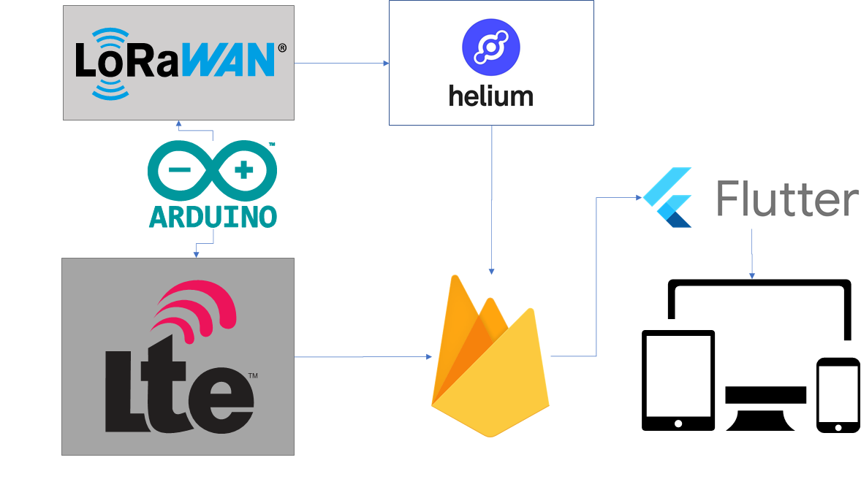

**2.2.1. Flutter**

Flutter is software developed by Google. It is an open source multi-platform framework used to develop applications from a single codebase [42]. Flutter uses the Dart programming language which “compiles to ARM or Intel machine code as well as JavaScript for fast performance on any device” [5]. In order words, code written in the Flutter framework can be deployed in mobile, web, desktop, or embedded devices. The design team utilizes the Flutter framework to design an application that can retrieve the data coming from Firebase in realtime to initiate a communication process with the customer’s end node devices. This data can be sent in the form of text, email, or push notification.

**2.2.2. Google Firebase**

Firebase is Google’s mobile application development platform that provides a real-time database [43]. With the help of Google Firebase, small tasks such as authentication, configuration, and push messaging can be utilized with little to no effort while developing an application. It also helps to reduce the amount of backend coding required. Shown below, is a figure that sums up the traditional without Firebase vs. modern with Firebase software development protocol.

Figure 2.3 - Firebase development [47]

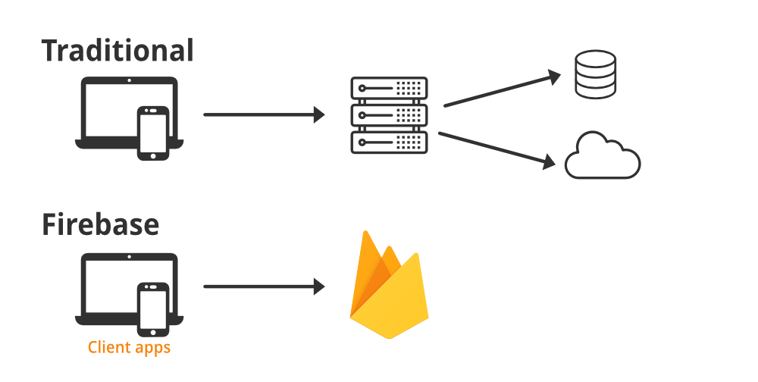

As shown in Figure 2.3, WRECKS uses Google Firebase as the backend which eliminates the requirement of having a server to forward the data coming from the sensors to the customers application.

**2.2.3. Hologram**

Hologram is an IoT Management system and global cellular network that can be used to add cellular connectivity to a wide range of IoT devices [44]. WRECKS uses Hologram SIM cards to provide a gateway for LTE networks in areas where there is no coverage for LoRaWAN.

**2.2.4. Helium**

Helium is a decentralized wireless network utilizing LoRaWAN to enable wireless connectivity to IoT devices over a wide area [45]. Helium also contains a powerful console to manage IoT deployments and can integrate with services such as Firebase for easy data management. WRECKS utilizes the Helium network via a LoRaWAN module and antenna to transmit crash data through the Helium console to Firebase.

**2.2.5. Arduino IDE**

The Arduino IDE is an open-source integrated development environment used to write, build, and upload software to Arduino-compatible microcontrollers [46]. This IDE comes with a host of libraries and example programs that make embedded software development in C straightforward. The Arduino software within WRECKS integrates every hard module together by taking data from the IMU, interpreting it, and sending it to the cellular and LoRaWAN modules.

**References**

[9] “Liter 3.7V 3000mAh 406080 Lipo Battery Rechargeable,” *Amazon.com,* 2022. [Online]. Available: <https://www.amazon.com/3000mAh-Battery-Rechargeable-Lithium-Connector/dp/B09FPQ62FM/ref=sr_1_2?crid=2ZB1688QC1W4A&keywords=rechargeable+3.7+v+battery&qid=1646769236&refinements=p_n_feature_five_browse-bin%3A23559008011&rnid=23559001011&s=hpc&sprefix=rechargeable+3.7+v+battery%2Caps%2C92&sr=1-2> (Accessed Mar. 08, 2022).

[10] “3.7V 4400mAh-16.28wh Rechargeable Li-ion Battery - VIDAR Real Capacity Super Durability Lithium Batteries with JST 2.0/2P Plug,”*Amazon.com,* 2022. [Online]. Available: <https://www.amazon.com/3-7V-4400mAh-16-28wh-Rechargeable-Li-ion-Battery/dp/B08PNSRM3Y/ref=sr_1_1?crid=3G43YSCVFVJGH&keywords=3.7V+4400mAh-16.28wh+Rechargeable+Li-ion+Battery+-+VIDAR+Real&qid=1646784329&s=hpc&sprefix=3.7v+4400mah-16.28wh+rechargeable+li-ion+battery+-+vidar+real+%2Chpc%2C103&sr=1-1> (Accessed Mar. 08, 2022).

[11] “Liter 3.7V 2400mAh 104050 Lipo Battery Rechargeable,” *Amazon.com,* 2022. [Online]. Available:

<https://www.amazon.com/2400mAh-Battery-Rechargeable-Lithium-Connector/dp/B09FK974GT/ref=sr_1_1?keywords=3.7+v+battery&qid=1646773270&refinements=p_n_feature_five_browse-bin%3A23559007011&rnid=23559001011&s=hpc&sr=1-1> (Accessed Mar. 08, 2022).

[12] “Liter 3.7V 2800mAh 123464 Lipo Battery Rechargeable,” *Amazon.com,* 2022. [Online]. Available:

<https://www.amazon.com/2800mAh-Battery-Rechargeable-Lithium-Connector/dp/B09FNYWP33/ref=sr_1_2?keywords=3.7+v+battery&qid=1646773312&refinements=p_n_feature_five_browse-bin%3A23559007011&rnid=23559001011&s=hpc&sr=1-2> (Accessed Mar. 08, 2022).

[13] “RAK5005-O | WisBlock Base Board,” *RakWireless.com*, 2022. [Online]. Available: <https://store.rakwireless.com/products/rak5005-o-base-board> (Accessed Mar. 08, 2022).

‌

[14] “Maxim Integrated MAX20474ATDA/V+,” *Mouser Electronics*, 2022. [Online]. Available: [https://www.mouser.com/ProductDetail/Maxim-Integrated/MAX20474ATDA-V%2b?qs=A6eO%252BMLsxmQpOzvW2yv6Iw%3D%3D](https://www.mouser.com/ProductDetail/Maxim-Integrated/MAX20474ATDA-V%2b?qs=A6eO%252BMLsxmQpOzvW2yv6Iw%3D%3D.) (Accessed Mar. 08, 2022).

‌

[15] “XINGYHENG 5Pcs XL6009 DC-DC Buck Boost Voltage Converter Power Module 4A 400KHz Adjustable Switch Module 3.8-30V to 1.25-35V Power Supply Module for Solar Panel,” *Amazon.com,* 2022. [Online]. Available: <https://www.amazon.com/XINGYHENG-XL6009-DC-DC-Converter-Power-Adjustable-Step-down/dp/B08PP1N8G5/ref=sr_1_19?keywords=Boost+Converter&qid=1646113200&sr=8-19>(Accessed Mar. 08, 2022).

‌

[16] “SUNYIMA 10Pcs 5V 60mA Epoxy Solar Panel Polycrystalline Solar Cells for Solar Battery Charger DIY Solar System Kits,” *Amazon.com,* 2022. [Online]. Available: <https://www.amazon.com/AOSHIKE-Polycrystalline-Battery-Charger-2-67x1-45inch/dp/B0736W4HK1/ref=sr_1_4?keywords=SUNYIMA+Solar+Panels&qid=1646772250&s=lawn-garden&sr=1-4> (Accessed Mar. 08, 2022).

‌

[17] “AOSHIKE 10Pcs 5V 30mA Mini Solar Panels for Solar Power,” *Amazon.com,* 2022. [Online]. Available: <https://www.amazon.com/AOSHIKE-Electric-Materials-photovoltaic-53x30MM/dp/B07BMMHMSJ/ref=sr_1_3?crid=10Q05YPFYLIM&keywords=aoshike+10+pcs+5v+30ma+mini+solar+panels&qid=1646772815&sprefix=AOSHIKE%2Caps%2C149&sr=8-3> (Accessed Mar. 08, 2022).

[18] “AM-5907CAR-DGK-T Panasonic - BSG | Sensors, Transducers | DigiKey,” *Digikey.com*, 2022. [Online]. Available: <https://www.digikey.com/en/products/detail/panasonic-bsg/AM-5907CAR-DGK-T/2165198> (Accessed Mar. 08, 2022).

‌

[19] “REYAX RYLR896 Lora Module SX1276 UART 868MHz 915MHz Antenna,” *Amazon.com,* 2022. [Online]. Available: [https://www.amazon.com/RYLR896-Module-SX1276-Antenna-Command/dp/B07NB3BK5H](https://www.amazon.com/RYLR896-Module-SX1276-Antenna-Command/dp/B07NB3BK5H.) (Accessed Mar. 08, 2022).

[20] “Gowoops SX1276 LoRa Radio Wireless 915Mhz UART Serial Module LoRaWAN Transmitter Receiver,” *Amazon.com,* 2022. [Online]. Available: <https://www.amazon.com/Gowoops-Wireless-Transmitter-Compatible-Microcomputer/dp/B07G7RZLTW/ref=pd_sbs_5/141-3004043-4104327?pd_rd_w=Ol66E&pf_rd_p=dfec2022-428d-4b18-a6d4-8f791333a139&pf_rd_r=1SHQPNNKQK2XQV085V2D&pd_rd_r=30139669-015c-4587-bdaa-c8dd41c81e04&pd_rd_wg=ySFCY&pd_rd_i=B07G7RZLTW&psc=1> (Accessed Mar. 08, 2022).

[21] “RAK4631 | nRF52840 SX1262 | Module for LoRaWAN,” *RakWireless.com*, 2022. [Online]. Available: <https://store.rakwireless.com/products/rak4631-lpwan-node> (Accessed Mar. 08, 2022).

[22] “Seeed Studio 102010128,” *Mouser.com*, 2022. [Online]. Available: <https://www.mouser.com/ProductDetail/Seeed-Studio/102010128?qs=WY0B%252Bpw29jMGjDlFmQEYGA%3D%3D> (Accessed Mar. 08, 2022).

[23] “HiLetgo Smallest SIM800L GPRS GSM Breakout Module,” *Amazon.com,* 2022. [Online]. Available: <https://www.amazon.com/HiLetgo-Smallest-Breakout-Quad-band-3-7-4-2V/dp/B01DLIJM2E/ref=pd_lpo_2?pd_rd_i=B01DLIJM2E&psc=1> (Accessed Mar. 08, 2022).

[24] “NB-IoT Cat-M (eMTC) GNSS HAT Based on SIM7080G with LTE,” *Amazon.com,* 2022. [Online]. Available: <https://www.amazon.com/Raspberry-SIM7080G-External-Interface-XYGStudy/dp/B08434FHLJ/ref=sr_1_7?crid=389MJCVFW41JF&keywords=nb-iot+LTE&qid=1646012159&s=electronics&sprefix=nb-iot+lte%2Celectronics%2C80&sr=1-7> (Accessed Mar. 08, 2022).

[25] “MIKROE-4472 MikroElektronika | Development Boards, Kits, Programmers,” *D*[*igikey.com*](http://www.digikey.com), 2022. [Online]. Available: <https://www.digikey.com/en/products/detail/mikroelektronika/MIKROE-4472/13958758> (Accessed Mar. 08, 2022).

[26] “RAK5860 | BG77 | NB-IoT Interface Module,” *RakWireless.com*, 2022. [Online]. Available: <https://store.rakwireless.com/products/rak5860-lte-nb-iot-extension-board> (Accessed Mar. 08, 2022).

[27] “W1096 PulseLarsen Antennas,” *Digikey.com*, 2022. [Online]. Available: <https://www.digikey.com/en/products/detail/pulselarsen-antennas/W1096/13244582>(Accessed Mar. 08, 2022).

[28] “W5150 PulseLarsen Antennas,” *Digikey.com*, 2022. [Online]. Available: <https://www.digikey.com/en/products/detail/pulselarsen-antennas/W5150/13244581> (Accessed Mar. 08, 2022).

[29] “W3907B0127 PulseLarsen Antennas,” *Digikey.com*, 2022. [Online]. Available: <https://www.digikey.com/en/products/detail/pulselarsen-antennas/W3907B0127/15287060>(Accessed Mar. 08, 2022).

[30] “Bingfu 4G LTE Antenna 9dBi SMA Male Cellular Antenna Compatible with 4G LTE Wireless CPE Router Hotspot,” *Amazon.com,* 2022. [Online]. Available: <https://www.amazon.com/Bingfu-Cellular-Wildlife-Security-Amplifier/dp/B08139ZVVF/ref=sr_1_8?crid=RW4KT6092DBO&keywords=4g%2Bantenna&qid=1646771762&sprefix=4g%2Bantenna%2Caps%2C135&sr=8-8&th=1> (Accessed Mar. 08, 2022).

[31] “TEL0137 DFRobot,” *Mouser.com*, 2022. [Online]. Available: <https://www.mouser.com/ProductDetail/DFRobot/TEL0137?qs=DRkmTr78QAQBGHkfGqmsFw%3D%3D> (Accessed Mar. 05, 2022).

[32] “XA1110_1103891 Sierra Wireless,” *Digikey.com*, 2022. [Online]. Available: <https://www.digikey.com/en/products/detail/sierra-wireless/XA1110-1103891/8572914> (Accessed Mar. 05, 2022).

[33] “MC60CA-04-STD Quectel,” *Digikey.com*, 2022. [Online]. Available: <https://www.digikey.com/en/products/detail/quectel/MC60CA-04-STD/13278076> (Accessed Mar. 05, 2022).

[34] “OpenIMU330BI ACENNAr,” *Mouser.com*, 2022. [Online]. Available: <https://www.mouser.com/ProductDetail/ACEINNA/OpenIMU330BI?qs=B6kkDfuK7%2FAO2lij2iCtwg%3D%3D> (Accessed Mar. 06, 2022).

[35] “MT-1-0I-TXsens,” *Mouser.com*, 2022. [Online]. Available: <https://www.mouser.com/ProductDetail/Xsens/MTi-1-0I-T?qs=pBJMDPsKWf3QijwWCJT1NA%3D%3D> (Accessed Mar. 06, 2022).

[36] “MPU-6881 TDK,” *Mouser.com*, 2022. [Online]. Available: <https://www.mouser.com/ProductDetail/TDK-InvenSense/MPU-6881?qs=u4fy%2FsgLU9MthFpyRcZ0%252Bg%3D%3D> (Accessed Mar. 06, 2022).

[37] “RAK1904 | LIS3DH | 3-axis acceleration sensor,” *RakWireless.com*, 2022. [Online]. Available: <https://store.rakwireless.com/products/rak1904-lis3dh-3-axis-acceleration-sensor> (Accessed Mar. 06, 2022).

[38] “SCC2230-E02-05 Murata Electronics,” *Mouser.com*, 2022. [Online]. Available: <https://www.mouser.com/ProductDetail/Murata-Electronics/SCC2230-E02-05?qs=u1o5GQxYRwpFEw2sn75Q8Q%3D%3D> (Accessed Mar. 06, 2022).

[39] “Nano RP2040 Connect | Arduino Documentation,” *Arduino.cc*, 2022. [Online]. Available: <https://docs.arduino.cc/hardware/nano-rp2040-connect> (Accessed Mar. 08, 2022).

‌

[40] “Boron LTE CAT-M1 (NorAm),” *Particle.io*, 2022. [Online]. Available: <https://store.particle.io/products/boron-lte> (Accessed Mar. 08, 2022).

‌

[41] “Buy a Raspberry Pi Zero,” *Raspberrypi.com*, 2022. [Online]. Available: <https://www.raspberrypi.com/products/raspberry-pi-zero/> (Accessed Mar. 08, 2022).

[42] “Flutter - Beautiful native apps in record time,” *Flutter.dev*, 2019. [Online] Available: <https://flutter.dev/> (Accessed Mar. 08, 2022).

[43] “Firebase,” *Firebase.com*, 2018. [Online]. Available: <https://firebase.google.com/> (Accessed Mar. 08, 2022).

[44] “Cellular Connectivity for the Internet of Things | Hologram,” *Hologram.io*, 2022. [Online]. Available: <https://www.hologram.io/> (Accessed Mar. 08, 2022).

[45] “Helium & LoRaWAN,” *Helium.com*, 2022. [Online]. Available: <https://www.helium.com/lorawan> (Accessed Mar. 08, 2022).

[46] “Arduino - Home,” *Arduino.cc*, 2018. [Online]. Available: <https://www.arduino.cc/> (Accessed Mar. 08, 2022).

[47] “Firebase - Introduction,” *GeeksforGeeks*, Nov. 27, 2020. [Online]. Available: <https://www.geeksforgeeks.org/firebase-introduction/> (Accessed Mar. 08, 2022).

[48] “RAKwireless,” *GitHub.com*, 2022. [Online]. Available: <https://github.com/RAKWireless> (Accessed Mar. 08, 2022).