**2. APPROACH**

The Wireless Roadside Emergency Collision Kinetic Sensor (WRECKS) is a device that attaches to the terminal end section of a guardrail, alerting customers whenever their assets are hit. This device is important as there is currently no way for customers to track the status of their roadside infrastructure. Thus, WRECKS allows for a much faster response time to repair damaged guardrails. The design team’s sponsor, Atwood Fence Company, manufactures guardrails. Atwood Fencing approached the team with the idea for WRECKS and provided some of the constraints met in this approach document. The general architecture of the device is outlined in Figure 2.1.

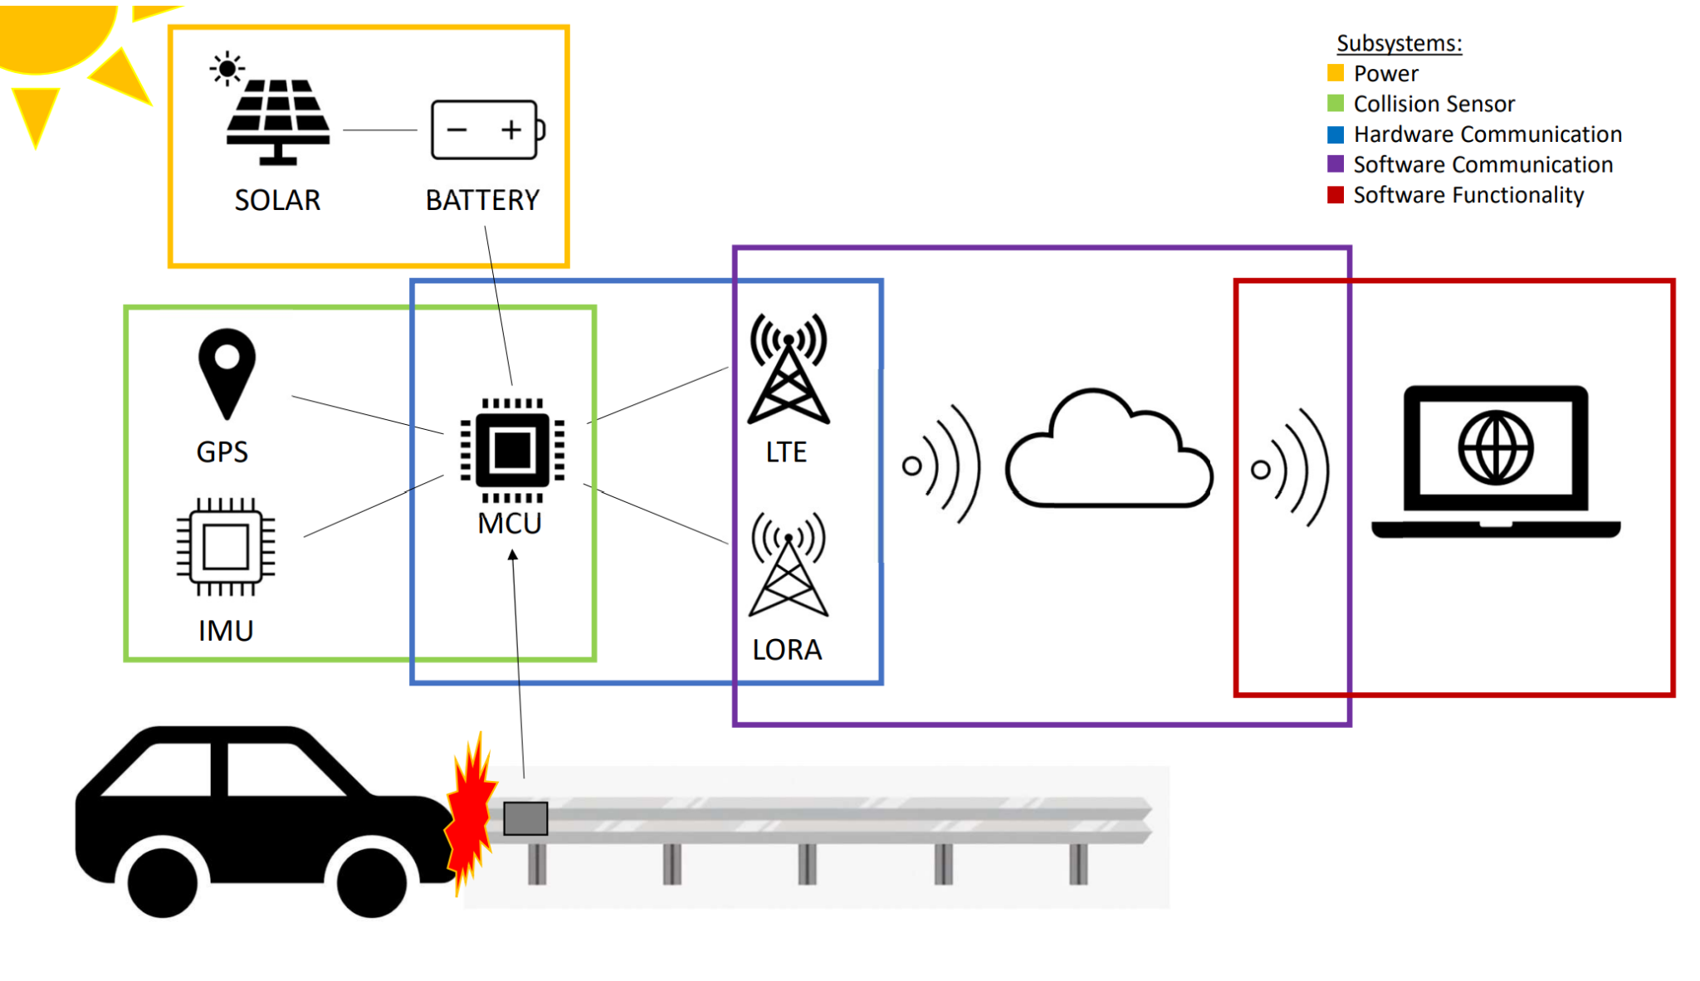

Figure 2.1 - WRECKS System Diagram

As shown in Figure 2.1, the WRECKS device is divided into 5 technical subsystems. The power subsystem is responsible for running the device. It accomplishes this task by using a main battery supplied by a solar panel. Next, the collision sensor subsystem is in charge of sensing when and where a crash has occurred and collecting the crash data. The hardware communication subsystem is responsible for sending crash data using established communication protocols. On the software side, the software communication subsystem receives and processes crash data from the sensor. Finally, the software functionality subsystem oversees the utilization of the data and the interface through which the customer interacts with the device.

**2.1. Hardware**

As discussed above, WRECKS’ hardware is divided into three subsystems: the power supply, collision sensor, and hardware communication. The power supply consists of a solar panel, a charging circuit, and a battery. In the collision sensor subsystem, WRECKS uses a global positioning system (GPS) and an inertial measurement unit (IMU). A Long-Range Wide Area Network (LoRaWAN) radio module, a Long-Term Evolution (LTE) cellular module, and a microcontroller are all utilized in the hardware communication subsystem.

**2.1.1. Microcontroller**

The microcontroller is the most important part of the WRECKS device. As the brains of the system, it receives and interprets the data recorded by the IMU and transmits this data via the cellular or LoRa modules. The microcontroller can interface with these sensors and modules at a high frequency. Since size is a crucial constraint in this project, the microcontroller has a small form factor. Lastly, the WRECKS device requires an inexpensive microcontroller to allow for the mass production of the system. Table 2.1 compares options for the microcontroller to be used in this project.

Table 2.1 - Comparison of Microcontrollers

|  |  |  |  |  |
| --- | --- | --- | --- | --- |
| **Product** | **Clock Speed** | **Input/Output** | **Dimensions (mm)** | **Cost**  **(USD)** |
| Requirements | 60 MHz | Pigtail,  battery, and solar connectors | 60 x 60 | $60.00 |
| RAK4631 + RAK5005-O [9],[10] | 64 MHz | 2x Pigtail, 1x battery connector, 1x solar connector, UART, I2C, GPIO, USB | 30 x 60 | $27.99 |
| Arduino RP2040 Connect [11] | 133 MHz | 14x Digital Pin, 8x Analog Pin, Micro USB, UART, SPI, I2C | 18 x 45 | $27.25 |
| Particle Boron LTE [12] | 64 MHz | 20 pin GPIO (6 Analog, 8 PWM, I2C, SPI, UART) | 23 x 50 | $59.37 |
| Raspberry Pi Zero [13] | 1 GHz | 40 pin GPIO | 30 x 65 | $5.00 |

The RakWireless RAK4631 is the ideal microcontroller for the WRECKS device. While the Raspberry Pi Zero beats the RAK4631 in clock speed and cost, the Raspberry Pi is out of stock and is therefore not a suitable option for the design team. The RAK4631 beats the Raspberry Pi by size, making it ideal to fit into WRECKS’ small form factor. RAK’s modularity makes it ideal for the project, since it comes with built-in LoRa and Bluetooth modules. Paired with the RAK5005-O baseboard, it can easily connect to the IMU and LTE modules, without adding much additional size. In this configuration, the RAK4631 also has direct connections to the battery and solar panel, with a built-in charging circuit. Thus, the RAK4631 and the RAK5005-O baseboard are clear choices for the WRECKS device, as they allow for convenient connection to all vital subsystems.

**2.1.2. LoRa Module**

A LoRa module is necessary for WRECKS as it allows for connection to the open-source LoRaWAN. This network is free to use and is the main form of communication for the WRECKS device. Table 2.2 shows options for multiple LoRaWAN modules.

Table 2.2 - Comparison of LoRa Modules

|  |  |  |  |  |  |
| --- | --- | --- | --- | --- | --- |
| **Product** | **Input Voltage**  **(V)** | **Maximum Current (mA)** | **Dimensions (mm)** | **US Band** | **Cost (USD)** |
| Requirements | 3.3 | 150 | 30 x 30 | YES | $20.00 |
| REYAX RYLR896 LoRa Module SX1276 UART [14] | 3.3 | 43 | 21.5 x 22.75 | YES | $19.50 |
| Gowoops SX1276 LoRa Radio Wireless [15] | 3.3 or 5 | 120 | 21 x 36 | YES | $21.99 |
| RakWireless  RAK4631 [10] | 3.3 | 125 | 20 x 30 | YES | $17.99 |
| Seeeduino LoRaWAN [16] | 3.3 | 200 | 23 x 28 | YES | $39.99 |

The design team selected the RakWireless RAK4631 as the LoRa module for the WRECKS device. It has a standard input voltage of 3.3 V and a standard current draw of 125 mA. Some of the other options have slightly lower current draws, but the RAK4631 is small and inexpensive. The main appeal of the RAK4631 is the fact that it comes with an onboard microcontroller (Section 2.1.1). This feature saves space and cost by combining two components and makes this LoRa module the ideal candidate.

**2.1.3. Cellular Module**

The WRECKS device uses a cellular module to remain connected in situations where LoRaWAN is unreliable. The 4G/LTE network has more consistent coverage than LoRa, but is more expensive, making it a sufficient backup option for communication. Table 2.3 compares different cellular network modules for the design team’s consideration.

Table 2.3 - Comparison of Cellular Modules

|  |  |  |  |  |
| --- | --- | --- | --- | --- |
| **Product** | **Input Voltage (V)** | **Dimensions (mm)** | **4G/LTE** | **Cost (USD)** |
| Requirements | 3.3 – 4.2 | 40 x 40 | YES | $35.00 |
| HiLetgo Smallest SIM800L [17] | 3.5 – 4.2 | 25 x 23 | NO | $8.99 |
| SIM7080G with LTE GPS External Antenna [18] | 5 | 30.2 x 65 | YES | $42.99 |
| NB IoT 5 Click [19] | 3.3 or 5 | 57.2 x 25.4 | YES | $49.99 |
| RAK5860 [20] | 4.2 | 35 x 25 | YES | $30.00 |

The RAKWireless RAK5860 is the clear candidate for the WRECKS device. It is the least expensive module to include 4G/LTE coverage and comes in a compact size. The input voltage of 4.2-V is standard and comparable to the other options. Additionally, the RAK5860 includes a GPS module on the same board. Similar to the RAK4631, this feature means that size and cost are saved as two separate modules are combined.

**2.1.4. Antenna**

The WRECKS device uses various communication modules to send the collision information to the customers’ mobile devices. In order for the LoRa and 4G/LTE modules to function properly, they need an antenna that meets the specifications for their respective protocols. Table 2.4 lays out some antenna options to be considered for the WRECKS device.

Table 2.4 - Comparison of Antennas

| **Product** | **Frequency Range** | **Gain**  **(dBi)** | **Connector** | **Cost (USD)** |
| --- | --- | --- | --- | --- |
| Requirements | 617 MHz ~ 960 MHz, 1.43 GHz ~ 3.5 GHz, 3.5 GHz ~ 6 GHz | 5 dBi | SMA Male | $15.00 |
| PulseLarson W1096X [21] | 698 MHz ~ 960 MHz, 1.71 GHz ~ 2.69 GHz, 3.4 GHz ~ 3.8 GHz | -3 dBi, -0.5 dBi, 1.5 dBi | RP SMA Male | $11.72 |
| PulseLarson W5150 [22] | 617 MHz ~ 960 MHz, 1.43 GHz ~ 3.5 GHz, 3.5 GHz ~ 6 GHz | 1.2 dBi, 2.5 dBi, 5.5 dBi | SMA Male | $14.34 |
| PulseLarson W3907B0127 [23] | 698 MHz ~ 960 MHz, 1.4279 GHz ~ 1.5109 GHz, 1.559 GHz ~ 1.61 GHz,  1.695 GHz ~ 2.2 GHz,  2.3 GHz ~ 2.7 GHz,  3.4 GHz ~ 3.6 GHz | 2.9 dBi, 1.7 dBi, 1.8 dBi, 3.4 dBi, 3.8 dBi, 4.2 dBi | IPEX MHF | $4.58 |
| Bingfu 4G LTE Antenna 9dBi SMA Male Cellular Antenna [24] | 698 ~ 960 MHz, 1710 ~ 2170 MHz, 2300 ~ 2700 MHz | 9 dBi | SMA Male | $6.99 |

The PulseLarson W5150 is the best fit for this design since it has a wide frequency coverage that includes both the LoRa and 4G/LTE networks. While the price is higher than the competitors, this antenna allows use on multiple frequencies, meaning that the WRECKS device requires fewer antennas to test, reducing the device’s overall cost.

**2.1.5. GPS Module**

WRECKS is designed to attach to guardrails. In order to be able to tell which guardrail is hit, the WRECKS device uses GPS to show the location of the collision. Table 2.5 shows a list of GPS modules considered by the design team.

Table 2.5 - Comparison of GPS Modules

|  |  |  |  |  |
| --- | --- | --- | --- | --- |
| **Product** | **Accuracy**  **(m)** | **Update Rate**  **(Hz)** | **Dimensions (mm)** | **Cost**  **(USD)** |
| Requirements | 2 | 10 | 40 x 40 x 10 | $30.00 |
| DFRobot TEL0137 [25] | 2.5 | 1 | 60 x 24 x 9 | $9.70 |
| RAK5860 [20] | 2 | 10 | 25 x 35 | $30.00 |
| XA1110_1103891 [26] | 3 | 1 – 10 | 12.5 x 12.5 x 6.8 | $19.87 |
| MC60CA-04-STD [27] | 2.5 | N/A | 18.7 x 16 x 2.1 | $21.61 |

The RAK5860 is the best fit for WRECKS, primarily because it includes multiple required modules. Thus, in order for the device to be purchased in bulk, this module allows WRECKS to be cost effective. Also, the RAK5860 is the most accurate GPS module, and it has the highest update rate of the options considered.

**2.1.6. Inertial Measurement Unit**

WRECKS’ notifications are sent when the device senses a collision. To achieve this goal, an internal measurement unit (IMU) is used to detect change in velocity and angle. The design team considered multiple IMU sensors listed in Table 2.6.

Table 2.6 - Comparison of Internal Measurement Units

|  |  |  |  |  |  |
| --- | --- | --- | --- | --- | --- |
| **Product** | **Sensor Type** | **Acceleration**  **(g)** | **Communication Protocol** | **Dimensions (mm)** | **Cost**  **(USD)** |
| Requirements | 3-axis | 2 – 16 | I2C or SPI | 15 x 15 | $10.00 |
| OpenIMU330BI [28] | 6-axis | 8 | SPI, UART | 11 x 15 | $114.79 |
| MTi-1-0I-T [29] | 9-axis | 16 | I2C, SPI, UART | 12 x 12 | $149.00 |
| MPU-6881 [30] | 6-axis | 2/4/8/16 | I2C, SPI | 3 x 3 | $11.77 |
| RAK1904 [31] | 3-axis | 2/4/8/16 | I2C, SPI | 10 x 10 | $3.30 |
| SCC2230-E02-05 [32] | 3-axis | 2 | SPI | 12 x 15 | $86.79 |

The RAK1904 is selected as WRECKS’ IMU because it meets all requirements and fits into the RAK ecosystem. Fitting into the RAK ecosystem ensures maximum compatibility among different pieces of the device. Additionally, the RAK1904 is the least expensive IMU out of the team’s options, ensuring WRECKS is affordable.

**2.1.7. Battery**

WRECKS is designed to be battery powered, lasting at least two weeks on a single charge. The battery is constantly charged via solar power. Additionally, the battery has a slightly higher voltage than required so that the voltage is regulated at a seamless, constant value. Table 2.7 shows a list of batteries considered for WRECKS.

Table 2.7 - Comparison of Power Sources/Batteries

| **Product** | **Output Voltage (V)** | **Capacity (mAh)** | **Dimensions (mm)** | **Cost (USD)** |
| --- | --- | --- | --- | --- |
| Requirements | 3.7 | 2500 | 80 x 80 x 10 | $12.00 |
| Liter 406080 Lipo [33] | 3.7 | 3000 | 80 x 60 x 4 | $10.99 |
| VIDAR Lithium-ion [34] | 3.7 | 4400 | 68 x 37 x 19 | $24.99 |
| Liter 104050 Lipo [35] | 3.7 | 2400 | 50 x 40 x 10 | $10.99 |
| Liter 123464 Lipo [36] | 3.7 | 2800 | 64 x 34 x 12 | $11.99 |

The Liter 406080 Lipo is the battery chosen to power WRECKS. This battery is an excellent choice as it is similar in dimensions to the RakWireless board, reducing the overall size of the device. Its current density of 3000 mAh is enough to exceed WRECKS’ two week battery charge constraint. The cost is $10.99, which is the highest capacity per dollar of the batteries shown.

**2.1.8. Battery Charging Circuit**

The battery charging circuit takes the power generated by the solar panel and charges the battery at a constant voltage. This device serves as the intermediary between WRECKS’ solar panel and battery sources. The charging circuit’s ratings match the solar panel’s voltage for its input and the battery’s voltage for its output. Listed in Table 2.8 are some options for WRECKS’ battery charging circuit.

Table 2.8 - Comparison of Battery Charging Circuits

|  |  |  |  |  |
| --- | --- | --- | --- | --- |
| **Product** | **Input Voltage**  **(V)** | **Output Voltage (V)** | **Dimensions (mm)** | **Cost (USD)** |
| Requirements | 5.0 | 3.7 | 60 x 60 | $10.00 |
| RakWireless RAK5005-O [9] | 4.5 – 5.5 | 3.3 – 4.3 | 30 x 60 | $9.99 |
| MAX2074ATDA [37] | 3 – 5.5 | 6 – 18 | 3 x 3.5 | $2.50 |
| XL6009  [38] | 3.8 – 32 | 1.25 – 35 | 48 x 24 | $2.80 |

The RakWireless RAK5005-O is the battery charging circuit of choice for this project. While it is bigger and more expensive than other options, it is ideal because it comes built into the MCU expansion board. Thus, it is unnecessary to purchase any extra parts and keeps the overall device less expensive and more compact. Whenever the choice arises, the design team has picked options that combine multiple systems into one module.

**2.1.9. Solar Panel**

WRECKS’ battery maintains its charge using a solar panel. The solar panel fits inside the device’s footprint and ensures that the battery is sufficiently charged at all times. As stated in 2.1.7, the power supply system is prepared for a worst-case scenario of two weeks without charging. Table 2.9 outlines some solar panel options for the design team’s consideration.

Table 2.9 - Comparison of Solar Panels

|  |  |  |  |  |
| --- | --- | --- | --- | --- |
| **Product** | **Output Voltage (V)** | **Output Current (mA)** | **Dimensions**  **(mm)** | **Cost (USD)** |
| Requirements | 5 | 30 | 70 x 70 | $5.00 |
| SUNYIMA [39] | 5 | 60 | 68 x 37 | $1.60 |
| AOSHIKE [40] | 5 | 30 | 53 x 30 | $1.60 |
| Panasonic AM-5907CAR-DGK-T [41] | 5 | 45.7 | 75 x 55 | $14.36 |

To utilize the RAK5005-O’s charging circuit with a solar source, a 5-V solar panel is required. SUNYIMA’s panel is the best selection for WRECKS’ power supply as the product fits the 5-V requirement set by the RAK5005-O, the cost is low, and the output current is the highest. This panel is also size effective, and fits nicely into the confines of WRECKS’ enclosure.

**2.1.10. Cost Breakdown**

Table 2.10 lists a breakdown of the cost of all the hardware components the design team has selected.

Table 2.10 - Cost Breakdown of Components

| **Product** | **Cost (USD)** |
| --- | --- |
| RakWireless RAK5005-O [9] | $9.99 |
| RakWireless RAK4631 [10] | $17.99 |
| RakWireless RAK5860 [20] | $30.00 |
| PulseLarson W5150 [22] | $14.34 |
| RakWireless RAK1904 [31] | $3.30 |
| SUNYIMA [39] | $1.60 |
| Liter 406080 Lipo [33] | $10.99 |
| **Total** | **$88.21** |

Due to the modularity of the RakWireless ecosystem, many of the modules can be combined, reducing the overall cost of the product. Thus, the total cost of all the parts specified in this document comes out to $88.21, meeting the price constraint of $100.00.

**2.2. Software**

Software development for WRECKS is accomplished using available frameworks to make the development process quick and robust. Figure 2.2 outlines the different software components used.

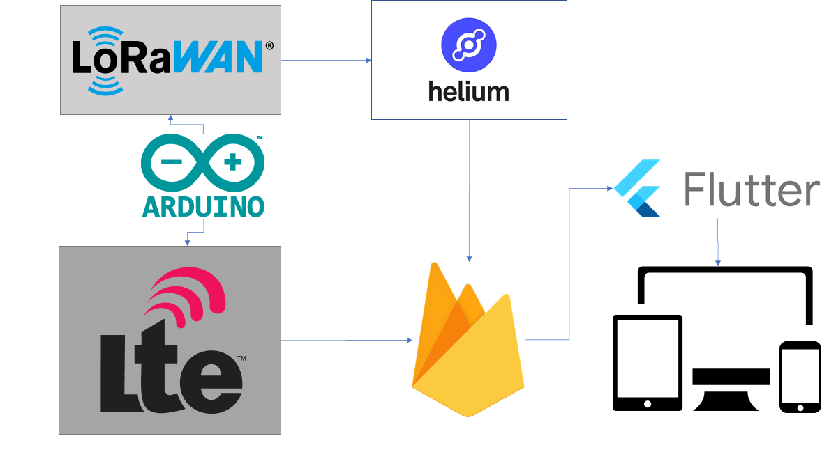

Figure 2.2 - Software Architecture Used in WRECKS

**2.2.1. Flutter**

Flutter is a software package developed by Google. It is an open source multi-platform framework used to develop applications from a single codebase [42]. Flutter uses the Dart programming language, which, “compiles to ARM or Intel machine code as well as JavaScript for fast performance on any device” [5]. In other words, code written in the Flutter framework can be deployed in mobile, web, desktop, or embedded devices. The design team utilizes the Flutter framework to design an application that can retrieve the data coming from Firebase in real time to initiate a communication process with the customer’s devices. This data can be sent in the form of text, email, or push notification.

**2.2.2. Google Firebase**

Firebase is Google’s mobile application development platform that provides a real-time database [43]. With the help of Google Firebase, tasks such as authentication, configuration, and push messaging can be utilized with minimal effort. It also helps to reduce the amount of backend coding required. Figure 2.3 sums up the traditional (without Firebase) versus modern (with Firebase) software development protocol.

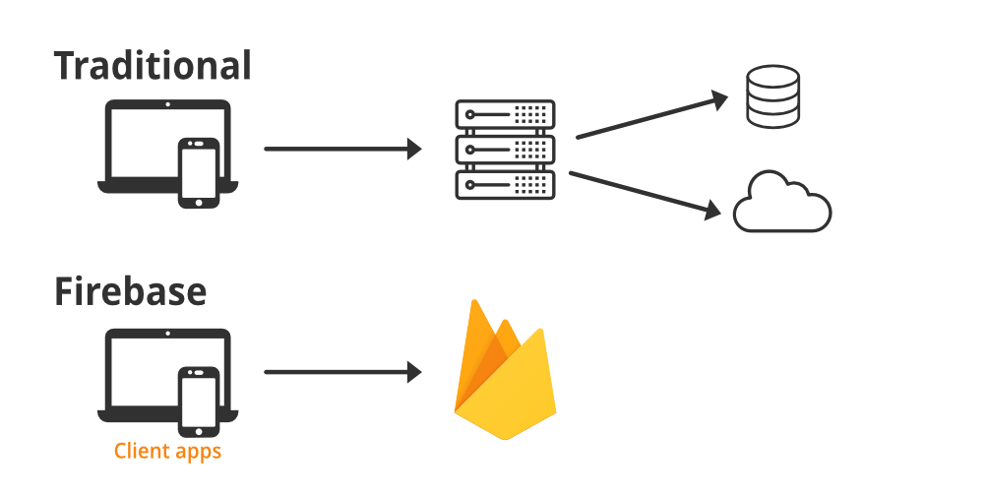

Figure 2.3 - Firebase Development [44]

As shown in Figure 2.3, WRECKS uses Google Firebase as the backend, which eliminates the requirement of having a separate server to forward the data coming from the sensors to the customers’ application.

**2.2.3. Hologram**

Hologram is an internet of things (IoT) management system and global cellular network that can be used to add cellular connectivity to a wide range of IoT devices [45]. WRECKS uses Hologram subscriber identification module (SIM) cards to provide a gateway for LTE networks.

**2.2.4. Helium**

Helium is a decentralized wireless network utilizing LoRaWAN to enable wireless connectivity to IoT devices over a wide area [46]. Helium also contains a powerful console to manage IoT deployments and can integrate with services such as Firebase for easy data management. WRECKS utilizes the Helium network via a LoRaWAN module and antenna to transmit crash data through the Helium console to Firebase.

**2.2.5. Arduino IDE**

The Arduino IDE is an open-source integrated development environment used to write, build, and upload software to Arduino-compatible microcontrollers [47]. This IDE comes with a host of libraries and example programs that make embedded software development in C straightforward. The Arduino software within WRECKS integrates every physical module together by taking data from the IMU and GPS, interpreting it, and sending it to the cellular and LoRaWAN modules.

**References**

[9] “RAK5005-O | WisBlock Base Board,” *RakWireless.com*, 2022. [Online]. Available:<https://store.rakwireless.com/products/rak5005-o-base-board> (Accessed Mar. 08, 2022).

[10] “RAK4631 | nRF52840 SX1262 | Module for LoRaWAN,” *RakWireless.com*, 2022. [Online]. Available:<https://store.rakwireless.com/products/rak4631-lpwan-node> (Accessed Mar. 08, 2022).

[11] “Nano RP2040 Connect | Arduino Documentation,” *Arduino.cc*, 2022. [Online]. Available:<https://docs.arduino.cc/hardware/nano-rp2040-connect> (Accessed Mar. 08, 2022).

[12] “Boron LTE CAT-M1 (NorAm),” *Particle.io*, 2022. [Online]. Available:<https://store.particle.io/products/boron-lte> (Accessed Mar. 08, 2022).

[13] “Buy a Raspberry Pi Zero,” *Raspberrypi.com*, 2022. [Online]. Available:<https://www.raspberrypi.com/products/raspberry-pi-zero/> (Accessed Mar. 08, 2022).

[14] “REYAX RYLR896 Lora Module SX1276 UART 868MHz 915MHz Antenna,” *Amazon.com,* 2022. [Online]. Available:  [https://www.amazon.com/RYLR896-Module-SX1276-Antenna-Command/dp/B07NB3BK5H](https://www.amazon.com/RYLR896-Module-SX1276-Antenna-Command/dp/B07NB3BK5H.) (Accessed Mar. 08, 2022).

[15] “Gowoops SX1276 LoRa Radio Wireless 915Mhz UART Serial Module LoRaWAN Transmitter Receiver,” *Amazon.com,* 2022. [Online]. Available: <https://www.amazon.com/Gowoops-Wireless-Transmitter-Compatible-Microcomputer/dp/B07G7RZLTW/ref=pd_sbs_5/141-3004043-4104327?pd_rd_w=Ol66E&pf_rd_p=dfec2022-428d-4b18-a6d4-8f791333a139&pf_rd_r=1SHQPNNKQK2XQV085V2D&pd_rd_r=30139669-015c-4587-bdaa-c8dd41c81e04&pd_rd_wg=ySFCY&pd_rd_i=B07G7RZLTW&psc=1> (Accessed Mar. 08, 2022).

[16] “Seeed Studio 102010128,” *Mouser.com*, 2022. [Online]. Available:<https://www.mouser.com/ProductDetail/Seeed-Studio/102010128?qs=WY0B%252Bpw29jMGjDlFmQEYGA%3D%3D> (Accessed Mar. 08, 2022).

[17] “HiLetgo Smallest SIM800L GPRS GSM Breakout Module,” *Amazon.com,* 2022. [Online]. Available: <https://www.amazon.com/HiLetgo-Smallest-Breakout-Quad-band-3-7-4-2V/dp/B01DLIJM2E/ref=pd_lpo_2?pd_rd_i=B01DLIJM2E&psc=1> (Accessed Mar. 08, 2022).

[18] “NB-IoT Cat-M (eMTC) GNSS HAT Based on SIM7080G with LTE,” *Amazon.com,* 2022. [Online]. Available: <https://www.amazon.com/Raspberry-SIM7080G-External-Interface-XYGStudy/dp/B08434FHLJ/ref=sr_1_7?crid=389MJCVFW41JF&keywords=nb-iot+LTE&qid=1646012159&s=electronics&sprefix=nb-iot+lte%2Celectronics%2C80&sr=1-7> (Accessed Mar. 08, 2022).

[19] “MIKROE-4472 MikroElektronika | Development Boards, Kits, Programmers,” *D*[*igikey.com*](http://www.digikey.com), 2022. [Online]. Available:<https://www.digikey.com/en/products/detail/mikroelektronika/MIKROE-4472/13958758> (Accessed Mar. 08, 2022).

[20] “RAK5860 | BG77 | NB-IoT Interface Module,” *RakWireless.com*, 2022. [Online]. Available:<https://store.rakwireless.com/products/rak5860-lte-nb-iot-extension-board> (Accessed Mar. 08, 2022).

[21] “W1096 PulseLarsen Antennas,” *Digikey.com*, 2022. [Online]. Available:<https://www.digikey.com/en/products/detail/pulselarsen-antennas/W1096/13244582> (Accessed Mar. 08, 2022).

[22] “W5150 PulseLarsen Antennas,” *Digikey.com*, 2022. [Online]. Available:<https://www.digikey.com/en/products/detail/pulselarsen-antennas/W5150/13244581> (Accessed Mar. 08, 2022).

[23] “W3907B0127 PulseLarsen Antennas,” *Digikey.com*, 2022. [Online]. Available:<https://www.digikey.com/en/products/detail/pulselarsen-antennas/W3907B0127/15287060> (Accessed Mar. 08, 2022).

[24] “Bingfu 4G LTE Antenna 9dBi SMA Male Cellular Antenna Compatible with 4G LTE Wireless CPE Router Hotspot,” *Amazon.com,* 2022. [Online]. Available: <https://www.amazon.com/Bingfu-Cellular-Wildlife-Security-Amplifier/dp/B08139ZVVF/ref=sr_1_8?crid=RW4KT6092DBO&keywords=4g%2Bantenna&qid=1646771762&sprefix=4g%2Bantenna%2Caps%2C135&sr=8-8&th=1> (Accessed Mar. 08, 2022).

[25] “TEL0137 DFRobot,” *Mouser.com*, 2022. [Online]. Available:<https://www.mouser.com/ProductDetail/DFRobot/TEL0137?qs=DRkmTr78QAQBGHkfGqmsFw%3D%3D> (Accessed Mar. 05, 2022).

[26] “XA1110_1103891 Sierra Wireless,” *Digikey.com*, 2022. [Online]. Available: <https://www.digikey.com/en/products/detail/sierra-wireless/XA1110-1103891/8572914> (Accessed Mar. 05, 2022).

[27] “MC60CA-04-STD Quectel,” *Digikey.com*, 2022. [Online]. Available:<https://www.digikey.com/en/products/detail/quectel/MC60CA-04-STD/13278076> (Accessed Mar. 05, 2022).

[28] “OpenIMU330BI ACENNAr,” *Mouser.com*, 2022. [Online]. Available:<https://www.mouser.com/ProductDetail/ACEINNA/OpenIMU330BI?qs=B6kkDfuK7%2FAO2lij2iCtwg%3D%3D> (Accessed Mar. 06, 2022).

[29] “MT-1-0I-TXsens,” *Mouser.com*, 2022. [Online]. Available:<https://www.mouser.com/ProductDetail/Xsens/MTi-1-0I-T?qs=pBJMDPsKWf3QijwWCJT1NA%3D%3D> (Accessed Mar. 06, 2022).

[30] “MPU-6881 TDK,” *Mouser.com*, 2022. [Online]. Available:<https://www.mouser.com/ProductDetail/TDK-InvenSense/MPU-6881?qs=u4fy%2FsgLU9MthFpyRcZ0%252Bg%3D%3D> (Accessed Mar. 06, 2022).

[31] “RAK1904 | LIS3DH | 3-axis acceleration sensor,” *RakWireless.com*, 2022. [Online]. Available:<https://store.rakwireless.com/products/rak1904-lis3dh-3-axis-acceleration-sensor> (Accessed Mar. 06, 2022).

[32] “SCC2230-E02-05 Murata Electronics,” *Mouser.com*, 2022. [Online]. Available:<https://www.mouser.com/ProductDetail/Murata-Electronics/SCC2230-E02-05?qs=u1o5GQxYRwpFEw2sn75Q8Q%3D%3D> (Accessed Mar. 06, 2022).

[33] “Liter 3.7V 3000mAh 406080 Lipo Battery Rechargeable,” *Amazon.com,* 2022. [Online]. Available:<https://www.amazon.com/3000mAh-Battery-Rechargeable-Lithium-Connector/dp/B09FPQ62FM/ref=sr_1_2?crid=2ZB1688QC1W4A&keywords=rechargeable+3.7+v+battery&qid=1646769236&refinements=p_n_feature_five_browse-bin%3A23559008011&rnid=23559001011&s=hpc&sprefix=rechargeable+3.7+v+battery%2Caps%2C92&sr=1-2> (Accessed Mar. 08, 2022).

[34] “3.7V 4400mAh-16.28wh Rechargeable Li-ion Battery - VIDAR Real Capacity Super Durability Lithium Batteries with JST 2.0/2P Plug,”*Amazon.com,* 2022. [Online]. Available:<https://www.amazon.com/3-7V-4400mAh-16-28wh-Rechargeable-Li-ion-Battery/dp/B08PNSRM3Y/ref=sr_1_1?crid=3G43YSCVFVJGH&keywords=3.7V+4400mAh-16.28wh+Rechargeable+Li-ion+Battery+-+VIDAR+Real&qid=1646784329&s=hpc&sprefix=3.7v+4400mah-16.28wh+rechargeable+li-ion+battery+-+vidar+real+%2Chpc%2C103&sr=1-1> (Accessed Mar. 08, 2022).

[35] “Liter 3.7V 2400mAh 104050 Lipo Battery Rechargeable,” *Amazon.com,* 2022. [Online]. Available:<https://www.amazon.com/2400mAh-Battery-Rechargeable-Lithium-Connector/dp/B09FK974GT/ref=sr_1_1?keywords=3.7+v+battery&qid=1646773270&refinements=p_n_feature_five_browse-bin%3A23559007011&rnid=23559001011&s=hpc&sr=1-1> (Accessed Mar. 08, 2022).

[36] “Liter 3.7V 2800mAh 123464 Lipo Battery Rechargeable,” *Amazon.com,* 2022. [Online]. Available: h[ttps://www.amazon.com/2800mAh-Battery-Rechargeable-Lithium-Connector/dp/B09FNYWP33/ref=sr_1_2?keywords=3.7+v+battery&qid=1646773312&refinements=p_n_feature_five_browse-bin%3A23559007011&rnid=23559001011&s=hpc&sr=1-2](https://www.amazon.com/2800mAh-Battery-Rechargeable-Lithium-Connector/dp/B09FNYWP33/ref=sr_1_2?keywords=3.7+v+battery&qid=1646773312&refinements=p_n_feature_five_browse-bin%3A23559007011&rnid=23559001011&s=hpc&sr=1-2) (Accessed Mar. 08, 2022).

[37] “Maxim Integrated MAX20474ATDA/V+,” *Mouser Electronics*, 2022. [Online]. Available: [https://www.mouser.com/ProductDetail/Maxim-Integrated/MAX20474ATDA-V%2b?qs=A6eO%252BMLsxmQpOzvW2yv6Iw%3D%3D](https://www.mouser.com/ProductDetail/Maxim-Integrated/MAX20474ATDA-V%2b?qs=A6eO%252BMLsxmQpOzvW2yv6Iw%3D%3D.) (Accessed Mar. 08, 2022).

[38] “XINGYHENG 5Pcs XL6009 DC-DC Buck Boost Voltage Converter Power Module 4A 400KHz Adjustable Switch Module 3.8-30V to 1.25-35V Power Supply Module for Solar Panel,” *Amazon.com,* 2022. [Online]. Available:<https://www.amazon.com/XINGYHENG-XL6009-DC-DC-Converter-Power-Adjustable-Step-down/dp/B08PP1N8G5/ref=sr_1_19?keywords=Boost+Converter&qid=1646113200&sr=8-19> (Accessed Mar. 08, 2022).

[39] “SUNYIMA 10Pcs 5V 60mA Epoxy Solar Panel Polycrystalline Solar Cells for Solar Battery Charger DIY Solar System Kits,” *Amazon.com,* 2022. [Online]. Available:<https://www.amazon.com/AOSHIKE-Polycrystalline-Battery-Charger-2-67x1-45inch/dp/B0736W4HK1/ref=sr_1_4?keywords=SUNYIMA+Solar+Panels&qid=1646772250&s=lawn-garden&sr=1-4> (Accessed Mar. 08, 2022).

[40] “AOSHIKE 10Pcs 5V 30mA Mini Solar Panels for Solar Power,” *Amazon.com,* 2022. [Online]. Available:<https://www.amazon.com/AOSHIKE-Electric-Materials-photovoltaic-53x30MM/dp/B07BMMHMSJ/ref=sr_1_3?crid=10Q05YPFYLIM&keywords=aoshike+10+pcs+5v+30ma+mini+solar+panels&qid=1646772815&sprefix=AOSHIKE%2Caps%2C149&sr=8-3> (Accessed Mar. 08, 2022).

[41] “AM-5907CAR-DGK-T Panasonic - BSG | Sensors, Transducers | DigiKey,” *Digikey.com*, 2022. [Online]. Available:<https://www.digikey.com/en/products/detail/panasonic-bsg/AM-5907CAR-DGK-T/2165198> (Accessed Mar. 08, 2022).

[42] “Flutter - Beautiful native apps in record time,” *Flutter.dev*, 2019. [Online] Available:<https://flutter.dev/> (Accessed Mar. 08, 2022).

[43] “Firebase,” *Firebase.com*, 2018. [Online]. Available:<https://firebase.google.com/> (Accessed Mar. 08, 2022).

[44] “Firebase - Introduction,” *GeeksforGeeks*, Nov. 27, 2020. [Online]. Available:<https://www.geeksforgeeks.org/firebase-introduction/> (Accessed Mar. 08, 2022).

[45] “Cellular Connectivity for the Internet of Things | Hologram,” *Hologram.io*, 2022. [Online]. Available:<https://www.hologram.io/> (Accessed Mar. 08, 2022).

[46] “Helium & LoRaWAN,” *Helium.com*, 2022. [Online]. Available:<https://www.helium.com/lorawan> (Accessed Mar. 08, 2022).

[47] “Arduino - Home,” *Arduino.cc*, 2018. [Online]. Available:<https://www.arduino.cc/> (Accessed Mar. 08, 2022).