**3. EVALUATION**

WRECKS is designed to allow customers to efficiently monitor guardrails by sending them a notification wherever one is hit. To accomplish this goal, WRECKS complies with the technical constraints described in Table 3.1 in order to ensure the device is reliable and affordable.

Table 3.1 - Technical Design Constraints

| **Name** | **Description** |
| --- | --- |
| Battery Life | The battery lasts two weeks without charging. |
| GPS Data | WRECKS uses a GPS that is accurate within 8 meters. |
| Sensor Data | The IMU sensor has a margin of error of 1%. |
| Sampling Rate | The device samples IMU data at 50 Hz. |
| Communication | The WRECKS system alerts customers to damaged safety assets via web and Android applications, as well as email and MMS messaging. |
| Latency | Notifications from WRECKS reach the customer no later than thirty seconds after a crash occurs. |

Each of the Technical Constraints listed above are tested in detail in the sections below.

**3.1. Test Certification - Power**

WRECKS uses a comprehensive power system consisting of a solar panel, a battery charging circuit, and a battery. The solar panel maintains the battery’s charge through a battery charging circuit to allow for constant power delivered to the device. WRECKS’ battery lasts for at least two weeks without charging from a solar supply. To verify WRECKS’ power functionality, tests were conducted on the amount of power generated by the solar panel, the current consumption of the device, and the battery’s charge over time.

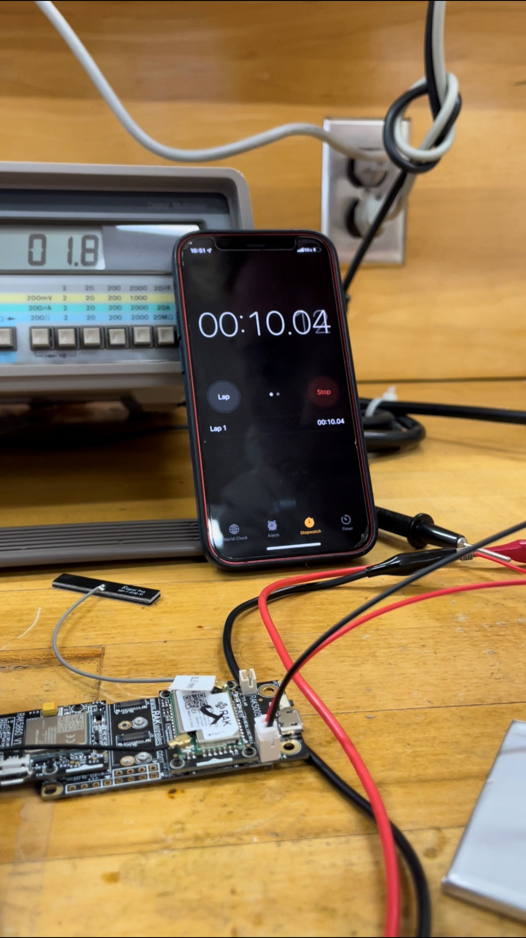

Figure 1: Experiment testbed for current consumption.

In order to ensure the solar panel as an adequate power source, the team conducted tests on the amount of current being drawn from the solar panel to the device’s battery charging circuit. This test is performed by inserting an ammeter in series with the solar panel source and the device’s solar input terminals. The team also measured the voltage of the solar panel by placing a voltmeter in parallel with the solar panel’s terminals. The data in Table 3.2 credits the solar panel to keep the battery charged.

Table 3.2 - Solar Power

| **Time of day** | **Voltage (V)** | **Current (mA)** |
| --- | --- | --- |
| Dawn |  |  |
| Mid-morning |  |  |
| High noon |  |  |
| Afternoon |  |  |
| Dusk |  |  |
| Midnight |  |  |

The table 3.2 shows the different power provided by the solar panel.

To view the amount of current the device will draw upon its different processes, the team performed tests to measure current consumption. To test current consumption, an ammeter is placed in series with the battery’s terminals and the board’s battery input terminals. The current consumption is listed in table 3.3.

Table 3.3 - Current Consumption

| **Process** | **Current (mA)** |
| --- | --- |
| Idle |  |
| Post-Collision |  |
| Nightly Update |  |

The table 3.3 shows the current consumption from the solar panel.

In order to understand the charging rate provided by the charging circuit with solar, an experiment testbed is set up to investigate and the result is presented in table 3.4.

Table 3.4 - Battery Charging Rate

| **Time of Day** | **Battery Voltage (V)** | **Battery Percentage (%)** |
| --- | --- | --- |
| Dawn |  |  |
| Mid-morning |  |  |
| High noon |  |  |
| Afternoon |  |  |
| Dusk |  |  |
| Midnight |  |  |

The table above shows battery voltage and battery percentage added to the battery in different times of day.

Table 3.5 - Battery Discharge Rate

| **Process** | **Battery Voltage (V)** | **Battery Percentage (%)** |
| --- | --- | --- |
| Idle |  |  |
| Post-Collision |  |  |
| Nightly Update |  |  |

At this rate, WRECKS’ battery is estimated to last ___.

**3.2. Test Certification - GPS Accuracy**

GPS accuracy is vital for this project, letting the customers know which specific asset is damaged based on its location. In order to test how accurate this is, the design team decided to compare the results of WRECKS’ GPS to the same location with a pin dropped on Google Maps.

**[Image placeholder]**

The results are compared in Table 3.x

Table 3.6 - GPS Accuracy

| Actual Coordinates | Measured Coordinates | % Error |
| --- | --- | --- |
|  |  |  |
|  |  |  |
|  |  |  |
|  |  |  |
|  |  |  |

The above table shows that the GPS module has an average error of – %.

**3.3 Test Certification - IMU Accuracy**

WRECKS uses an IMU to detect when the safety asset has been moved. The IMU can detect both the angle at which it is tilted as well as force exerted on it. If the guardrail is tilted, then that would reflect on the IMU as well as a certain amount of force. Both of these data points can be used to determine when the device has been crashed.

**[Image placeholder]**

Sections 3.3.1 and 3.3.2 describe the tests for each of these two data points.

**3.3.1 IMU Threshold**

The first step to test WRECKS’ IMU is to determine how much force needs to be detected in order for the device to alert customers of a crash. If that value is too low, then there would be false alerts in events such as high wind. To get an idea of what kind of force vehicles exert, the design team sent a driver to rapidly accelerate his vehicles with another member in the passenger seat reading IMU values from a laptop. Unfortunately, this did not work as the force of the vehicle’s maximum acceleration was not enough to make the value change in any significant way.

Upon further evaluation, the design team decided to apply various different forces to the device and measure their values. This gives the team an idea of how much force is exerted in those situations and allows for an estimate of what force may be in a vehicular collision. The results from these tests are described in Table 3.7.

Table 3.7 - IMU Threshold Tests

| Force Description | Force Measured (g) |
| --- | --- |
| Shake |  |
| Drop |  |
| Kick |  |
| Throw |  |
|  |  |

From this, the design team was able to estimate the threshold for a crash to be ___.

**3.3.2 IMU Tilt Accuracy**

The tilt on the IMU can detect when a highway safety asset is damaged by sensing when it is not in its intended position. To test the accuracy of the tilt, the design team tilted the IMU at various angles measured with a protractor and compared with the sensor's reading. The results are described in Table 3.8.

Table 3.8 - IMU Tilt Accuracy

| **Measured Angle (Degrees)** | **IMU Reading Angle (Degrees)** | **Error (%)** |
| --- | --- | --- |
| 15 |  |  |
|  |  |
|  |  |
| 30 |  |  |
|  |  |
|  |  |
| 45 |  |  |
|  |  |
|  |  |
| 90 |  |  |
|  |  |
|  |  |

Table 3.8 shows the tilt accuracy and percentage of error from the IMU sensor.

**3.4. Test Certification - Microcontroller**

WRECKS’ microcontroller is used to combine all data together and send the signal to customers. The design team’s constraint is that this information should update at a frequency of 50 Hz. To test that WRECKS meets this constraint, the design team decided to send a data request from the microcontroller to the IMU, recording the exact time of the request. Once the data is received, the time is again recorded, and the sampling rate latency is calculated.

**[Image placeholder]**

Table 3.9 shows the results of this test, done 3 times to ensure redundancy.

Table 3.9 - Microcontroller Update Rate

|  | **Time of Request** | **Time of Receival** | **Update Rate** |
| --- | --- | --- | --- |
| Test 1 |  |  |  |
| Test 2 |  |  |  |
| Test 3 |  |  |  |

As shown above, the

**3.5. Test Certification - Communication**

WRECKS utilizes both LoRaWAN and 4G/LTE communication to transmit data. To ensure a sufficient connection could be made at all times, the design team tested both types of communication in multiple locations with two different antennas.

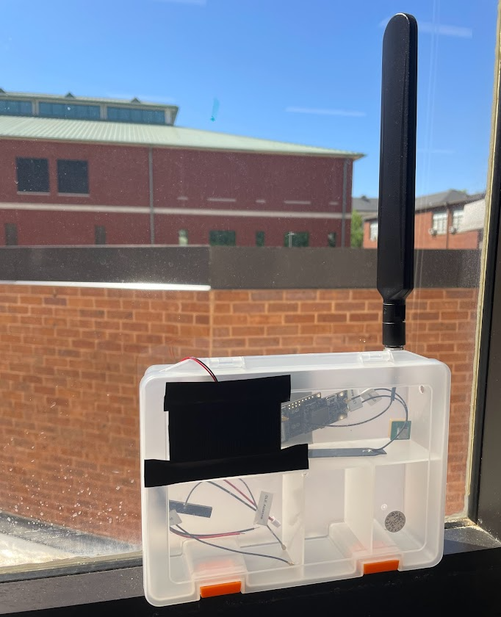

**Figure 3.x**

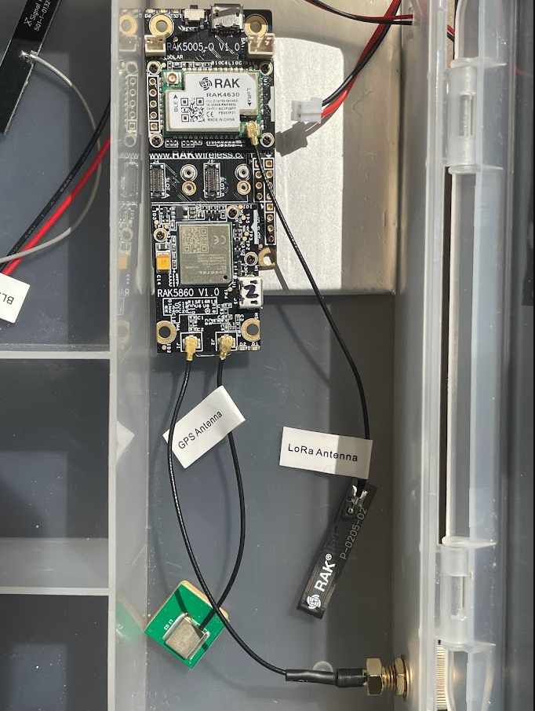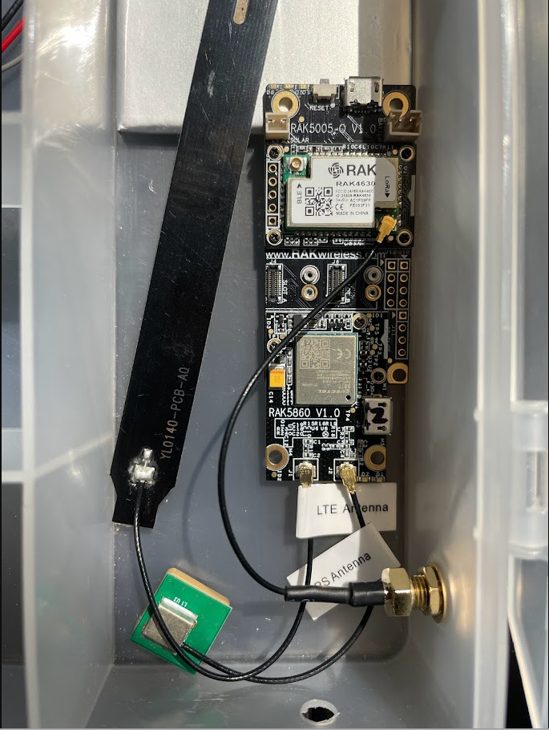

**Figure 3.x**

The test results can be found in Tables 3.10 through 3.13

Table 3.10 - Test Certification for LoRaWAN with RakWireless antenna

| **RakWireless included LoRaWAN antenna** | | | |
| --- | --- | --- | --- |
| **Location** | Senior design lounge | Downtown Starkville | Rural |
| **Channel ID** |  |  |  |
| **RSSI** |  |  |  |
| **SINR** |  |  |  |
| **RSSI (dBm)** |  |  |  |

The table shown above shows signal strength in different regions.

Table 3.10 repeats this experiment using the PulseLarson antenna instead of the

Table 3.11 - Test Certification for LoRaWAN with PulseLarson antenna

| **PulseLarson 5150 (LoRAWAN)** | | | |
| --- | --- | --- | --- |
| **Location** | Senior design lounge | Downtown Starkville | Rural |
| **Channel ID** |  |  |  |
| **RSSI** |  |  |  |
| **SINR** |  |  |  |
| **RSSI (dBm)** |  |  |  |

Table 3.11 shows the results of this experiment using LTE instead of LoRa.

Table 3.12 - Test Certification for LTE with RakWireless antenna

| **RakWireless included LTE antenna** | | | |
| --- | --- | --- | --- |
| **Location** | Senior design lounge | Downtown Starkville | Rural |
| **Technology used** | eMTC |  |  |
| **LTE Band** | LTE BAND 12 |  |  |
| **Channel ID** | 5110 |  |  |
| **LTE RSSI** | -68 |  |  |
| **LTE RSRP** | -97 |  |  |
| **LTE SINR** | 93 |  |  |
| **LTE RSRQ** | -16 |  |  |
| **RSSI (dBm)** | 23 |  |  |

Table 3.12 shows the experiment repeated with the PulseLarson antenna instead of the RAK.

Table 3.13 - Test Certification for LoRaWAN with PulseLarson antenna

| **PulseLarson 5150 (LTE)** | | | |
| --- | --- | --- | --- |
| **Location** | Senior design lounge | Downtown Starkville | Rural |
| **Technology used** | eMTC |  |  |
| **LTE Band** | LTE BAND 12 |  |  |
| **Channel ID** | 5110 |  |  |
| **LTE RSSI** | -67 |  |  |
| **LTE RSRP** | -98 |  |  |
| **LTE SINR** | 105 |  |  |
| **LTE RSRQ** | -18 |  |  |
| **RSSI (dBm)** | 21 |  |  |

Based on these experiments, the design team conclused that WRECKS on average can send the notification in ___.

**3.6. Test Certification - Latency**

**[Image placeholder]**

Figure: Android app

Table 3.13 shows the latency for different technologies for Android applications.

Table 3.14: Latency for different technologies for mobile app

| **Protocol** | **Time to receive the notification** |
| --- | --- |
| LTE |  |
| LoRa |  |

From the above table it shows that the customer can receive the notification in —s with LTE whereas with LoRa it took – s.

**[Image placeholder]**

Figure: Web app

The table below shows the latency for different technologies for web application.

Table 3.15: Latency for different technologies for web app

| **Protocol** | **Time to receive the notification** |
| --- | --- |
| LTE |  |
| LoRa |  |

From the above table it shows that the customer can receive the notification in —s with LTE whereas with LoRa it took – s.

**3.7. Test Certification - Enclosure**

As specified in the practical constraints, the device must be IP-67 certified, meaning it is completely impervious to dust, and can survive submersion up to 1 meter. The design team chose to 3D print an enclosure to allow for easy manufacturability. The 3D model of the enclosure, modeled in AutoDesk Fusion 360, is shown here.

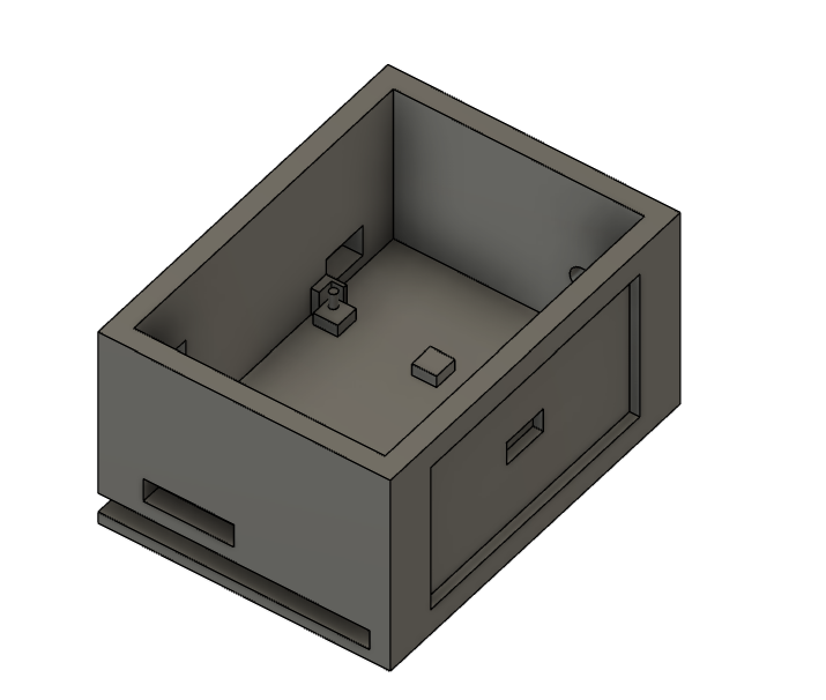

Image 3.X

The enclosure includes an exterior spot for the solar panel and antenna on the, and convenient space on the interior to mount the board, small antennas, and batteries. The following image shows the enclosure and device being exposed to water and dust.

**[Image placeholder]**

This image shows the condition of the enclosure’s interior after exposure to the elements.

**[Image placeholder]**

As shown by the previous images, the 3D printed enclosure keeps the internal of the WRECKS’ dry and functioning.