**EXECUTIVE SUMMARY**

Guardrails are a critical part of roadside infrastructure and keeping drivers safe. Terminal end sections (TES) of guardrail act as a crumple zone for cars to crash into, providing a cushion. The design team’s customer, Atwood Fence Company, is in the business of distributing and installing guardrails and terminal end sections. As these guardrails are found all over the country with terminal end sections on the ends, upkeep and maintenance of these assets becomes troublesome. Having to send employees up and down road systems to check the status of the guardrails costs companies like Atwood lots of time and money. Thus, these companies need a way to effectively monitor their products. The solution to this problem is WRECKS, which stands for the Wireless Roadside Emergency Collision Kinetic Sensor. WRECKS is mounted on a terminal end section of guardrail, and notifies the customer when their asset, such as a terminal end section, is crashed into.

WRECKS’ constraints were selected to make the device durable, compact, inexpensive, and accurate. It can last throughout the 5-year lifespan of a guardrail, and is IP-67 rated to survive any type of weather. Discreetly mounted on the guardrail via an adhesive pad, WRECKS sits at just under 100 x 100 x 50 mm. The total cost of the device is under $100, allowing the device to be affordable to customers. Since the primary purpose of WRECKS is to communicate when crashes occur, the device pinpoints the exact location of the crash within 8 meters, and sends a notification to the customer in under 30 seconds. These constraints mean that WRECKS is a product that customers can trust to notify them no matter the circumstances.

As shown in Figure 1, WRECKS’ approach to the problem is divided into 5 main subsystems. The sensor subsystem uses a GPS and an inertial measurement unit (IMU) to tell the microcontroller when and where a crash has occurred. This sensor data is processed and communicated via either a LoRAWAN module or an LTE module to ensure connection in any location; this process is done in the hardware communication subsystem. In the software communication subsystem, the data is received by a server, and then displayed in a user-friendly and intuitive manner in the software functionality subsystem. Lastly, WRECKS would not function without power, so the power subsystem uses a battery and solar panel to ensure that the device is always active.

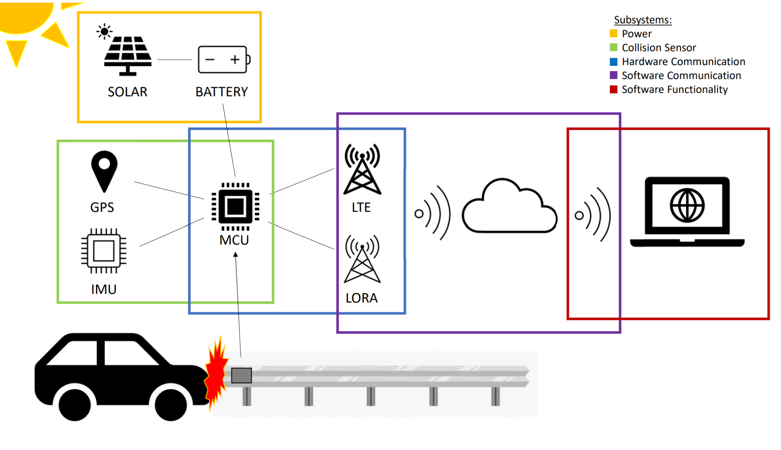

Figure 1 - WRECKS System Diagram

The goal of WRECKS is to provide a simple and efficient way for customers to monitor their roadside safety assets. Moving forward, WRECKS can be made smaller and more cost effective, while being marketed toward even more industry segments. One day, WRECKS could be on every sign, guardrail, and lightpost in the country.