Agent 1: Intelligent Automated Web Scraper & Data Extractor
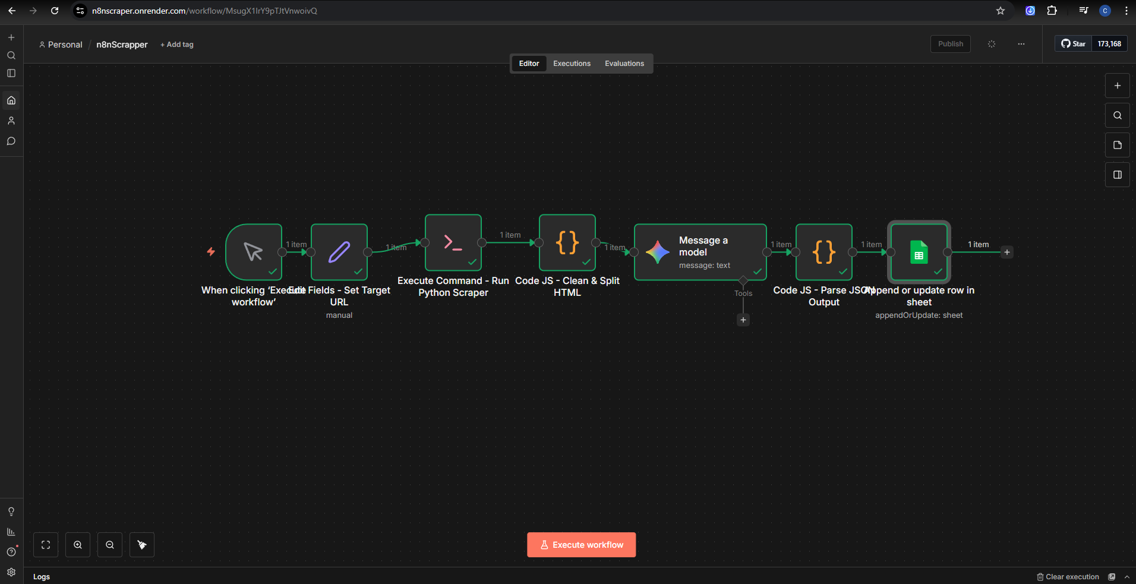
Overview: An end-to-end operational automation designed to bypass anti-bot protections, scrape dynamic multi-page e-commerce product data, and use an LLM to structure raw HTML into a clean, actionable product catalog stored in a spreadsheet.
Logic Map:
- Manual Trigger & Configuration: The workflow is initiated manually, passing target parameters to an "Edit Fields" node which dynamically sets the Target URL for the current run.
- Python Script Execution: An Execute Command node triggers a custom-built Python CLI utility. This script utilizes Playwright and Chromium to handle dynamic rendering, pagination, and manual anti-bot evasion.
- Data Pre-processing (Low-Code Expression): A Code JS node executes custom JavaScript to clean, sanitize, and split the raw HTML output, ensuring it fits within the context window limits of the downstream LLM.
- AI Structuring (Prompt Pattern Application): The cleaned HTML is passed to a "Message a model" node. Using strict constraint-based prompt patterns, the LLM extracts the relevant information and formats it into a standardized JSON schema.
- JSON Parsing: A second Code JS node validates and parses the AI-generated JSON output to ensure data integrity.
- Data Storage: The finalized data payload is automatically routed to a Google Sheets node to append or update a row, completing the data pipeline.
Outcomes & Job Alignment:
- Operational Efficiency: Replaces hours of manual data entry with a scalable, automated pipeline, demonstrating strong ops automation capabilities.
- Cross-Environment Scripting: Highlights proficiency in bridging traditional coding with low-code environments by successfully triggering and handling outputs from Python scripts via CLI within n8n, as well as utilizing inline JS expressions for data manipulation.
- AI Grounding & Constraints: Proves the ability to use LLMs programmatically by applying strict prompt constraints to force accurate JSON outputs from messy, unstructured HTML data.
- Commercial Application: Demonstrates the ability to build automated market research and data pipeline tools, transforming unstructured web pages into structured datasets for pricing analysis or inventory monitoring.

Agent 2: Multi-Tool Supervisor AI Assistant (with RAG)
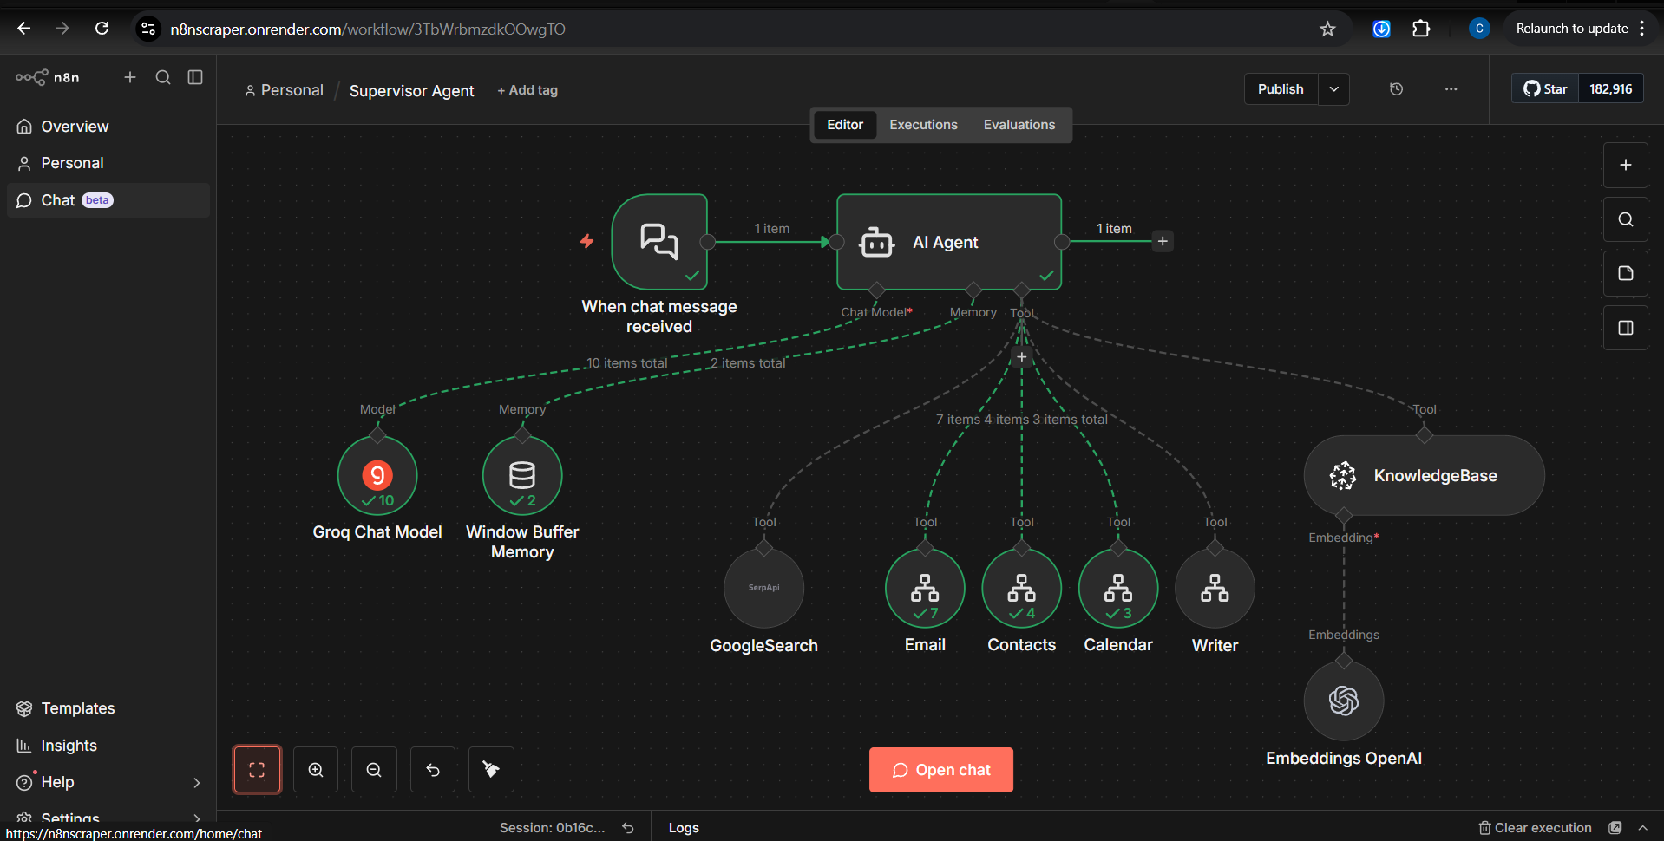
Overview: A centralized, chat-driven AI agent capable of autonomous reasoning and tool use. It handles real-time user requests by dynamically deciding whether to search the web, query internal RAG knowledge bases, or execute administrative tasks via API integrations.
Logic Map:
- Event Trigger: A chat interface node listens for incoming natural language requests from the user.
- Supervisor Orchestration: The core "AI Agent" node receives the prompt. It evaluates the user's intent and delegates tasks based on its available toolset.
- Cognitive Engine & Memory: The agent is powered by a high-speed Groq Chat Model for rapid reasoning, coupled with a Window Buffer Memory node to maintain conversational context across multiple turns.
- Dynamic Tool Execution: Depending on the prompt, the agent routes the task to one (or several) of its integrated tools:
  - Internal Knowledge (RAG): Accesses a KnowledgeBase tool powered by OpenAI Embeddings to retrieve grounded, company-specific or technical documentation.
  - External Knowledge: Utilizes a GoogleSearch (SerpAPI) tool to fetch real-time, live web data.
  - Ops Automation: Triggers API-driven tools to interact with Email, Contacts, Calendar, and a content Writer, allowing the agent to draft messages or schedule meetings autonomously.
Outcomes & Job Alignment:
- Advanced RAG Implementation: Demonstrates a clear understanding of RAG (Retrieval-Augmented Generation) by integrating OpenAI vector embeddings into a Knowledge Base tool, ensuring the agent's answers are grounded in internal data rather than just baseline training data.
- Complex Prompt Patterns & Agentic Workflows: Showcases the use of "ReAct" (Reasoning and Acting) prompt patterns, allowing the agent to intelligently select which API tools to use based on user context.
- API & Ops Automation: Highlights the ability to connect and validate multiple external APIs (Search, Email, Calendar, OpenAI, Groq) within a single unified low-code architecture to solve complex operational bottlenecks.

