MATH 4773 Laboratory 5: Multiple Regression part 3

In this laboratory you will extend the MLR of parts 1,2 to include interval parameter estimates and point estimates for mean values of y and new y values.

# Objectives

In this lab you will learn how to make functions that create:

1. Confidence intervals
2. Point estimates
3. Plots (using ggplot and pairs)

### Tasks

Please complete this Lab using RMD. Make sure you use a table of contents that floats. Each task should have a separate heading.

* Task 1
  + Download from CANVAS the zipped data files, “Dataxls”
  + Unzip the contents into a directory on your desktop (call it LAB)
  + Download the file “lab5.r”
  + Place this file with the others in LAB5.
  + Start Rstudio
  + Open “lab5.r” from within Rstudio (this is an exemplar file).
  + Using hash commenting and at the top of Lab 5 place the task number eg #Task 1
  + Go to the “session” menu within Rstudio and “set working directory” to where the source files are located.
  + Copy and paste the working directory by issuing the command getwd(): under #Task 1
* Task 2
  + Make sure you install the readxl package if you haven’t already.
  + On page 583 the text MS has an example worked in SAS and minitab using the data set CLERICAL.xls
  + Read the data into R and replace the first 4 entries in the column “X5-Checks” with c(600,500,1000,900).
  + Do the same analysis in R using the modified data with lm() and other functions and answer the questions giving all relevant output – put answers after each part as below:
    - A)
    - B)
    - C)
    - D)
    - E)
    - F)
    - G)
* Task 3
  + In this task you will use Theorem 11.3 page 574 to make a function – myl()
    - that produces $\left(1-α\right)100\%$ confidence intervals for $E(l)$ given $Y,X, α, a,l$
    - a plot using pairs() to show all pairwise plots of the data used in the analysis
  + Using the modified CLERICAL data with alpha = 0.05 and $a$ such that $E\left(l\right)=β_{1}-β_{2}$ call your function and place all output here:
  + Interpret the confidence interval that your function produces.
* Task 4
  + Do the same with $α=0.10$ and $a$ such that $E\left(l\right)=2β_{1}-4β_{3}-3β_{0}$
  + Place output here after calling your function:
  + Interpret the confidence produced.
* Task 5
  + Find a 95% ci for $E(Y)$ when the x variables take the second row of the design matrix.
  + What is the exact expression for $a$? Place here:
  + Use your function and page 575 place output here:
  + Interpret the confidence interval – be careful!
* Task 6
  + Make a new function called myy()
  + Use the theory on page 577 to make your function produce a confidence interval for a new y value – what inputs will your function take? Place here:
  + Use the second row of the design matrix to predict a new y value – this will be $\hat{y}$ and a confidence interval for the new y value.
  + Alter the function myy() so that it produces:
    - A pairs plot of the data
    - ggplot of the $Y vs x_{i}$ for each i
    - A plot of the cis and point estimates (x=1:n) (see if you can improve on this) I used matplot() and segments()

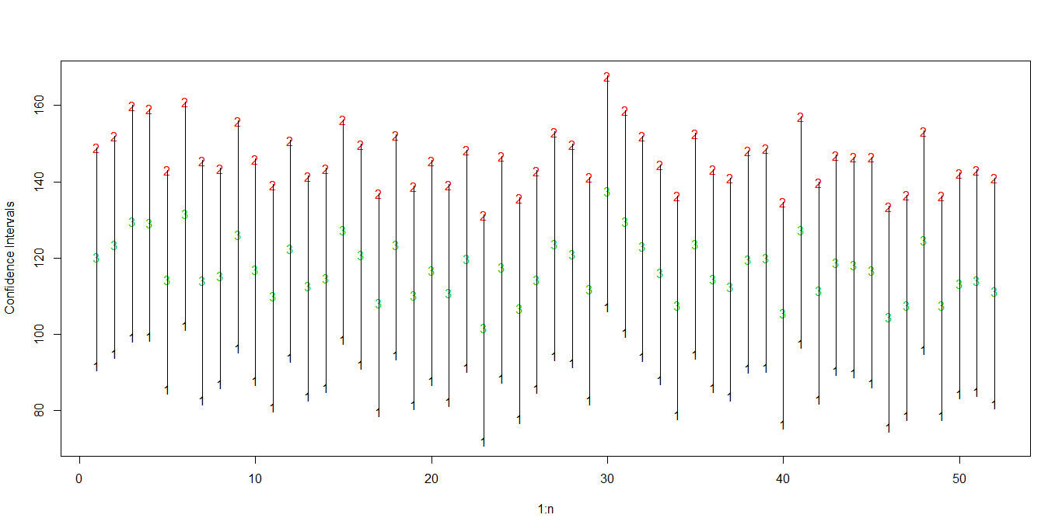

* + - A list containing the confidence interval and point estimate for a new y value for each row of the design matrix.
  + Run your function on the adjusted CLERICAL data set and make sure it all knits!
* Task 7
  + Add and document myl() and myy() to your ILAS2019 package
  + For task 7 run both functions in your lab5.rmd document using the following invocations

ILAS2019::myl()

ILAS2019::myy()

Use data of your choice.