Software System Test Plan

Messenger
Client – Server Application
Simple Message Protocol (SMP)

Version 1

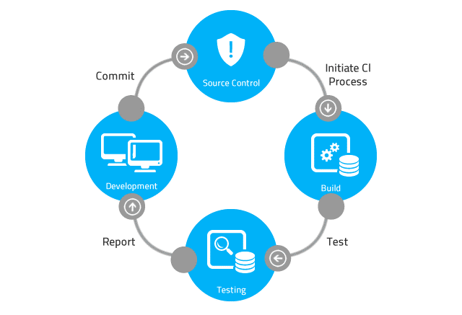

Table of Contents

Table of Contents 2
Revision History 4
1 Introduction 5
2 Documentation 5
3 References 5
3.1 Reference 1: SMP_Software_Project_Information_File.docx 5
3.1.1 Description 5
3.2 Reference 2: SMP_Software_Project_Plan.docx 5
3.2.1 Description 5
3.3 Reference 3: SMP_Software_Design_Specification.docx 5
3.3.1 Description 5
3.4 Reference 4: SMP_Software_Requirements.docx 5
3.4.1 Description 5
3.5 Reference 5: SMP_Software_Technical_Specification.docx 6
3.5.1 Description 6
4 Test System Configurations 6
4.1 Configuration 1: One Local Area Network (LAN) 6
4.1.1 Description 6
4.1.2 Diagram -- SMP Client Producer Sends SMP PUT Request 6
4.1.3 Diagram -- SMP Client Consumer Sends SMP GET Request 7
4.2 Configuration 2: Two Local Area Networks 7
4.2.1 Description 7
4.2.2 Diagram -- SMP Client Producer Sends SMP PUT Request 7
4.2.3 Diagram -- SMP Client Consumer Sends SMP GET Request 8
5 Configuration Files 9
5.1 Configuration File 1 Name 9
5.1.1 Description 9
5.2 Configuration File 2 Name 9
5.2.1 Description 9
6 Test Automation Suite 9
7 Test Cases – SMP Server Requirements 9
7.1 Test Case – Application Start Feature (Not Automated) 9
7.1.1 Target Requirement: Requirement 1: Application Start Feature 9
7.1.2 Test Case Description 9
7.1.3 Test Case Steps 9
7.2 Test Case – Show Messages Feature (Not Automated) 10
7.2.1 Target Requirement: Requirement 2: Show Messages Feature 10
7.2.2 Test Case Description 10
7.2.3 Test Case Steps 10
8 Test Cases – SMP Client Producer Requirements 10
8.1 Test Case – Send Message Feature (Not Automated) 10
8.1.1 Target Requirement: Requirement 1: Send Message Feature 10
8.1.2 Test Case Description 10
8.1.3 Test Case Steps 10
8.2 Test Case – SMP Server Offline (Not Automated) 11
8.2.1 Target Requirement: TBD 11
8.2.2 Test Case Description 11
8.2.3 Test Case Steps 11
9 Test Cases – SMP Client Consumer Requirements 11
9.1 Test Case – Get Message Feature (Not Automated) 11
9.1.1 Target Requirement: Requirement 1: Get Message Feature 11
9.1.2 Test Case Description 11
9.1.3 Test Case Steps 12
9.2 Test Case – No Priority One Messages (Not Automated) 12
9.2.1 Target Requirement: Requirement 1: Get Message Feature 12
9.2.2 Test Case Description 12
9.2.3 Test Case Steps 12
9.3 Test Case – SMP Server Offline (Not Automated) 13
9.3.1 Target Requirement: TBD 13
9.3.2 Test Case Description 13
9.3.3 Test Case Steps 13
10 Appendix 13
10.1 Acronyms 13
10.2 Engineering Terms 13
10.2.1 Software Development 13
11 Notes 13
12 System Test Schedule 14

Revision History

Rev. | Date | Authors | Comments
1 |  |  | 1. Initial release.
2 | 11/26/25 | Jeffrey Guo | - Testing version 1.0
3 | 11/27/25 | Jeffrey Guo | - Continued testing version 1.0

Introduction

This document is intended to be used for verifying the Messenger Simple Message Protocol (SMP) Client – Server software application prior to release. The primary goal is to verify that all expected software application features have been implemented.

Documentation

For each version of released code, this document is to be saved in a location specified in the Software Project Information File (SPIF) with the following information:

Software Application Name: Messenger Client – Server Application
Software Application Version: Version 1
Software Application Repository: GitHub: https://github.com/NCSS/Messenger
Name of tester:
System Test Date:

References

Reference 1: SMP_Software_Project_Information_File.docx

Description
The software project information file.

Reference 2: SMP_Software_Project_Plan.docx

Description
The software project plan.

Reference 4: SMP_Software_Project_Interface_Prototype.docx

Description
The prototype of the UI.

Reference 4: SMP_Software_Requirements.docx

Description
The software requirement document.

Reference 5: SMP_Software_Technical_Specification.docx

Description
The software technical specification.

Reference 3: SMP_Software_Design_Specification.docx

Description
The software design specification.

Test System Configurations

Configuration 1: One Local Area Network (LAN)

Description
This configuration requires that the SMP Server, SMP Client Producer, and the SMP Client Consumer are all connected to the same LAN.

Diagram -- SMP Client Producer Sends SMP PUT Request
SMP Client Producer sends an SMP PUT Request packet to the SMP Server

SMP Server sends back an SMP PUT Response Packet

Diagram -- SMP Client Consumer Sends SMP GET Request
SMP Client Consumer sends an SMP GET Request packet to the SMP Server

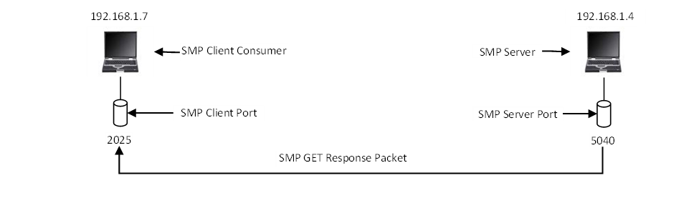
SMP Server sends back an SMP GET Response Packet

Figure 1: LAN System Test Configuration

Configuration 2: Two Local Area Networks

Description
This configuration requires that the SMP Server is connected to a separate LAN, and the SMP Client Producer, and the SMP Client Consumer are connected to a different LAN.

Diagram -- SMP Client Producer Sends SMP PUT Request
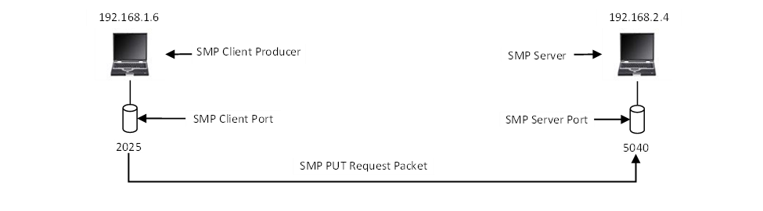
SMP Client Producer sends an SMP PUT Request packet to the SMP Server
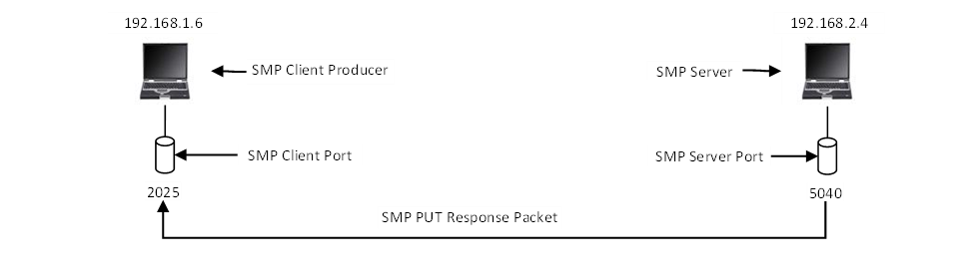
SMP Server sends back an SMP PUT Response Packet

Diagram -- SMP Client Consumer Sends SMP GET Request

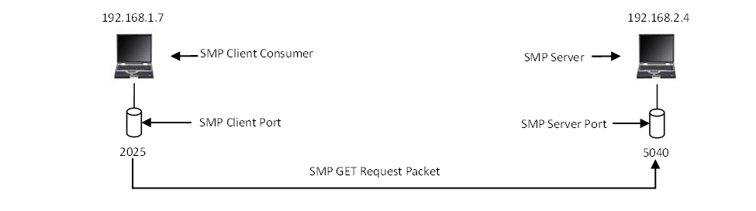
SMP Client Consumer sends an SMP GET Request packet to the SMP Server

SMP Server sends back an SMP GET Response Packet

Figure 2: Two Separate LANs System Test Configuration

Configuration Files

A test case may require a particular software system configuration file. The required configuration files are listed here.

Configuration File 1 Name

Description
TBD

Configuration File 2 Name

Description
TBD

Test Automation Suite

Test cases that have been automated are marked as Automated. The test automation suite must run the automated test cases before each software application version release. The test automation suite and test case source code are saved in a location specified in the Software Project Information File (SPIF).

Test Cases – SMP Server Requirements

Test Case – Application Start Feature (Not Automated)

Target Requirement: Requirement 1: Application Start Feature
Notes:

Test Case Description
Description: This feature allows the SMP server to start processing SMP client requests. The UI for this feature can be a command-line option in the case of a command-line UI (CLUI), or a clickable button, in the case of a graphical user interface (GUI).

Test Case Steps
- Start the SMP Server application.
- Click the Start button.
- Verify the server is listening to client requests on port 50400.
  - netstat -na | find 50400

Test Case – Show Messages Feature (Not Automated)

Target Requirement: Requirement 2: Show Messages Feature
Notes:

Test Case Description
Description: Reads SMP message records from the SMP message file and displays the message date, message priority, and message content for each of the messages in the file and outputs the messages. The UI for this feature can be a command-line option in the case of a command-line UI (CLUI), or a clickable button in the case of a graphical user interface (GUI).

Test Case Steps
- Start the SMP Server application.
- Click the Show Message button.
- Verify the client messages are displayed in the Messages window.

Test Cases – SMP Client Producer Requirements

Test Case – Send Message Feature (Not Automated)

Target Requirement: Requirement 1: Send Message Feature
Notes:

Test Case Description
Description: The SMP Message Producer client program is designed to send an SMP PUT request to the server. This feature allows a user to send an SMP message to the server. The message sent to the server consists of the message date, message priority and the message content. The server adds the record to a file associated with the message priority. The UI for this feature can be a command-line option in the case of a command-line UI (CLUI), or a clickable button in the case of a graphical user interface (GUI).

Test Case Steps
- Start the SMP Server application.
- Start the SMP Client Producer application.
- Enter the IP address of the SMP Server application.
- Enter the port number of the SMP Server application.
- From the Message Priority options, select Low.
- Enter Test Message Low in the Message Content text entry box.
- Click the Send Message button.
- Verify the SMP Server sent back a response.
  - Note the SMP Server response in the Server Response text box.
- Verify the SMP Server received the message.
  - Verify the Message Type text box displays PutMessage.
  - Verify the Message Priority text box displays Low.

Test Case – SMP Server Offline (Not Automated)

Target Requirement: TBD
Notes:

Test Case Description
Description: The SMP Message Producer client program is designed to send an SMP PUT request to the server. If the SMP Server is offline, when a SMP PUT request is sent to the server, the SMP Message Producer should display a Message Box notifying the user.

Test Case Steps
- Verify the SMP Server is OFFLINE.
- Start the SMP Client Producer application.
- Enter the IP address of the SMP Server application.
- Enter the port number of the SMP Server application.
- From the Message Priority options, select Low.
- Enter Test Message Low in the Message Content text entry box.
- Click the Send Message button.
- Verify the SMP Client Producer displays a Message Box notifying the user that the SMP PUT request failed.

Test Cases – SMP Client Consumer Requirements

Test Case – Get Message Feature (Not Automated)

Target Requirement: Requirement 1: Get Message Feature
Notes:

Test Case Description
Description: The SMP Message Consumer client program is designed to send an SMP GET request to the server to retrieve the next message. This feature allows a user to retrieve an SMP message from the server. Which message is sent back from the server depends on the priority selected. The message sent back to the client consists of the message date, message priority and the message content. The server deletes the record from the file after the client acknowledges that it has received the message. The UI for this feature can be a command-line option in the case of a command-line UI (CLUI), or a clickable button in the case of a graphical user interface (GUI).

Test Case Steps
- Start the SMP Server application.
- Start the SMP Client Consumer application.
- Enter the IP address of the SMP Server application.
- Enter the port number of the SMP Server application.
- From the Message Priority options, select Low.
- Click the Get Message button.
- Verify the SMP Server sent back a response.
  - The message content should be displayed in the Message Content text box.
- Verify the SMP Server
  - Received the acknowledgement message from the SMP Client Consumer.
  - Verify the Message Type text box displays GetMessage.
  - Verify the Message Priority text box displays Low.
  - Verify the message is deleted from the Low Priority Messages file.

Test Case – No Priority One Messages (Not Automated)

Target Requirement: Requirement 1: Get Message Feature
Notes:

Test Case Description
Description: The SMP Message Consumer client program is designed to send an SMP GET request to the server to retrieve the next message.

This feature allows a user to retrieve an SMP message from the server. Which message is sent back from the server depends on the priority selected. The message sent back to the client consists of the message date, message priority and the message content. The server deletes the record from the file after the client acknowledges that it has received the message. The UI for this feature can be a command-line option in the case of a command-line UI (CLUI), or a clickable button in the case of a graphical user interface (GUI).

Test Case Steps
- Start the SMP Server application.
- Start the SMP Client Consumer application.
- Enter the IP address of the SMP Server application.
- Enter the port number of the SMP Server application.
- From the Message Priority options, select Low.
- Click the Get Message button.
- Verify the SMP Server sends back the following response: No Priority Low Messages Available
- Verify the SMP Client Consumer displays a Message Box notifying the user that No Priority Low Messages Available.

Test Case – SMP Server Offline (Not Automated)

Target Requirement: TBD
Notes:

Test Case Description
Description: The SMP Message Consumer client program is designed to send an SMP GET request to the server to retrieve the next message. If the SMP Server is offline, when a SMP GET request is sent to the server, the SMP Message Consumer should display a Message Box notifying the user.

Test Case Steps
- Verify the SMP Server is OFFLINE.
- Start the SMP Client Consumer application.
- Enter the IP address of the SMP Server application.
- Enter the port number of the SMP Server application.
- From the Message Priority options, select Low.
- Click the Get Message button.
- Verify the SMP Client Consumer displays a Message Box notifying the user that the SMP GET request failed.

Appendix

Acronyms
SMP – Simple Message Protocol

Engineering Terms

Software Development
Client – A software application that sends and receives messages to and from a server application.
Server – A software application that processes messages from client applications.
Producer – A software application that produces messages.
Consumer – A software application that consumes messages.

Notes

System Test Schedule

System Test Date | Hours | Team Member | Comments
11/26/25 | 3 | Jeffrey Guo | Testing for bugs in version 1.0. Discovered unintended crashes when the server is offline, and when messages that don’t exist are requested
11/27/25 | 2 | Jeffrey Guo | Discovered bug where server crashes if the target file to write to doesn’t exist.

