Software Project Information File

Messenger
Client – Server Application
Simple Message Protocol (SMP)

Version 1

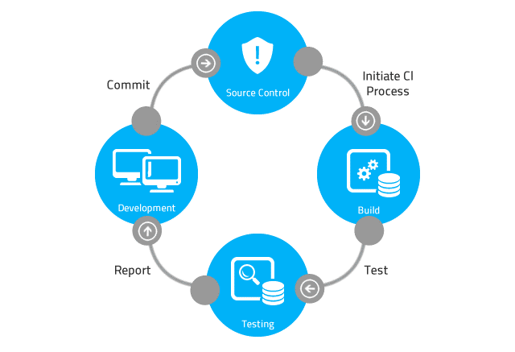

CONTENTS

1. CONTENTS 2
2. REVISION HISTORY 3
3. PURPOSE 4
4. SCOPE 4
5. SOFTWARE PROJECT REPOSITORY LOCATION 4
6. Project Members 4
7. REFERENCES 4
8. DOCUMENTS and LOCATION 4
9. CODING STANDARD 5
10. SOFTWARE BUILD INSTRUCTIONS 5

REVISION HISTORY

Rev. | Date | Author | Comments
1 | 5/1/2023 | Michael Koepp | Initial release.
2 | 11/24/25 | Jeffrey Guo  Collin DeForest  Ben Fry-Holman | Implemented version 2.0

PURPOSE

The Software Project Information File (SPIF) is used to determine the location of the Software Project Repository and other important artifacts.

Each software project must contain a Software Project Information File (SPIF). The SPIF must be located in the root directory of the Software Project Repository.

The contents of the SPIF should include:

- The location of the Software Project Repository.
- The name and location of the main software development documents.
- Instructions on how to build the software, and the names and locations of all tools needed to build the software, or the name of the file that has this information. If a reference to a file is made that has this information, then the Software Project Repository directory should contain this file.

SCOPE

This document is to be referred to when creating or modifying software development projects.

SOFTWARE PROJECT REPOSITORY LOCATION

Description: The repository is versioned controlled using the Git DVCS.
Location: GitHub: https://github.com/NCSS/Messenger
Login: See project manager or project technical lead

Project Members

Product Manager: Winnie Pooh
Project Manager: Mickey Mouse
Technical Lead: Minnie Mouse
Systems Test Lead: Donald Duck
Alternate Contact: Daffy Duck

REFERENCES

File Name: Software_Development_Process.doc
File Location: GitHub: https://github.com/NCSS/Messenger/Docs/Refs
File Name: Software_Development_Process_Checklist.doc
File Location: GitHub: https://github.com/NCSS/Messenger/Docs/Refs

DOCUMENTS and LOCATION

Software Project Plan

File Name: SMP_Software_Project_Plan.docx
File Location: GitHub: https://github.com/NCSS/Messenger/Docs

Software Requirements Document

File Name: SMP_Software_Requirements.docx
File Location: GitHub: https://github.com/NCSS/Messenger/Docs

Software Design Specification

File Name: SMP_Software_Design_Specification.docx
File Location: GitHub: https://github.com/NCSS/Messenger/Docs

Software Technical Specification

File Name: SMP_Software_Technical_Specification.docx
File Location: GitHub: https://github.com/NCSS/Messenger/Docs

Software System Test Plan

File Name: SMP_Software_System_Test_Plan.docx
File Location: GitHub: https://github.com/NCSS/Messenger/Docs

CODING STANDARD

File Name: CSharp_Coding_Guidelines.pdf
File Location: GitHub: https://github.com/NCSS/Messenger/Docs/Standards
File Name: CppCodingStandards.pdf
File Location: GitHub: https://github.com/NCSS/Messenger/Docs/Standards
File Name: CCodingStandards.pdf
File Location: GitHub: https://github.com/NCSS/Messenger/Docs/Standards

SOFTWARE BUILD INSTRUCTIONS

Build Files:
SMP_GUI.sln

Required Build Tools
Microsoft Visual Studio Community 2022 (64-bit) - Current
Version 17.3.5

Microsoft .NET Framework
Version 4.8.09032

Build Instructions
- Start Visual Studio
- Open SMP_GUI.sln
- Choose Build->Rebuild Solution

