Software Project Interface Prototype

Messenger
Client – Server Application
Simple Message Protocol (SMP)

Version 1

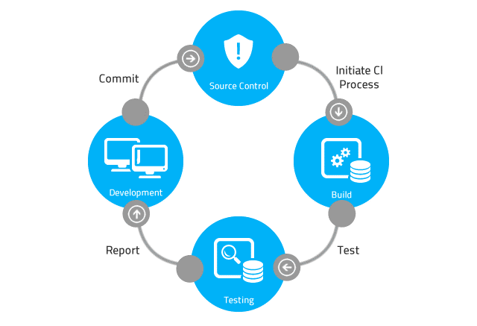

Table of Contents

Table of Contents 2
1 User Interfaces – GUI Versions 3
1.1 SMP Server Interface 4
1.1.1 Start Server Button 4
1.1.2 Show Messages Button 4
1.2 Message Producer Client Interface 5
1.2.1 Send Message Button 5
1.3 Message Consumer Client Interface 5
1.3.1 Get Message Button 5
2 User Interfaces – CLUE Versions 7
2.1 SMP Message Producer Client Interface 7
2.2 SMP Message Server Interface 7
2.3 SMP Message Consumer Client Interface 8
2.4 SMP Server Admin Interface 8

User Interfaces – GUI Versions
Software Application User Interface (UI)

User Interface (UI) Design focuses on anticipating what users might need to do and ensuring that the interface has elements that are easy to access, understand, and use to facilitate those actions.

Based on the software requirements document, the team’s next task is to develop the software application’s user interface (UI). The UI can be console-based, implemented as a command-line user interface (CLUI), or graphical-based, implemented as a graphical user interface (GUI).

NOTE: Software development team members have created a CLUI prototype. Base the GUI on the CLUI prototype.

Your team’s project manager should be prepared to present and discuss the software applications UI.

References

https://www.usability.gov/what-and-why/user-interface-design.html
https://en.wikipedia.org/wiki/Graphical_user_interface
https://www.w3computing.com/systemsanalysis/graphical-user-interface-gui-design/
https://www.interaction-design.org/literature/topics/ui-design

SMP Server Interface

Start Server Button
The Start Server button starts the SMP Server. An SMP message consists of a priority level, the message content, and the current date and time. The server adds the message to a text file. There is one text file for each of the priority levels. The text files serve as queues. Which text file the server writes to depends on the priority selected.

Show Messages Button
Depending on which option button is selected, the Show Messages button should read in records from the appropriate file and display the message date, message priority, and message content for each of the messages in the file and list the messages in the Messages window.

Registrations Button

Opens the Registration Management form which displays registered users from the registration database file. Including radio button options: "Show User IDs Only" or "Show User IDs and Passwords", the show registrations button to display data based on selected option, and when showing passwords, they are decrypted using the server's private key and displayed in clear text.

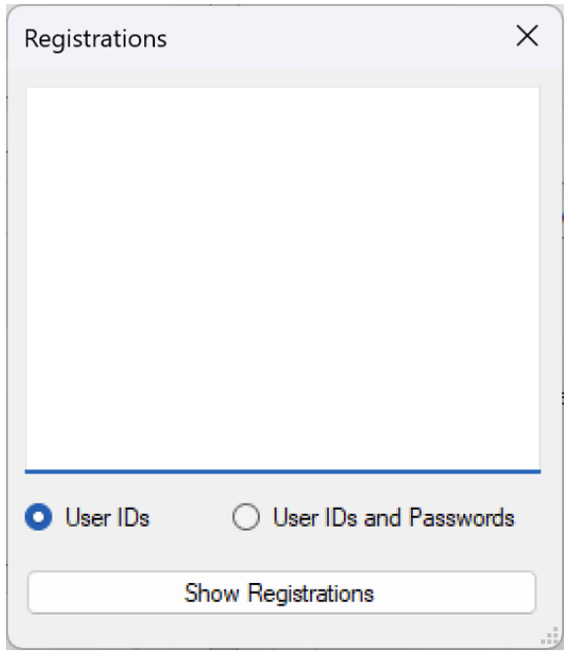
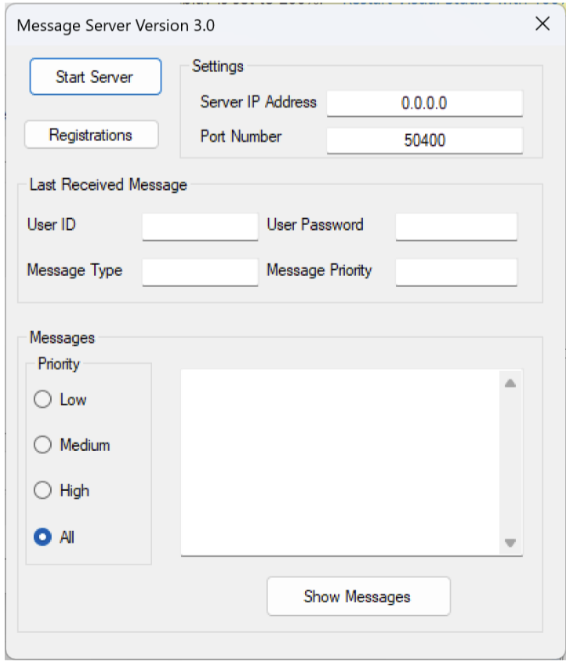

Message Producer Client Interface

Send Message Button
The SMP Message Producer client program is designed to send an SMP PUT request to the server.

When the Send Message button is clicked, an SMP message is sent to the server. The message sent to the server consists of a date and time stamp, the message priority, and the message content. The server adds the record to the file associated with the message priority.

Register Credentials Button
Opens the Client Registration with a User ID text box, password text box, register button that encrypts credentials using the public key and sends to the server. The server stores the User ID and password in registration database file.

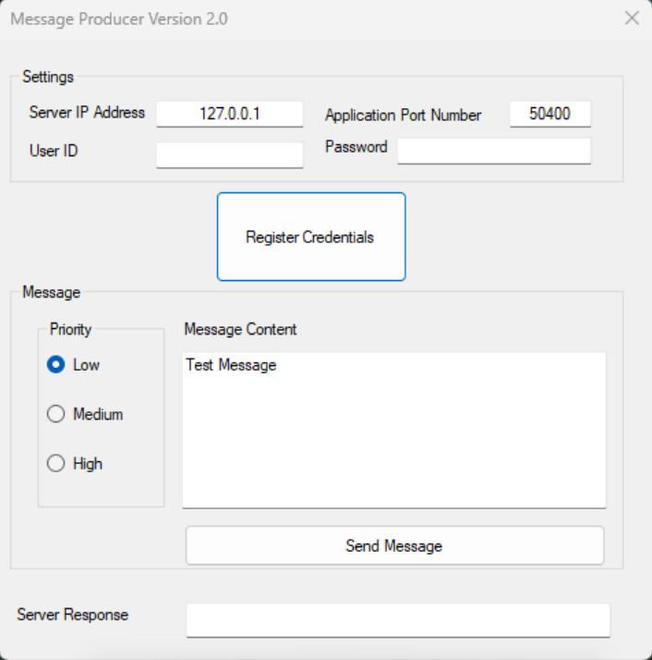

Message Consumer Client Interface

Get Message Button
The SMP Message Consumer client program is designed to send an SMP GET request to the server.

When the Get Message button is clicked, an SMP GET request is sent to the server. The server responds with an SMP message. Which message is sent back from the server depends on the priority selected. The message sent back to the client consists of the message date and time stamp, message priority and message content. After the client acknowledges that it has received the message, the server deletes the record from the file.

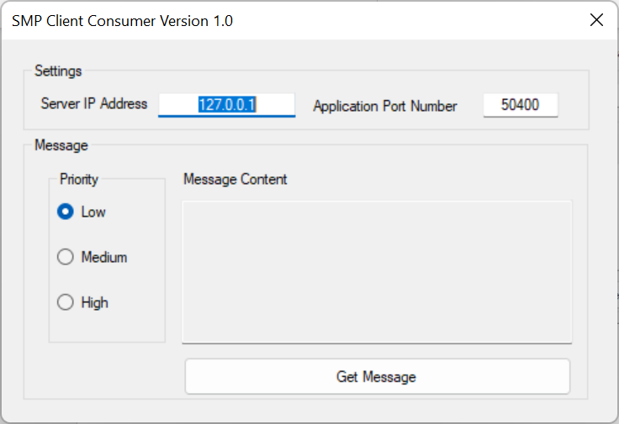

User Interfaces – CLUE Versions

SMP Message Producer Client Interface
Using TCP/IP and the Sockets API (Application Programming Interface), the SMP Message Producer client program is designed to send messages to a server. A message consists of the current date and time, a priority level, and the message body.

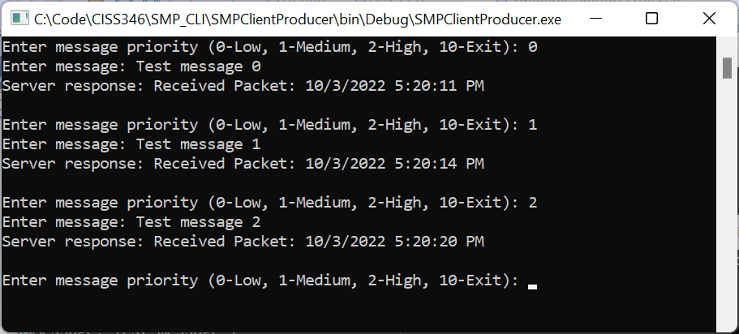

SMP Message Server Interface
The SMP Message Server program is designed to listen for SMP requests sent to it by SMP Producer and SMP Consumer clients. An SMP message consists of the current date and time, a priority level, and the message body. The server adds the SMP message to a text file. There is one text file for each of the priority levels. The text files act as queues. Which text file the server writes to depends on the priority selected.

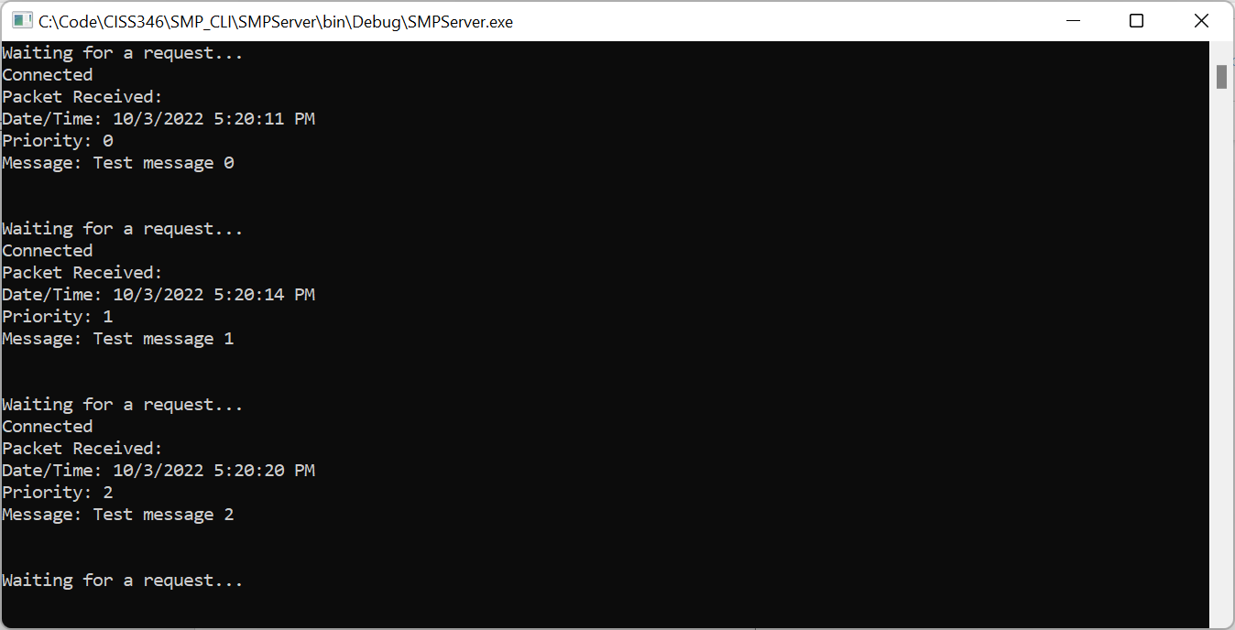

SMP Message Consumer Client Interface
The SMP Message Consumer client program is designed to send an SMP request to the server to retrieve the next message. The server sends back a message. Which message is sent back from the server depends on the priority selected. The message sent back to the client consists of the message body and message date. The server deletes the record from the file after the client acknowledges that it has received the message.

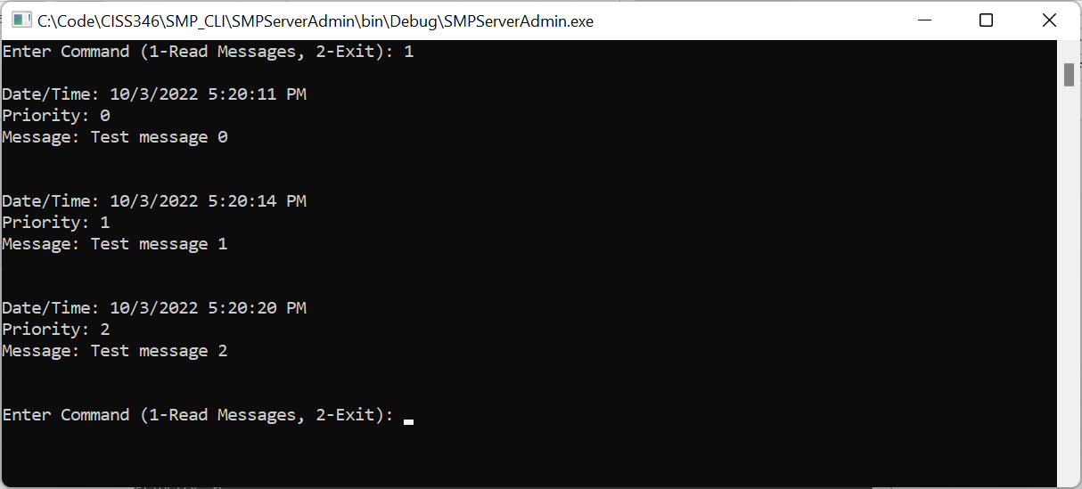

SMP Server Admin Interface
The SMP Server Admin reads in records from the appropriate file and displays the message date, the message priority, and the message.

TBD

