Software Requirements Specification

Give Day Alumni
Timeline Ticker
Version 1

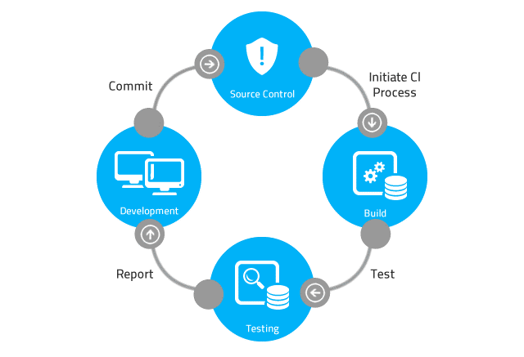

Table of Contents

Table of Contents 2
Revision History 3
1 Introduction 4
2 Requirements 4
2.1 Give Day Requirements 4
2.1.1 Requirement 1: Alumni List 4
2.1.2 Requirement 2: Historical Timeline 5
2.1.3 Requirement 3: Alumni URL Generation and Output 5
2.1.4 Requirement 4: Alumni Website and Timeline Access 5
2.1.5 Requirement 5: Comment System 5
3 Considerations 7
3.1 Dependencies 7
3.2 Assumptions 7
3.3 General Constraints 7
3.4 Guidelines 7
3.5 Development Methods 7
4 Notes 8

Revision History

Rev. | Date | Authors | Comments
1 | 10/19/25 | Collin DeForest | 1. Initial release.

Introduction

Perhaps the most important part of the software system definition is the Software Requirements Specification document. The role of the Software Requirements Specification document is to define in detail the functionality of the software system. The Software Requirements Specification document defines the software requirements for each software system component. The software requirements specification document typically includes software configurations, software installation procedures, database installation procedures, and training standards.

Because the software requirements specification document defines the system functionality in great detail, the software requirements definition process is usually a very formal and time-consuming process. Using an agile software development methodology, requirements gathering is an iterative process. During each iteration, the team develops a better understanding of the system and the system’s operating environment.

This Software Requirements document contains SMP client and server application development requirements and other requirements specific to customers contracting with Never Crash Software Services and vendors developing a software or hardware product or software subsystem for Never Crash Software Services.

NOTE: This document contains software application development requirements and other requirements specific to customers contracting with Never Crash Software Services and vendors developing a software or hardware product or software subsystem for Never Crash Software Services. This document is NOT intended to serve as a non-disclosure agreement, letter of intent, request for proposal or quotation, joint marketing agreement or purchase agreement. These or other documents that may be required to define any business relationship or agreements between any vendor and Never Crash Software Services shall be executed separately as required.

All licenses for this software application are owned by the principal contracting agency, Reality Software.

Requirements

SMP Server Requirements

Requirement 1: Alumni List
- Type: Data

- Description: This feature utilizes a provided list of Computer Science alumni as the foundational dataset for the project. The list will be used to identify each alumnus’s graduation year, enabling the us to direct them to the appropriate section of the website corresponding to their class year.

Requirement 2: Historical Timeline
- Type: User Interface

- Description: This feature presents a chronological timeline highlighting departmental history and alumni-related milestones dating back to 1961. The timeline may include photos, notable events, and other relevant information.

Requirement 3: Alumni URL Generation and Output
- Type: Data Processing / Security

- Description: This feature generates unique, encrypted URLs for each alumnus and produces a result we can return to our client. This ensures individualized and secure website access.

Requirement 4: Alumni Website and Timeline Access
- Type: Web Application

- Description: This feature delivers a centralized website where alumni can view the historical timeline, explore relevant information, and navigate using their unique access links. The primary interface will be designed for ease of use and accessibility due to varying ages of alumni.

Requirement 5: Comment System
- Type: User Interaction/Database

- Description: This feature enables alumni to leave public comments on the website for others to view, fostering community engagement. A backend system will store and retrieve these comments.

Considerations

Describes the issues that need to be addressed before implementing a software solution.

Dependencies
We’ll need the data for the alumni so we can generate the encrypted URL links, database for storing comments, and a way to host the website.

Assumptions
None

General Constraints

Unlike most projects, which are due at the end of the Spring Quarter, this project has an accelerated timeline with a completion deadline set for April.

Guidelines
The project team has been granted significant flexibility in determining the approach and implementation. Any concerns or issues that arise during development may be brought to the attention of the client or project advisor for guidance.

Development Methods
We’ll be following the Waterfall development methodology:
- Requirements and Planning:
Identify and document all project requirements, data needs, and system functionalities. Establish dependencies and define deliverables.
- Design and Development
Implement the website architecture, database integration, and user interface according to the approved specifications.
- Testing and Verification
Conduct thorough testing to validate functionality, usability, and security.
- Deployment and Review
Deploy the completed application to the hosting environment.

Notes

