Terence Carey, Collin Bauer
MATH307 – Discrete Structures II
April 28, 2019

Transitive Closure by Graph Powering Animation

#This is a very rough draft. Feel free to change anything at any time.
#There are some random comments thrown in here, proceeded by bashes (#)

For our project, we chose to use the Python library Manim by 3Blue1Brown, which gives methods for drawing and manipulating a mathematical graph and outputs an animation to an MP4 file. Our program effectively does three things
- Accepts an input file, with lists of vertices and edges, and creates an initial graph
- From that graph, runs each set of edges through an adjacency algorithm, and does the transitive closure algorithm which I currently don’t remember how to describe.
- For each step in the closure, generates a frame of animation which is then appended to an MP4 output, which visually demonstrates the closure in action.
All of the code written for this project, including input files and output

Table of Contents
- What Transitive Closure Is
- Choosing a Language and Library
- Closure Algorithm in Python
- Complete examples

What a Transitive Closure is
In set theory, the binary relation R of a set A is considered transitive if for two pairs (a, b) and (b, c), the pair (a, c) is also in the relation. The transitive closure of a relation is a process which guarantees a relation will have this property by combining the union of relation R with R^2, R^3, and so on to R^n, where n is the number of values in set A.
For example, consider the relation R = {(1,2),(1,3), (2,1), (3,1)} defined on the set A = {1,2,3}. Upon inspection, it can be seen that R contains (2,1) and (1,3) but not (2,3) and is therefore not transitive. To find the transitive closure of R, first find R² = {(1,1), (2,2), (3,3), (3,2), (2,3)} and R³ = {(1,2), (1,3), (2,1), (3,1)}. Then, find R ∪ R² ∪ R³ = {(1,1), (1,2), (1,3), (2,1), (2,2), (2,3), (3,1), (3,2), (3, 3)}. You then have the transitive closure of R.
…In the Context of a Graph
For a symmetric relation, the relation can be represented in the form of a simple graph G with vertices that correspond to the set A that the relation is defined on and with edges that correspond to if the two elements relate to each other. For a symmetric relation R represented in this form, if two vertices u and v are adjacent to the same vertex w in the graph, then u and v will be adjacent to each other in the graph form of R2
Take the above example of the relation R = {(1,2), (1,3), (2,1), (3,1)} defined on the set A = {1, 2, 3}. The image below on the left is a representation of this relation as a graph.
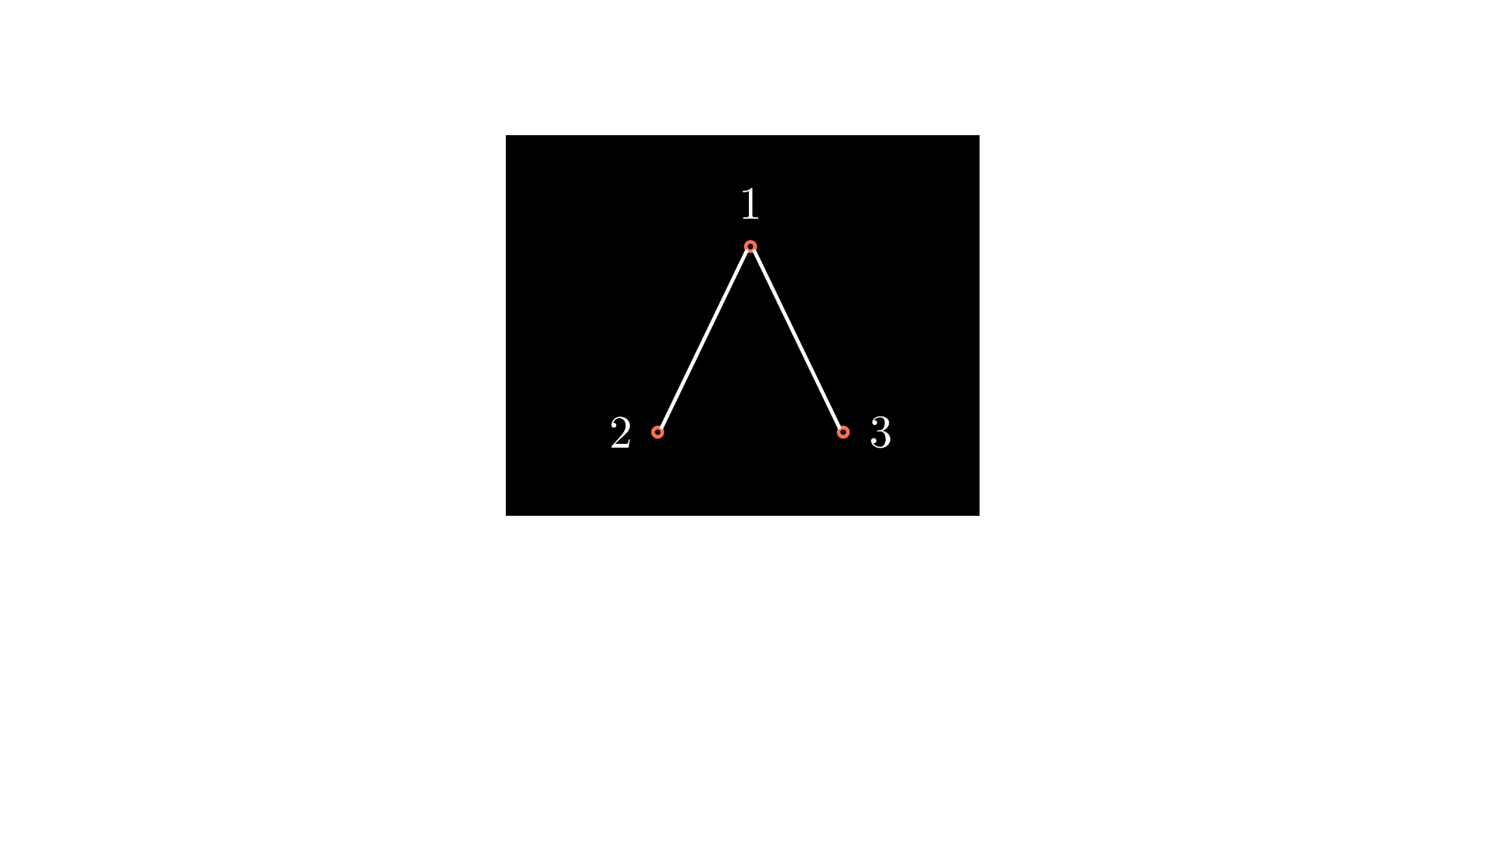
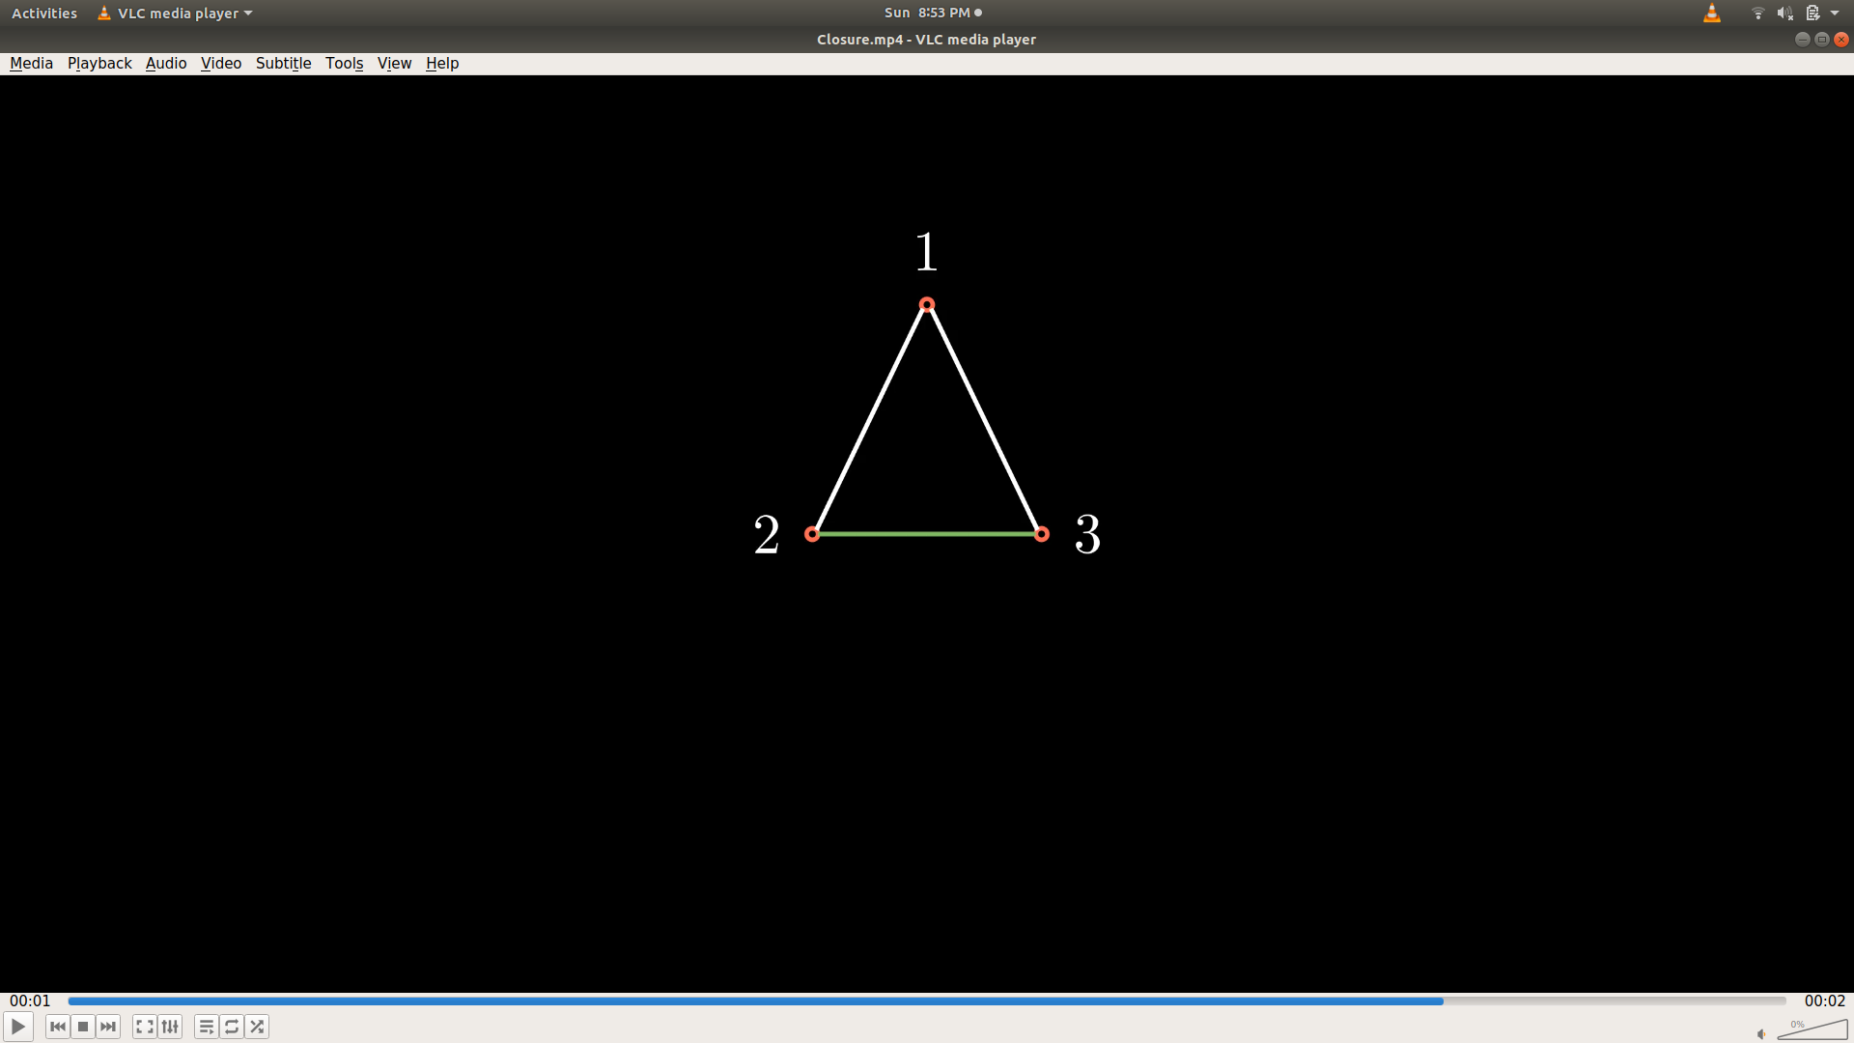

From above, R² = {(1,1), (2,2), (3,3), (2,3), (3,2)} but in a simple graph the edges that would come from {(1,1), (2,2), (3,3)} are not used as they would be self-loops. The image above on the right represents R ∪ R². The white lines are edges that are from R while the green lines are edges from R². While it is required to get to R^{|A|} to guarantee that the transitive closure of a relation defined on a set A is found, in this case this case it was found with R ∪ R².
For all of the graphs in this project, we have green as the color that represents edges that were added in the newest power of R, yellow represents edges that were added in the second newest power of R, red represents edges that were added two powers ago, and white represents any edges that were initially there or added more than two powers prior to the current power displayed.
…In the Context of a Matrix
Another way to represent a relation or a graph is using a matrix. In the matrix that represents a relation R, each column or row corresponds to an element of the set A on which R is defined. Taking again the example of R = {(1,2), (1,3), (2,1), (3,1)} on the set A = {1, 2, 3} you would have the 1st column and the 1st row represent the element 1, the 2nd column and the 2nd row represent the element 2, and the 3rd column and the 3rd row represent the element 3. Then, if two elements that correspond to the ith row and the jth column, respectively, are related through R, you would put a 1 in the i,j component of the matrix. In the case of a symmetric relation R, if the ith element and the jth element are related then you would also know that the jth element and the ith element are related. Thus, in matrix form, a symmetric relation will look like a relation such that the matrix is equal to its transpose. The matrix form for the relation R = {(1,2), (1,3), (2,1), (3,1)} is below.

Choosing a Language and Library
For our project we decided the best course of action was to create a utility that could output output a video with each step. We chose to use a package utilizing Python since it was a language we were both familiar with and an easy language to test and debug.
3Blue1Brown is a Youtuber known for creating animated videos on mathematics, especially for Linear Algebra. He wrote a Python package which can draw circles, lines, and various shapes on a graph and color and animate each element individually. The Mathematical Animation Engine, or Manim for short, is what we chose to implement for our project. Manim can be found at https://github.com/3b1b/manim
Manim is a very elegant tool, once working, but it has many dependencies, most of which are listed by requirements.txt. Manim was built for Linux, so we both installed it on Ubuntu for ease of use.

#snippet of code from testingstuff.py

Closure Algorithm in Python
Our next step was to translate the transitive closure algorithm to Python syntax.
#snippet of code from actualWork.py
Appling the Algorithm to an Input File

#animation, before, during and after pictures of 2+ examples

