HASH FUNCTION EFFICIENCY

* Speed
* Avalanche
* Pigeonhole principle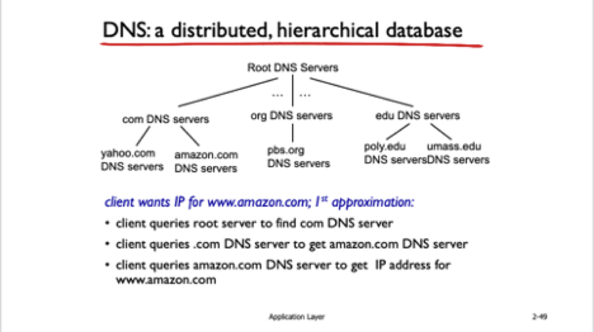

HTTP (GET, POST)

DNS (Domain Name System)

* Hostname to IP address, Host aliasing
* Load Distribution, Mail server aliasing

Transport

* UDP
  + Streaming multimedia apps
  + DNS (Domain Name System)
  + SNMP (Simple Network Management Protocol

DHCP

- How your local router switch assigns you an IP address