Go to preferences, and change sketchbook locatain to the dropbox folder

We can now keep all our libraries together

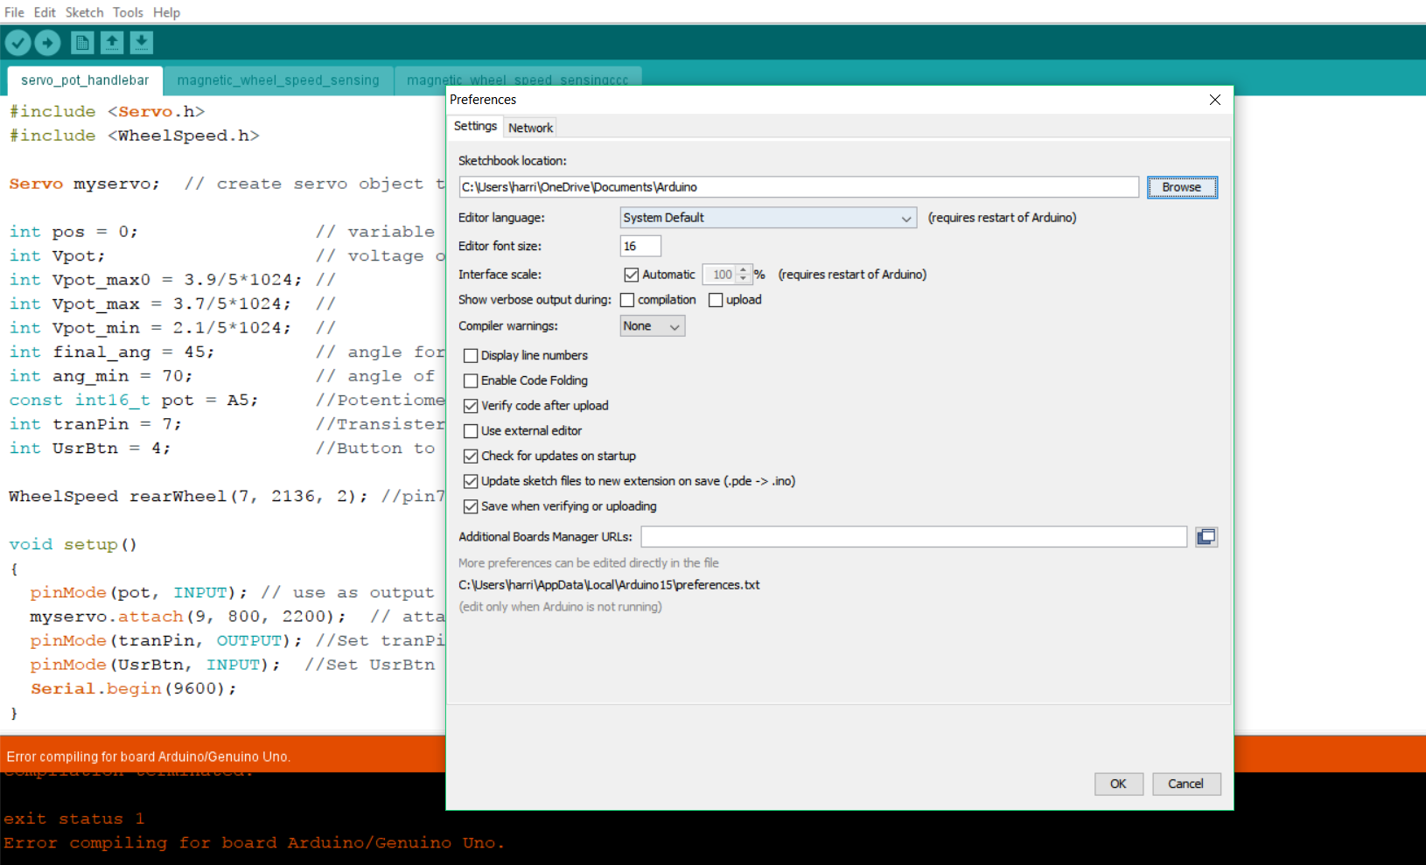

Change to:

