KYAMBOGO UNIVERSITY
PCS — Front-End Design
All Screens, Elements & User Flows

Every screen the system needs, for every role — sketched, labelled and explained
Public Catalogue · SysAdmin · Dean · HOD · Coordinator · Registrar · Admissions Officer
Companion to | Kyambogo PCS — Consolidated System Design Reference (architecture, DB, API)
Screens covered | 24 screens across the public catalogue and all six admin-portal roles
Fidelity | Low-fidelity skeleton screens — layout & function, not final visual design
Date | July 2026

Table of Contents
Table of Contents 1
1. How to Read This Document 1
1.1 Screen Inventory 1
2. Global Navigation Patterns 1
2.1 Public Catalogue Shell 1
2.2 Admin Portal Shell 1
3. Shared: Login & Onboarding 1
4. Public Catalogue — Applicant Front End 1
Screen 1 — Catalogue Home / Browse 1
Screen 2 — Search & Filter Results 1
Screen 3 — Programme Profile 1
Screen 4 — AI Assistant — Compare & Eligibility 1
6. System Administrator Front End 1
Screen 7 — Dashboard 1
Screen 8 — Create Account (Dean / Academic Registrar) 1
Screen 9 — Roles & Permissions 1
Screen 10 — Audit Log 1
Screen 11 — Backup & Restore 1
Screen 12 — AI Configuration 1
7. Dean Front End 1
Screen 13 — Faculty Overview Dashboard 1
Screen 14 — Recommend a Change 1
8. Head of Department Front End 1
Screen 15 — Onboard a Programme Coordinator 1
Screen 16 — Review Queue 1
9. Programme Coordinator Front End 1
Screen 17 — Edit Programme Profile 1
Screen 18 — Bulk Import 1
Screen 19 — My Programmes 1
10. Academic Registrar Front End 1
Screen 20 — Create a Call for Application 1
Screen 21 — Calls for Application List 1
Screen 22 — Assign Admissions Officer 1
11. Admissions Officer Front End 1
Screen 23 — Assigned Calls 1
Screen 24 — Close a Call 1
12. How the Roles Connect 1
12.1 Account Delegation 1
12.2 Programme Publication 1
12.3 Admissions Cycle 1
13. Notes for the Team 1

1. How to Read This Document
Every screen below is a low-fidelity skeleton wireframe: it fixes layout, which elements exist, and which functional requirement (FR/SEC/P code) each element satisfies — deliberately ahead of visual/brand design, so the team can agree on structure and flow first.
Each screen is documented the same way:
- On screen — what's actually placed on the page: navigation, fields, tables, buttons, badges.
- Primary action — the one main thing a user does here, and what it triggers server-side.
- Flow — where the user arrived from, and where they land next.
Note: These are structural sketches for design review, not final UI. Colours, spacing, and copy are placeholders — the Design System section of the companion System Design document has the customisable palette/typography tokens.

1.1 Screen Inventory
# | Screen | Role | Section
1 | Catalogue Home / Browse | Applicant (public) | 4.1
2 | Search & Filter Results | Applicant (public) | 4.2
3 | Programme Profile | Applicant (public) | 4.3
4 | AI Assistant — Compare & Eligibility | Applicant (public) | 4.4
5 | Login | All admin roles | 5.1
6 | Onboarding — OTP & Set Password | Invited admin user | 5.1
7 | SysAdmin Dashboard | System Administrator | 6.1
8 | Create Account (Dean / Registrar) | System Administrator | 6.2
9 | Roles & Permissions | System Administrator | 6.3
10 | Audit Log | System Administrator | 6.4
11 | Backup & Restore | System Administrator | 6.5
12 | AI Configuration | System Administrator | 6.6
13 | Faculty Overview Dashboard | Dean | 7.1
14 | Recommend a Change | Dean | 7.2
15 | Onboard Programme Coordinator | Head of Department | 8.1
16 | Review Queue | Head of Department | 8.2
17 | Edit Programme Profile | Programme Coordinator | 9.1
18 | Bulk Import | Programme Coordinator | 9.2
19 | My Programmes | Programme Coordinator | 9.3
20 | Create Call for Application | Academic Registrar | 10.1
21 | Calls for Application List | Academic Registrar | 10.2
22 | Assign Admissions Officer | Academic Registrar | 10.3
23 | Assigned Calls (monitor) | Admissions Officer | 11.1
24 | Close a Call | Admissions Officer | 11.2
25 | Forgot / Reset Password | All admin roles | 3
26 | Session Lock (idle-timeout overlay) | All admin roles | 3
27 | User Management list + account drawer (lineage, lifecycle) | SysAdmin / Dean / HOD / Registrar | 6
28 | Dean Publish / Reject queue | Dean | 7
29 | 404 / Error boundary screens | All roles | 2

2. Global Navigation Patterns
There are exactly two page shells in the whole system. Every screen in this document is built from one of them, so once a user learns one screen in a shell, every other screen in that shell behaves the same way.

2.1 Public Catalogue Shell
- Dark top bar with the university/catalogue name — persistent on every public page, no login required.
- Content area directly below: hero/search on the home page, filters + results on search, tabs + apply box on a profile page.
- No sidebar — the public site is shallow by design (browse → results → profile → apply), so a persistent sidebar would add navigation the applicant doesn't need.

2.2 Admin Portal Shell
- Dark top bar identifying the portal and the signed-in user's role/avatar.
- Left sidebar, grouped by function, scoped to what that role is allowed to do (RBAC applied to the menu itself, not just the API — SEC5.1).
- Main content area on the right: dashboards, forms and tables all sit in this same frame.
- The same shell is reused for all six roles — only the sidebar items and dashboard contents change. This is why Sections 6–11 below look structurally identical; that's intentional, it's one shell configured six ways.

3. Shared: Login & Onboarding
Every admin-portal role — SysAdmin, Dean, HOD, Coordinator, Registrar, Officer — signs in through the same screen. Which sidebar and dashboard they land on afterwards depends entirely on their role, resolved server-side after authentication.
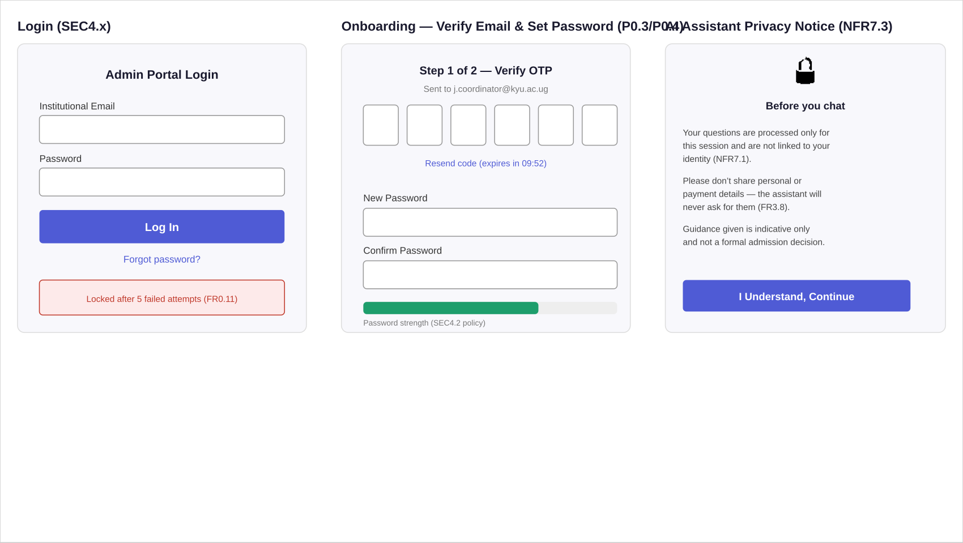
Login (SEC4.x), onboarding OTP + password set-up (P0.3/P0.4), and the AI assistant's privacy notice (NFR7.3).
- On screen: institutional email + password fields, a lockout warning after 5 failed attempts (FR0.11), and a forgot-password link.
- Primary action: Log In — validates credentials, issues a Sanctum session, then redirects to the role-appropriate dashboard (Section 6.1, 7.1, etc.).
- Flow: a newly-created account (Section 6.2) instead lands on the middle onboarding screen first — verify OTP, set a password, then proceed to login.

4. Public Catalogue — Applicant Front End
The applicant never logs in. Every screen here is anonymous and only ever shows published data (FR1.14).
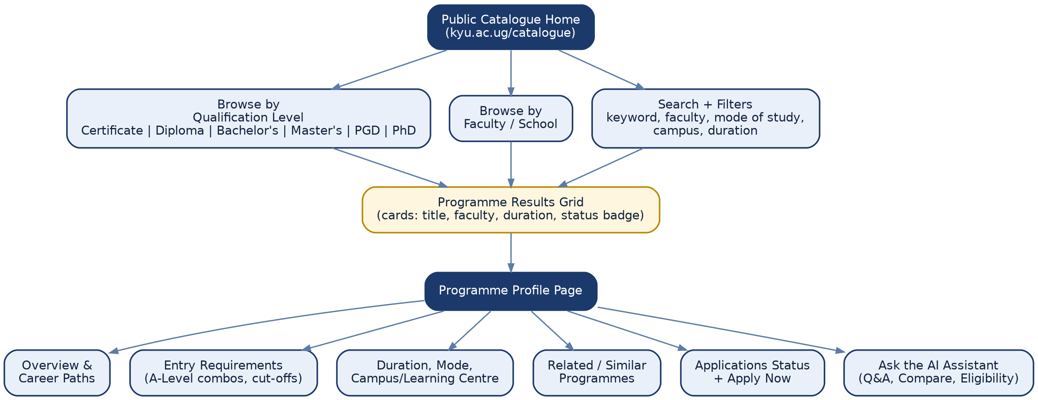
Applicant flow: three ways in, one results grid, one profile page, six things to do once there.

Screen 1 — Catalogue Home / Browse
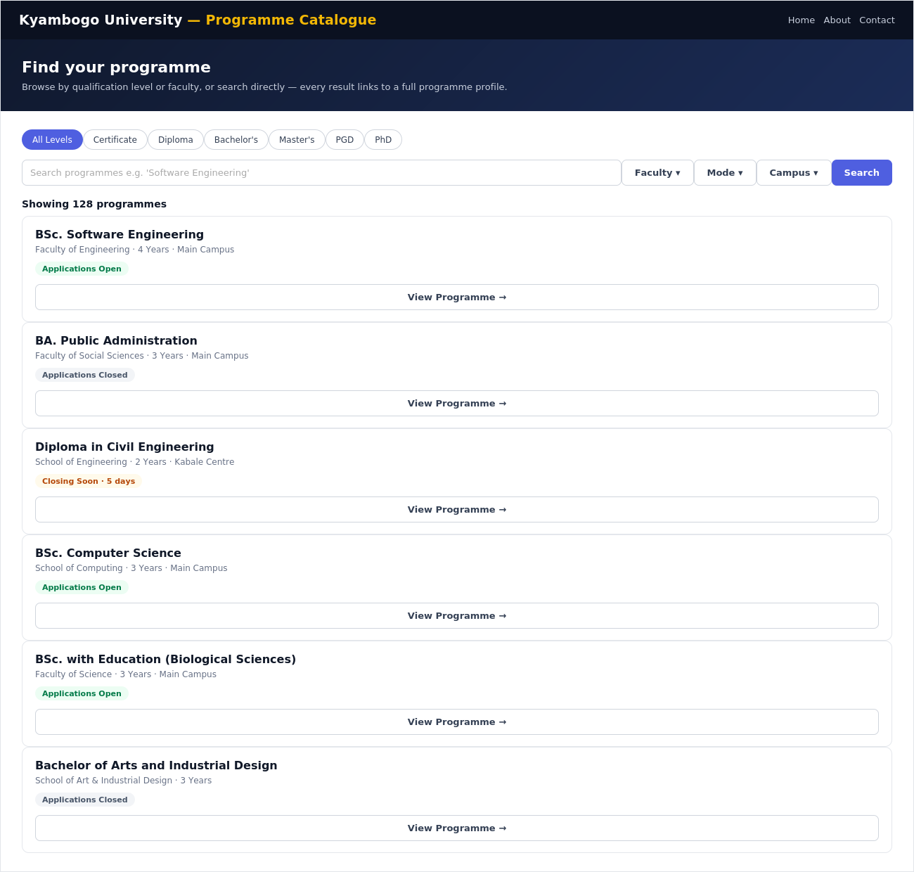
Catalogue Home / Browse (Applicant) — P1.4/FR1.11
- On screen: level chips (Certificate → PhD), a combined search + faculty/mode/campus filter bar, and a card grid — each card shows programme name, faculty, duration, campus and a live Applications status badge.
- Primary action: Click a level chip or type a search term — both narrow the same results grid in place, no page reload.
- Flow: Clicking a card goes to the Programme Profile (Screen 3). Typing and pressing Search goes to the full Search & Filter view (Screen 2) if refinement is needed.

Screen 2 — Search & Filter Results
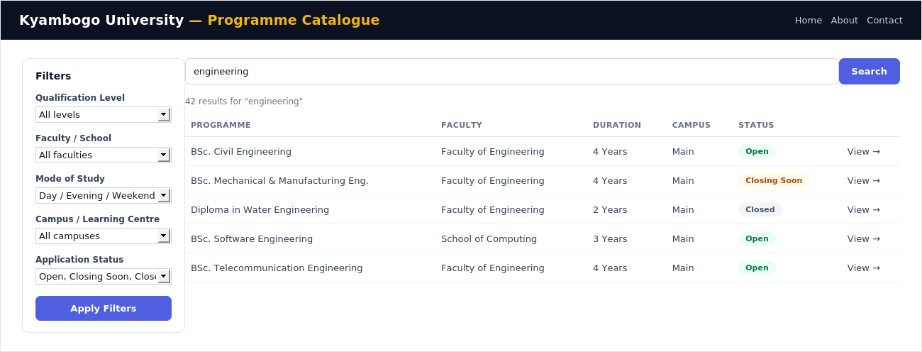
Search & Filter Results (Applicant) — FR1.11/FR1.12
- On screen: a persistent left-hand filter panel (level, faculty, mode, campus, application status) and a results table/list, so filters stay visible while scrolling long result sets — the gap identified in both benchmark sites (see the companion System Design doc, Section 6).
- Primary action: Apply Filters re-queries GET /programmes with the selected facets as query parameters.
- Flow: Reached from Screen 1's search bar, or a direct link/bookmark with filters pre-set in the URL. Each row's View → goes to Screen 3.

Screen 3 — Programme Profile
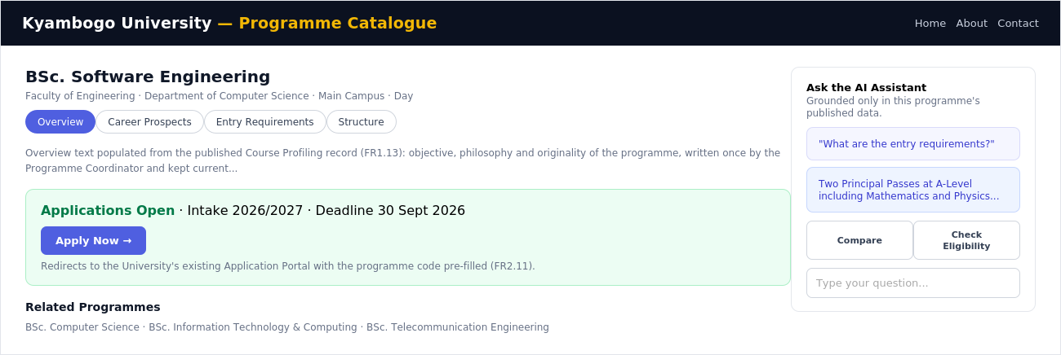
Programme Profile (Applicant) — P1.5/FR1.14
- On screen: programme title and metadata, a tabbed content area (Overview, Career Prospects, Entry Requirements, Structure), a status-coloured Apply box, related programmes, and a side panel embedding the AI assistant.
- Primary action: Apply Now — redirects to the University's existing external Application Portal with the programme code pre-filled (FR2.11); PCS does not process applications itself.
- Flow: Reached from Screens 1 or 2. The AI panel here is a compact version of Screen 4; "Compare" or a longer question expands it to the full assistant.

Screen 4 — AI Assistant — Compare & Eligibility
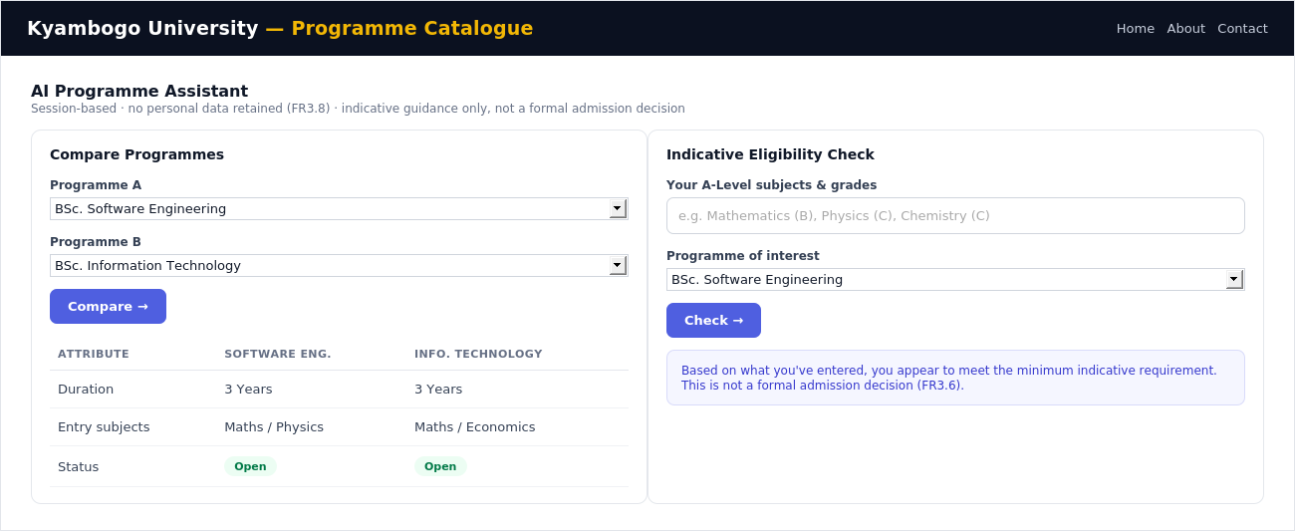
AI Assistant — Compare & Eligibility (Applicant) — FR3.1–FR3.6
- On screen: two tools: a side-by-side Compare Programmes table, and an indicative Eligibility Check that takes A-Level subjects/grades as free text.
- Primary action: Compare → or Check → sends a POST to /ai/compare or /ai/eligibility; every response is screened against the guardrail rules before it's shown (FR3.9–FR3.12).
- Flow: Opened from the AI panel on Screen 3, or directly from the catalogue home. Nothing entered here is retained beyond the browser session (FR3.8).

6. System Administrator Front End
The SysAdmin's sidebar is the fullest in the system — this is the only role with visibility into platform health, security configuration and every account, matching Module 0's role as the system's governing layer.

Screen 7 — Dashboard
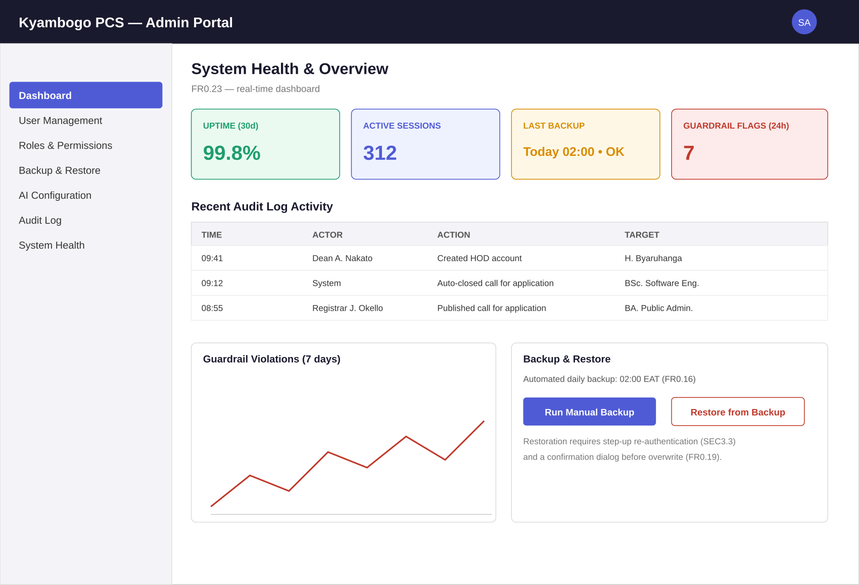
Dashboard (SysAdmin) — FR0.23
- On screen: four live KPI tiles (uptime, active sessions, last backup, guardrail flags), a recent audit-log feed, a guardrail-violation trend chart, and quick backup/restore controls.
- Primary action: none required — this is a monitoring landing page; each tile/section links deeper (e.g. into the full Audit Log, Screen 10).
- Flow: default landing page immediately after SysAdmin login.

Screen 8 — Create Account (Dean / Academic Registrar)
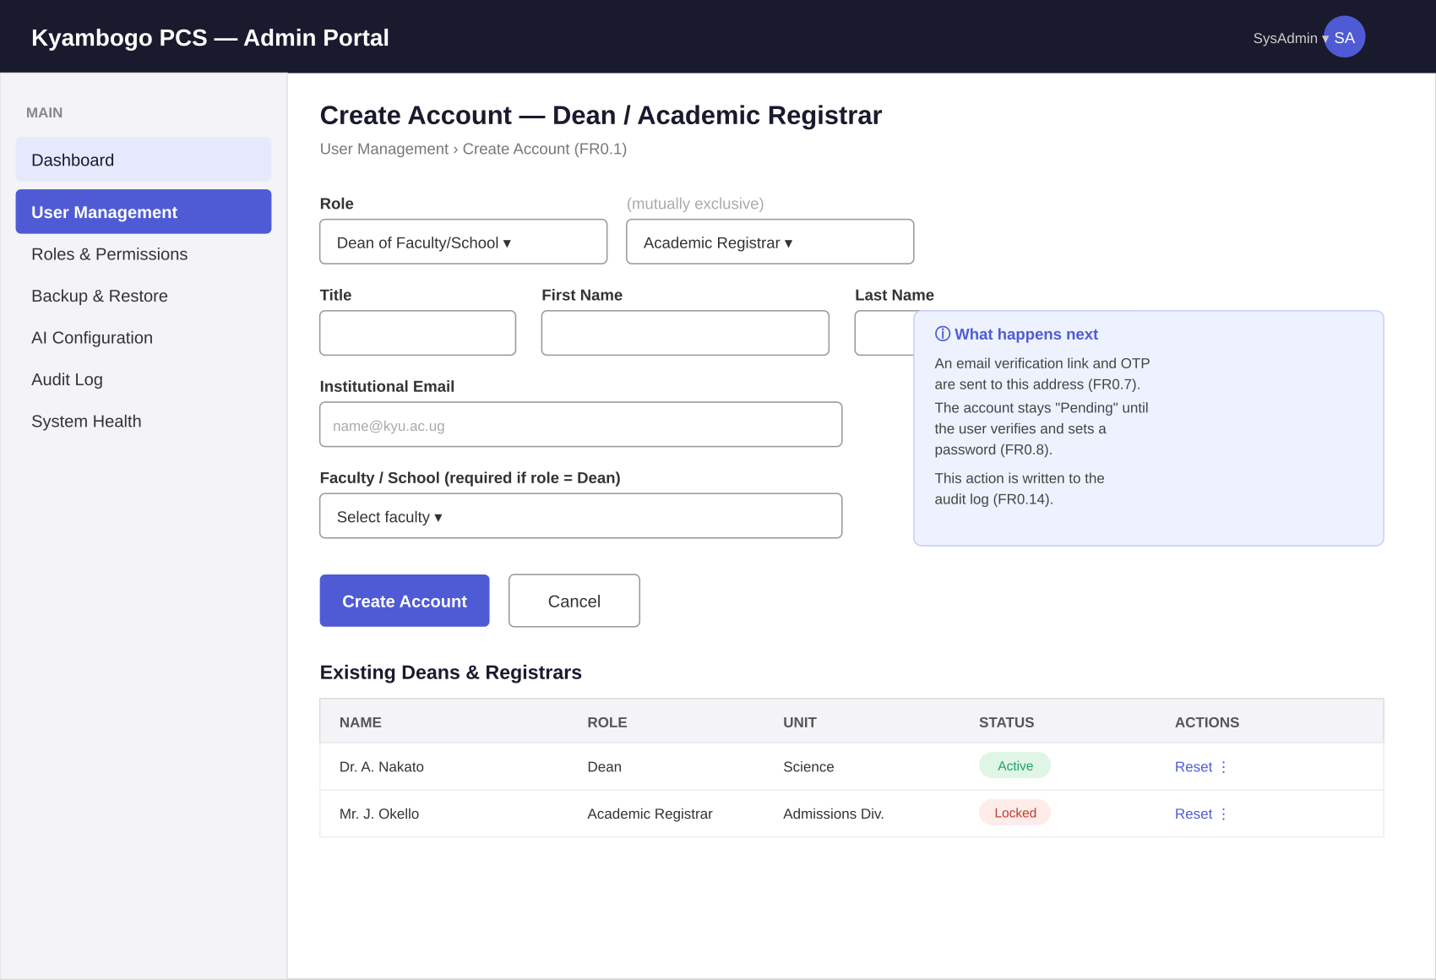
Create Account (SysAdmin) — P0.1, FR0.1
- On screen: a role-scoped creation form (only Dean or Registrar selectable — the two roles SysAdmin is allowed to create), and the resulting list of existing Deans/Registrars with status and a scoped reset action.
- Primary action: Create Account — sends POST /users; the system emails an OTP/verification link and the account sits Pending until the invitee verifies (FR0.7/FR0.8).
- Flow: the invited user next sees the Onboarding screen (Section 3), not Login, until their password is set.

Screen 9 — Roles & Permissions
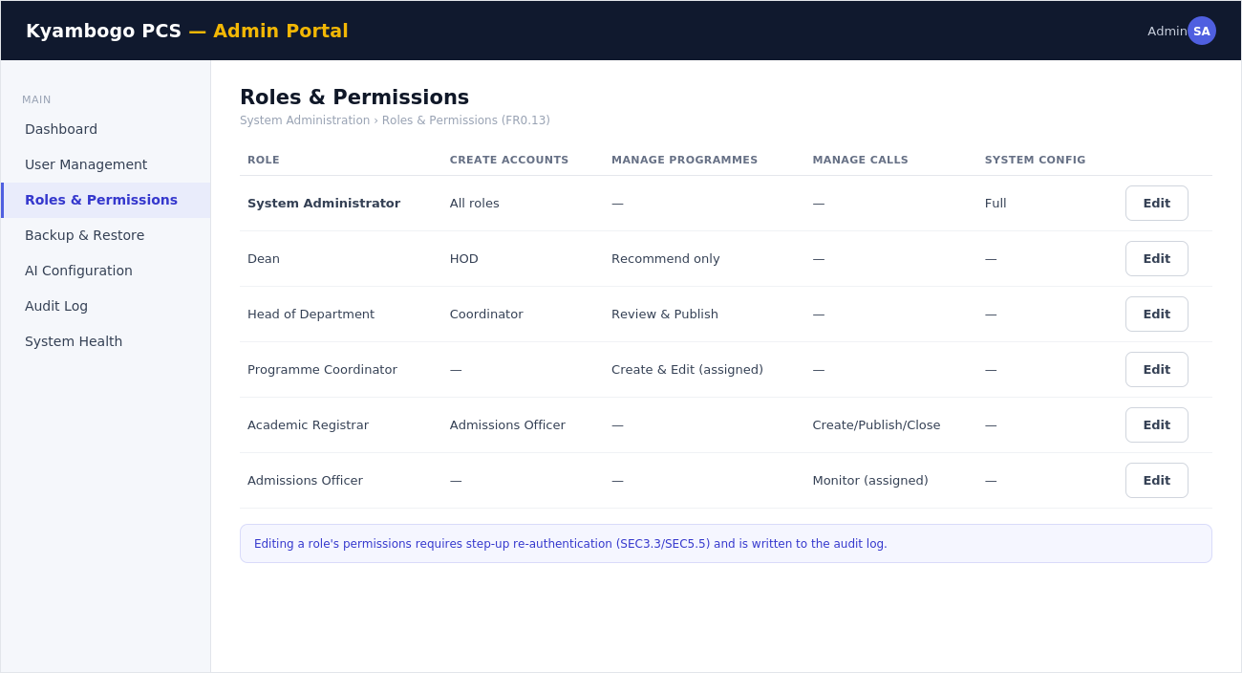
Roles & Permissions (SysAdmin) — FR0.13
- On screen: a permission matrix, one row per role, summarising what each may create/manage, with an Edit action per row.
- Primary action: Edit opens a step-up re-authentication challenge (SEC3.3/SEC5.5) before any permission can change.
- Flow: Any change here immediately affects what every other role's sidebar and API access looks like — it's the control panel behind Sections 7–11.

Screen 10 — Audit Log
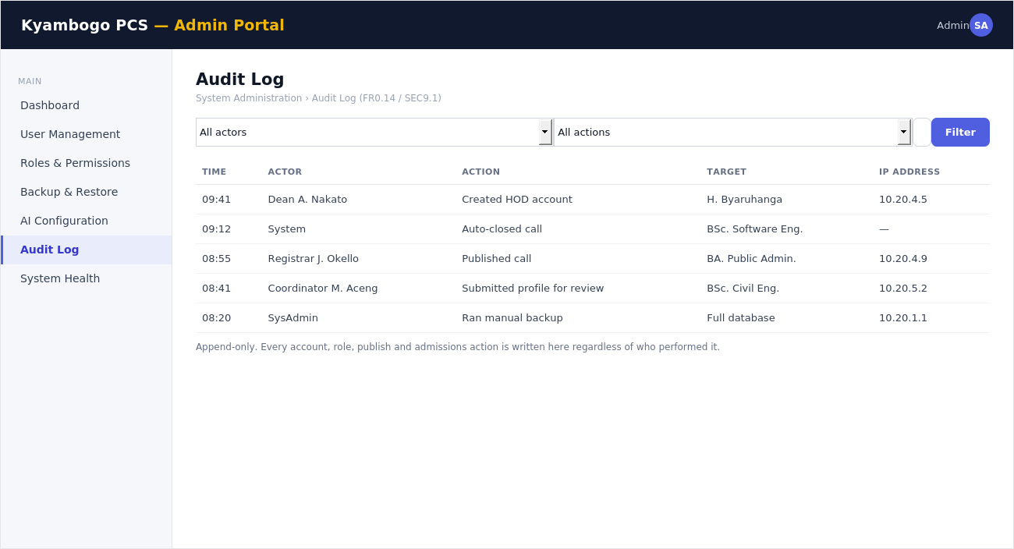
Audit Log (SysAdmin) — FR0.14/SEC9.1
- On screen: actor/action/date filters over an append-only table of every account, role, publish and admissions action system-wide.
- Primary action: Filter re-queries GET /audit-log; rows are read-only, nothing here can be edited or deleted.
- Flow: Reached from the Dashboard's recent-activity feed, or directly via the sidebar for a full historical query.

Screen 11 — Backup & Restore
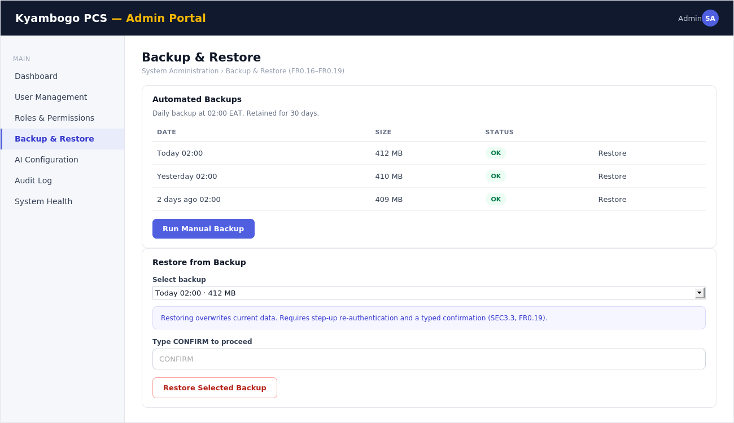
Backup & Restore (SysAdmin) — FR0.16–FR0.19
- On screen: a history of automated daily backups with size/status, and a restore panel requiring backup selection plus a typed confirmation.
- Primary action: Restore Selected Backup requires step-up re-authentication and overwrites current data — deliberately friction-heavy given the blast radius (SEC3.3).
- Flow: Manual backups triggered here also appear immediately in the Dashboard's Last Backup tile.

Screen 12 — AI Configuration
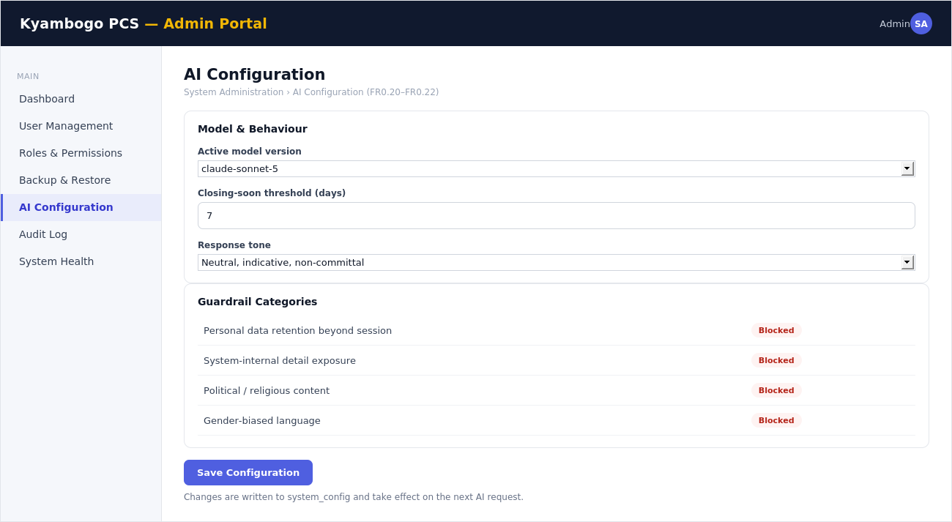
AI Configuration (SysAdmin) — FR0.20–FR0.22
- On screen: the active AI model version, the closing-soon threshold (days) used across every programme profile, and toggles for each guardrail category.
- Primary action: Save Configuration writes to system_config; takes effect on the next AI request, no redeploy needed.
- Flow: This is the only screen that changes the behaviour of the public AI Assistant (Screen 4) — a direct link between an admin action and public-site behaviour.

7. Dean Front End
The Dean's portal is deliberately narrow: oversight of the faculty and a formal way to suggest changes, without direct edit rights over programme content (that stays with the HOD/Coordinator chain).

Screen 13 — Faculty Overview Dashboard
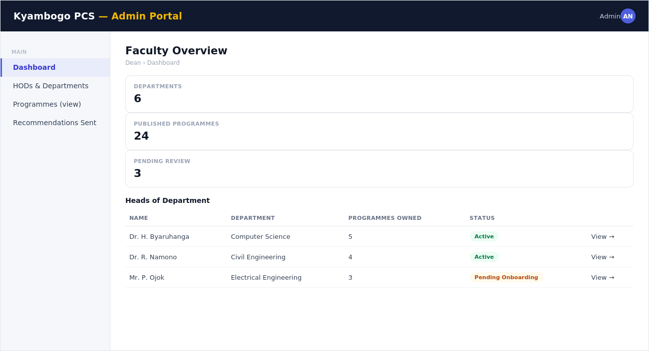
Faculty Overview Dashboard (Dean) — Section 3.1 delegation model
- On screen: three KPI tiles (departments, published programmes, pending review) and a list of the faculty's HODs with the programmes each owns.
- Primary action: View → on an HOD row drills into that department's programme list (read-only for the Dean).
- Flow: Default landing page after Dean login. HOD creation isn't done here — that's a SysAdmin action (Screen 8) that names the Dean's faculty.

Screen 14 — Recommend a Change
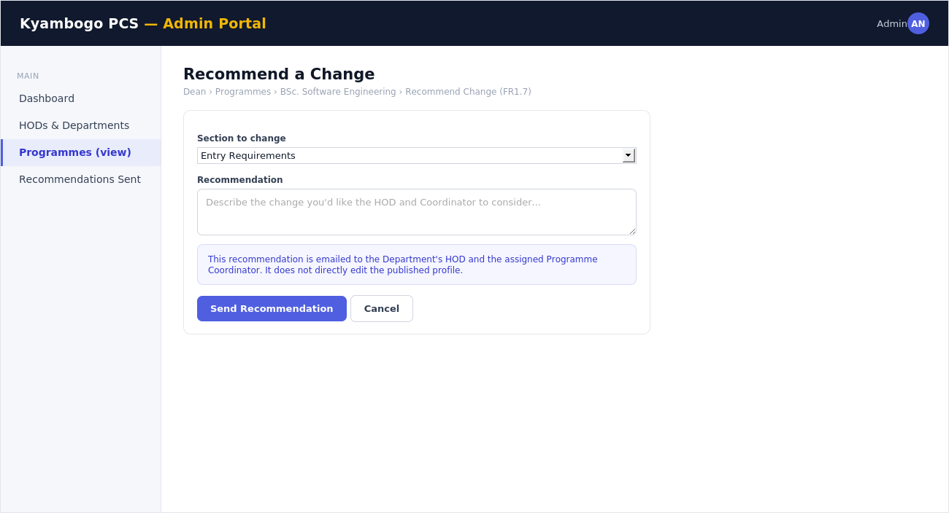
Recommend a Change (Dean) — FR1.7
- On screen: a targeted recommendation form against one programme's section (Overview, Requirements, or Structure) with a free-text explanation.
- Primary action: Send Recommendation emails the HOD and the assigned Coordinator — it does not edit the live published profile directly.
- Flow: Reached from a programme's read-only view under the Dean's faculty overview. The Coordinator receiving it may act via Screen 17.

8. Head of Department Front End
The HOD is the review-and-publish gate for their department's programme content — this is where Module 1's publication workflow actually lives.
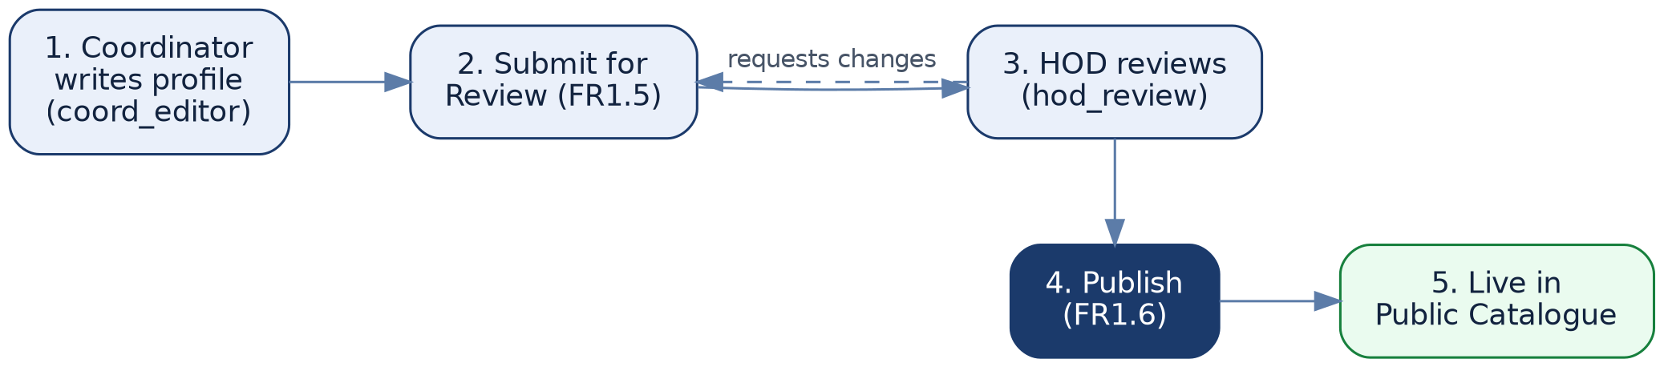
Programme publication lifecycle — from Coordinator draft to a live catalogue entry.

Screen 15 — Onboard a Programme Coordinator
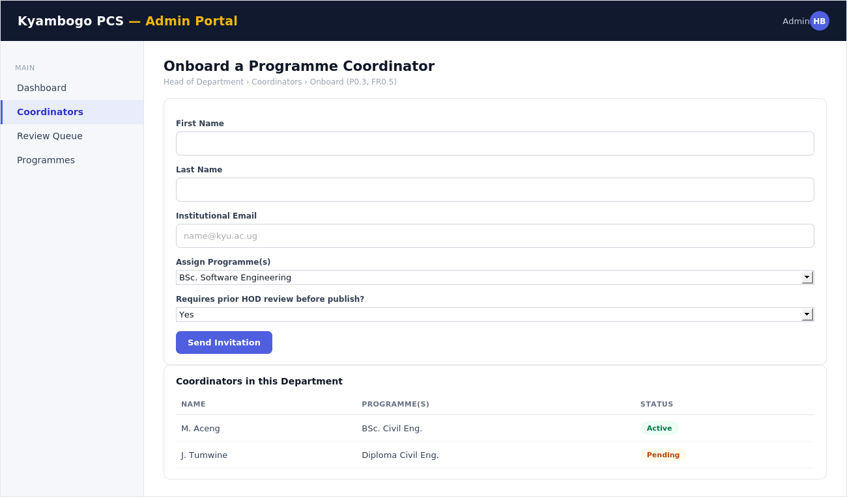
Onboard a Programme Coordinator (HOD) — P0.3, FR0.5
- On screen: an invitation form (name, email, programme assignment, whether prior review is required) beside a live list of the department's existing coordinators and their status.
- Primary action: Send Invitation triggers the same OTP-based onboarding as Screen 8, scoped to Coordinator.
- Flow: The requires_prior_review toggle set here decides whether that Coordinator's future submissions land in Screen 16 or publish directly.

Screen 16 — Review Queue
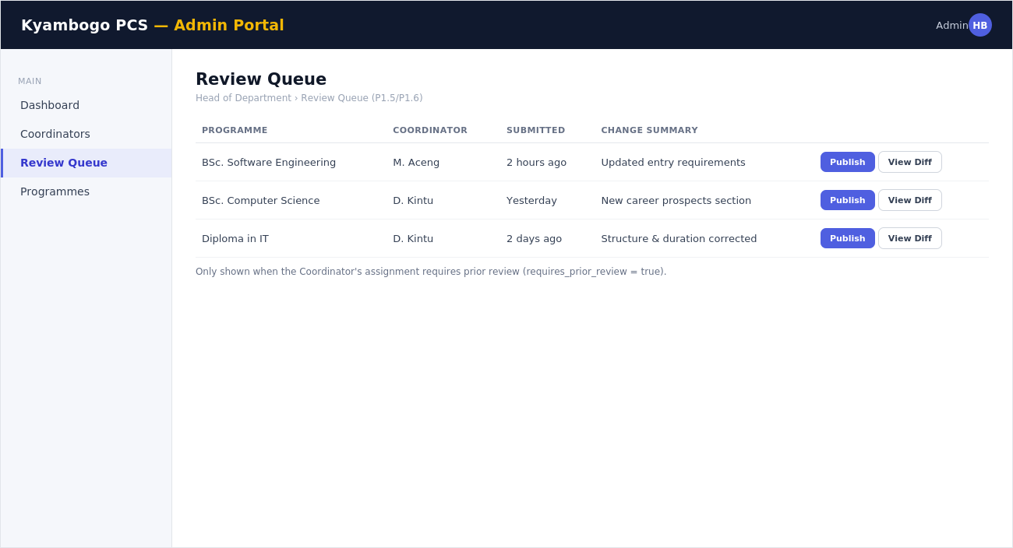
Review Queue (HOD) — P1.5/P1.6
- On screen: every profile a Coordinator has submitted for review, with who submitted it, when, and a summary of what changed.
- Primary action: Publish approves and makes the profile live in the public catalogue immediately (Screen 1/3); View Diff shows the change before deciding.
- Flow: Only populated when a Coordinator's assignment requires prior review (Screen 15). Otherwise Coordinators publish directly from Screen 17.

9. Programme Coordinator Front End
The Coordinator's portal is content-authoring focused — the smallest sidebar in the system, matching a role that owns specific programmes rather than people or policy.

Screen 17 — Edit Programme Profile
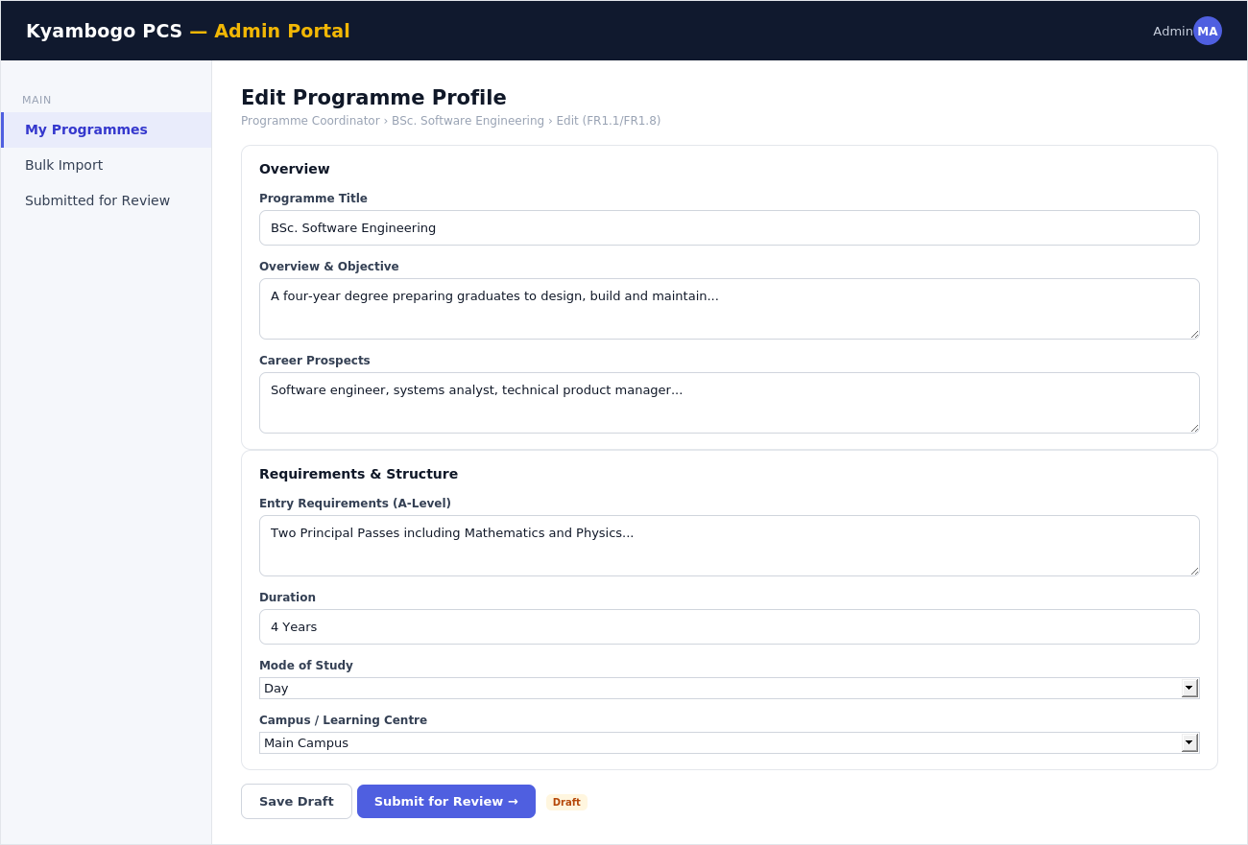
Edit Programme Profile (Coordinator) — FR1.1/FR1.8
- On screen: a two-column editor: overview/career-prospects on the left, entry requirements/structure (duration, mode, campus) on the right — the exact fields that render on the public Programme Profile (Screen 3).
- Primary action: Submit for Review sends the draft to the HOD's queue (Screen 16) if required, otherwise Publish is available directly.
- Flow: Reached from My Programmes (Screen 19) or a Dean's Recommendation (Screen 14). A Draft tag shows in the header until it's published.

Screen 18 — Bulk Import
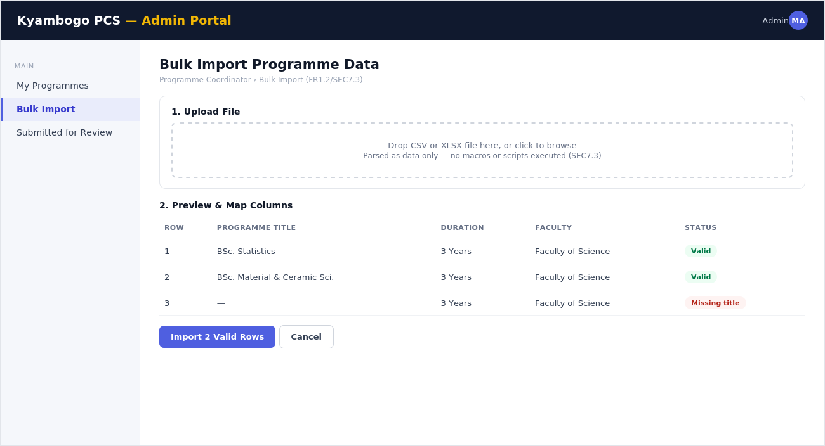
Bulk Import (Coordinator) — FR1.2/SEC7.3
- On screen: a file drop-zone for CSV/XLSX, and a validation preview table flagging rows with missing required fields before anything is saved.
- Primary action: Import N Valid Rows only commits rows that pass validation; the file is parsed as data only — no macros/scripts are executed (SEC7.3).
- Flow: Successfully imported rows appear as new Draft entries in My Programmes (Screen 19), ready for the normal edit/review/publish flow.

Screen 19 — My Programmes
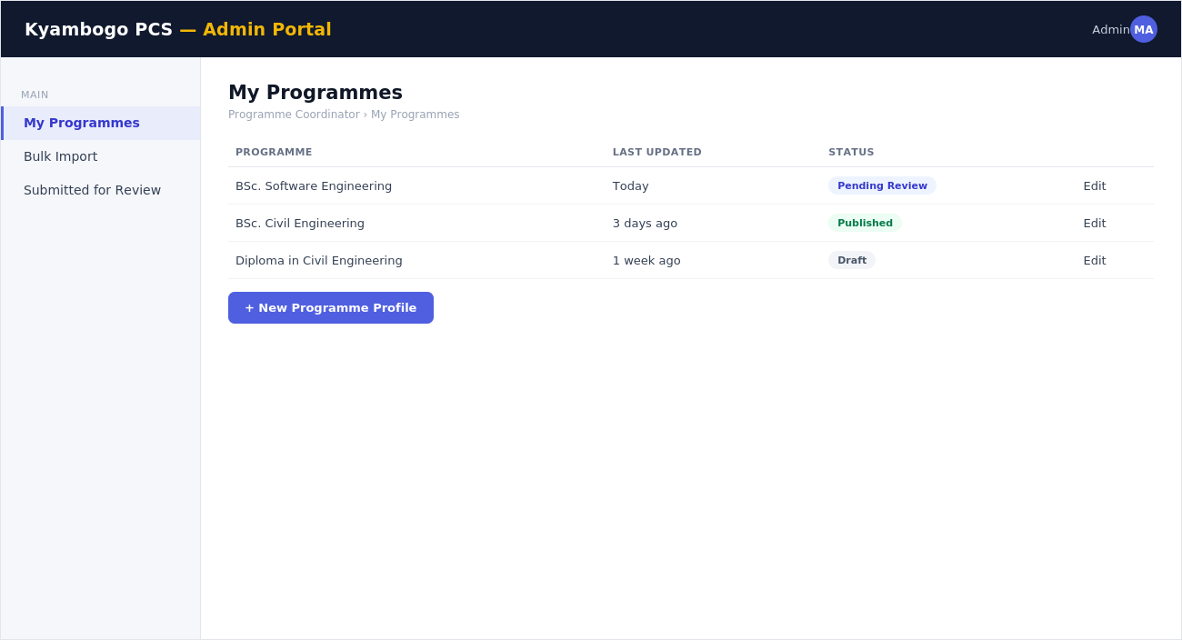
My Programmes (Coordinator) — —
- On screen: every programme this Coordinator is assigned to, with a status pill — Draft, Pending Review, or Published.
- Primary action: + New Programme Profile starts a blank Screen 17 editor.
- Flow: The Coordinator's landing page after login; each row's Edit opens Screen 17.

10. Academic Registrar Front End
The Registrar owns the admissions calendar end-to-end and is the only role that can delegate monitoring to Admissions Officers.
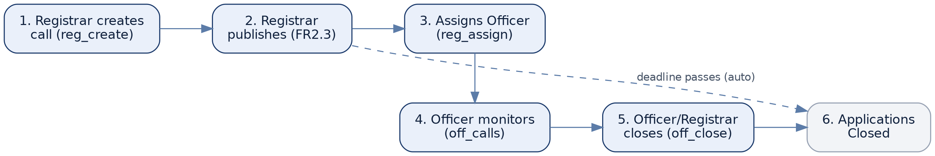
Admissions call lifecycle — from creation to close, automatic or manual.

Screen 20 — Create a Call for Application
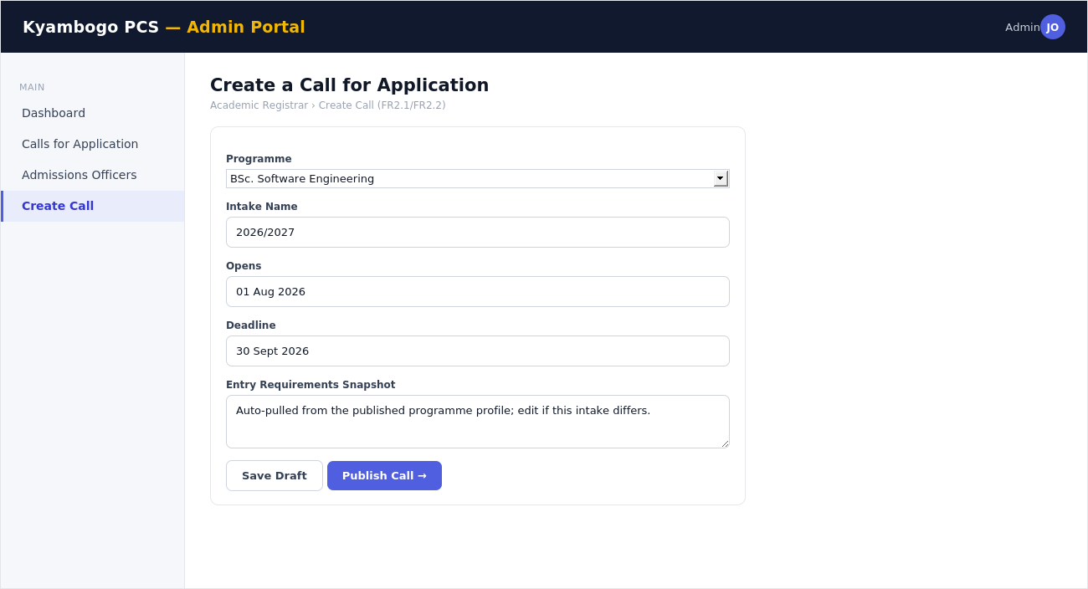
Create a Call for Application (Registrar) — FR2.1/FR2.2
- On screen: programme selector, intake name, open/deadline dates, and an entry-requirements snapshot auto-pulled from the published programme profile (editable per intake).
- Primary action: Publish Call → sets the programme's public status to Applications Open (visible immediately on Screen 1/3).
- Flow: Draft calls can be saved and published later; publishing is the trigger that turns on the applicant-facing Apply Now button.

Screen 21 — Calls for Application List
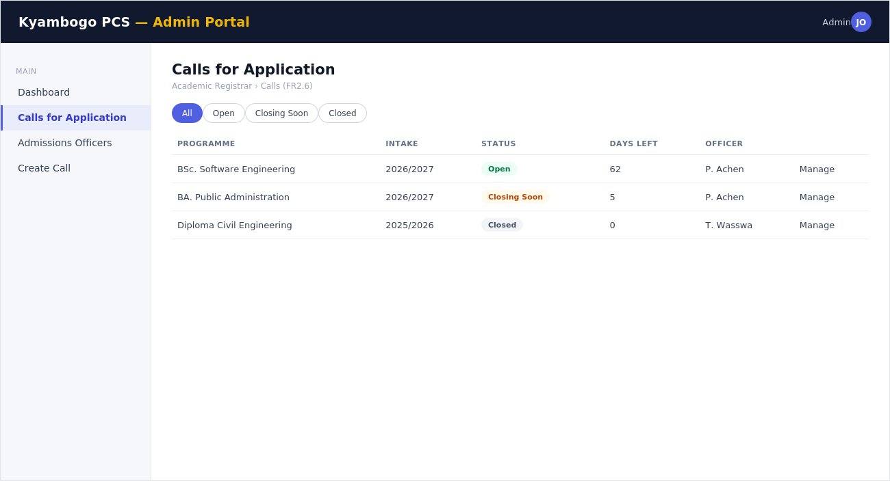
Calls for Application List (Registrar) — FR2.6
- On screen: every call the Registrar owns, filterable by status (Open/Closing Soon/Closed), with days-remaining and the assigned officer visible per row.
- Primary action: Manage → opens the call for editing, reassignment, or manual close.
- Flow: Default landing page after Registrar login; feeds directly from the same data Screen 23 shows the Officer, just unscoped.

Screen 22 — Assign Admissions Officer
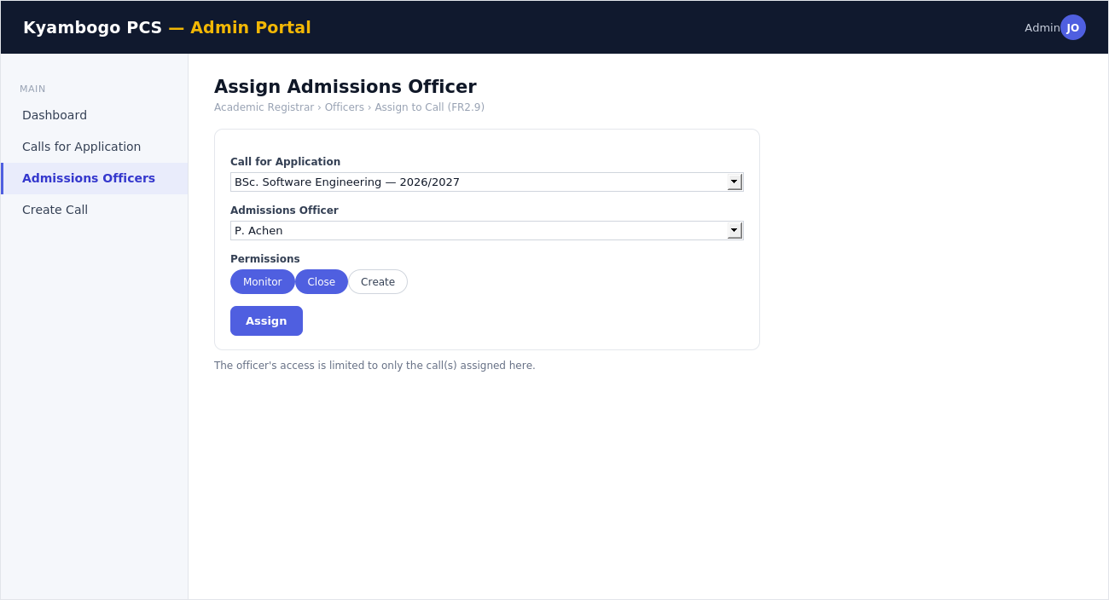
Assign Admissions Officer (Registrar) — FR2.9
- On screen: a call selector, an officer selector, and a permission chip set (Monitor / Close / Create) scoped to that one call.
- Primary action: Assign writes to admissions_officer_assignments — the officer's access is limited to exactly what's granted here.
- Flow: This is what makes Screen 23 show only a subset of Screen 21's full list, per officer.

11. Admissions Officer Front End
The narrowest portal in the system by design (FR2.9) — an Officer sees and can only act on the specific call(s) a Registrar assigned.

Screen 23 — Assigned Calls
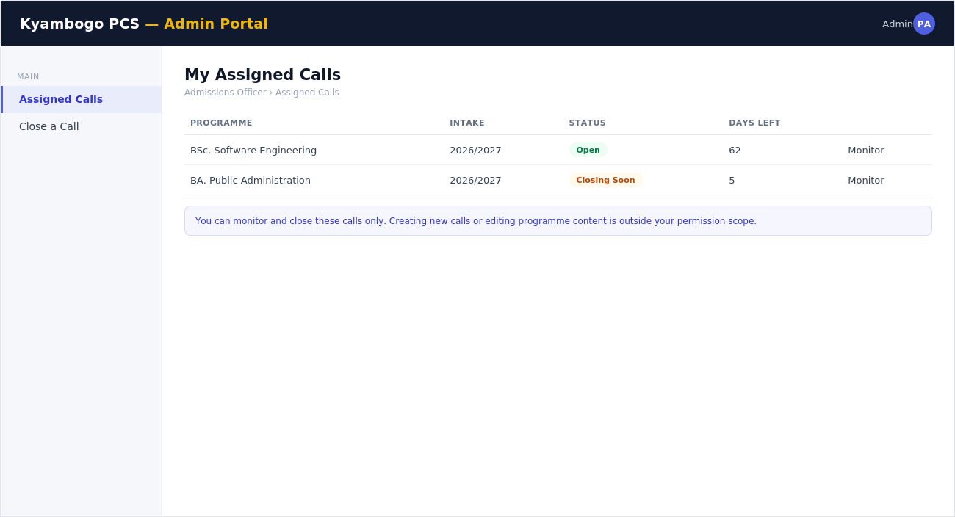
Assigned Calls (Officer) — —
- On screen: only the calls this Officer was assigned (Screen 22), with the same status/days-remaining pattern used everywhere else in the system.
- Primary action: Monitor opens read-level detail on applications volume and status for that call.
- Flow: Default landing page after Officer login.

Screen 24 — Close a Call
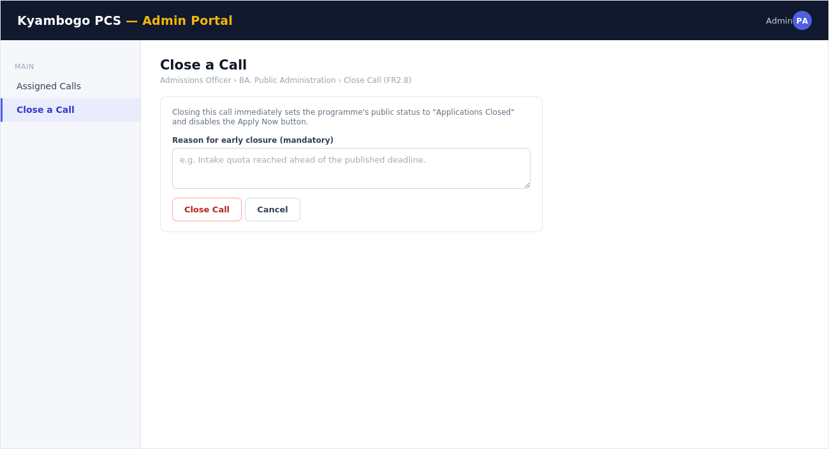
Close a Call (Officer) — FR2.8
- On screen: a warning that closing immediately flips the programme's public status, and a mandatory reason field.
- Primary action: Close Call requires a typed reason — this is written to the audit log alongside who closed it and when.
- Flow: Immediately reflected on the public Programme Profile (Screen 3) — Applications Open becomes Applications Closed.

12. How the Roles Connect
Three flows tie every screen above together. Understanding these is the fastest way to understand the whole front end.

12.1 Account Delegation
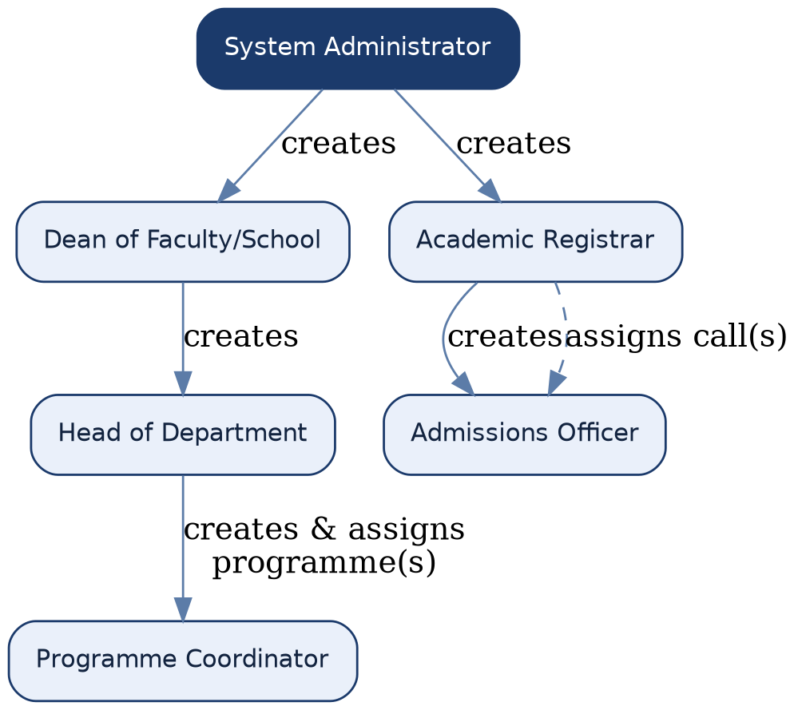
Who creates whom (Section 3.1 of the requirements document).

12.2 Programme Publication
Coordinator (Screen 17) → HOD review (Screen 16) → live on the Public Catalogue (Screens 1/3). See Figure in Section 8.

12.3 Admissions Cycle
Registrar (Screens 20–22) → Officer monitoring (Screens 23–24) → public status badge (Screens 1/3). See Figure in Section 10.

13. Notes for the Team
- All 24 screens use the two shells defined in Section 2 — implement the shells once (React layout components) and every screen in this document becomes a content slot inside one of them.
- Status pill colours (green/amber/grey/red) are used identically across every role's screens — keep that mapping centralised in the front-end code, not re-implemented per screen.
- This document intentionally stays low-fidelity. Once the visual design system is confirmed (see the companion System Design document, Section 8), re-skin these frames rather than starting new layouts.
- The Screen Inventory (Section 1.1) is a good checklist for sprint planning — one card per screen, cross-referenced to its FR/SEC/P code for traceability.

