KYAMBOGO UNIVERSITY
Centralized Programme Catalogue and Application Information System
System Design & Visual Blueprint
Information Architecture · Architecture · Data Model · Interface Contract · Skeleton Screens
Companion, illustrated edition of the System Design, Interfaces & Skeleton Screens document
paired with Module 0 — User Management (SDLC, Process Flows and Functional Requirements)
Prepared for: Kyambogo University Programme Catalogue & Admissions Project Team
Organised by: Gumisiriza Joel and Ochieng Charles
July 2026

Table of Contents
Table of Contents 1
1. Purpose, Scope & How to Use This File 1
1.1 What is new in this edition 1
1.2 Related documents 1
2. Programme Catalogue — Information Architecture Redesign 1
2.1 What we kept from Kampala International University 1
2.2 What we improved beyond both sites 1
2.3 Proposed site map 1
3. System Architecture 1
3.1 Key architectural decisions 1
4. Database Design 1
4.1 Entity notes 1
5. User Roles, Hierarchy & Delegation 1
5.1 Roles at a glance 1
5.2 Permission summary by function 1
6. API / Interface Contract (Summary) 1
6.1 Module 0 — User Management (selected endpoints) 1
6.2 Module 1 — Course Profiling 1
6.3 Module 2 — Admissions 1
6.4 Module 3 — AI Navigation 1
7. Skeleton Screens — Public Catalogue 1
7.1 Home & category browse 1
7.2 Programme profile with embedded AI assistant 1
8. Skeleton Screens — Admin Portal: Onboarding 1
9. Skeleton Screens — Admin Portal: System Administration 1
10. Skeleton Screens — Admin Portal: Course Profiling Workflow 1
11. Skeleton Screens — Admin Portal: Admissions Workflow 1
12. Notes for the Team & How to Extend This File 1

1. Purpose, Scope & How to Use This File
This document is a customisable, illustrated companion to the team's System Design, Interfaces & Skeleton Screens document and the Module 0 — User Management specification. It translates the agreed functional requirements, process flows and API contract into a single visual blueprint: an improved public-catalogue information architecture, a system architecture diagram, a conceptual data model, and a full set of annotated skeleton screens covering every accredited role, not only the System Administrator.
Every diagram in this file was generated as an editable figure and embedded as an image so the whole document can be revised in Microsoft Word: headings use Word's built-in heading styles (so the Table of Contents above updates automatically — right-click it and choose “Update Field” after any edits), tables can be extended with new rows, and captions reference the functional (FR), non-functional (NFR) and security (SEC) requirement codes they satisfy so any change can be traced back to its source requirement.
To customise: replace placeholder names/dates on the cover page, edit any heading or paragraph directly, and if you change a diagram, regenerate it from the source files the team maintains and re-insert the image at the same position. Tables (API contract, roles, permissions) are plain Word tables — add or remove rows as the design evolves.

1.1 What is new in this edition
- A benchmarked, improved information architecture for the public programme catalogue (Section 2), designed against Kampala International University's catalogue-view page and against Kyambogo University's current, unfiltered undergraduate-programmes listing.
- A redrawn, single-source system architecture and entity-relationship diagram (Sections 3–4).
- A complete skeleton-screen set covering all six accredited roles — System Administrator, Dean, HOD, Programme Coordinator, Academic Registrar and Admissions Officer — not only the System Administrator screens shown in the original design pass (Sections 7–11).

1.2 Related documents
- Kyambogo_PCS_SystemDesign.docx — the original system design, interfaces and skeleton-screens pass this file extends.
- Kyambogo_PCS_Module0_UserManagement.docx — the authoritative source for the full functional, non-functional and security requirements (FR/NFR/SEC), process flows, and the permission/CRUD matrices summarised in this file.

2. Programme Catalogue — Information Architecture Redesign
The public catalogue is the system's most-used surface — it is where every applicant's journey starts (P1.4/P1.5). Before finalising its layout, we benchmarked two live examples: Kyambogo University's current undergraduate-programmes page, and Kampala International University's programme catalogue, which uses a cleaner qualification-level entry point. The comparison below informed the information architecture proposed for this system, which combines the strongest ideas from both with capabilities neither site currently offers (live application-status, faculty browsing, and AI-assisted search).
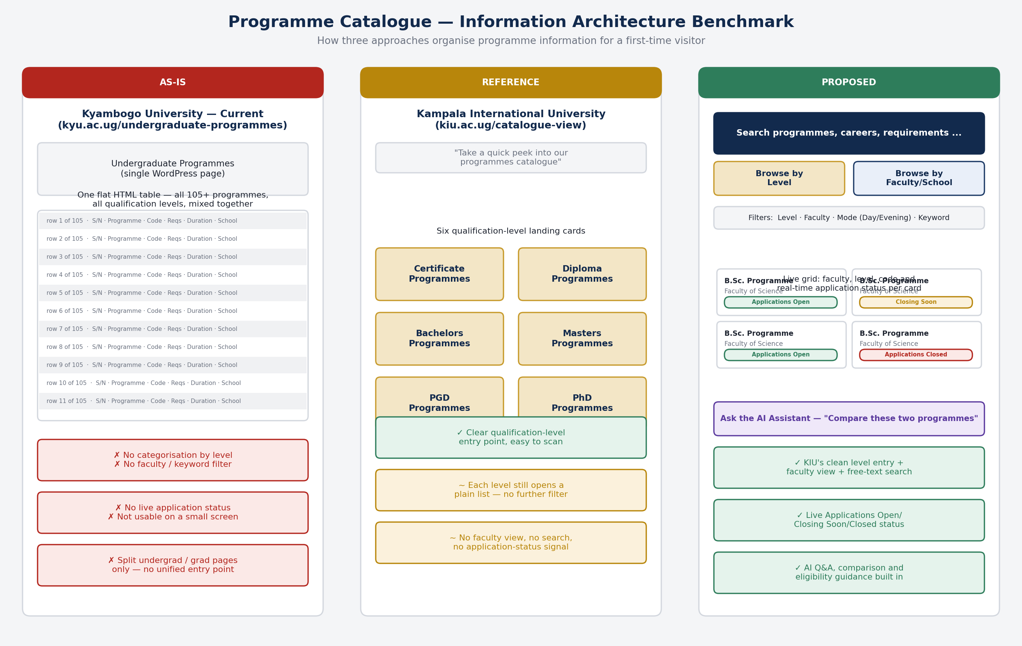
Figure 1 — Catalogue information-architecture benchmark: Kyambogo University (as-is) vs. Kampala International University (reference) vs. the proposed Kyambogo PCS design.

2.1 What we kept from Kampala International University
- A clear, qualification-level landing point (Certificate / Diploma / Bachelor's / Postgraduate) so a first-time visitor immediately narrows 100+ programmes to a manageable set — KYU's current site offers no equivalent first filter.
- A card-based visual language rather than a dense HTML table, which is far more usable on the mobile devices most applicants use to browse.

2.2 What we improved beyond both sites
- Dual entry points: browse by qualification level (as KIU does) or by faculty/school (which neither site offers cleanly) — useful for a visitor who already knows they want to study, say, Engineering, but not yet which programme.
- A persistent keyword/free-text search across programme titles, careers and requirements, absent from both reference sites.
- Live application-status badges (Applications Open, Closing Soon, Applications Closed) driven directly by Module 2's calls-for-application data (FR2.6), so the catalogue never shows a stale “Apply” option for a closed intake — a gap in both KYU's and KIU's current listings.
- An embedded AI assistant (Module 3) for programme Q&A, side-by-side comparison and indicative eligibility checking, docked on every catalogue page — a capability neither benchmarked site has.

2.3 Proposed site map
The structure below keeps every programme reachable within two clicks of the home page, whichever entry point (level, faculty, or search) the visitor chooses.
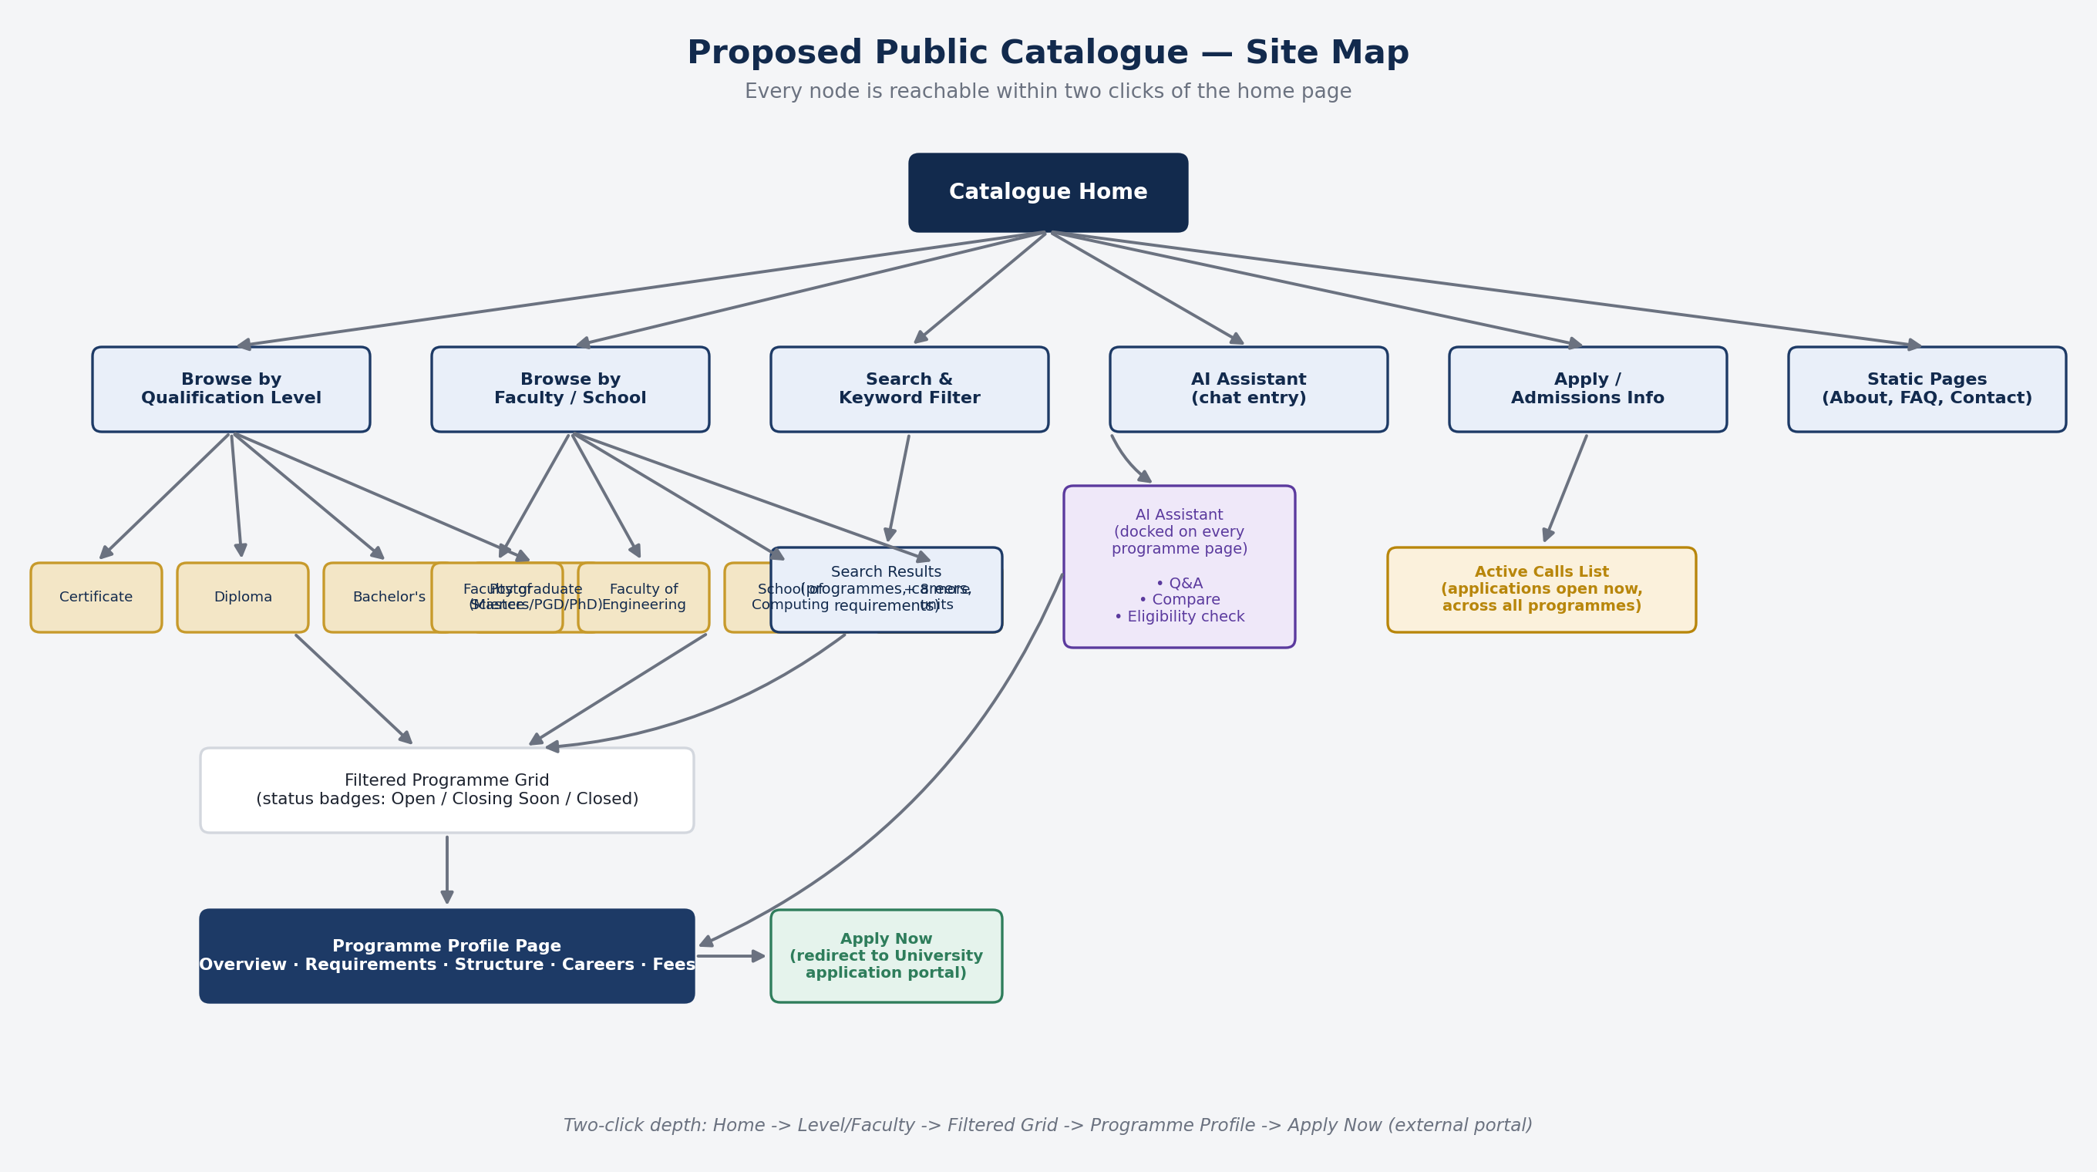
Figure 2 — Proposed public catalogue site map. Implements P1.4/P1.5, FR1.11–FR1.14, and the Apply Now redirect (P2.6).

3. System Architecture
The system is layered so that every request — whether from the public catalogue or the admin portal — passes through the same authentication, authorization and audit-logging layer before reaching a module. This directly implements the requirement that Module 0 “underpins every other module” and that role-based access control is enforced server-side, not only in the UI (SEC5.1).
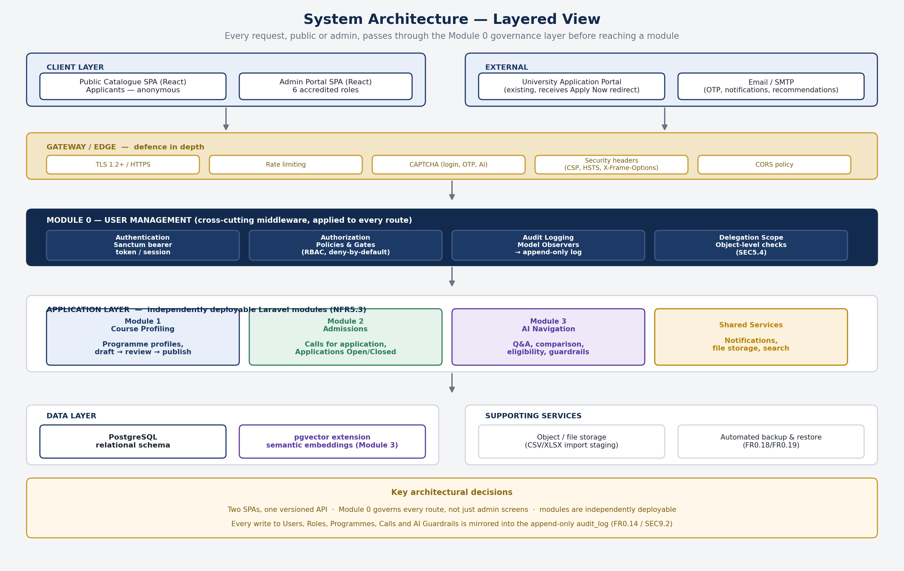
Figure 3 — High-level layered architecture: client, gateway, Module 0 middleware, application modules, data layer and supporting services.

3.1 Key architectural decisions
- Two SPAs, one API. The public catalogue and the admin portal are separate React applications so the much larger admin surface (six roles, dozens of screens) is never shipped to anonymous applicants — both consume the same versioned Laravel API.
- Module 0 as middleware, not just a module. Authentication (Sanctum), RBAC (Policies/Gates) and audit logging (Model Observers) are cross-cutting concerns applied to every route, matching the requirement that the System Administrator's own account — and every other account — is governed by the same rules.
- Independent deployability (NFR5.3). Modules 0–3 are organised as separate Laravel modules/service providers sharing one database in the initial deployment, so a Module 3 (AI) change does not require redeploying Module 1 or 2.
- Defence in depth at the gateway. Rate limiting and CAPTCHA sit in front of login, OTP and AI endpoints (SEC10.1/SEC10.2); security headers (CSP, HSTS, X-Frame-Options) are set on every response (SEC8.2).
- Ky design system. All admin screens are built from one reusable component kit (buttons, fields, modals, confirms, toasts, empty/skeleton states, stat cards, countdowns); brand = KYU blue #1B5EA9, orange #F8B13A, dark-navy sidebar; real KYU data (motto, faculties/departments, apply-portal URL) used throughout.
- RBAC architecture. A single navigation/permission configuration drives sidebar visibility plus a 403 route guard; dashboards are role-aware (each role gets its own stats, actions and focus panel; the audit trail is SysAdmin-only).
- Data strategy. The prototype runs on mocks shaped exactly like /api/v1 responses; one services layer is the swap point; integration order = login/token → read programmes → write accounts → pipeline → calls.
- Status vocabulary (database contract). users active/pending/locked/suspended/inactive; programmes draft/submitted/hod-reviewed/published/rejected; calls draft/open/closed (+ derived closing-soon); staff permanent/temporary/part-time/contract; officer per-call permissions create/monitor/close.

4. Database Design
The entity-relationship diagram below covers the entities Module 0 owns directly, plus the cross-module foreign keys it must enforce for referential integrity (NFR6.1). It is a conceptual model — the attribute-level physical schema (types, indexes, constraints) remains the Database & Security lead's detailed deliverable, built on this structure.
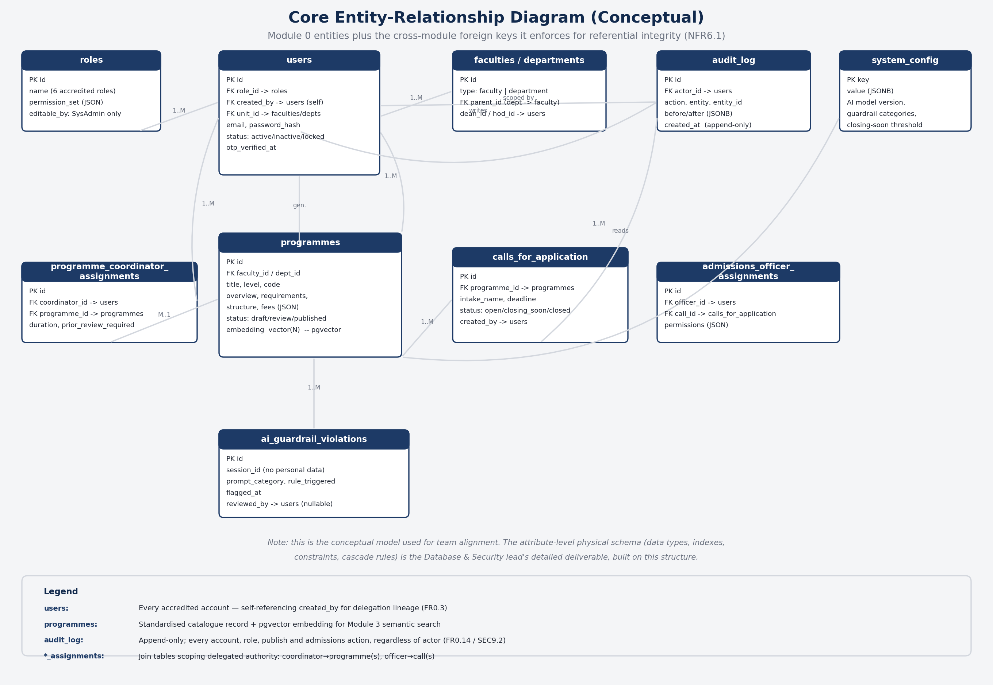
Figure 4 — Core entity-relationship diagram (conceptual).

4.1 Entity notes
Entity | Notes
users | Every accredited account (SysAdmin → Dean → HOD → Coordinator, Registrar → Officer). One role per account (FR0.3). Self-referencing created_by for delegation lineage.
roles | The six accredited roles and their permission sets; editable only by SysAdmin (FR0.13).
faculties / departments | Academic units; a faculty has a Dean, a department has an HOD, scoping every query beneath them (SEC5.2).
programmes | Standardised metadata record per catalogue entry, plus a pgvector embedding column for Module 3 semantic search.
programme_coordinator_assignments | Join table: which Coordinator owns which programme(s), for what duration, and whether prior review is required.
calls_for_application | One row per intake; drives the Applications Open/Closing Soon/Closed state shown on the programme page.
admissions_officer_assignments | Join table: which Officer may create/monitor/close which specific call(s).
audit_log | Append-only; every account, role, publish and admissions action is written here regardless of who performed it (FR0.14, SEC9.2).
ai_guardrail_violations | Flagged AI responses, retained for the project team's Maintenance & Review stage (FR3.12).
system_config | Key/value store for AI model version, closing-soon threshold, guardrail categories (FR0.20–FR0.22).

5. User Roles, Hierarchy & Delegation
Seven distinct user roles interact with the system: one public-facing role (the Applicant) and six accredited roles that hold a system account, all created, governed and audited through Module 0. Account creation is deliberately delegated rather than centralised entirely with the System Administrator — this keeps the person creating an account close to the person they are creating it for, while Module 0 still gives the System Administrator system-wide visibility, override and audit capability over every account regardless of who created it.
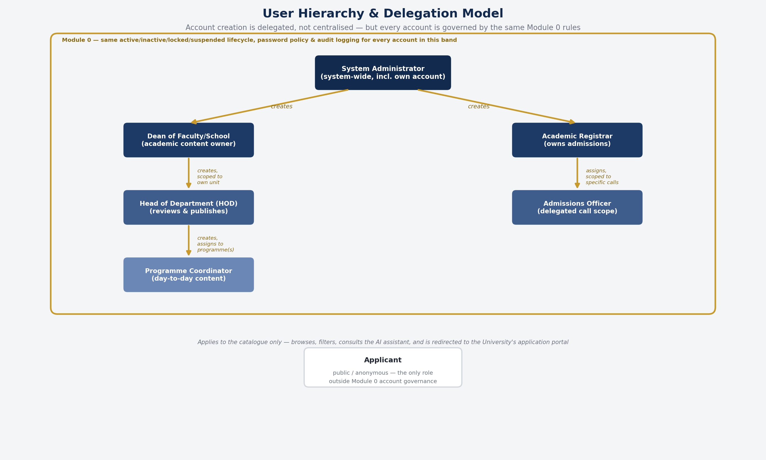
Figure 5 — User hierarchy and delegation model. Every account inside the gold boundary shares the same lifecycle, password policy and audit logging.

5.1 Roles at a glance
Role | Creates / Delegates To | Scope
System Administrator | Dean of Faculty/School; Academic Registrar | System-wide; the only role that can view and manage every account in every unit.
Dean of Faculty/School | Head of Department (HOD) | Limited to HOD accounts within the Dean's own faculty/school.
Head of Department (HOD) | Programme Coordinator | Limited to Coordinator accounts within the HOD's own department, and the programme(s) assigned.
Academic Registrar | Admissions Officer | Limited to Officer accounts within the Registrar's division, and the calls assigned to them.
Programme Coordinator | — | Populates and maintains content for assigned programme(s); submits for HOD review or publishes directly.
Admissions Officer | — | Delegated tasks on the specific call(s) the Registrar assigned.

5.2 Permission summary by function
Module | Function | Applicant | Dean | HOD | Coordinator | Registrar | Officer | SysAdmin
Catalogue | View programmes | ✓ | ✓ | ✓ | ✓ | ✓ | ✓ | ✓
Catalogue | Create / edit programme | ✗ | ✗ | ✗ | ✓ | ✗ | ✗ | ✓
Catalogue | Review & publish | ✗ | Publish/Reject | Forward/Reject | Submit only | ✗ | ✗ | Publish on behalf
Admissions | Create application call | ✗ | ✗ | ✗ | ✗ | ✓ | ✓* | ✗
Admissions | Close application call | ✗ | ✗ | ✗ | ✗ | ✓ | ✗ | ✗
AI | Ask questions | ✓ | ✓ | ✓ | ✓ | ✓ | ✓ | ✓
Users | Create Dean / Registrar | ✗ | ✗ | ✗ | ✗ | ✗ | ✗ | ✓
Users | View / manage all accounts | ✗ | ✗ | ✗ | ✗ | ✗ | ✗ | ✓
* scoped strictly to the actor's own delegated unit, faculty, department, division or assignment. See Module 0 §7.1–7.2 for the full permission and CRUD matrices.

6. API / Interface Contract (Summary)
All endpoints are versioned under /api/v1, require HTTPS/TLS 1.2+ (SEC4.6), and authenticate via a Sanctum bearer token or first-party session cookie with a matching X-XSRF-TOKEN header on state-changing requests (SEC3.1). Every endpoint enforces RBAC server-side and rejects by default when no explicit permission rule matches (SEC5.3). The tables below are a first-pass contract for team alignment; confirm field-level request/response shapes with whoever owns each module before implementation.

6.1 Module 0 — User Management (selected endpoints)
Method | Endpoint | Description | Access
POST | /auth/login | Authenticate; issues a Sanctum session/token. | Public
POST | /auth/otp/verify | Verifies onboarding OTP, activates account. | Public (invited)
GET | /users | Lists accounts, scoped to caller's delegation level. | SysAdmin/Dean/HOD/Registrar
POST | /users | Creates an account within caller's allowed delegation. | SysAdmin/Dean/HOD/Registrar
POST | /users/{id}/deactivate | Deactivates an account; blocks further login. | Scoped
PATCH | /roles/{id}/permissions | Alters role permissions; requires step-up re-auth. | SysAdmin
GET | /audit-log | Queries the append-only audit trail. | SysAdmin
POST | /system/backup | Triggers a manual full database backup. | SysAdmin
GET | /system/health | Uptime, active sessions, recent errors, backup status. | SysAdmin
POST | /auth/password/forgot | Sends a secure, single-use reset link (30-minute expiry). | Public
POST | /auth/password/reset | Sets a new password from a valid token; invalidates other sessions. | Public (token)
PATCH | /system/config | Updates the closing-soon threshold and system settings. | SysAdmin
POST | /system/restore | Restores from a selected backup; step-up re-auth required. | SysAdmin

6.2 Module 1 — Course Profiling
Method | Endpoint | Description | Access
GET | /programmes | Public listing; filter by category, faculty, keyword. | Public
GET | /programmes/{id} | Public profile; only published data is ever returned. | Public
POST | /programmes | Creates a new programme profile (draft). | Coordinator
PATCH | /programmes/{id} | Edits a profile the coordinator is assigned to. | Coordinator
POST | /programmes/{id}/submit-for-review | Submits a draft to the HOD when prior review is enabled. | Coordinator
POST | /programmes/{id}/publish | Approves and publishes a profile. | Dean (single final publisher); SysAdmin on behalf
POST | /programmes/bulk-import | Bulk-populates structural fields from CSV/XLSX. | Coordinator
POST | /programmes/{id}/recommend | Dean submits a change recommendation. | Dean
POST | /programmes/{id}/forward | HOD forwards a reviewed submission to the Dean. | HOD
POST | /programmes/{id}/reject | Rejects with optional comment; returns to Coordinator. | HOD / Dean
DELETE | /programmes/{id} | Deletes a programme; step-up; blocked while an active call exists. | SysAdmin

6.3 Module 2 — Admissions
Method | Endpoint | Description | Access
POST | /programmes/{id}/calls | Creates a call for application against a programme. | Registrar / Officer*
POST | /calls/{id}/publish | Publishes the call; sets programme status to Applications Open. | Registrar / Officer*
GET | /calls/{id} | Reads a call's status and days-remaining. | Registrar/Officer/Public (status only)
POST | /calls/{id}/close | Closes a call manually with a mandatory reason. | Registrar; Officer only if explicitly delegated (off by default)

6.4 Module 3 — AI Navigation
Method | Endpoint | Description | Access
POST | /ai/chat | Programme Q&A; answers grounded only in published Module 1 data. | Public (session)
POST | /ai/compare | Structured side-by-side comparison of named programmes. | Public (session)
POST | /ai/eligibility | Indicative eligibility read against admission requirements. | Public (session)
GET | /ai/guardrail-violations | Reviewable log of flagged AI responses. | SysAdmin
Every /api/v1/ai/* request is checked against the guardrail rules (P3.4) before a response is returned: no personal data is retained beyond the session (FR3.8), no system-internal details are exposed (FR3.9), and responses are gender- and politically/religiously neutral (FR3.10/FR3.11). Violations are logged, not silently dropped (FR3.12).

7. Skeleton Screens — Public Catalogue
The wireframes below are deliberately low-fidelity — they establish layout, information hierarchy and which functional requirement each element satisfies, ahead of visual design. Annotations reference the FR/SEC/P codes they implement.

7.1 Home & category browse
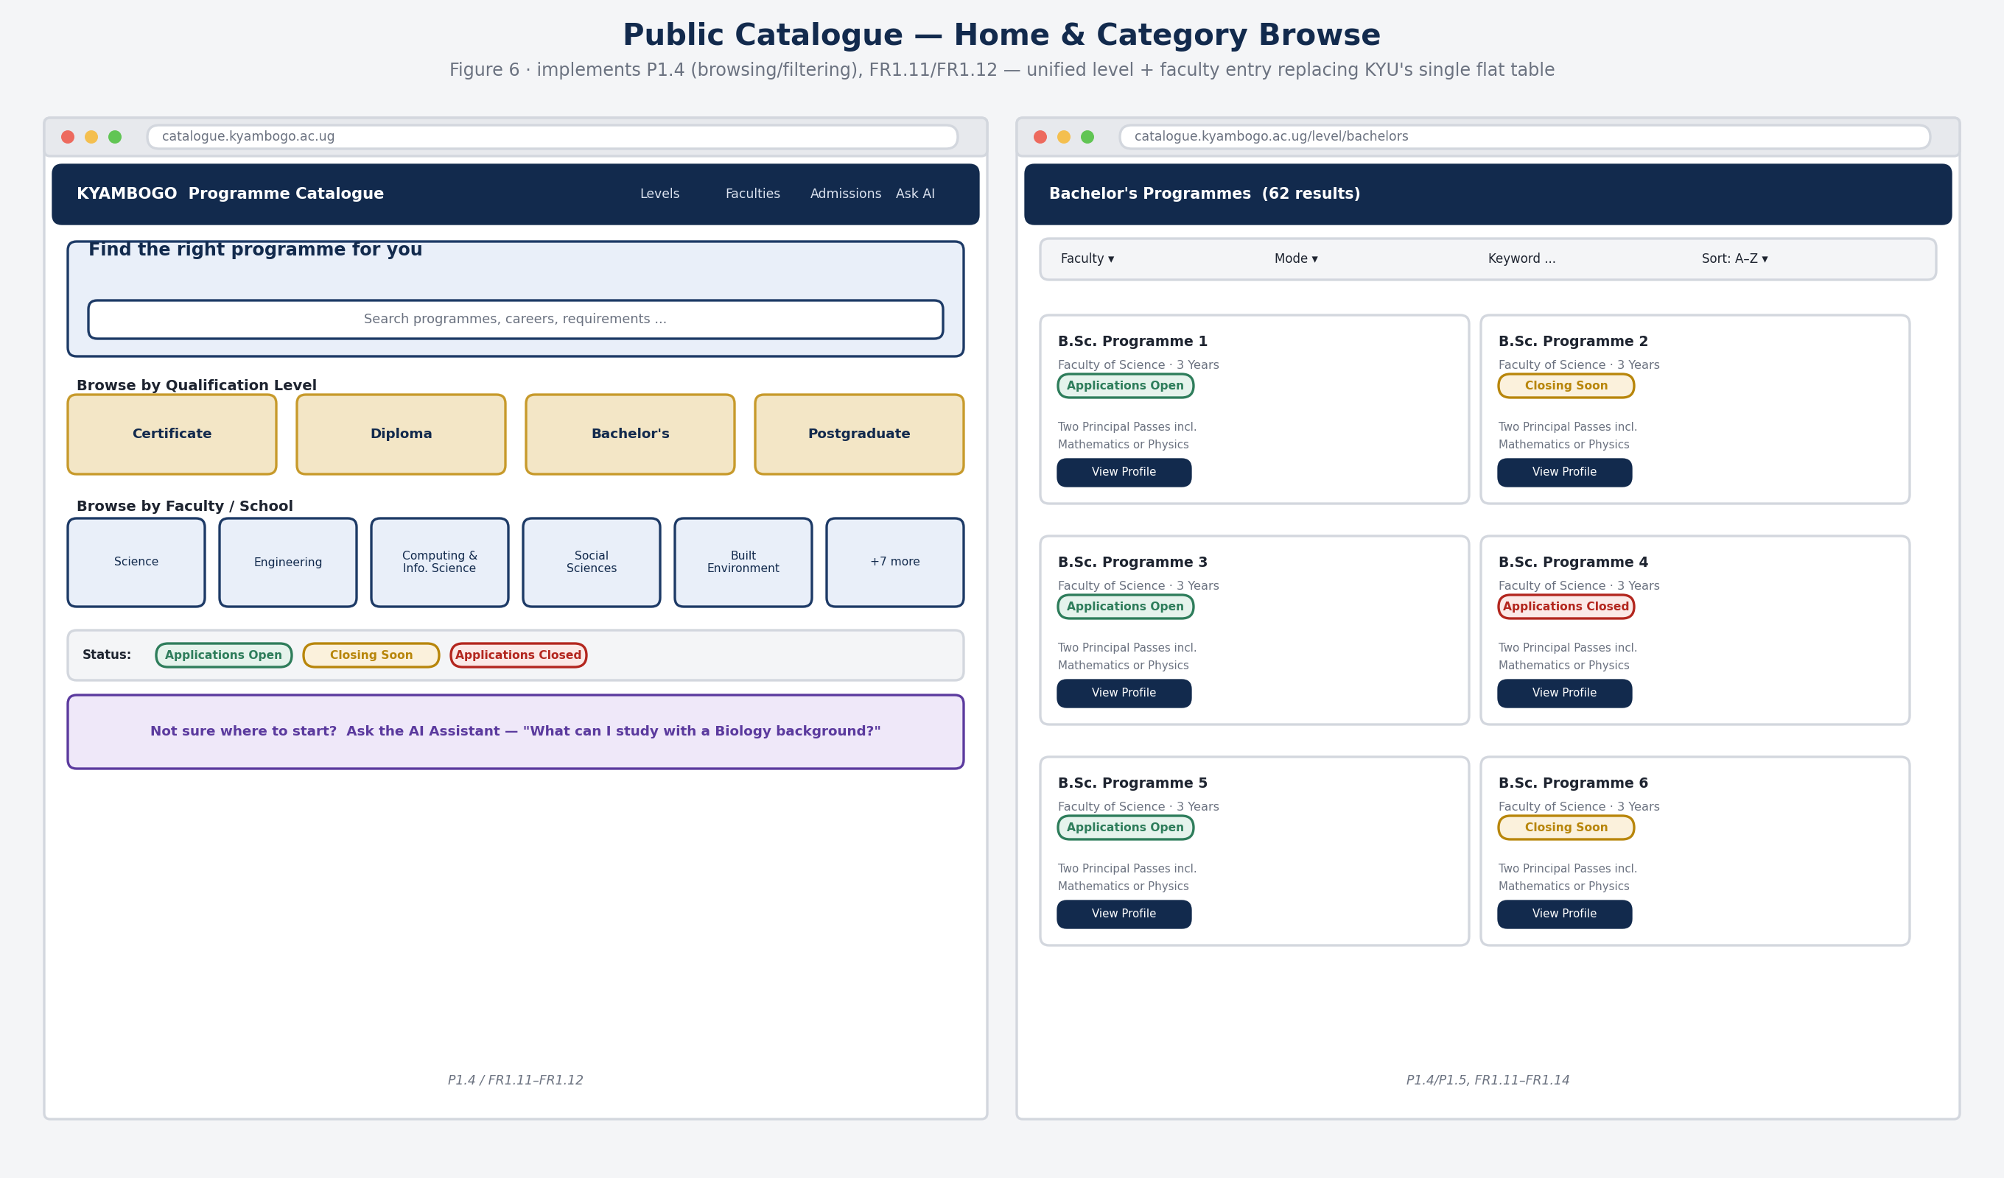
Figure 6 — Catalogue home (level + faculty entry, search, status legend, AI teaser) and filtered category results grid.

7.2 Programme profile with embedded AI assistant
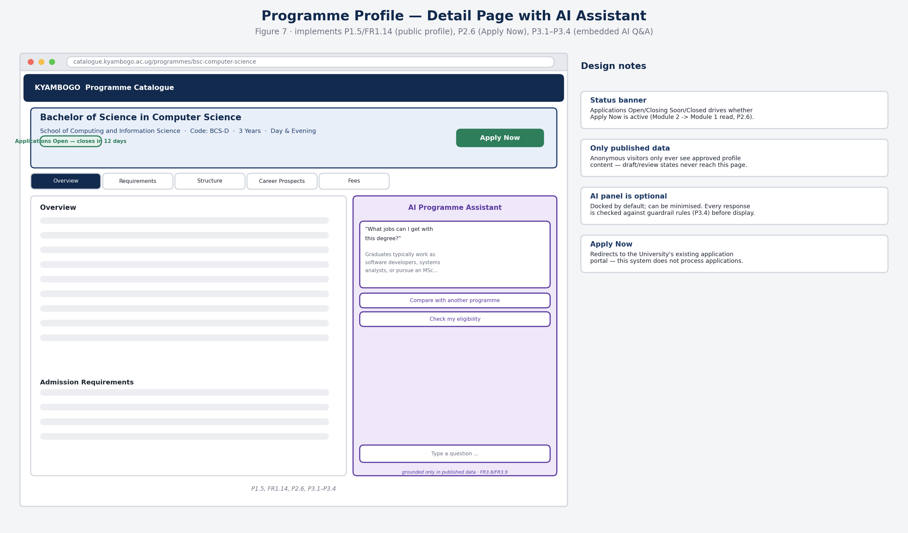
Figure 7 — Programme profile page: content tabs, live application-status banner, Apply Now action, and the docked AI assistant panel.

8. Skeleton Screens — Admin Portal: Onboarding
Every accredited account — regardless of role — follows the same three-step onboarding sequence: credential sign-in, OTP verification, and password set-up. This consistency is deliberate: it is the same lifecycle that governs the System Administrator's own account (Module 0, Section 3.1 note).
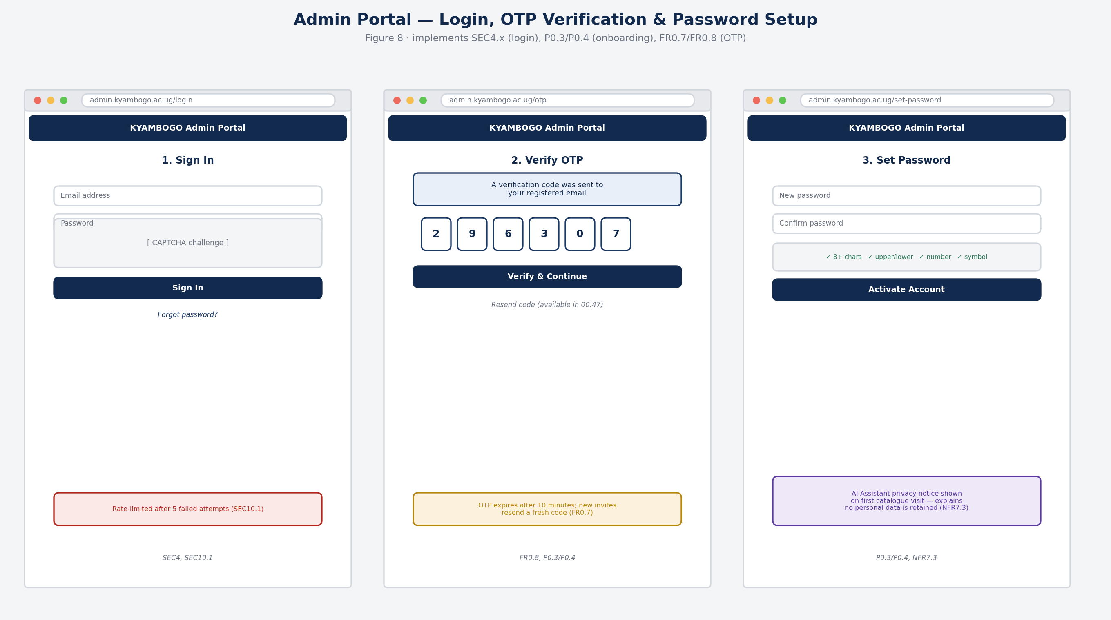
Figure 8 — Admin login (SEC4.x), OTP verification (FR0.7/FR0.8) and password set-up during onboarding (P0.3/P0.4).

9. Skeleton Screens — Admin Portal: System Administration
The System Administrator's screens combine top-level account creation with system-wide oversight: health, audit activity, guardrail trends and backup/restore controls. All System Administrator actions are themselves written to the same audit log used to govern every other role.
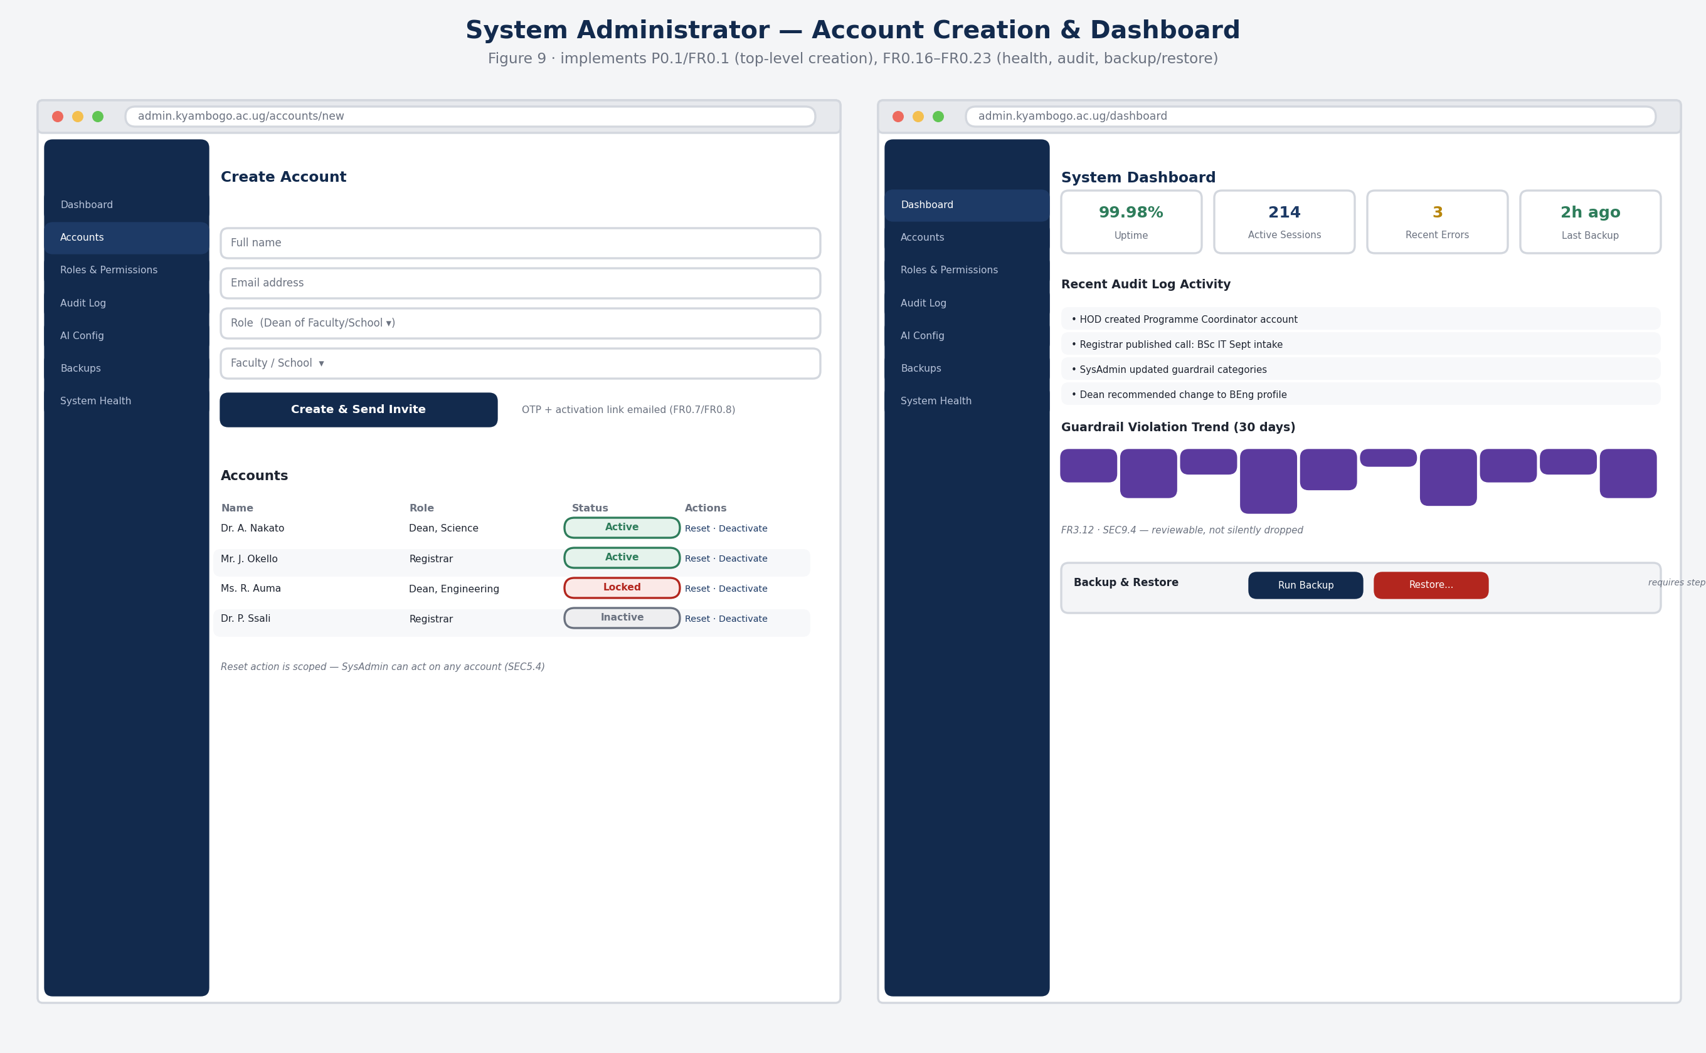
Figure 9 — SysAdmin: top-level account creation (P0.1, FR0.1) and the system health / audit / guardrail / backup dashboard (FR0.16–FR0.23).

10. Skeleton Screens — Admin Portal: Course Profiling Workflow
Programme content flows from Coordinator to HOD to Dean. A Coordinator edits and either submits for review or publishes directly, depending on how the HOD has configured prior review (FR1.5); the HOD's review queue and the Dean's faculty-wide oversight view sit alongside it.
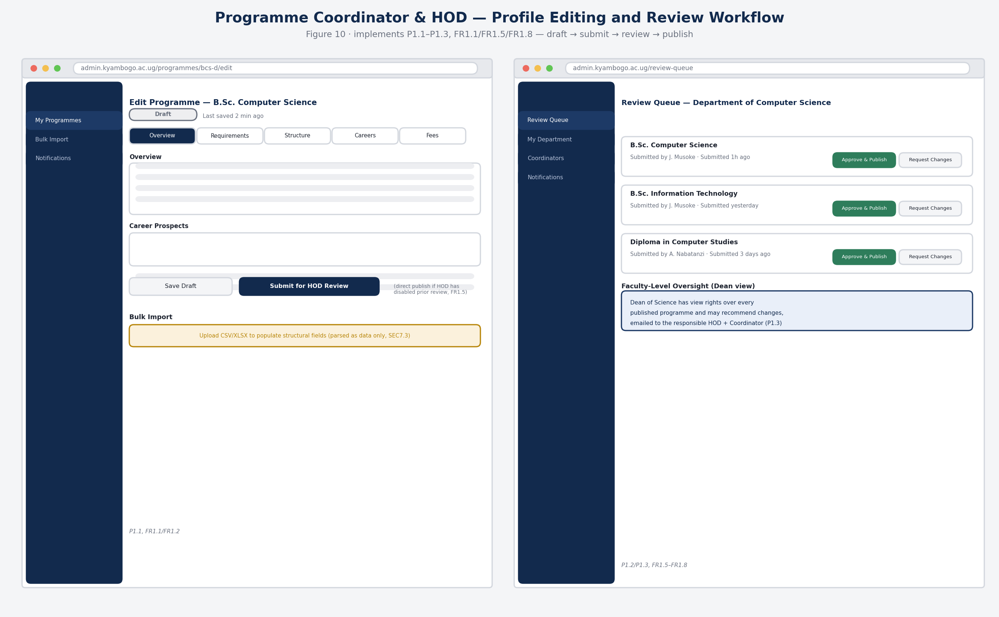
Figure 10 — Programme Coordinator profile editor (draft → submit) and HOD review queue with Dean oversight panel (P1.1–P1.3, FR1.1/FR1.5/FR1.8).

11. Skeleton Screens — Admin Portal: Admissions Workflow
The Academic Registrar owns the full lifecycle of a call for application — creation, publication, monitoring and closure — and may delegate scoped tasks on specific calls to an Admissions Officer. Publishing a call synchronises the programme's public status instantly.
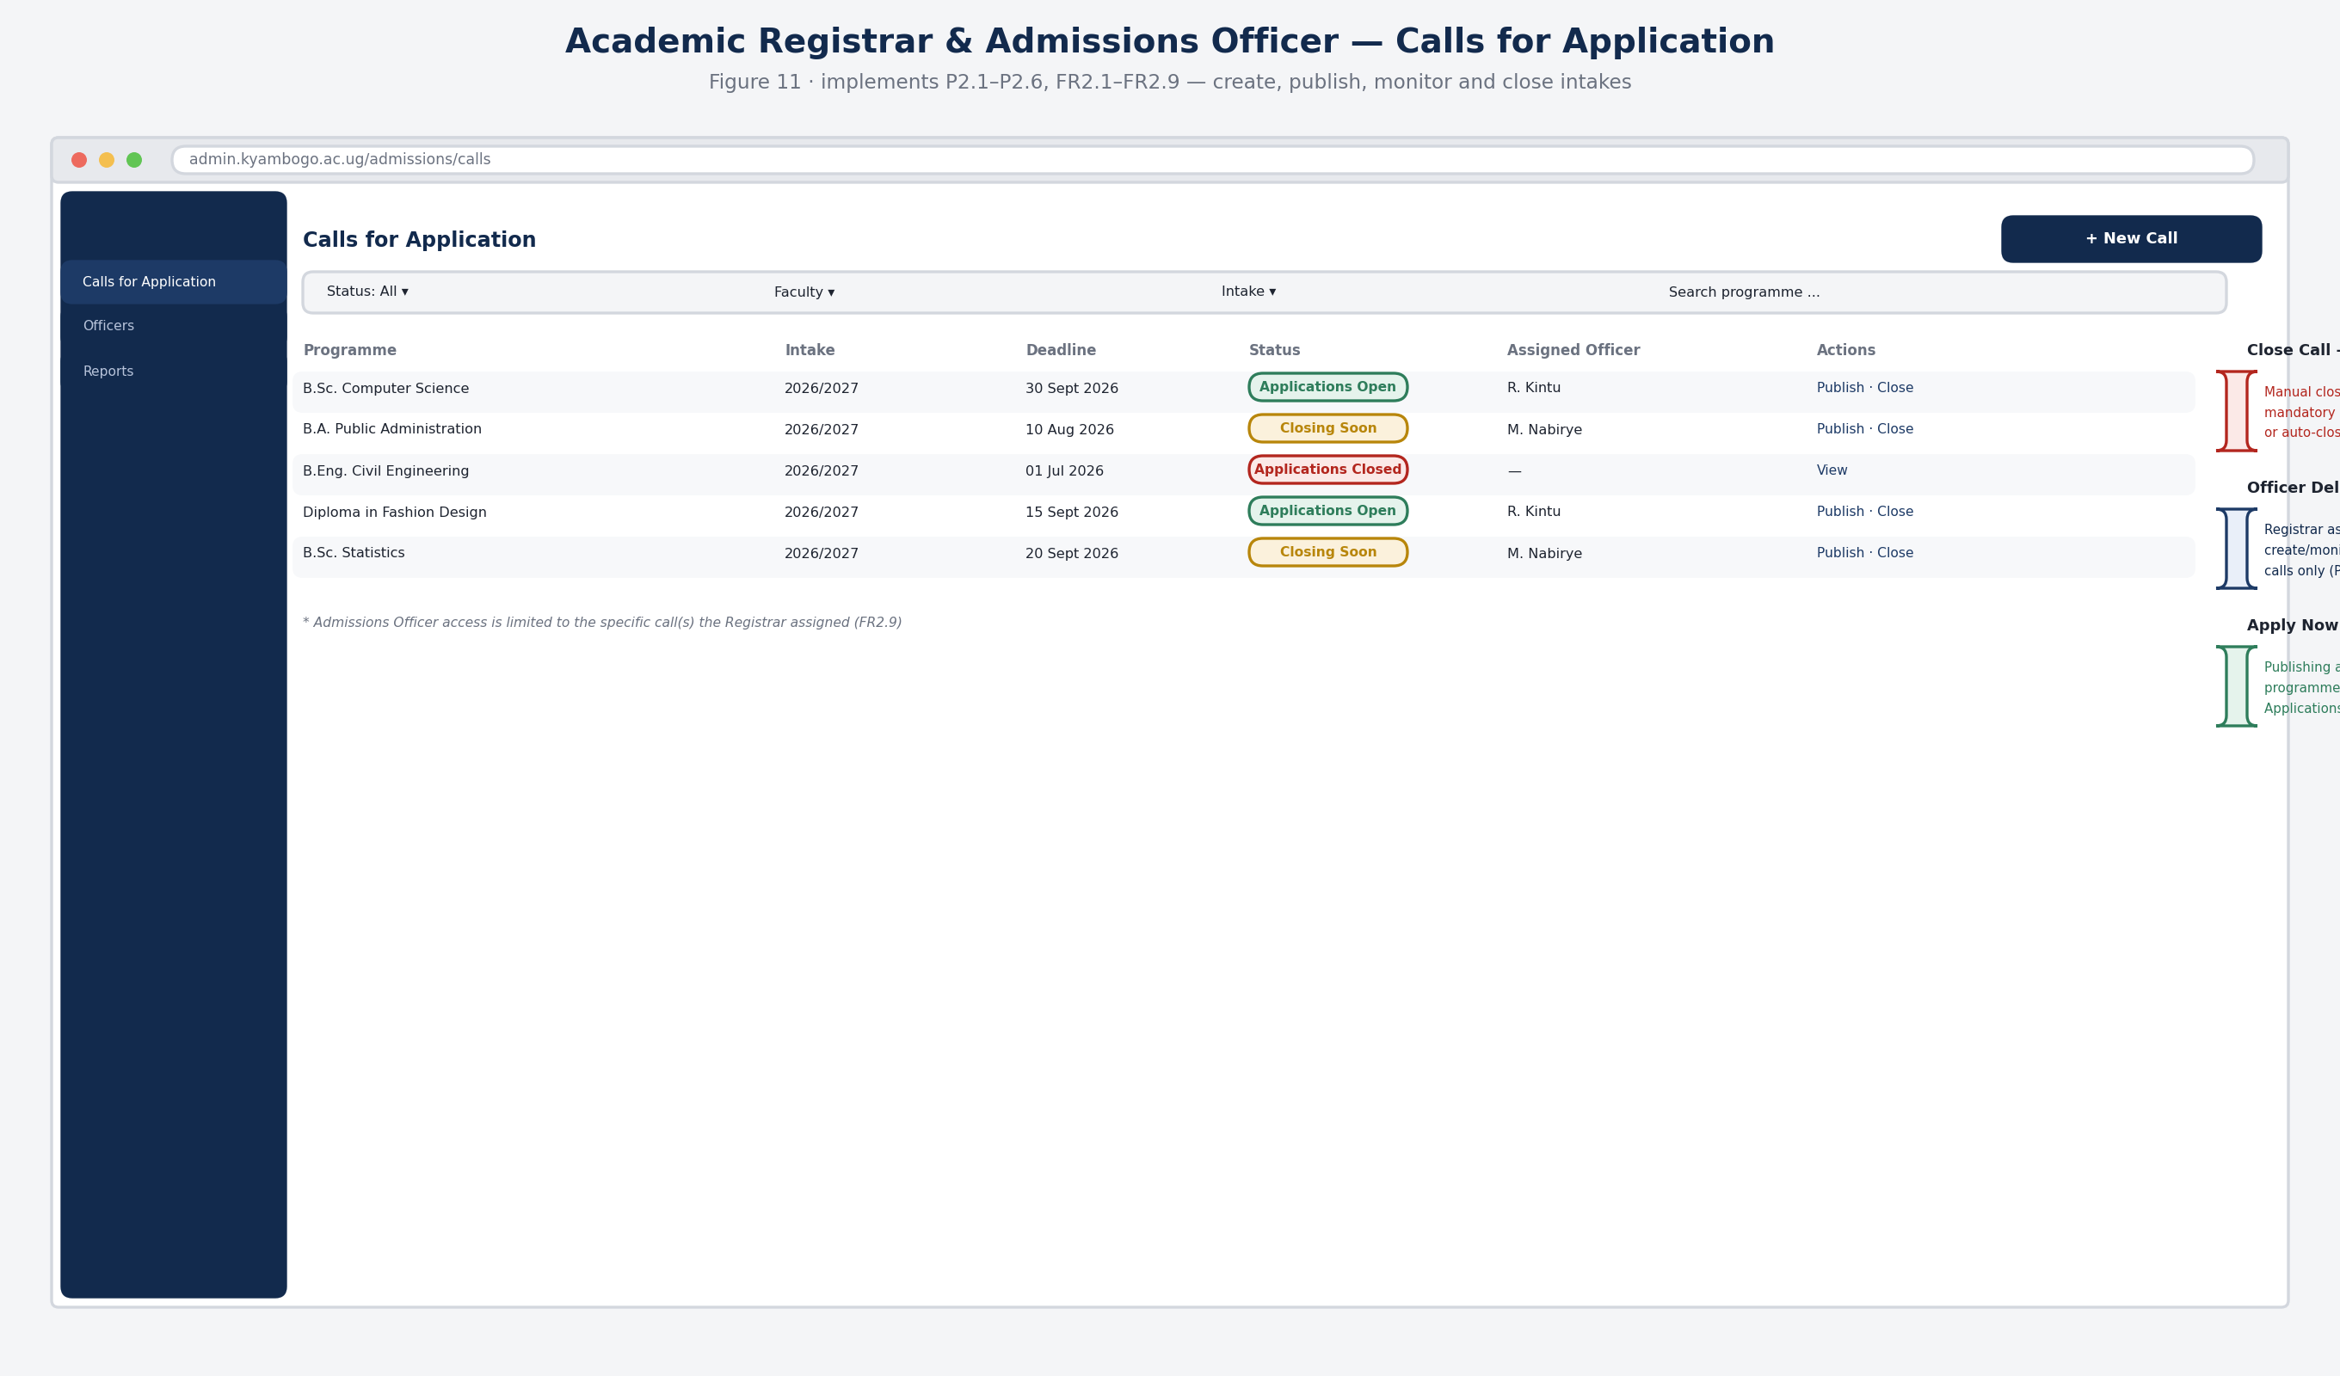
Figure 11 — Calls-for-application dashboard: filterable list, status badges, close-with-reason, and officer delegation (P2.1–P2.6, FR2.1–FR2.9).

12. Notes for the Team & How to Extend This File
- This design is scoped from the current Module 0 and System Design documents; every screen shown follows the same admin-portal shell, scoped by role (Section 3.1 delegation model in Module 0).
- The API tables in Section 6 are a first-pass contract for team alignment — confirm field-level request/response shapes with whoever owns each module before implementation starts.
- The ERD (Section 4) is conceptual; the Database & Security lead should treat it as a starting point for the physical schema, indexes and constraint definitions.
- The catalogue information architecture in Section 2 is a recommendation, not a final visual design — once agreed, hand it to whoever builds the high-fidelity mockups as the layout and content-hierarchy reference.
- To keep this file current: update the relevant figure's source script, re-export the PNG, and replace the image in place; update any table by editing rows directly in Word; the Table of Contents on page 2 updates automatically on right-click → Update Field.

