Client-Side Scripting

AngularJS

Submitted To: Anne Obrien

Submitted By: Colm Gallagher (T00170514)

Computing with Multi Media

Date Submitted: 19/03/2019

**Table of Contents**

Introduction 3

1. What is a JavaScript framework? 4

2. The creation of *AngularJS* 5

3.The role of *AngularJS* as a framework 6

4.Features of *AngularJS* 7

4.1.Data-binding 7

4.2. Scope 7

4.3. Controller 7

4.4. Services 7

4.5. Filters 7

4.6. Directives 7

4.7. Templates 7

4.8. Routing 7

4.9. Model View Whatever 7

4.10. Deep Linking 8

4.11. Dependency Injection 8

5.Pros and cons of *AngularJS* 9

5.1.Pros 9

5.2. Cons 9

6.Examples of *AngularJS* usage 10

7.*AngularJS* sample code and implementation 11

8.Conclusion 13

9. Appendices 14

9.1. Appendix A – DZone survey 2018 14

9.2.Appendix B – Companies using *AngularJS*………………………………….15

9.3. Appendix C – Sample Code from tutorialspoint.com 18

**Introduction**

The aim of this report is to provide a brief understanding of what a JavaScript framework is. I will be focussing on *AngularJS*. This is one of the most popular JavaScript frameworks in industry.

I will detail the following:

## The creation of *AngularJS*

## The role of *AngularJS* as a framework

## Features of *AngularJS*

## Pros and cons of *AngularJS*

## Examples of *AngularJS* usage

## *AngularJS* sample code and implementation

1. **What is a JavaScript framework?**

A JavaScript framework, in general, is a template used by developers to make the building of websites and web applications a lot simpler and more efficient.

Eradicating the need to write code from scratch, which can be very time consuming, frameworks contain pre-written JavaScript code, functions, and guidelines, which puts in place a steady platform from which a developer can construct quicker builds, thus allowing them more time to concentrate on the finer details of the job at hand.

Frameworks are also open source which brings down the cost of applications significantly, *and* means they generally have a very good level of security. This is because a large amount of the open source communities are developers themselves and so can act as testers, ensuring that bug detection is greatly increased.

A 2018 survey carried out by *DZone* shows that the three most commonly used JavaScript frameworks are:

* ***React***
* ***Angular***
* ***Vue***

*An image of the survey is shown in Figure 1 - Appendix A.*

**2. The creation of *AngularJS***

*AngularJS* was founded in 2009 by Adam Abrons and Misko Hevery, two developers employed by *Google*. Originally a side project, named *GetAngular*, the leap to a framework was caused due to a wager!

Hevery grew frustrated with the length of time and energy he was using on a project called *Google Feedback* and so bet his boss that he could make the whole thing more efficient by using *GetAngular*. Although he lost the bet, by reducing the code from 17,000 lines down to 1,500 lines in just three weeks, he impressed his boss sufficiently enough for the development of *AngularJS* to begin.

Hevery proclaimed that the goal of AngularJS was to:

“Eliminate the guesswork in creating web app structure and take the pain and the boilerplate out of web client apps” (median.com, 2017).

The original pitch for AngularJS:

“We would like to introduce to you a new way of building web applications! All you need is basic working of HTML & CSS and you can declaratively build a web-application in minutes” (median.com, 2017).

1. **The role of *AngularJS* as a framework**

A decade ago, it was pretty much a given that the *HTML* language was static. *AngularJS* changed that by letting users turn *HTML-*based documents into dynamic content.

(tutorialspoint.com, 2019) Definition of *AngularJS*:

“AngularJS is a structural framework for dynamic web applications. It lets you use HTML as your template language and lets you extend HTML's syntax to express your application components clearly and succinctly. Its data binding and dependency injection eliminate much of the code you currently have to write. And it all happens within the browser, making it an ideal partner with any server technology”.

*AngularJS* is one of the most popular front-end frameworks today and its core aim is to simplify the building of single page web applications (SPAs) by utilising the features outlined in the next section of the report.

1. **Features of *AngularJS***
   1. **Data-binding**

It is the automatic synchronization of data between model and view components.

* 1. **Scope**

These are objects that refer to the model. They act as a glue between controller and view.

* 1. **Controller**

These are JavaScript functions that are bound to a particular scope.

* 1. **Services**

AngularJS come with several built-in services for example $https: to make a XMLHttpRequests. These are singleton objects which are instantiated only once in app.

* 1. **Filters**

These select a subset of items from an array and returns a new array.

* 1. **Directives**

Directives are markers on DOM elements (such as elements, attributes, css, and more). These can be used to create custom HTML tags that serve as new, custom widgets. AngularJS has built-in directives (ngBind, ngModel...)

* 1. **Templates**

These are the rendered view with information from the controller and model. These can be a single file (like index.html) or multiple views in one page using "partials".

* 1. **Routing**

It is concept of switching views.

* 1. **Model View Whatever**

MVC is a design pattern for dividing an application into different parts (called Model, View and Controller), each with distinct responsibilities. AngularJS does not implement MVC in the traditional sense, but rather something closer to MVVM (Model-View-ViewModel). The Angular JS team refers it humorously as Model View Whatever.

* 1. **Deep Linking**

Deep linking allows you to encode the state of application in the URL so that it can be bookmarked. The application can then be restored from the URL to the same state.

* 1. **Dependency Injection**

AngularJS has a built-in dependency injection subsystem that helps the developer by making the application easier to develop, understand, and test.

1. **Pros and cons of *AngularJS***
   1. **Pros**

* Owned by *Google* meaning the high standard of quality is always maintained. An announcement made in January 2018 confirmed that support will continue until June 30th, 2021 before *AngularJS* is phased out in favour of its successor, *Angular*
* (skillcrush.com, 2018) AngularJS is still considered an industry standard, with [an “Angular jobs” search on Indeed](https://www.indeed.com/q-Angularjs-jobs.html) bringing up over 6,000 jobs listings as of this writing.
* Developers can be more efficient by using less code
* Runs on all major browsers and mobile platforms
* Part of the MEAN stack (along with *MongoDB*, *ExpressJS*, and *Node.js*) making it possible to code from front end to back end in just JavaScript
* Two-way data binding means users view changes in real time giving a far more interactive experience
* A large community of users to get help from ensuring solutions are found quickly for any bugs
  1. **Cons**
* *Angular* isn’t backwards compatible, meaning after 2021 *AngularJS* will be phased out
* Apps which rely on constant DOM manipulation such as video games can tend to lag
* Lack of flexibility compared to rivals, *React*, and *Vue* due to rigidly working only within the Angular framework

1. **Examples of *AngularJS* usage**

Many of the world’s largest companies have links with *AngularJS:*

* NBC
* Nike
* Dell
* Intel
* ABC
* Amazon
* Wal-Mart
* YouTube
* American Express
* Google
* Marriott
* Virgin America

*Images of other company examples shown in Figures 2, 3, 4, 5, 6, and 7 - Appendix B.*

1. ***AngularJS* sample code and implementation**

The following is sample code from tutorialspoint.com. It details how *AngularJS* is used with a search bar:

|  |  |  |
| --- | --- | --- |
| <!DOCTYPE html> | | |
|  | <html> |
|  |  |
|  | <head> |
|  | <meta charset="utf-8"/> |
|  | <title>Learn AngularJS - Instant Search</title> |
|  |  |
|  | <link href="<http://fonts.googleapis.com/css?family=Cookie|Open+Sans:400,700>" rel="stylesheet" /> |
|  |  |
|  | <!-- The main CSS file --> |
|  | <link href="style.css" rel="stylesheet" /> |
|  |  |
|  | <!--[if lt IE 9]> |
|  | <script src="http://html5shiv.googlecode.com/svn/trunk/html5.js"></script> |
|  | <![endif]--> |
|  | </head> |
|  |  |
|  | <!-- Initialize a new AngularJS app and associate it with a module named "instantSearch"--> |
|  | <body ng-app="instantSearch" ng-controller="InstantSearchController"> |
|  |  |
|  | <div class="bar"> |
|  | <!-- Create a binding between the searchString model and the text field --> |
|  | <input type="text" ng-model="searchString" placeholder="Enter your search terms" /> |
|  | </div> |
|  |  |
|  | <ul> |
|  | <!-- Render a li element for every entry in the items array. Notice |
|  | the custom search filter "searchFor". It takes the value of the |
|  | searchString model as an argument. |
|  | --> |
|  | <li ng-repeat="i in items | searchFor:searchString"> |
|  | <a href="{{i.url}}"><img ng-src="{{i.image}}" /></a> |
|  | <p>{{i.title}}</p> |
|  | </li> |
|  | </ul> |
|  |  |
|  | <!-- Include AngularJS from Google's CDN --> |
|  | <script src="<https://ajax.googleapis.com/ajax/libs/angularjs/1.0.7/angular.min.js>"></script> |
|  | <script src="script.js"></script> |
|  | </body> |
|  | </html>  *Images of this code in action on user side are shown in Figures 8, 9, 10 - Appendix C.* |

1. ***Conclusion***

Although the popularity of *AngularJS* has slightly dipped according to so some surveys, it is still holding a strong spot in the top three of the industry. The commitment by google to support it through until June 2021 will ensure it keeps a leading position in the near future.

I am enthusiastic about investigating *AngularJS* in more detail to see how it can help me with future projects.

1. **Appendix**

## 9.1 Appendix A – DZone survey 2018

Figure 1 – An image of the DZone survey 2018 (What is a JavaScript framework? 1.).

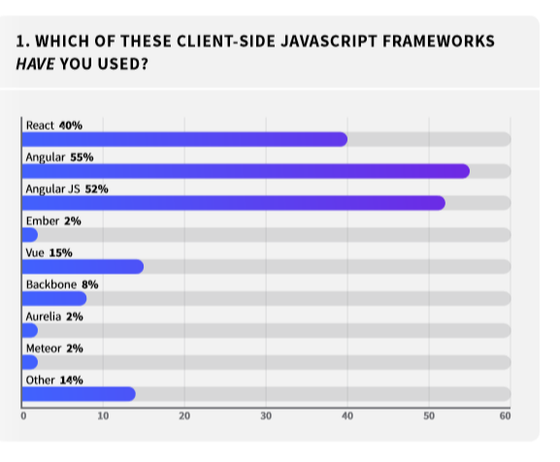

**9.2 Appendix B – Companies using *AngularJS***

Figure 2 – An image of *AngularJS* being used by *Colgate* (Examples of *AngularJS* usage 6.).

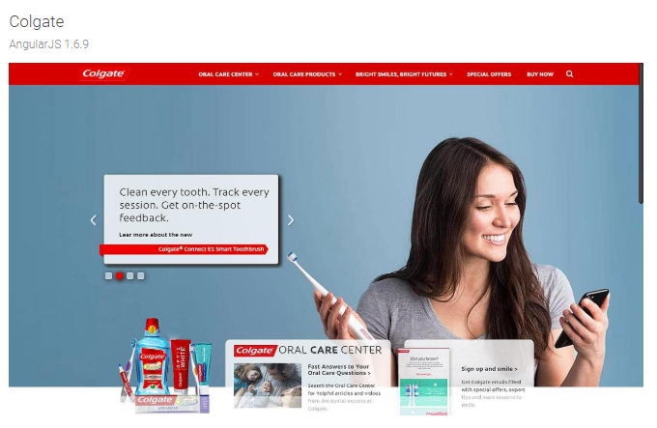

Figure 3 – An image of *AngularJS* being used by *Fitbit* (Examples of *AngularJS* usage 6.).

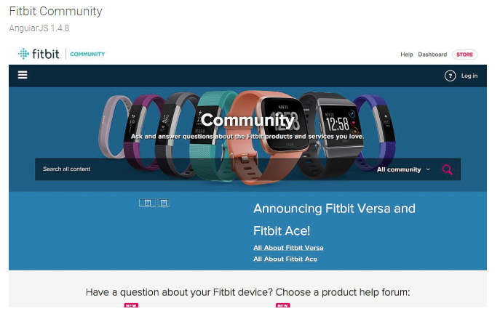

Figure 4 – An image of *AngularJS* being used by *Live Nation* (Examples of *AngularJS* usage 6.).

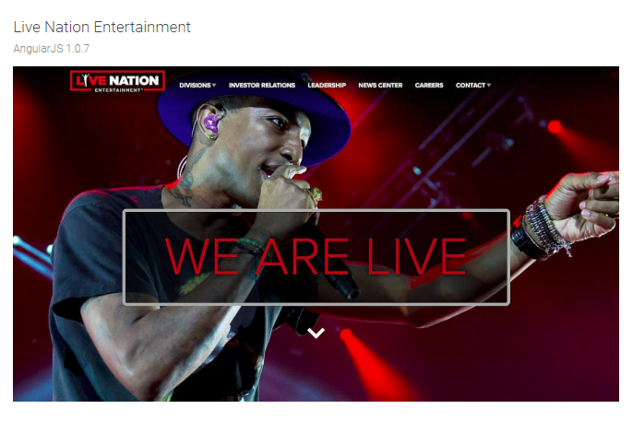

Figure 5 – An image of *AngularJS* being used by *Mastercard* (Examples of *AngularJS* usage 6.).

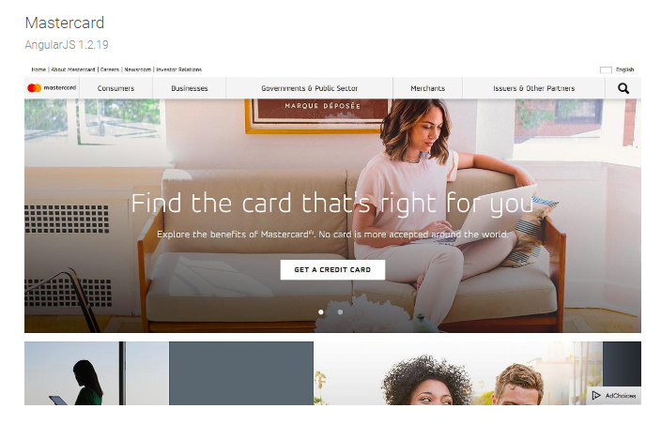

Figure 6 – An image of *AngularJS* being used by *McDonalds* (Examples of *AngularJS* usage 6.).

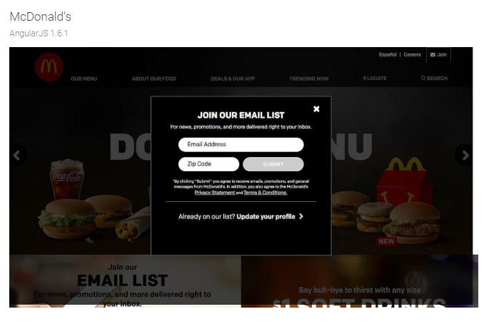

Figure 7 – An image of *AngularJS* being used by *Microsoft* (Examples of *AngularJS* usage 6.).

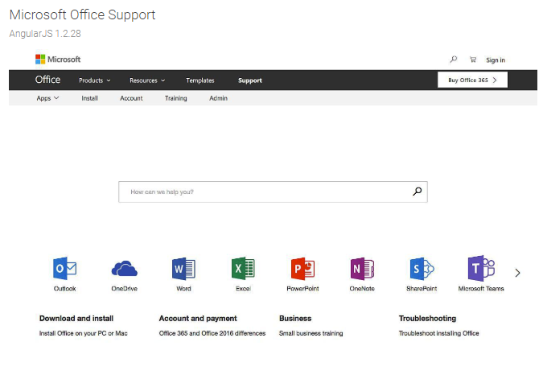

## 9.3 Appendix C – Sample Code from tutorialspoint.com

Figure 8 – An image of the search bar before text is entered (*AngularJS* sample code and implementation 7.).

|  |  |
| --- | --- |
|  |  |
|  |  |

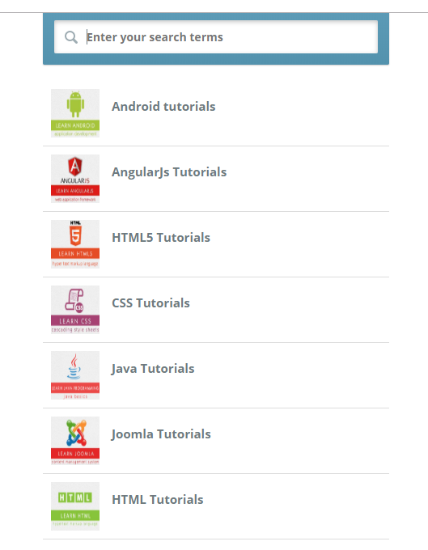

Figure 9 – An image of the search bar with”html” entered (*AngularJS* sample code and implementation 7.).

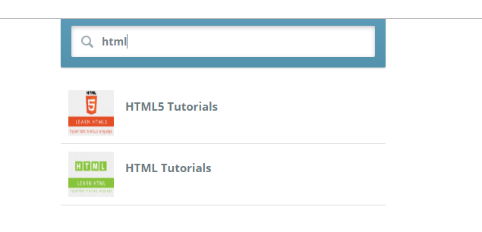

Figure 10 – An image of the search bar with”joom” entered (*AngularJS* sample code and implementation 7.).

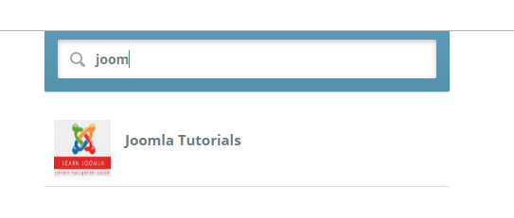

**References**

AltexSoft. (2019). *JavaScript Ecosystem: 38 Tools for Front- and Back-End Development*. [online] Available at: https://www.altexsoft.com/blog/engineering/javascript-ecosystem-38-tools-for-front-and-back-end-development/ [Accessed 18 Mar. 2019].

AltexSoft. (2019). *The Good and the Bad of Angular Development*. [online] Available at: https://www.altexsoft.com/blog/engineering/the-good-and-the-bad-of-angular-development/ [Accessed 18 Mar. 2019].

Austin, A. (2019). *An Overview of AngularJS for Managers - Andrew Austin*. [online] Andrewaustin.com. Available at: https://andrewaustin.com/an-overview-of-angularjs-for-managers/ [Accessed 18 Mar. 2019].

Brandrick, C. (2019). *Angular 1.0 Turns Five Years Old*. [online] Medium. Available at: https://medium.com/dailyjs/angular-1-0-turns-five-years-old-4d7108a5e412 [Accessed 17 Mar. 2019].

Columbus, L. (2019). *Miško Hevery, Inventor of Angular And How Open Source Languages Are Redefining Enterprise Software*. [online] Forbes.com. Available at: https://www.forbes.com/sites/louiscolumbus/2016/11/14/misko-hevery-inventor-of-angular-and-how-open-source-languages-are-redefining-enterprise-software/#70f999c9270d [Accessed 18 Mar. 2019].

Made with Angular. (2019). *Home*. [online] Available at: https://www.madewithangular.com/ [Accessed 19 Mar. 2019].

GitHub. (2019). *angular/angular.js*. [online] Available at: https://github.com/angular/angular.js [Accessed 17 Mar. 2019].

Guru99.com. (2019). *AngularJS Hello World Application: Your First Example Program*. [online] Available at: https://www.guru99.com/angularjs-first-program.html [Accessed 17 Mar. 2019].

Guru99.com. (2019). *AngularJS Tutorial for Beginners: Learn in 7 Days!*. [online] Available at: https://www.guru99.com/angularjs-tutorial.html [Accessed 18 Mar. 2019].

Jayaraj, D. (2019). *What is a JavaScript framework?*. [online] https://www.quora.com/. Available at: https://www.quora.com/What-is-a-JavaScript-framework [Accessed 18 Mar. 2019].

Morris, S. (2019). *Tech 101: What Is a JavaScript Framework? Here’s Everything You Need to Know*. [online] Skillcrush. Available at: https://skillcrush.com/2018/07/23/what-is-a-javascript-framework/ [Accessed 18 Mar. 2019].

Phelps, K. and Baker, J. (2019). *Dynamic Web and Mobile Application Development - Dzone Research Guides*. [online] dzone.com. Available at: https://dzone.com/guides/dynamic-web-and-mobile-application-development [Accessed 17 Mar. 2019].

Stack Overflow. (2019). *Stack Overflow Developer Survey 2018*. [online] Available at: https://insights.stackoverflow.com/survey/2018/ [Accessed 18 Mar. 2019].

Twitter.com. (2019). *Misko Hevery (@mhevery) on Twitter*. [online] Available at: https://twitter.com/mhevery [Accessed 18 Mar. 2019].

Wodehouse, C. (2019). *AngularJS: A Powerful JavaScript Framework*. [online] https://www.upwork.com/. Available at: https://www.upwork.com/hiring/development/angularjs-basics/ [Accessed 17 Mar. 2019].

www.tutorialspoint.com. (2019). *AngularJS Overview*. [online] Available at: https://www.tutorialspoint.com/angularjs/angularjs_overview.htm [Accessed 19 Mar. 2019].