Analysis

Contents

Summary 2

Use Cases 2

## Summary

This document outlines the Use Cases necessary to develop the proposed solution. The associated Class diagram will define;

***Classes*** – The attributes of each class and the operations associated with the class.

***Relationships*** – The interdependency between the classes and the type of relationship.

## Use Case Diagram

## 

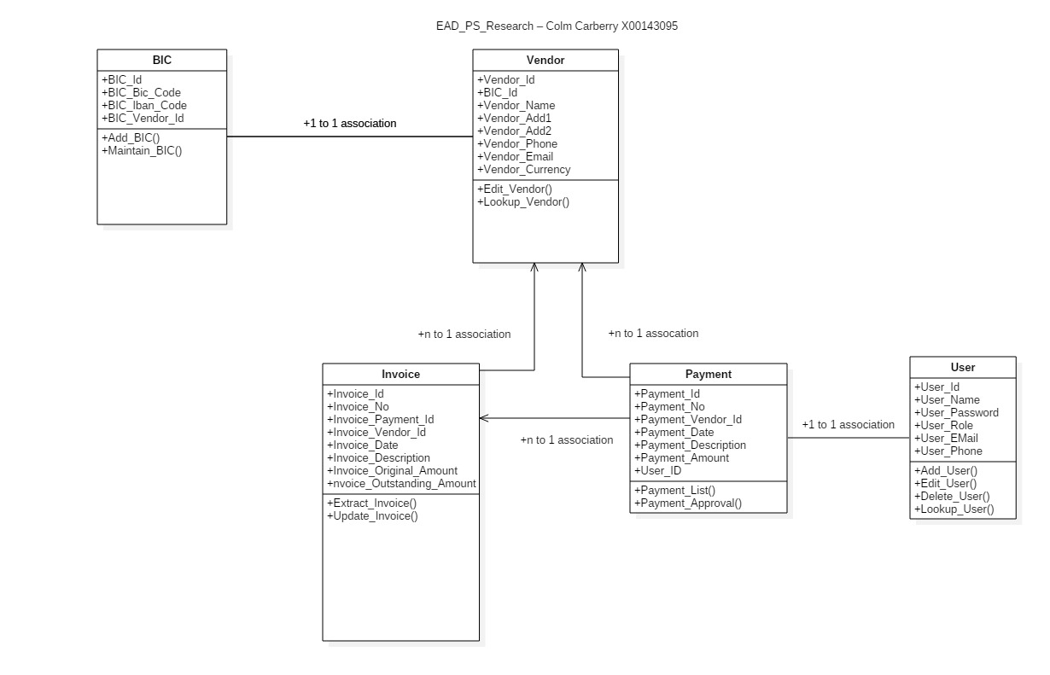

## Use Cases

|  |  |
| --- | --- |
| **Template for Use Case Description** | |
| **Use Case:** | Maintain Vendor |
| **Actor (s):** | Staff member |
| **Goal:** | Maintain existing vendor record |
| **Overview:** | Staff member will maintain contact information on existing vendor record and enter bank details |
| **Successful Scenario:** | 1. Enter vendor details – Name , Address, Contact details 2. Enter BIC / IBAN details |
| **Alternative Scenario:** | If vendor does not exist – end process |

|  |  |
| --- | --- |
| **Template for Use Case Description** | |
| **Use Case:** | Extract Invoices |
| **Actor (s):** | Staff member |
| **Goal:** | Extract a range of invoices from Financial system for processing in the SEA system |
| **Overview:** | Staff member will extract a range of invoices based on agreed criteria |
| **Successful Scenario:** | 1. A data set is created with a range of invoices for processing |
| **Alternative Scenario:** | No invoices are available for processing – end process |

|  |  |
| --- | --- |
| **Template for Use Case Description** | |
| **Use Case:** | Create Payment List |
| **Actor (s):** | Staff member |
| **Goal:** | Create a list of invoices to be processed for payment based on agreed criteria |
| **Overview:** | Staff member will review outstanding invoices and mark records for payment |
| **Successful Scenario:** | 1. A payment list is generated for review by a Manager |
| **Alternative Scenario:** | No invoices are available for processing  – end process |

|  |  |
| --- | --- |
| **Template for Use Case Description** | |
| **Use Case:** | Approve Payments |
| **Actor (s):** | Manager |
| **Goal:** | Create final Payment List |
| **Overview:** | Manager reviews Payment List and approves invoice for payment  Manager reviews payment list and removes invoice from Payment List |
| **Successful Scenario:** | 1. A payment list is generated for processing |
| **Alternative Scenario:** | Insufficient funds available to complete all transactions  – end process |

|  |  |
| --- | --- |
| **Template for Use Case Description** | |
| **Use Case:** | Update Bank |
| **Actor (s):** | Staff Member |
| **Goal:** | Create SEPA Bank File |
| **Overview:** | Staff member generates a SEPA compliant Bank File |
| **Successful Scenario:** | SEPA Bank File presented for payment  SEPA Bank File approved  Payment File created |
| **Alternative Scenario:** | SEPA Bank File invalid – end process  Vendor details incorrect – remove from file |

|  |  |
| --- | --- |
| **Template for Use Case Description** | |
| **Use Case:** | Update Financials |
| **Actor (s):** | Staff Member |
| **Goal:** | Create Payment transaction |
| **Overview:** | Staff member interfaces Payment File |
| **Successful Scenario:** | Payment file validated successfully  Payment records posted to vendor account |
| **Alternative Scenario:** | Payment File invalid – end process  Vendor details invalid – end process |

|  |  |
| --- | --- |
| **Template for Use Case Description** | |
| **Use Case:** | Maintain User |
| **Actor (s):** | Administrator |
| **Goal:** | Maintain User Details |
| **Overview:** | Administrator maintains existing users and adds new users |
| **Successful Scenario:** | 1. New user is created and assigned a role 2. Existing user details are amended – Name, Contact details, E-Mail address, Role 3. Existing user is deleted |
| **Alternative Scenario:** | 1. User is active – cannot delete user |