Research

Contents

Problem Domain 2

Aims 2

Scope 2

Users 3

System Comparison 4

Technology 5

Development 5

Database 7

System Architecture 9

Bibliography 11

## Problem Domain

SEPA (Single Euro Payment Area) is an EU initiative to harmonise cashless payments between member countries (Chen, 2018). While the SEPA system was first introduced in 1999 it only replaced individual national payment systems in 2011. The system was extended in 2017 to accept payments up to €15,000 Euros.

From 1st February 2014 all national Direct Debit and Credit Transfer processes must be replaced by SEPA-compliant equivalents.

## Aims

SEPA payments are generated electronically by presenting a properly formatted file to a payments system.

The project will aim to provide a solution for accounting staff to generate SEPA transaction files for presentation to a payments system.

## Scope

The project relates to extending the functionality of an existing non SEPA compliant Financial Accounting system to automate the management of payments to vendors.

SEPA requires two critical pieces of data

* BIC – Bank Identifier Code to replace the traditional Sort Code
* IBAN – International Bank Account Number to replace the traditional Bank Account Number

This requires development to upgrade existing Financial Accounting Systems to provide the required functionality (Synergy Network, 2014)

## Users

The system will support the following roles;

Accounting staff – responsible for day to day activities to manage the payment process.

Accounting staff - data entry. Staff enter financial transactions into the current Purchase Ledger system which will form the basis for payment decisions.

Accounting staff – payment lists. Staff will provide draft payment lists for review by Managers. This process is based on their experience and general rules for managing the payment process.

Managers – responsible for authorising payments.

Managers review the payments lists received and determine based on certain criteria which payments will be completed. There are two main criteria for decision making;

* The cash flow situation
* The age of the outstanding transaction

Administrators – maintain the electronic system

The administrator is responsible for maintaining the roles within the system and for managing the creation, amendment and deletion of users.

## System Comparison

SEPA payments conform to a standard and commercial solutions exist to manage the creation of SEPA compliant payment files

There are two main types of solutions

1. SEPA functionality embedded in Financial Accounting Systems

|  |  |
| --- | --- |
| Microsoft Dynamics NAV | (Microsoft Corporation, 2017) |
| Sage Accounting | (Sage, 2018) |
| Oracle NetSuite | (Oracle , 2016) |

|  |  |
| --- | --- |
| Pros | Cons |
| SEPA compliance included in licensing fee | Requires configuration / consultancy to implement |
| No end user involvement in defining requirements | Licensing costs of applications are high |

1. SEPA Editors

|  |  |
| --- | --- |
| SEPA Direct Payments | (SEPA Direct Payments, 2019) |
| SEPAEditor | (Exalog, 2019) |
| EazyEFT SEPA Edition | (Lir Software , 2019) |

|  |  |
| --- | --- |
| Pros | Cons |
| Provides SEPA functionality for non-compliant systems | Operational costs calculated per transaction |
| Supports SME enterprises at a lower price tariff | Consultancy requirements to implement |
|  | Requires end user involvement to test / implement |

## Technology

### Development

The following technologies were considered to develop the solution

|  |  |  |  |
| --- | --- | --- | --- |
| Technology | Description | Pros | Cons |
| Windows Desktop App | Supports UWP, WPF, and Windows Forms (Microsoft Cororation, 2018)  (Microsoft Corporation, 2018) | sophisticated and customizable UI  Visual designers and UI markup for rapidly creating UI  suited for line-of-business applications | Windows 10 required  Uses a derivative of the XML standard – XAML  Implements Silverlight – a separate Run Time System |
| UWP App | Universal Windows Platform App (Microsoft Corporation, 2018) | Adaptive UI Supporting multiple devices  Supported by Microsoft Store for distribution | Windows 10 required  No backward compatibility |
| ASP.NET MVC Framework | A technology for developing web applications | Structured environment  Separation of concerns by using a Model, View, Controller approach (MVC)  Web based technology implementing HTML5 standard | Requires a set of supporting technologies -(HTML/CSS/JavaScript/.NET)  To implement web development |

Having considered the available frameworks, the ASP.NET MVC server-side web application framework option was chosen for its ability to build cross-platform apps and dynamic web services. (Microsoft Corporation, 2018)

Asp.Net MVC architecture separates an application into three main parts Model, View, Controller. This assists in managing the “separation of concerns” when developing applications.

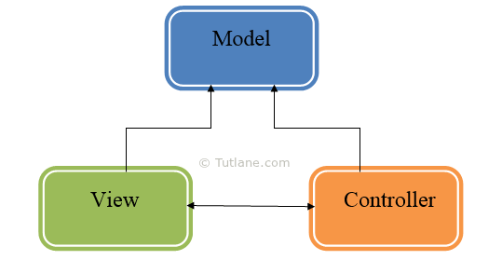

Figure 1 – Asp.Net MVC Architecture

**Model** – defines the business logic and data

**View** – the visual representation of the Model

**Controller** – is concerned with the application logic. The Controller is the link between the Model and the View

Supporting technologies are required to manage the link between the server-side processes and the client-side processing. The main supporting toolkit will be Bootstrap (Bootstrap, 2019). Bootstrap is an open source toolkit which manages the front-end Web framework.

Bootstrap provides templates based on HTML and CSS to allow the development of client-side elements such as buttons, forms and navigation. The framework also supports JavaScript extensions.

Bootstrap (Rascia, 2015) provides a responsive design framework that assist in the creation of web pages that provide independence from the end user device screen dimensions.

### Database

Database technologies (Foote, 2016) fall into two main categories – relational and non-relation databases.

Relation databases or Relational Database Management Systems (RDBMS) work with structured data and tend to be strong in transaction processing type environments. These can be categorised as systems where data is being updated constantly and the transactions are frequent and of short duration.

Non-relational databases or NoSQL databases tend to be used where data is unstructured or semi-structured. NoSQL databases are used for processing document stores and blob data.

As the proposed system is Financial Management system and RDBMS type database is proposed.

RDBMS databases are available for many different vendors including Microsoft, Oracle, Amazon and IBM. The commercial product range is extensive and licensing models differ between both vendors and products.

Two database systems were, therefore, considered. These were chosen taking into consideration the target market which consists of SME type businesses where cost in a consideration.

|  |  |  |  |
| --- | --- | --- | --- |
| Technology | Description | Pros | Cons |
| Microsoft SQL Server | Relational database  (Manoharan, 2013)  (Begg, 2002) | Manages Structured, tightly coupled data effectively  Multiple Licensing models to support SME business | Tightly coupled relationship definition required  Scaling database size / redundancy incurs additional licensing costs |
| NoSQL | Big Data | Manages structured,  semi structured, and  unstructured data using  key pairs effectively  Loosely coupled entities supported | CRUD operations slower |

The Microsoft SQL Server option was chosen based on its ability to support the target market. The product will scale to support larger databases and additional users if necessary.

## System Architecture

The solution will be deployed as a web application. The solution will be developed using a 3-tier architecture approach

***“A three-tier architecture is a client-server architecture in which the functional process logic, data access, computer data storage and user interface are developed and maintained as independent modules on separate platforms.”*** (Techopedia, 2019)

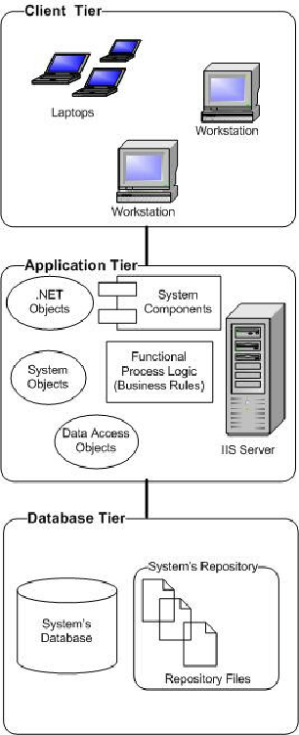

Figure 2 – 3-Tier architecture

Client – the client or presentation tier will consist of a dynamic web browser interface. The client will be deployed as a series of web pages to present options to the user based on their profile.

Data will be collected, validated and returned to the server-side layer for processing.

It will consist of the following components;

* HTML5 - Content
* JavaScript - Behaviour
* CSS - Layout

Middle – the middle tier is responsible for the application functionality. The application logic resides in this tier and integrates with the client and data tiers to provide the requested processing. The application logic will be developed using the C# language. It will consist of the following components;

* Microsoft IIS – the application or web server
* Web application framework
* Server-side scripting

Data – the data tier which implements a database management system that provides access to application data will consist of the following components;

* Microsoft SQL Server – MSSQL

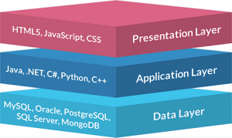

Figure 3 – 3 Tier Layers (Jinfonet Software , 2019)

## Bibliography

Begg, T. C. C., 2002. *Database Systems A Practical Approach to Design, Implementation and Management.* 3rd ed. Harlow: Pearson Education Limited.

Chen, J., 2018. *Single Euro Payment Area (SEPA).* [Online]   
Available at: https://www.investopedia.com/terms/s/sepa.asp  
[Accessed 25 January 2018].

Exalog, 2019. *Switch to SEPA now !.* [Online]   
Available at: http://www.sepaeditor.com/en/Home.html  
[Accessed 04 02 2019].

Lir Software , 2019. *EazyEFT SEPA Edition.* [Online]   
Available at: https://www.lirsoftware.com/EazyEFTSEPAEdition.aspx  
[Accessed 04 02 2019].

Manoharan, Y. L. a. S., 2013. *A performance comparison of SQL and NoSQL.* Auckland, s.n.

Microsoft Cororation, 2018. *Choose Your Platform.* [Online]   
Available at: https://docs.microsoft.com/en-us/windows/desktop/choose-your-technology#uwp-wpf-and-windows-forms  
[Accessed 28 01 2019].

Microsoft Corporation, 2017. *How to: Activate SEPA Payments.* [Online]   
Available at: https://docs.microsoft.com/en-us/dynamics-nav-app/localfunctionality/netherlands/how-to-activate-sepa-payments  
[Accessed 04 02 2019].

Microsoft Corporation, 2018. *What's a Universal Windows Platform (UWP) app?.* [Online]   
Available at: https://docs.microsoft.com/en-us/windows/uwp/get-started/universal-application-platform-guide  
[Accessed 28 01 2019].

Microsoft Corporation, 2018. *What's a Universal Windows Platform (UWP) app?.* [Online]   
Available at: https://docs.microsoft.com/en-us/windows/uwp/get-started/universal-application-platform-guide  
[Accessed 04 02 2019].

Miles, R., 2016. *Begin to Code with C#.* Washington: Microsoft Press.

Oracle , 2016. *NETSUITE ELECTRONIC PAYMENTS.* [Online]   
Available at: http://www.netsuite.com/portal/assets/pdf/ds-electronic-payments.pdf  
[Accessed 04 02 2019].

Sage, 2018. *E-Banking.* [Online]   
Available at: https://my.sage.co.uk/public/irl-sage-ebanking/irl-compatible-banks.aspx  
[Accessed 04 02 2019].

SEPA Direct Payments, 2019. *SEPA Credit Transfer File Converter.* [Online]   
Available at: https://www.sepadirectdebits.ie/direct-debit-software/product-tour/sepa-converter?gclid=EAIaIQobChMIzq6miZei4AIVa7HtCh257QlaEAAYAiAAEgKPZPD_BwE  
[Accessed 04 02 2019].

Synergy Network, 2014. *Get your Accounting Software SEPA Ready.* [Online]   
Available at: https://www.synergynet.ie/sepa-countdown/  
[Accessed 28 01 2019].