Enterprise Application Options:

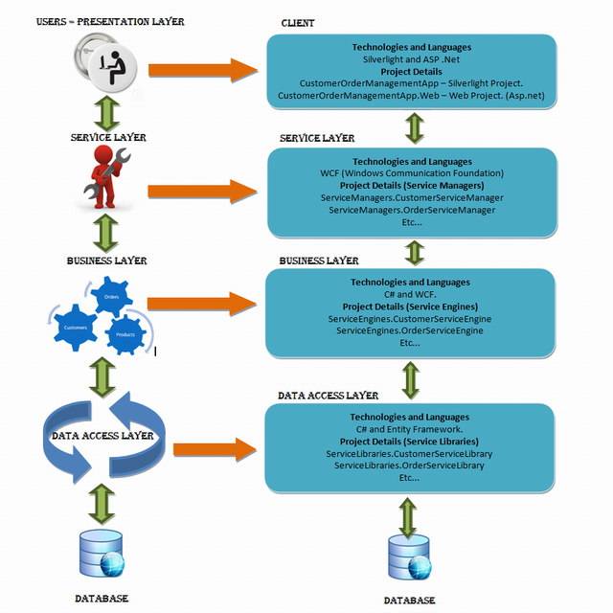

2 Program options:

|  |  |  |
| --- | --- | --- |
|  | Enterprise applications | |
| Layers: | Loan application | Planning application |
| User – presentation | Data capture (fact find) | Data input incl scanned maps and building plans |
| Service layer | Credit score | Storage under plan reference key |
| Business layer | Loan approval | Approval process v local development plan |
| Data access layer | Account retrieval & loan setup | Storage for public access |