MealItems

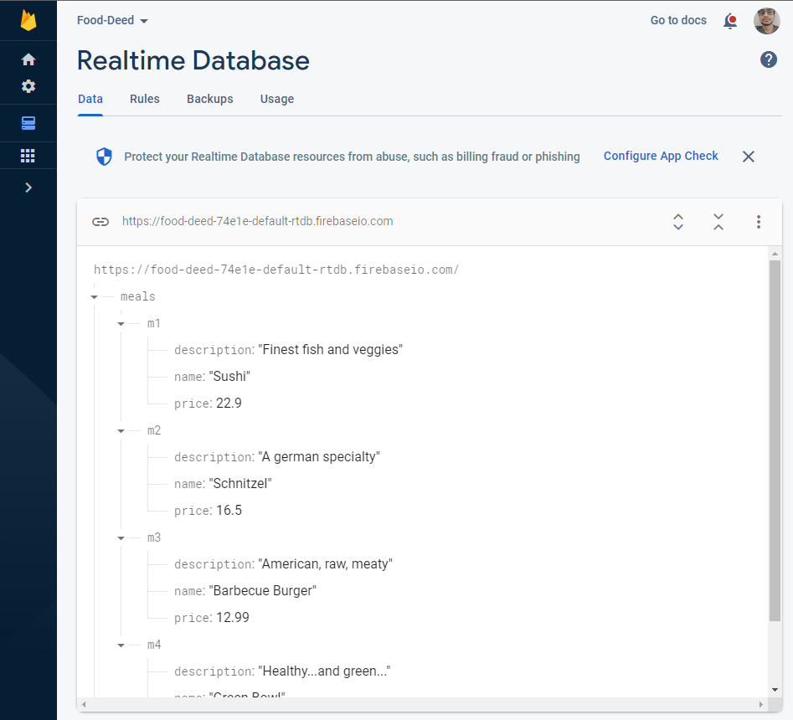

Order details

