Soal
Case

Bowling

Below are some specifications you need to follow.
Project Structure
Your project should contain a main html file, several JavaScript files, assets, and the three.js library. You are to acquire three.js either from the three.js official website, github repository, or CDN link.
You are required to include the following piece of code in your html file.
<style>
* { margin: 0; padding: 0; }
html, body { height: 100%; width: 100%; overflow: hidden; }
canvas { height: 100%; width: 100%; }
</style>
<script src="[Path to index.js file]" type="module"></script>
You are free to split your code into several different JavaScript file, but code the main logic for creating the scene inside “index.js” file.
Renderer
Property | Value
Type | WebGL Renderer
Antialiasing | Yes
Size | Window Size
Camera
Property | Value
Type | Perspective Camera
Field of View | 75
Aspect Ratio | Window Ratio
Near Frustum | 0.1
Far Frustum | 1000
Position | Vector3 (20, 60, 180)

Objects
  - Floor (Box Geometry)
Property | Value
Material | Mesh Phong Material
Width | 250
Height | 2
Depth | 150
Texture | floor.png
Position | Vector3 (35, -14, 35)
Rotation | Vector3 (0, -π/4, 0)
Receive shadow | Yes
  - Pin
The pin will consist of upper, lower, neck, and head section. All sections will be assembled in Group. Note that the position and rotation of every section is relative to the Group.
    - Upper (Cylinder Geometry)
Property | Value
Material | Mesh Phong Material
Radius Top | 3
Radius Bottom | 8
Height | 20
Radial Segments | 12
Height Segments | 12
Color | #FFFFFF
Position | Vector3 (0, 9, 0)
Cast shadow | Yes
    - Lower (Cylinder Geometry)
Property | Value
Material | Mesh Phong Material
Radius Top | 8
Radius Bottom | 5
Height | 12
Radial Segments | 12
Height Segments | 12
Color | #FFFFFF
Position | Vector3 (0, -7, 0)
Cast shadow | Yes

    - Neck (Cylinder Geometry)
Property | Value
Material | Mesh Phong Material
Radius Top | 4
Radius Bottom | 3
Height | 12
Radial Segments | 12
Height Segments | 12
Color | #FFFFFF
Position | Vector3 (0, 23, 0)
Cast shadow | Yes
    - Head (Sphere Geometry)
Property | Value
Material | Mesh Phong Material
Radius | 4
Width Segments | 32
Height Segments | 16
Color | #FF0000
Position | Vector3 (0, 25, 0)
Cast shadow | Yes
  - Ball (Sphere Geometry)
Property | Value
Material | Mesh Phong Material
Radius | 10
Width Segments | 32
Height Segments | 16
Texture | bowling-ball.png
Position | Vector3 (90, -3, 90)
Rotation | Vector3 (π/2, π/2, π/2)
Cast shadow | Yes

Light
All lights in the scene will be able to cast shadows
  - Spotlight
Property | Value
Color | #FFFFFF
Intensity | 1
Position | Vector3 (100, 200, 300)
Shadow map width | 1024
Shadow map height | 1024
Shadow Camera Near | 0.5
Shadow Camera Far | 500
Cast Shadow | Yes
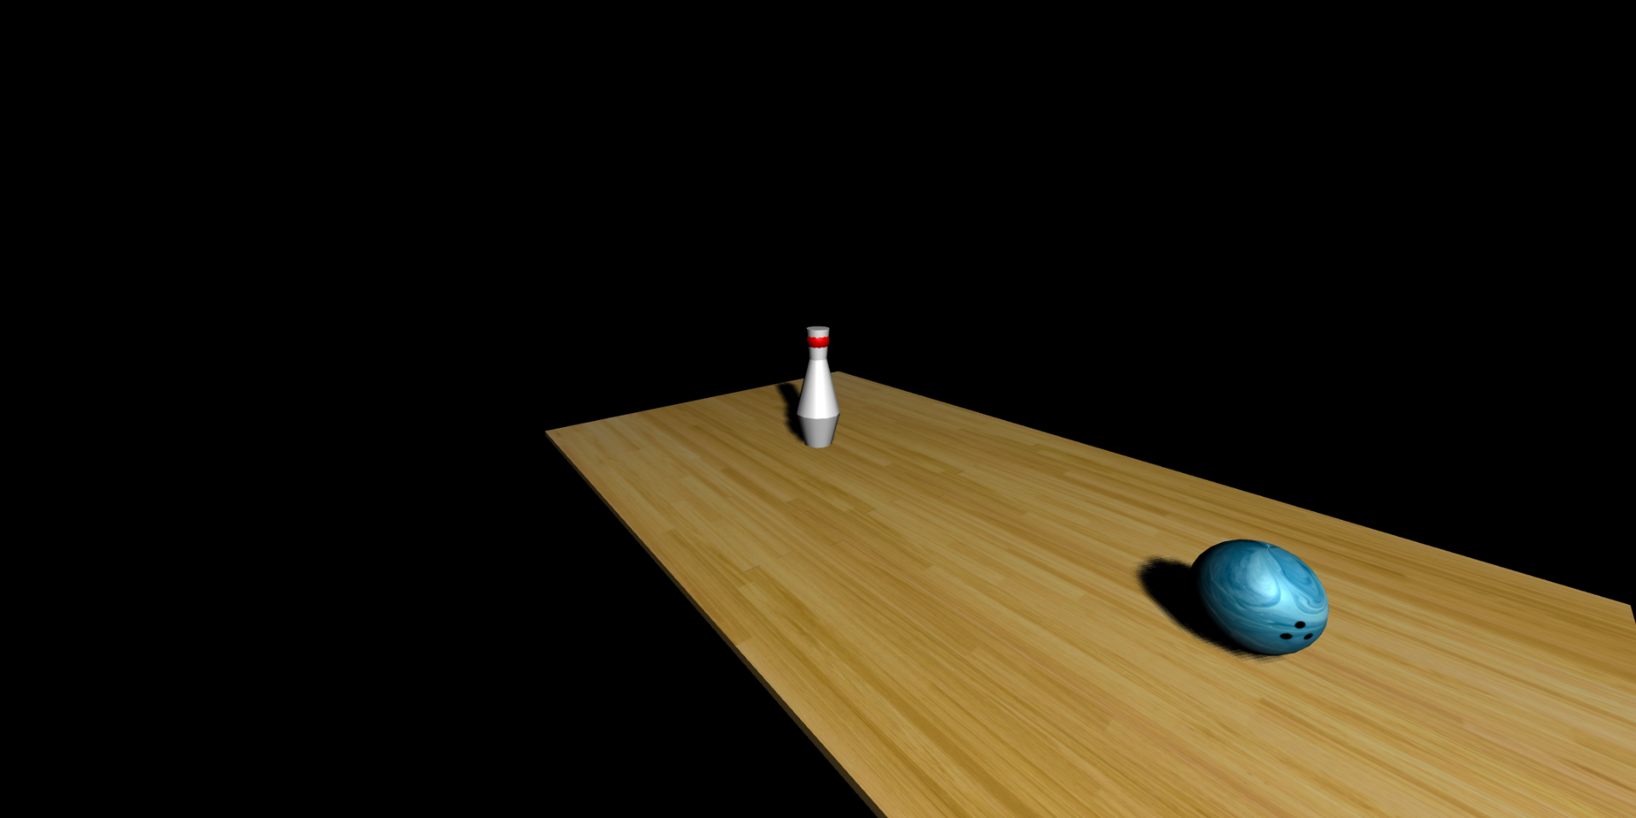
Figure 1. Result

If there are any problems, please ask your assistant!

References:
https://stock.adobe.com/tr/contributor/207871140/mari-dein?asset_id=310746063
https://denverdustless.com/maple-flooring-hard-enough-to-bowl-on/

