UK CanSat Competition

Team name: CERC
School: Cambourne Village College

Preliminary Design Review

Date: 21/11/25

Introduction

1.1 Team Organisation and Roles
Team Lead - To organise the members, tasks and building of the Cansat, ensure that deadlines are being met and complete most documentation
Software design lead - Create and manage software as per required for the CanSat, working closely with the electrical design lead.
Electrical design lead - Design the necessary circuitry and use relevant microcontrollers and sensors to create necessary systems for the Cansat.
Mechanical design lead - Use CAD, sketches and other relevant design tools to engineer the Cansat’s structure. Works closely with the electrical design lead.
Landing and ground systems lead - Ensures the reliability of the ground telecommunication systems and designs the landing system
Testing lead - Design experiments to test components and the Cansat as a whole, carry these out and record relevant data to allow other members to make improvements

1.2 Mission Overview

1.2.1 Mission Objectives
This part is not a description of the CanSat, it is only a summary of the main goals that your CanSat will achieve, and a sentence on what these goals achieve with relation to scientific/engineering objectives.
Our main objectives are:
- To measure temperature and air pressure to calculate altitude and demonstrate correlations between these values
- To calculate speed and direction with an accelerometer and gyroscope to estimate the trajectory and position of the CanSat over time
- To collect relevant scientific data that is sent to the ground station and later analysed
Primary Mission:
This part should contain a list of primary objectives of your mission – such as given in CanSat requirements.
The primary mission of our Cansat is to measure air pressure and temperature using sensors, and transmit this as telemetry data every second to our ground station. We will calculate altitude directly from air pressure and send this data as well. The received data will be formatted into a csv file which we can then analyse and plot. More detail on this is given in the software design section.
Secondary Mission:
This part should contain a concise list/description of the secondary mission you are planning to achieve.
For our secondary mission, we will use a sensor that acts as an accelerometer and gyroscope to work out relevant aerodynamic behaviour of our CanSat. We will work out the level of turbulence using the accelerometer. We will also measure the oscillation and rotation of our CanSat with our gyroscope, and use that to evaluate the stability of our parachute.
We hypothesise that turbulence will decrease as altitude increases, and that there will be some oscillation with our parachute but it will be mostly stable.

1.2.2 What will you measure, why and how?
Concise description of what measurements your CanSat will make, why you will take these measurements and what sensing capabilities will be required. Include some thoughts on how you will analyse the data.
For the primary mission:
- To control the activities of our sensors we will use a Pi Pico as our microcontroller
- To measure air pressure and temperature we will use a BMP-280
- To send and receive radio signals we will use two Adafruit LoRa radio modules and a Yagi antenna
- To program the sensors we will be using CircuitPython
- We will calculate the terminal velocity of our CanSat by looking at the rate of descent of our altitude measurements
- We can also calculate the drag coefficient of our parachute. We simply use the fact that when the CanSat reaches its terminal velocity, the force of drag is equal to the weight force of the CanSat. Then we can do similar calculations to those we used to calculate the size of our parachute to work out the drag coefficient.
For the secondary mission:
- To calculate the turbulence of our CanSat we will use the MPU6050 accelerometer. As it returns acceleration in all three axes, we can ignore the vertical axis of acceleration, and look at the two remaining axes. By taking the variance in this acceleration data in certain sections of our flight, we can use this as a measure of turbulence.
- To calculate the oscillation of our CanSat, we can look towards our gyroscope. As it returns values in degrees per second, we will analyse this data. To give a measure of our CanSat’s oscillation, we will consider a few factors. A constant spin is unavoidable and should not be penalized heavily, as some spin is unavoidable, so our calculation will involve the variance in our data. However, an extreme rate of rotation is also unwanted, so we multiply by the mean of our data, punishing a high overall rate of spin, and also multiply by the peak rate of change to punish any small sections of extremes. We also want to punish sudden jerks, so we multiply by the mean angular acceleration. We will likely scale each individual value between 0 and 1 to keep the end value in this range as well. This creates a holistic measure of oscillation that can easily be used to evaluate the effectiveness of our parachute.
- To analyse and plot data we will use the python libraries numpy, pandas and matplotlib.
One problem with our approach of calculating position with an accelerometer is that small errors in acceleration measurements can lead to huge inaccuracies in position. We will combat this by combining the measurements of altitude from our BMP-280 with the accelerometer to create a more accurate reading. As well as this, to measure turbulence we ideally want a high sampling rate, but the radio module we are using may not allow us to transmit data at this rate. Therefore, we may consider also storing more data internally on the CanSat, to ensure even better measurements
For our secondary mission we hypothesise that the turbulence will decrease as altitude increases
More details around these choices of hardware and software are explained in their respective sections

2 Project Planning

2.1 Time schedule
A detailed project time plan which shows the tasks required to complete the project and the time (suggested to be hours required) allocated to each step. This should cover all scientific, technical and outreach tasks that need to be done and is updated with each report. A Gantt chart may be used to display this project planning. This must be at least a high-level weekly plan.
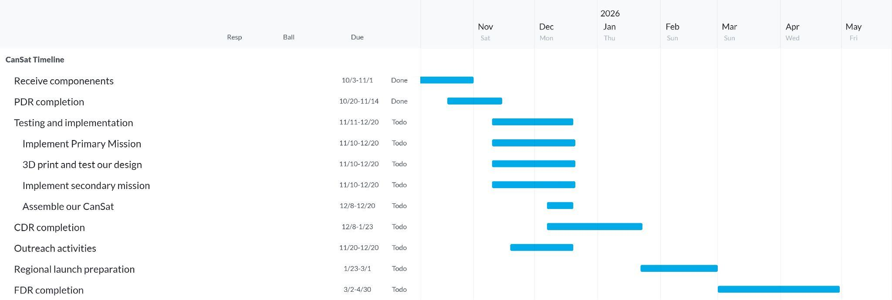
We plan to split the work for our CanSat build evenly between our team, so that we can work in parallel, completing many tasks at a faster rate. This will also allow us to let our team members shine in their respective strengths. This is preferred to all of us working on one project at a time, as those without experience will be sitting idle whilst those with experience will take extra workloads.
We have broken up the main tasks into various subtasks, and divided them between people. This approach started with the PDR, where based on their roles, we tasked specific people with specific sections, which their area of expertise could aid in.
For the assembly of our CanSat, we plan to, as aforementioned, split the work into multiple tasks that can be completed in parallel. These will ideally be completed in pairs.
For the primary mission, we will first get the BMP-280 to work and give accurate readings of temperature and pressure, and calculate altitude from the pressure. We will then implement the telemetry. For our CanSat’s design, we are ahead of schedule and have already started on some CAD sketches that can be 3D printed. For this subtask we will 3D print our design and test its strength as described in the testing section. As for the secondary mission, there are again two parts. First we need to get the sensor to work and test its accuracy, and then we need to design a program that will use these values to calculate the CanSat’s position, and test its accuracy.
After all of these separate tasks are completed, towards the end of the time we have allocated to implementation in our Gantt chart, we will put all of these components together and assemble our CanSat. This will then be tested.
After this we can begin work on our CDR. For this we will follow a similar work ethic to that which we used in our PDR, assigning individuals certain sections. This will be a more detailed version of our PDR, elaborating on ideas, explaining finalised choices and showing the work that we have done in between the design reports. After the CDR our focus will shift entirely towards refining and testing our CanSat to ensure that it is ready for the regional launch
If we are accepted into the nationals, our focus will then shift towards the FDR and national launches. We will focus more on the FDR than the launches as this is where the most improvements will need to be made. We will follow the same work ethic yet again, but this time learning from our experiences in the regional launches and our feedback for the PDR and CDR.

2.2 Team and External Support
Your team is your most vital resource. You must be aware of your competencies and be able to identify where you may need to expand the team or ask for external support. Please describe the tools and support available to you and what external support you are planning to get. Please identify, based on your team skills, what support you may need. In any project it is important to seek external help and support.

2.3 Risk Analysis
What could go wrong for the project? Think about the team, time constraints, equipment or technical issues. This will change as the project develops.
Risk | Potential consequences | Potential mitigations
Team management difficulties/skill gaps | Could lead to poor documentation and designs if team members are unclear on their task, are assigned to a task they are not comfortable with, or do not have a task to do. This will contribute to the probability of technical failures on the launch day and in general. The team would not be being utilised to its full potential. | We will use rigid planning structures, giving each member a specific role and our team leader will assign each role separate tasks to work on according to their strengths and weaknesses, as outlined in previous sections. Where there are skill gaps, we will ensure that external support is provided. Our team leader reviews all important changes to documentation, ensuring quality and providing support if standards are not met.
Time constraints | Possibility of unfinished or poor quality documentation as deadlines are not being met, critical oversights in design leading to preventable failures of the CanSat, or unfinished assembly of the CanSat before launch day, which has happened to teams in previous years. | Much like the previous risk, we will attempt to mitigate this with strict planning schedules. We will aim to have important documentation started as soon as possible before the deadline, and have a working draft soon after. CanSat assembly, such as 3D printing, will be done as soon as the applicable designs and programs are ready, to ensure there is ample time for testing.
Equipment failures | Unreliable equipment at the ground station ,such as a poorly assembled antenna, or issues like poor soldering inside the CanSat itself, will likely cause us to lose some or all of our data, negating much of the work put in and giving a disappointing outcome to the launch. | As long as time scheduling is followed as above, we should have a working version of the ground system and CanSat months before the launch. We will use this time to ensure everything is built as robustly as possible, and carry out extensive testing on all important systems. Depending on the conclusions made from this , we will make necessary adaptations to the design, prioritising reliability and functionality over more advanced features.
Technical difficulties with design
If all timing guidelines are followed, the above mitigations should be enough to prevent any major issues. However, if unexpected problems arise, we will try to reassess all risks and put in place additional mitigations if necessary. If this is the case, we may need to scrap some parts of the project such as the secondary mission so we can ensure all basic objectives are still being met.

3 Cansat Design
Please complete all the following sections. The information provided can change between each report as the CanSat is tested and changes are made to the design.

3.1 Mechanical design
For the PDR this should contain a high-level description, a sketch or sketches of the CanSat and information on the identification of potential suitable materials and their justification. In the CDR include evidence of prototypes such as photos or CAD sketches if this is being used. The FDR should cover the final iteration of the mechanical design. If changes were made include why. Design justifications are important for each sketch or CAD rendering etc.

3.2 Electrical design
For the PDR consider which processor or microcontroller will be used and include initial plans for which sensors will be used. For the CDR please include high level systems diagrams, circuit diagrams, block diagrams etc. Include which sensors are being used and the justification for this. The FDR should cover the final iteration of the electrical design. If changes were made include why.
For our main microcontroller/processor, we initially shortlisted two main options : The Raspberry Pi Pico and the Arduino Feather.
Raspberry Pi Pico | Arduino Feather
- Very light and low form factor  - Very low cost, fitting our budget  - Good support for Micropython/Circuitpython, both of which our team has experience in  - Multiple different interfaces (I2C, SPI etc.) to add secondary mission sensors. | - Also light and small  - More expensive  - Some, but less, support for Circuitpython, C/C++ may be required  - Less pins and interfaces for additional sensors beyond the primary mission.  - Lots of variants like WiFi/SD Card
Although both would make good choices as they have excellent support for our chosen sensors, especially the Feather, we decided to use the Raspberry Pi Pico. Our team has far more experience with it and its supported languages, allowing us to create more ambitious and robust programs . Additionally, the pico is much easier to learn, allowing us to teach less experienced members of the group and perform potential workshops with a much wider audience.
For our temperature/pressure sensor, we have chosen the BMP 280. While potentially more advanced/powerful models are available such as the BME 280, which would allow us to measure humidity, or the BMP 390, which would allow us to take reading with much higher precision, we have still chosen the 280. High precision or humidity readings would be excessive, as the tolerances below will more than suffice for 400m, and the BMP280 also has the best compatibility with CircuitPython and the Pi Pico, again allowing us to teach others easily. Its tolerances are as follows:
Pressure range : 300 – 1100 hPa Relative accuracy : ±0.12 hPa, equiv. to ±1 m (@25C)
Temperature range : -40 – +85 °C Temperature offset : 1.5 Pa/K, equiv. to 12.6 cm/K (@900Pa)
Datasheet used : https://cdn-shop.adafruit.com/datasheets/BST-BMP280-DS001-11.pdf
As for our telemetry, we will most likely be using the Adafruit LoRa RFM9x. The RFM9x is a long-range transceiver, enabling us to use the same module for receiving on the ground and in the CanSat, drastically decreasing the margin for error. Again, it is also completely compatible with the Pi Pico and CircuitPython. However, a major concern for using this module would be the range capabilities. Although it is technically capable of 2km in range, initial testing has found this may be unrealistic. This issue becomes more of a concern as the radio requires 5V to operate at full capacity, and 3-4V may only be possible due to space restrictions in the can. To counteract this, we will use a quarter-wavelength whip antenna on the CanSat, which resonates with the 433Mhz frequency the radio uses and allows for better transmission. However, this may still not give us the required range and signal strength, so we will carry out extensive testing to conclude as to whether utilising a different radio module is necessary.
Datasheet used:
https://cdn-learn.adafruit.com/assets/assets/000/031/659/original/RFM95_96_97_98W.pdf?1460518717
Lastly, for our secondary mission we will be using the MPU6050. The MPU is an accelerometer as well as a gyroscope, and gives separate values for each axis, making calculations much easier to perform. One critical advantage of this sensor is its very small footprint of 20x15mm, as with the BMP and radio there is very little space left. In addition, it operates at a low minimum voltage of 2.3V, works on a simple I2C interface, and once again is completely compatible with circuitpython. However, one major disadvantage is its relatively low accuracy and tolerance. A small variation in readings could change calculated values by a lot. Unfortunately, the aforementioned space restrictions prohibit us from being able to use a more powerful sensor. Additional adjustments will have to be made to compensate in the calculations, such as averaging the height with the BMP’s altitude reading.

3.3 Software design
For the PDR think about what software is needed and how feasible it is to use. Identify what software modules are going to be needed to be developed and perhaps include high level flow diagrams. For the CDR include block and flow diagrams and a high-level description of the design as the software is starting to be put together and tested. A full copy of the code is not required. The FDR should cover the final iteration of the software design. If changes were made include why.
The software required for the CanSat consists of a measurement system, radio transmission system, ground system and potential post analysis systems.
We are using Thonny for the Raspberry Pi Pico due to its ease and speed of development and our group’s familiarity with the interpreter and GitHub for the version control and efficient group development workflow.The LoRa radio rfm9x and the sensor bmp280 have great compatibility with CircuitPython (a python based language) which our group knows extensively and contains thorough documentation online. This makes both the language, the sensors and the microcontroller suitable for our project as opposed to an Arduino and C/C++ development.
A module to develop is a radio and sensor class(es) that contains the core methods for the radio transmissions and measurements in the CanSat code which is passed as a library into the main routine where all the checks and transmissions are made.This makes the code more readable and easier to debug and track errors in the future (future-proofing code)
Other code to be developed is the receiving and storage of data in the ground station. Here we simply wait for the laptop to establish a connection to the radio and print the data Received data on temperature, air pressure, acceleration, direction and signal strength will then be formatted into a csv file, so that we can analyse this later on.
To analyse the data, we will use various python libraries. To read the data off of the csv we will use pandas as it is easy to use and designed for this purpose, allowing us to quickly obtain and format the data we need. To perform some of the complex calculations that will be necessary to compute the position of the CanSat from its acceleration and direction, we will use numpy due to its plethora of built in, optimized functions that fit our purposes. To display our data we will use maplotlib, as it works well with numpy and has an excellent variety of 2D and 3D graphs in Python. Finally, to analyse turbulence as described in the mission overview, we will use scikit learn, as without its built in functions it would be a tedious process with lots of room for errors. Our team has some experience with these libraries and they give us a holistic toolkit to scientifically analyse our data
What follows are flowcharts that show the logic and selection of how our code functions.

This is the flowchart for the CanSat code that takes measurements and sends them to the ground station via Radio:
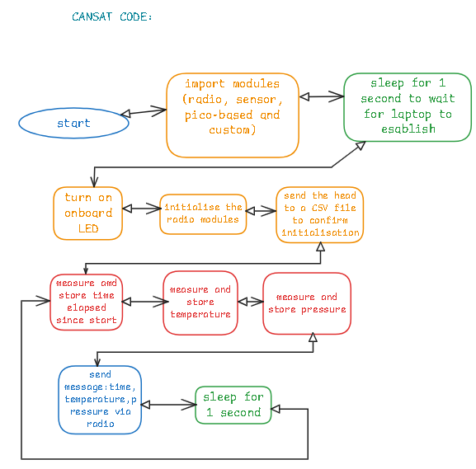

This is the flowchart for the ground station code that receives and prints the incoming radio data to console.
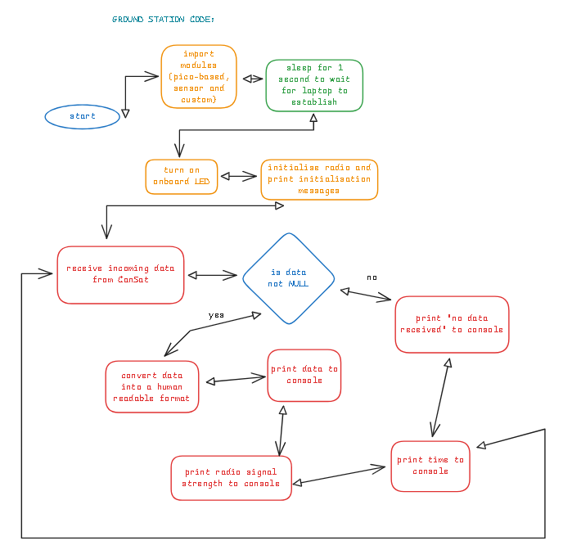
These are two of the custom methods for the radio - there exist other functions for the sensor but they are extremely similar to the radio methods structurally that no new information is shown by displaying them so they are omitted from this documentation. These methods can still be found in the github linked at the end of this section.
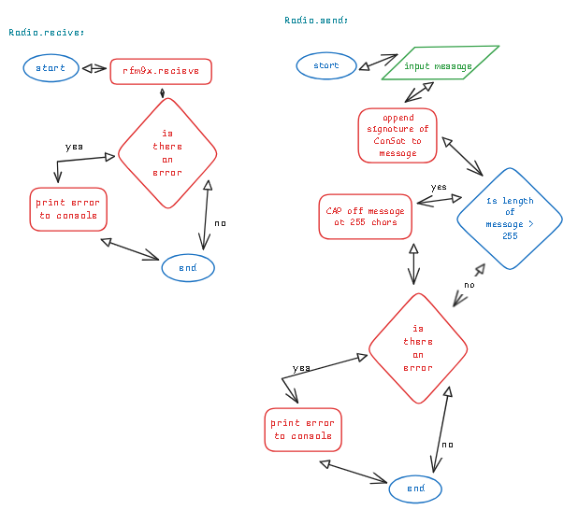
The full code for this project can be found at https://github.com/ColouredCat/CanSat along with some other documentation pieces.

3.4 Landing and recovery system
For the PDR include some calculations and identification of suitable designs. Include basic sketches. For the CDR include the final parachute design and the calculations used to reach the final decision. The FDR should cover the final iteration of the landing and recovery system. If changes were made include why. This section should be more in-depth if the mission includes special landing gear or separating parts.

For the CanSat’s landing system, we’ve chosen to use a hexagonal shaped parachute. This particular design offers a moderate drag coefficient (~0.75 - 0.8) and we are confident in making it accurately. The hexagonal shape can be sewn together from 6 separate triangles, each congruent to each other.
To find the cross-sectional area for the parachute, we need to consider the following constraints:
- The descent rate of the CanSat must be between 10 - 15 m/s
- The CanSat’s mass must be between 300 - 350 grams
- For this calculation, as this is only an estimation, we will be taking the upper bound for the mass

For this calculation, we will be using this equation which expresses the equal weight force and drag force when the terminal velocity is reached:
m$⋅$g - ½$⋅$CD$⋅$𝜌$⋅$A$⋅$v^2 = 0

The variables in the equation are:
m = mass of CanSat, in this case, ~350 grams
g = gravitational acceleration on Earth, ~9.8 m/s^2
CD = drag coefficient, the total drag resistance, not directional, in this case, 0.75, taken from the lower bound in the case of slight inaccuracies in the making of the parachute
𝜌 = fluid density, in this case, density of air (however only at sea level, provides a moderately valid estimation), 1.225 kg/m^3
A = cross-sectional area of the parachute
v = the required terminal velocity of the CanSat, in this case, 10 m/s

This shows the balance in drag and weight force from the 2 parts of the equation:
m$⋅$g = FG, the force an object exerts when accelerated by gravity
½$⋅$CD$⋅$𝜌$⋅$A$⋅$v^2 = FD, the drag force required to reach the terminal velocity of v
- The equation expresses them both being equal (one subtracting the other = 0), as the forces would be when the object moves at constant velocity

This can be rearranged to make area the subject:
m$⋅$g = ½$⋅$CD$⋅$𝜌$⋅$A$⋅$v^2
2$⋅$m$⋅$g = CD$⋅$𝜌$⋅$A$⋅$v^2
A = 2$⋅$m$⋅$g / CD$⋅$𝜌$⋅$v^2
Now we substitute the values:
A = 2$⋅$0.35$⋅$9.8 / 0.75$⋅$1.225$⋅$10^2
A $≈$ 0.0747 m^2 or 747 cm^2
From these calculations we reach the estimated parachute design of a hexagonal shape with a side length of ~17 cm and a cross-sectional area of ~747 cm^2.

We are also not very concerned about the tangling issues when deploying the parachute, as this design does not require a massive mess of strings. Adding any extra components to aid the deployment might add extra complications and problems we have to deal with. We will be very careful in preparing the parachute to avoid as many opportunities for tangling as possible.
We also believe that the parachute would, most likely, not fail the deployment. As these early estimates show that the parachute is not small in size and it will definitely catch air during launch. However, we must also take into account the weight of the fabric of the parachute. If it is too heavy, it might not be able to spread out completely and lose stability and be less effective.

3.5 Ground support equipment
For the PDR identify what equipment will be needed. This includes laptops, Yagi antennas or any other equipment that you need on the ground to support the launch. For the CDR include information on any prototypes developed. The FDR should cover the final iteration of the ground support equipment. If changes were made include why.
On the ground, the most important component for us is the antenna. As mentioned in the electrical design section, weak radio connection is a major risk. Therefore, for our antenna we will be using a UHF yagi antenna. This antenna is perfect as our radio modules operate at 433Mhz in the UHF band, it is very lightweight and manoeuvrable, and operates with a high gain of 7 dBi. However, the antenna is uni-directional, so we will have to track the visual trajectory of the CanSat in order to get optimal results. We will dedicate a person to this on the launch day, but this still may reduce the efficiency of the radio as it will be very difficult to track it at high altitudes.
As for other equipment on the ground, we will be using another Pi Pico connected to a laptop via USB. The pico will use another adafruit radio module to transfer data over serial to a python program that will process the data. This is outlined in the software design section. In order to ensure minimal margin for error, we will need to ensure that the radio, antenna, pico and USB cable are attached as securely as possible, as even a second of connection loss during the launch could cause large loss of data. Additionally, we will have to ensure the laptop is sufficiently charged, to maximise the reliability of our setup. The overall process of the ground equipment is outlined bellow:
- Data is received with the antenna
- Data is passed over a serial connection to the the laptop
- The python program on the laptop records the data into a CSV file
- After the launch, the CSv file is analysed and processed

3.6 Testing

For the PDR include a test plan. For the CDR, show evidence of initial tests for each aspect of the CanSat and the decisions made based on them. For the FDR include all finalised tests and decisions made based on them. Results could be displayed in a table of tests and results, and there must be verification against the CanSat requirements found on page 8 of the competition guidelines.

3.7 Overall testing for launch
A brief description of tests carried out to plan for a launch. How can you best simulate the conditions for your launch?

4 Outreach programme
Consider all types of media to promote and disseminate information about your project. For the PDR include an outreach plan or schedule and consider the target age/demographic. For CDR include details of outreach done and justifications of the approach taken.

For our outreach, we plan to take a varied approach with differing methods to promote the CanSat competition. Here are a few of our ideas:
- Social media
Our local robotics club has a fairly large social media presence that we could use to our advantage. Using some videos from both our participation in the competition last year and our current work, we could raise awareness of this competition and encourage STEM related activities
- Teaching sessions
Another idea of ours is to provide a workshop-like service at our local robotics club. We could create an event open to the public where we talk about our experiences and work related to the CanSat competition, how it has helped us, and perhaps demonstrate some sensors and the telemetry of our CanSat. This would be open to all in our local area.
- Assemblies
Assemblies in our school are conducted on various topics, and often students get opportunities to participate in them. We believe that by conducting a presentation to our school, we could spread our knowledge and skills to our peers and show the benefit of STEM competitions like CanSat. Some members of our robotics club have done similar assemblies successfully in the past, so we are confident that we can get a slot.

- Local Newspaper:
Our town has a local monthly newspaper which is read by many of its residents. Some of our team members were able to make an appearance on it last year after the regional launch, helping them advertise the competition and its benefits. We plan to use this advertising platform again this year, as we have already had success with it in the past. It also allows us to reach a lot of younger students, who may not have access to our other advertising platforms such as social media.

