# The Rise of the Human-AI Team: How to Thrive in Africa’s Evolving Job Market

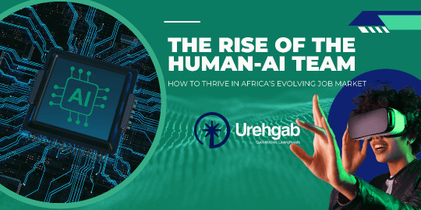Hey, Nigeria!

You've probably heard the buzz about AI. From news headlines to social media, it feels like this technology is everywhere, and a lot of the talk is about whether it is a threat or an opportunity.

At Urehgab, we see it as a powerful new tool, one that is creating a new kind of partnership between people and technology right here in Africa. This isn't about robots replacing us. It is about a fundamental shift in how we work.

The future is not just about the "Human" or the "AI" alone; it is about the Human-AI team.

For employers, this means using smart tools to find the perfect hire faster than ever.

For job seekers, it means showcasing the unique skills that AI can't replicate. We are here to help you navigate this exciting new landscape.

### For Employers: Smarter Hiring, Faster Growth

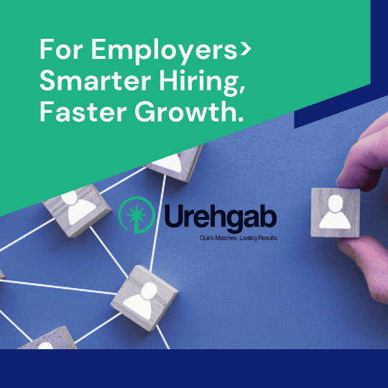Your goal is to find top talent and scale your business.

AI in recruitment is designed to help you do just that. Instead of spending hours sifting through hundreds of CVs, AI-powered systems can now do the heavy lifting, identifying candidates whose skills and experience perfectly match your needs.

We are seeing major African players, from financial institutions to manufacturing companies, start to leverage these tools to streamline their hiring processes.

But here is the key: AI doesn’t make the final decision; It provides the shortlist.

It frees up your HR team to focus on what they do best: conducting meaningful interviews, assessing a candidate’s cultural fit, and building the relationships that form the foundation of a successful team.

The human touch remains irreplaceable.

### For Job Seekers: How to Get Noticed by the Machine and the Human

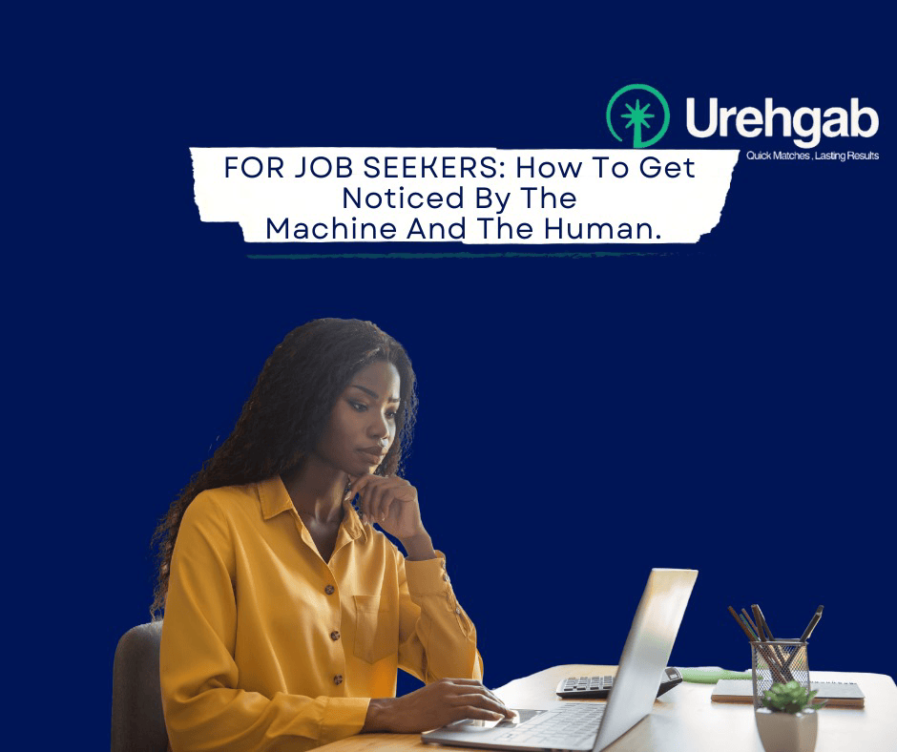If you are looking for your next career move, this new reality is a huge opportunity.

Your CV is no longer just for human eyes; it also needs to be optimized for an AI system.

This means using specific keywords and formatting your resume clearly.

Tools like Andela's Talent Decision Engine, for example, use AI to match talent with roles. Knowing this allows you to tailor your application to speak to both the algorithm and the recruiter.

This also means focusing on your uniquely human skills. While an AI can draft an email or analyze data, it can't lead a team with empathy, innovate on the fly, or build a strong client relationship.

These are the skills that will make you indispensable. The conversations around this are happening everywhere, from tech hubs to the streets of Lagos.

The jobs of the future will be less about routine tasks and more about critical thinking, creativity, and emotional intelligence.

### Our Promise to You

At Urehgab, we are at the forefront of this change.

We use the latest technology to give our clients access to the best candidates, and we provide our job seekers with the resources they need to stand out in a competitive market.

We are more than just a recruitment agency; we are a strategic partner dedicated to helping you adapt and thrive.

Ready to find your next great hire or your next big career opportunity?

**CTA:**

(Click here to explore our services for employers) or (here to browse our current job openings).

Let’s build the future of work together.

Thank you for reading.