Student projects for
Murach’s HTML and CSS (6th Edition)
Each of the projects that follows asks you to create a small website of your own. You can do that after you complete the first eight chapters. Then, you can enhance the initial version of your website as you read the rest of the chapters.
Specifications for the starting versions of all of the projects

Prerequisites
- Chapters 1 through 8
- (Optional) Chapter 16

General
- Develop a website that consists of at least three pages: a home page and two other pages.
- You decide what subject you’re going to use for your website. It can be about you, a relative, a friend, a pet, a course, a hobby, a product, an issue…you decide.
- Be sure that you know enough about the subject of your website so it will be easy for you to create the content for your pages. If possible, you should also have three or more related image files that you can use in your web pages.

Content
The goal of these projects is to give you a chance to develop a small website using HTML and CSS, not to create content. With that in mind, you should feel free to:
- Copy content from other websites or sources and adapt it to your own website
- Copy images from other websites or sources

Basic skills
As you develop your website, you should demonstrate your HTML and CSS skills. The initial version of your website should show your mastery of:
- Headings, text, and character entities
- Links and lists
- Images
- Margins and padding
- Borders and backgrounds
- Flexbox layout
- Navigation menus
- Responsive web design

Design, graphics, and typography
- Use the guidelines presented in this book, especially in chapter 16, to make the design of your website as effective as possible.

HTML and CSS files and directories
- The HTML file for the home page should be named index.html.
- The names of the other pages should indicate what the pages represent.
- The HTML files for the website should be stored in the root directory.
- The CSS files for the website should be stored in a directory named styles.
- The images for the website should be stored in a directory named images.
Section 2 enhancements

Chapter 9: Lists and Links
- Improve the lists.
- Improve the links.

Chapter 10: Images, icons, fonts, and colors
- Add an image to a figure that includes a caption.
- Download and use one or more icons.
- Use an embedded font.

Chapter 11: Tables
- Add a table that presents tabular data.

Chapter 12: Forms
- Add a form that lets the user submit data such as first name, last name, email address, and comments.

Chapter 13: Audio and video
- Add audio or video.

Chapter 14: Grid layout
- Redo your home page to use grid layout.
- Use grid layout to implement a complex page layout.

Chapter 15: More CSS skills
- Add a transition or a transform that uses a transition.
- Add an animation.
Section 3 enhancements

Chapter 16: Users, usability, and web design
- Improve the usability of one or more of your pages.

Chapter 17: Deployment
- Deploy your website to the internet for testing.
Project 1: One two-column layout
This project asks you to develop a website that consists of a home page and two or more other pages, all with a header, two columns, and a footer.

The layout for all pages
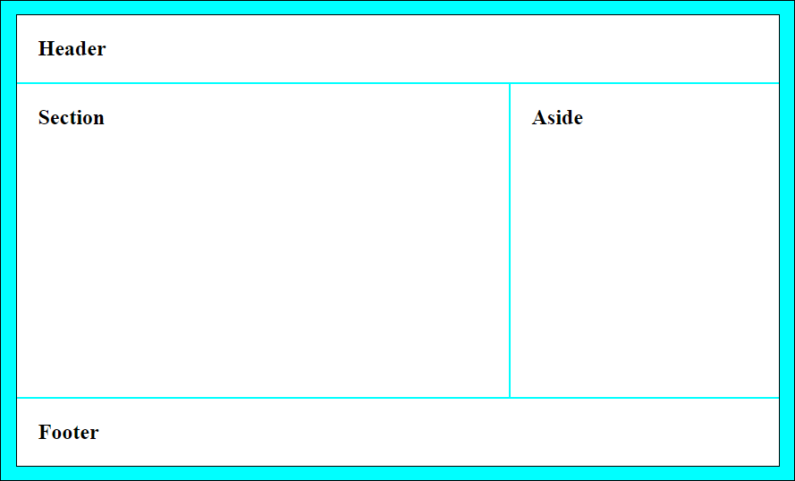

Page layout
- The header for each page should include a website title and a tag line, but a logo image is optional.
- You don’t have to use borders for any of the components of a page. The layout shown above is just intended to show you the layout for the components of the pages.

Page contents
- The home page should include an image and text.
- The home page should include an unordered or ordered list. This list can be in the section or the aside.
- The aside for the home page should include at least two links to other pages. The asides for the other pages should include at least a link back to the home page.
- Beyond these minimal specifications, present your content in whatever way you think works the best. Have some fun with it.
Project 2: Multiple two-column layouts
This project asks you to develop a website that consists of a home page and two or more other pages, all with a header, two columns, and a footer. However, the home page and the other pages have different page layouts.

The layout of the home page
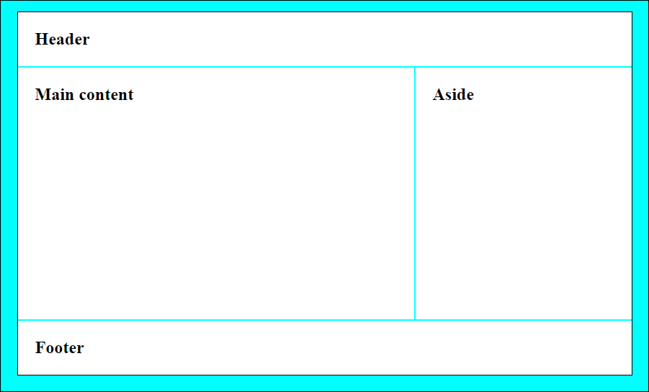

The layout of the other pages
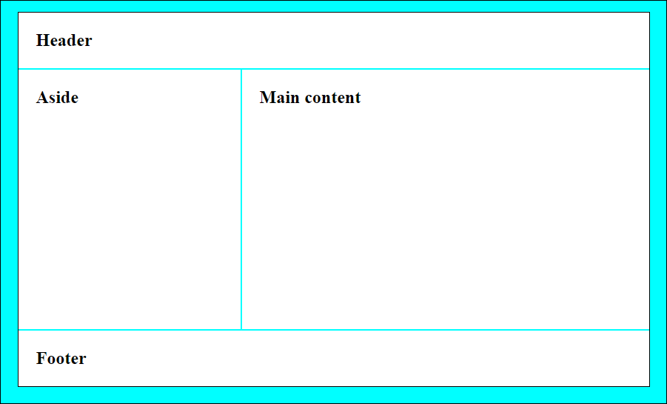

Project 3: Three columns for the home page and two columns for other pages
This project asks you to develop a website that consists of a home page and two or more other pages. For this project, the home page has three columns, and the other pages have two columns.

The layout of the home page
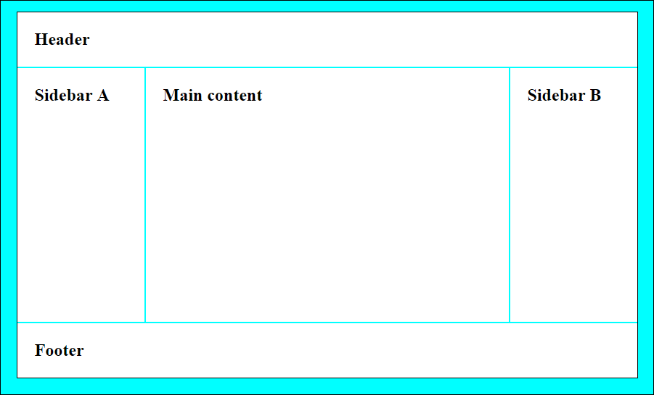

The layout of the other pages


Sample project
The pages that follow illustrate an acceptable implementation of the page layout described in project 2. These pages should give you an idea of what you can do as you develop your own project.

Home page on large screens (desktop)
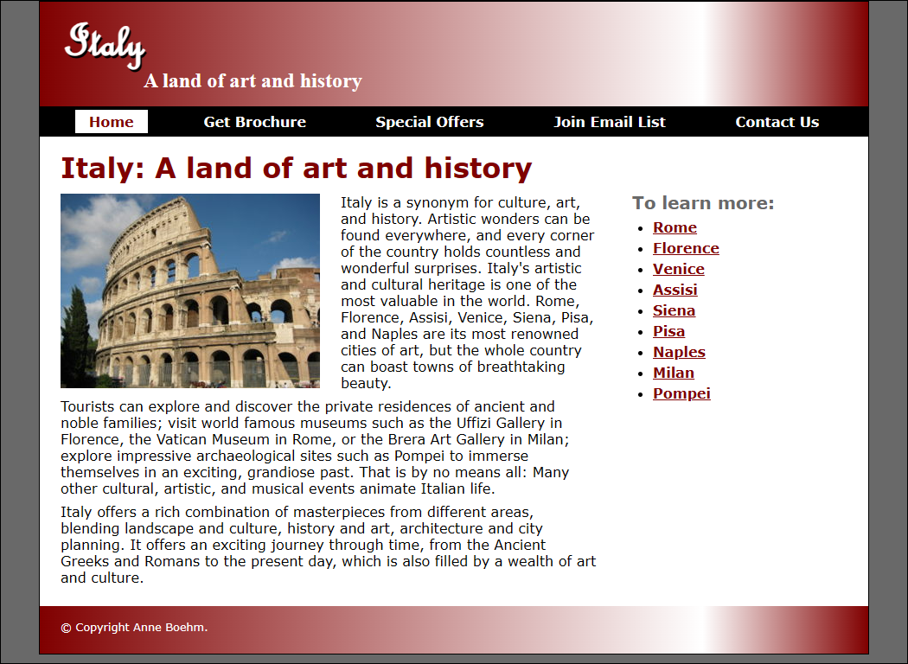

Features
- Various heading levels and fonts including an embedded font
- 2-column layout with section on the left and aside on the right
- Text with floated image in the section
- List with links in aside
- Fluid layout
- Scalable image in section
- Horizontal navigation menu
- Gradient in header and footer
- Character entity in footer

Home page on small screens (mobile)
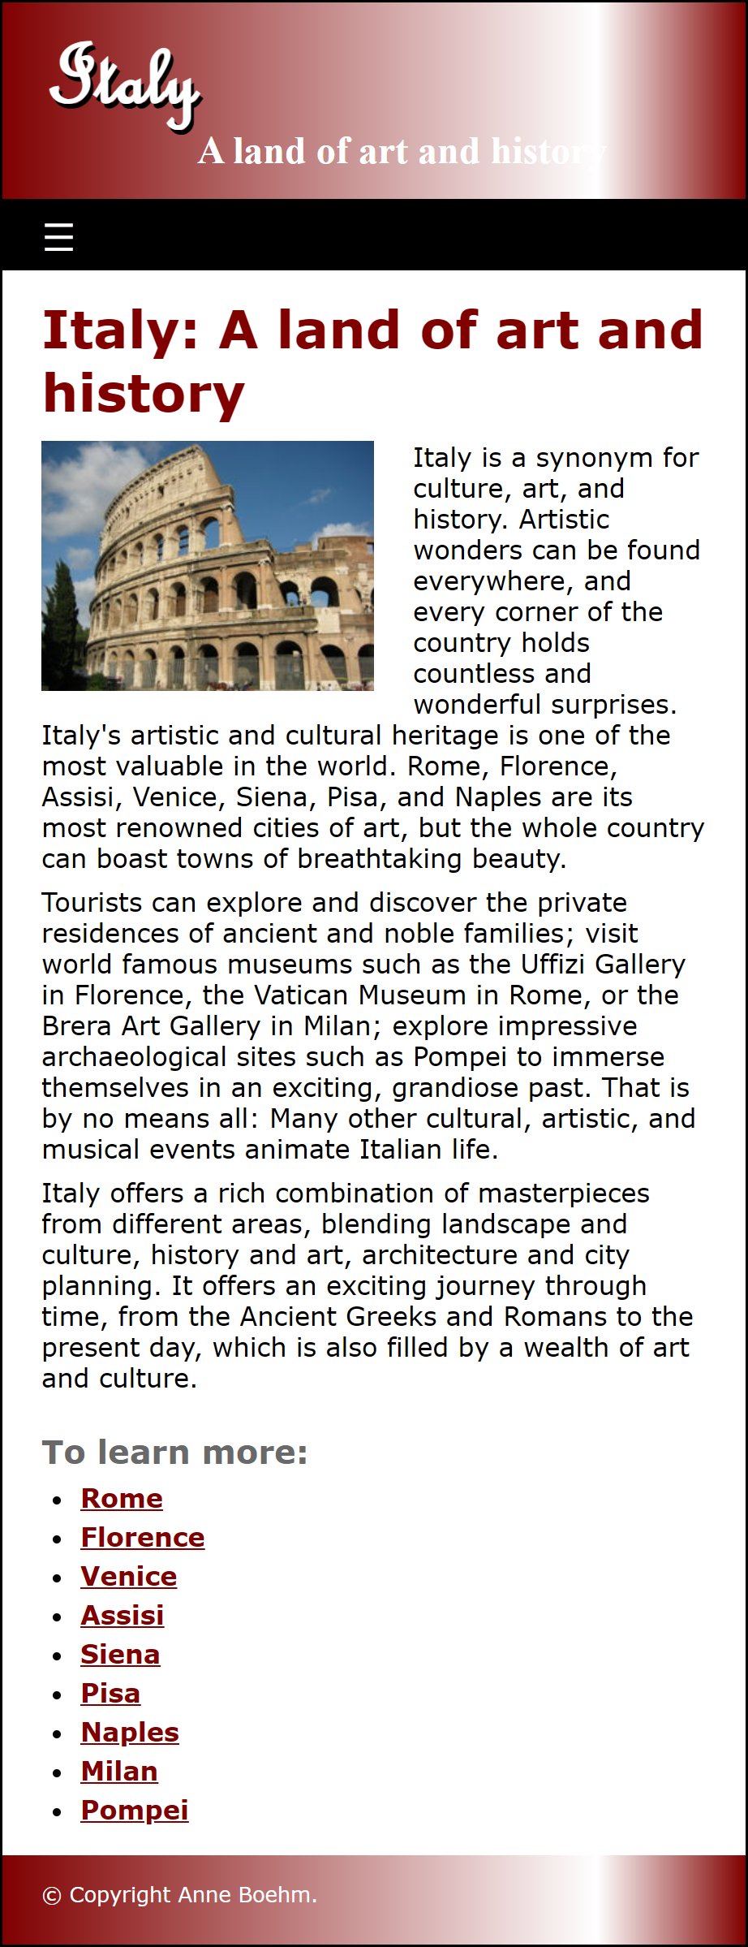

Features
- 1-column layout with a section followed by a sidebar
- Hamburger menu icon provides access to drop-down navigation menu

Brochure page on large screens (desktop)
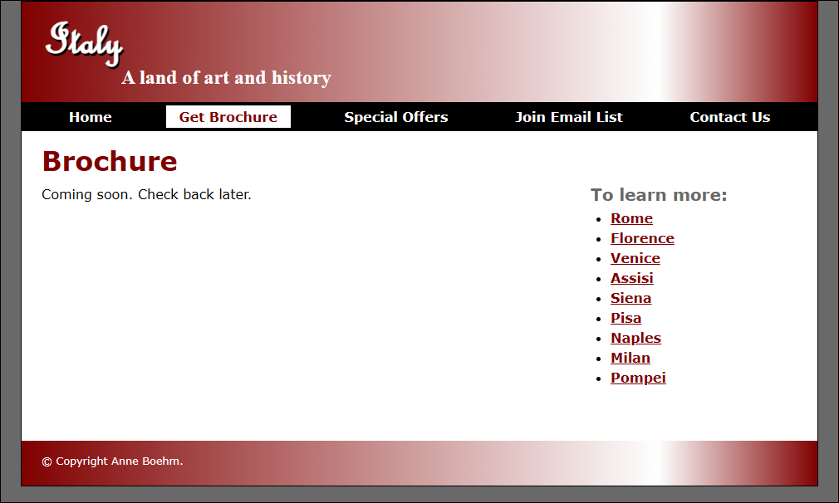

Brochure page on small screens (mobile)
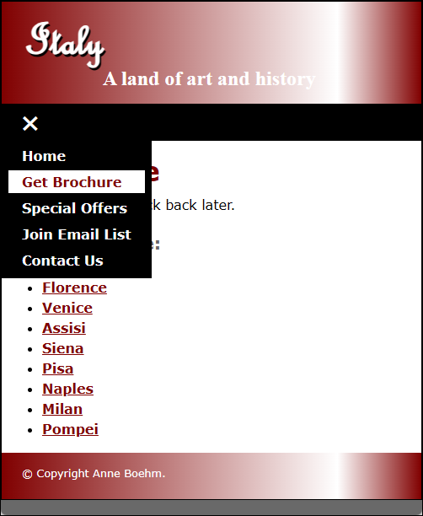

Features
- The navigation menu works like the home page, but the “Get Brochure” item is the current item, and the Home item links to the home page.

City page on large and small screens
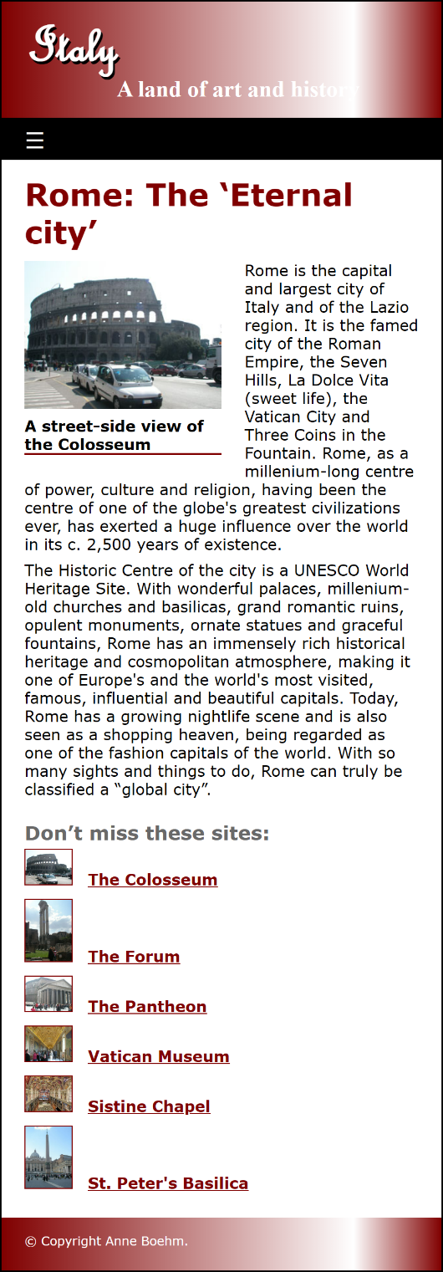
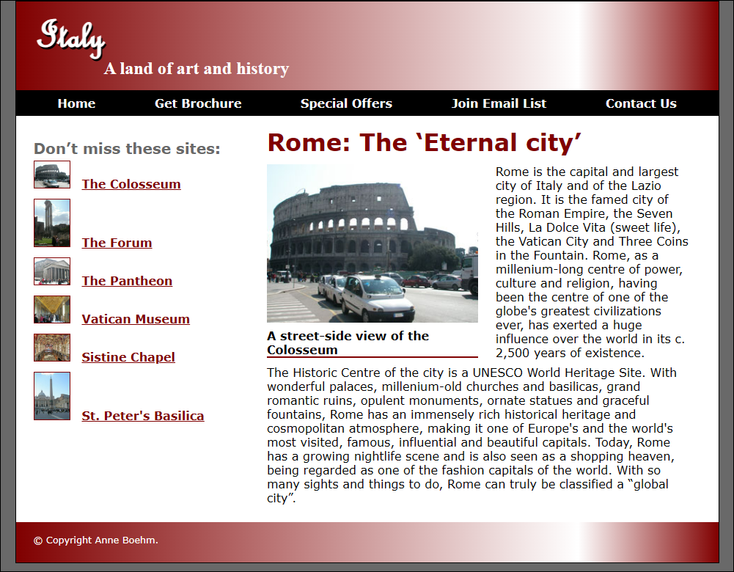

Features for small screens
- 1-column layout with aside below
- Image links in aside
- Figure with image and caption

Features for large screens
- 2-column layout with left aside

Site page on large screens (desktop)
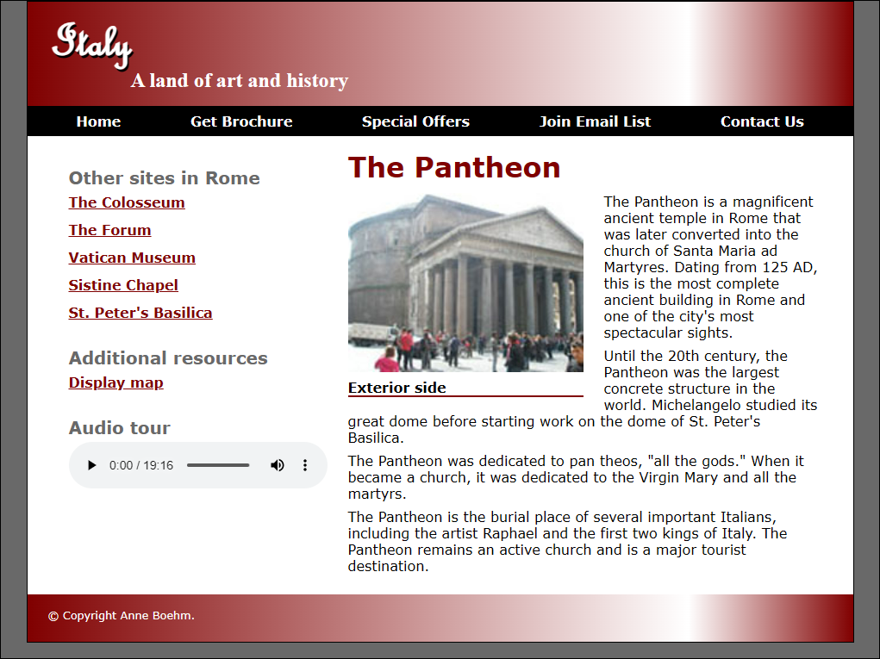

Features
- Controls for playing an audio file
- A link to a PDF file

