Pharmaceutical Report - Ethics, Privacy, Security and Dementia Medication EDA
Exploratory analysis of donepezil hydrochloride and rivastigmine, 2020-2024

Ethics, Privacy and Security

Ethical considerations
This project examines associations between socioeconomic deprivation, time and pharmaceutical dispensing across New Zealand health districts. Care is required when interpreting differences between districts or population groups. Differences in dispensing should not be presented as evidence that people living in more or less deprived areas behave in a particular way, or that socioeconomic status itself directly causes differences in medication use. Other factors, such as population size, age structure, access to healthcare and differences in health needs, may also influence dispensing patterns.
The data are observational and aggregated, so the analysis can identify patterns and associations but cannot establish causal relationships. For example, an association between deprivation and the dispensing of dementia medications would not by itself show that deprivation caused the difference. Conclusions will therefore be phrased in terms of associations rather than causation.
There is also a risk of stigmatising particular districts or socioeconomic groups when presenting geographic differences. Results should be reported neutrally and with appropriate context rather than describing areas as better or worse based only on their pharmaceutical dispensing. Raw dispensing counts should also be interpreted carefully because districts have different population sizes. Population-adjusted rates are therefore used alongside raw counts in the exploratory analysis.

Privacy considerations
The pharmaceutical data used in this project are aggregated at the health-district level rather than containing individual patient-level records. This reduces privacy risk because the analysis is not intended to identify individual people. However, privacy remains important when counts are very small.
Small values in the pharmaceutical dataset are suppressed and represented as <6. These suppression rules help reduce the possibility of information about small groups being disclosed. The analysis therefore does not attempt to reconstruct or publish the exact original values behind suppressed observations.
For the exploratory analysis, suppressed observations were treated as values within the range 1-5 and imputed as 3, the midpoint of that range. An indicator was retained to record which observations had originally been suppressed. This allows the observations to remain in the analysis without presenting the imputed value as the true underlying count.
The population estimates and deprivation data are used at aggregated geographic levels. Results combining these data with pharmaceutical dispensing are therefore interpreted at the district level and should not be assumed to describe particular individuals living within a district.

Security considerations
The project data and analysis files should be stored only in locations accessible to members of the project group and should not contain unnecessary copies of the datasets. Analysis is carried out using scripted code where possible so that data transformations are transparent and reproducible. Original datasets should also be kept separate from cleaned or transformed versions so that the source data are not accidentally overwritten.
In the work completed so far, data preparation and analysis have been carried out using R scripts, suppressed pharmaceutical counts remain identifiable during cleaning, and results included in the report are aggregated summaries, tables and figures rather than individual-level information.
If additional time and resources were available, further security measures could include restricting access to the project repository and shared files to authorised group members, maintaining regular backups, using version control to track changes to code, and reviewing files before publication to ensure that no sensitive or accidentally reconstructed information is released. Any future use of more detailed health or demographic data would require stronger access controls and additional consideration of privacy.

Dementia medication dispensing
As part of the exploratory analysis, we focused on donepezil hydrochloride and rivastigmine, two pharmaceuticals in the selected dementia-medication subset. Dispensing patterns were examined nationally and across New Zealand health districts from 2020 to 2024.
The dataset contains two dispensing Type categories: Initial dispensings and Dispensings. The analysis presented in this report uses Type = "Dispensings" because the research question concerns total dispensing activity. In the dataset, NumDisps records the number of dispensing events and NumPpl records the number of people who received a dispensing.
Small counts recorded as <6 were treated as values within the range 1-5 and imputed as 3, the midpoint of that range. Indicator variables were retained so that observations originally suppressed remained identifiable. When comparing health districts, the national "New Zealand" total was excluded so that national and district-level observations were not mixed.

National dispensing trends
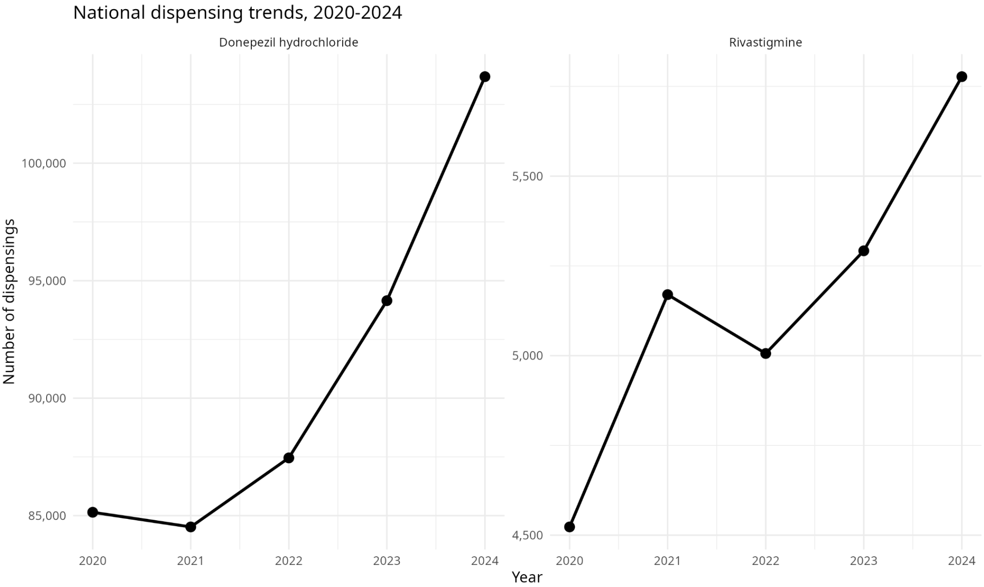
Figure 1. National dispensing trends for donepezil hydrochloride and rivastigmine, 2020-2024.
Figure 1 shows an overall increase in national dispensing of both selected dementia medications. Donepezil hydrochloride decreased slightly between 2020 and 2021 and then increased in each subsequent year. It rose from 85,142 dispensings in 2020 to 103,683 in 2024, an overall increase of 21.8%. Rivastigmine increased from 4,523 dispensings in 2020 to 5,777 in 2024, an overall increase of 27.7%. Although rivastigmine had the larger proportional increase, its dispensing volume remained much lower than that of donepezil.
Year | Donepezil  dispensings | Donepezil  people | Rivastigmine  dispensings | Rivastigmine  people
2020 | 85,142 | 8,582 | 4,523 | 585
2021 | 84,519 | 8,883 | 5,170 | 657
2022 | 87,456 | 9,370 | 5,006 | 667
2023 | 94,148 | 10,348 | 5,292 | 706
2024 | 103,683 | 11,024 | 5,777 | 727
Table 1. National dispensings and people receiving a dispensing, 2020-2024.
Table 1 complements the dispensing trend by showing the number of people who received a dispensing. For donepezil, NumPpl increased from 8,582 to 11,024 between 2020 and 2024; for rivastigmine it increased from 585 to 727. NumPpl is a count of people receiving a dispensing and should not be interpreted as the total resident population of a health district.
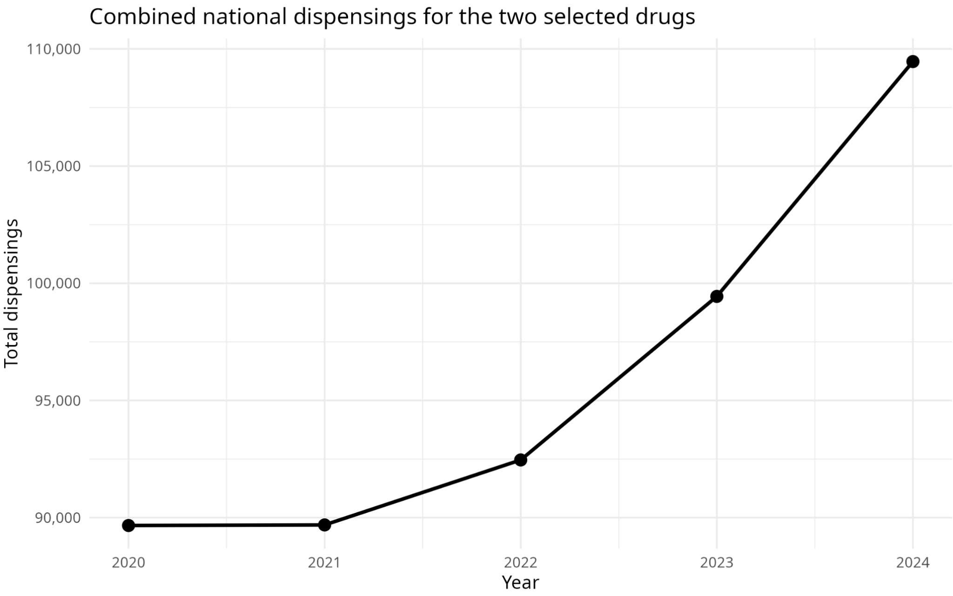
Figure 2. Combined national dispensings for donepezil hydrochloride and rivastigmine, 2020-2024.
The aggregated view shows that combined dispensing of the two selected medications increased from 89,665 in 2020 to 109,460 in 2024, an increase of approximately 22.1%. This provides a simple overall view while Figure 1 retains the separate drug-level trends.

Geographic variation in 2024
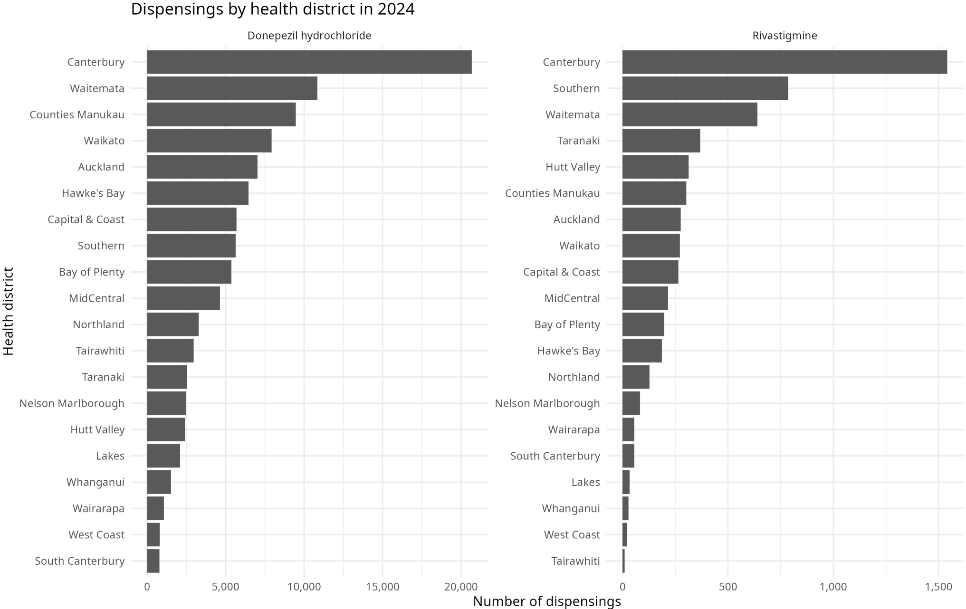
Figure 3. Number of dispensings by health district in 2024, using separate x-axis scales for each medication.
Figure 3 shows substantial geographic variation in dispensing volumes across health districts in 2024. Canterbury recorded the highest raw dispensing count for both medications, with 20,680 donepezil dispensings and 1,541 rivastigmine dispensings. Donepezil dispensing was also relatively high in Waitemata, Counties Manukau and Waikato. The separate x-axis scales make the distribution of the much smaller rivastigmine counts visible rather than compressing them against the donepezil scale.
These are raw dispensing volumes and should not be interpreted as evidence of higher medication use per person. To provide population context, the analysis also uses Stats NZ estimates of the population aged 65 years and over, a more relevant denominator for a dementia-medication analysis than total population.

Population-adjusted geographic context
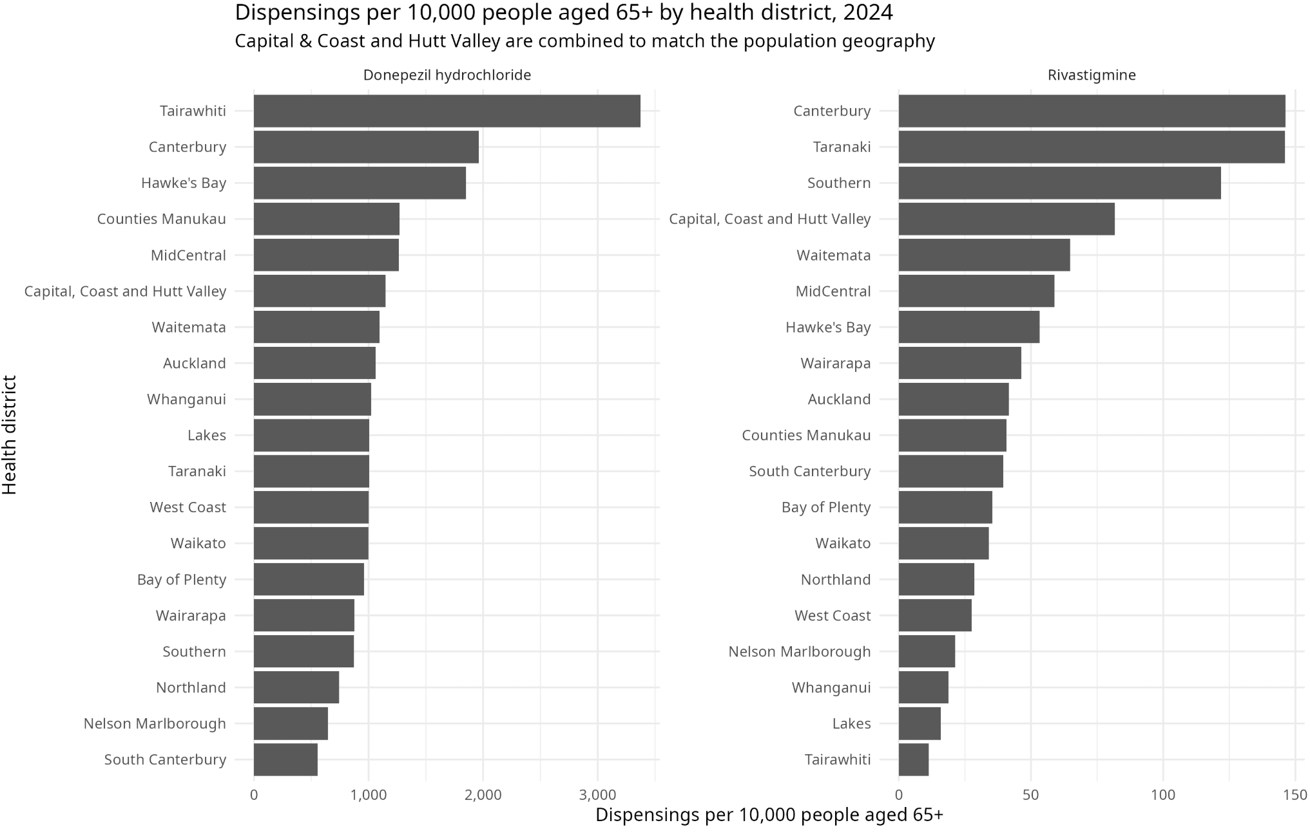
Figure 4. Dispensings per 10,000 people aged 65+ by health district in 2024.
Figure 4 adjusts 2024 dispensing counts using the estimated population aged 65 years and over. The population dataset combines Capital & Coast and Hutt Valley into a single geography, so dispensing counts for those two pharmaceutical districts were combined only for this population-adjusted analysis. All remaining district names matched after harmonising Tairawhiti and Waitemata spelling conventions.
The population-adjusted view changes the geographic interpretation. Tairawhiti has the highest donepezil dispensing rate at approximately 3,374 dispensing events per 10,000 people aged 65+, while Canterbury is second at approximately 1,962 per 10,000. For rivastigmine, Canterbury and Taranaki have the highest rates, both close to 146 dispensings per 10,000 people aged 65+. These are rates of dispensing events, not the percentage of older residents taking the medicine, because one person may receive multiple dispensings during a year.
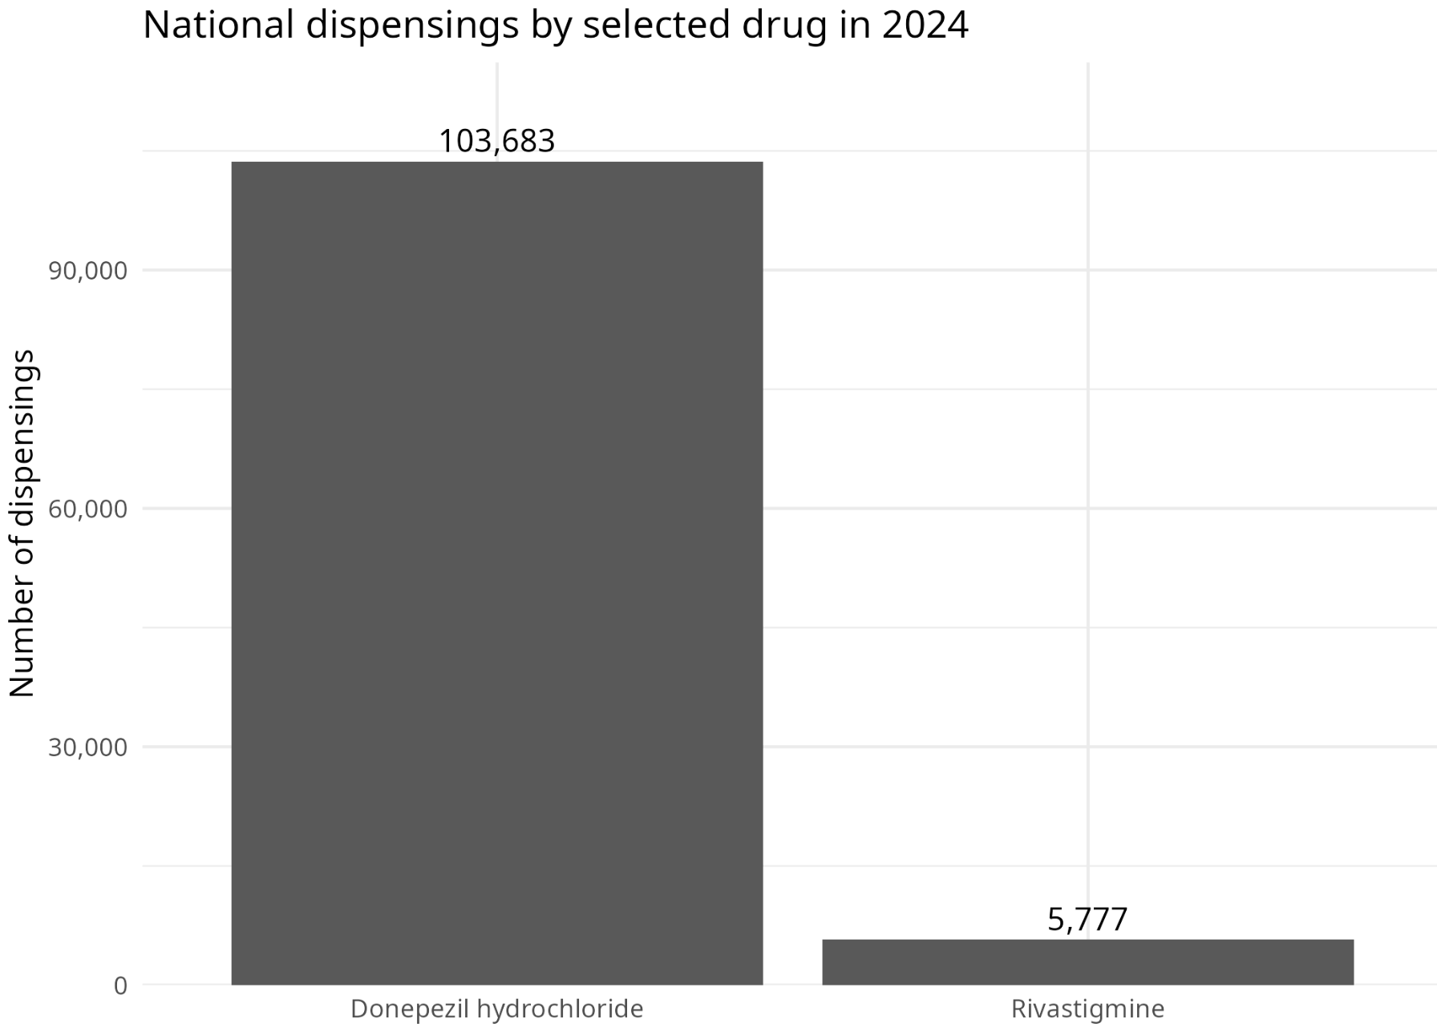
Figure 5. National dispensings of donepezil hydrochloride and rivastigmine in 2024.
Figure 5 separates the overall drug-level comparison from the district comparison. Donepezil accounted for 103,683 national dispensings in 2024 compared with 5,777 for rivastigmine. This difference in scale is important when interpreting percentage changes, because relatively small absolute changes in rivastigmine can produce large proportional changes.

Annual change over time
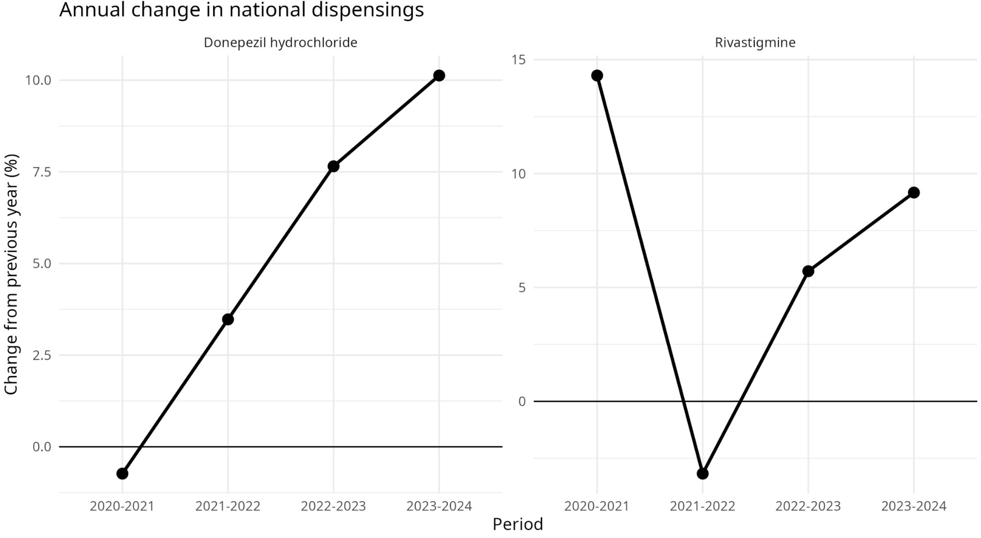
Figure 6. Annual percentage change in national dispensing for each selected medication.
Figure 6 shows that the overall increases were not uniform across the study period. Donepezil decreased by 0.7% from 2020 to 2021, then increased by 3.5%, 7.7% and 10.1% in successive years. Rivastigmine increased by 14.3% in 2020-2021, decreased by 3.2% in 2021-2022, and then increased by 5.7% and 9.2% in the final two periods. Reporting annual changes reveals variation that is hidden by a simple 2020-to-2024 endpoint comparison.
Pharmaceutical | 2020-21 | 2021-22 | 2022-23 | 2023-24 | Overall  2020-24
Donepezil hydrochloride | -0.7% | +3.5% | +7.7% | +10.1% | +21.8%
Rivastigmine | +14.3% | -3.2% | +5.7% | +9.2% | +27.7%
Table 2. Annual percentage change in national dispensing, 2020-2024.

Relative district trends over time
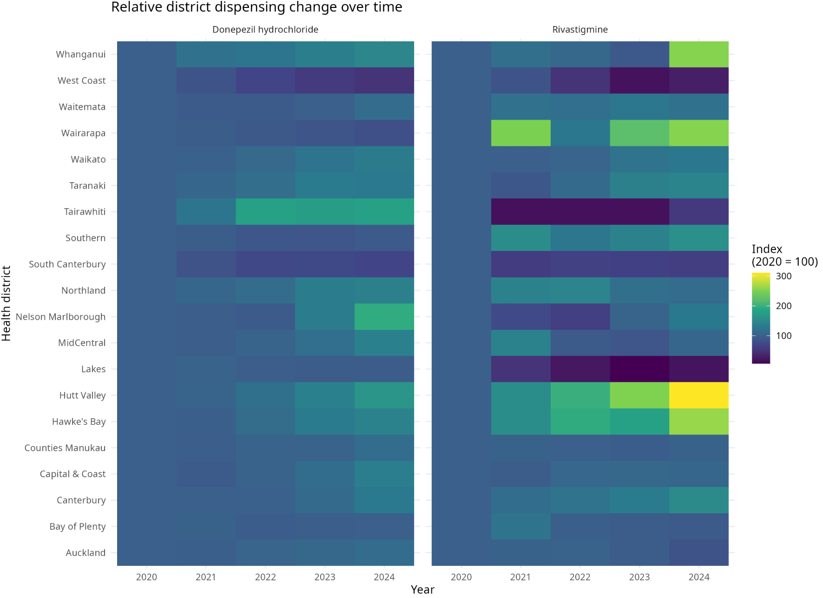
Figure 7. Relative district dispensing change over time, indexed to 2020 = 100.
Figure 7 replaces the earlier cluttered multi-line district plot with an indexed heatmap. Each district is compared with its own 2020 level, making relative changes easier to compare while preserving the distinction between the two medications. The heatmap highlights, for example, strong relative growth in Hutt Valley rivastigmine dispensing and marked declines in Lakes and West Coast, while donepezil growth is more broadly distributed across several districts.

Selected district-level changes
Rather than presenting all district percentage changes in a single crowded figure, Tables 3a and 3b highlight the largest percentage increase, largest percentage decrease and largest absolute increase for each medication. The complete district-change table is retained separately for the appendix / supporting analysis.
District | 2020 | 2024 | Absolute change | Change (%) | Reason selected
Nelson Marlborough | 1,268 | 2,469 | +1,201 | +94.7% | Largest percentage increase
West Coast | 1,612 | 802 | -810 | -50.2% | Largest percentage decrease
Canterbury | 15,921 | 20,680 | +4,759 | +29.9% | Largest absolute increase
Table 3a. Selected district-level changes for donepezil hydrochloride, 2020-2024.
District | 2020 | 2024 | Absolute change | Change (%) | Reason selected
Hutt Valley | 101 | 314 | +213 | +210.9% | Largest percentage increase
Lakes | 173 | 33 | -140 | -80.9% | Largest percentage decrease
Canterbury | 1,007 | 1,541 | +534 | +53.0% | Largest absolute increase
Table 3b. Selected district-level changes for rivastigmine, 2020-2024.
The selected results show why percentage and absolute changes need to be considered together. Nelson Marlborough had the largest proportional increase in donepezil, but Canterbury added many more dispensings in absolute terms. For rivastigmine, Hutt Valley increased by approximately 210.9% from a comparatively small baseline of 101 dispensings. Large percentages based on small starting counts should therefore be interpreted cautiously.

EDA summary
Overall, the exploratory analysis indicates increasing national dispensing of both selected dementia medications, with variation across years and health districts. Population adjustment shows that the districts with the largest raw dispensing counts are not always those with the highest dispensing activity relative to the older population. These results provide a stronger basis for the next stage of the project, where dispensing patterns can be examined alongside district-level socioeconomic deprivation while continuing to avoid causal interpretation of observational associations.

