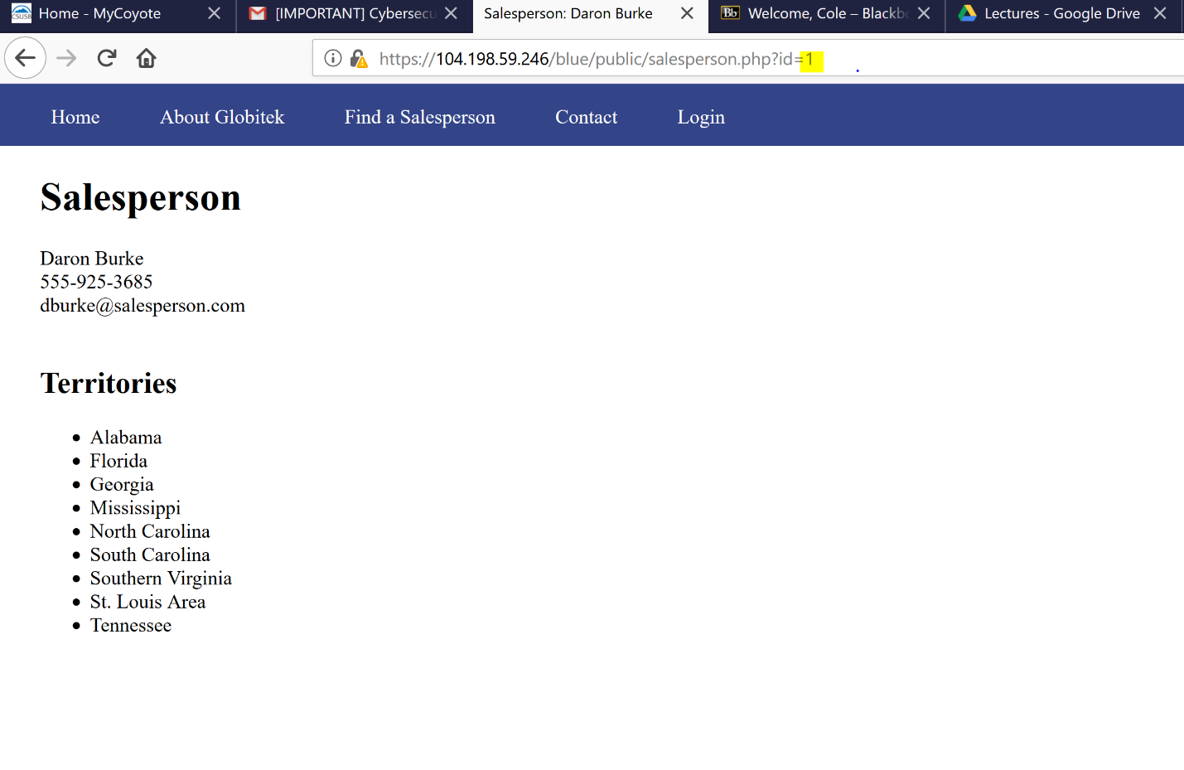

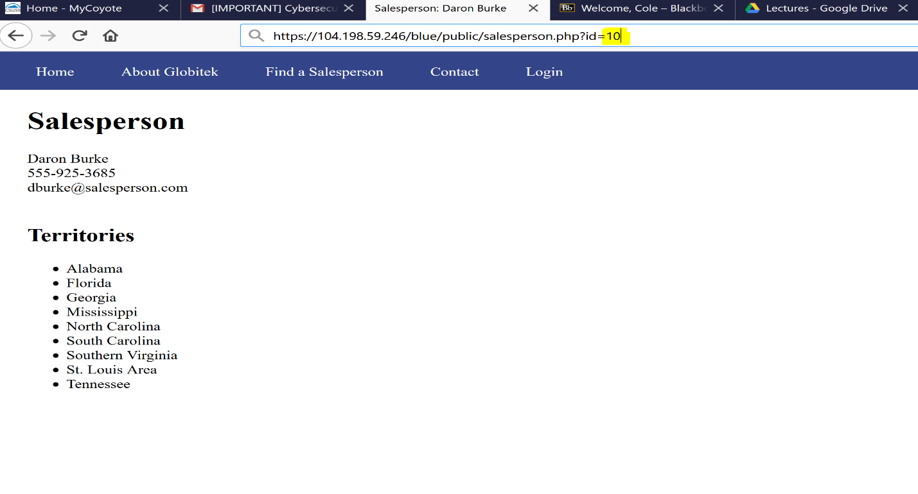

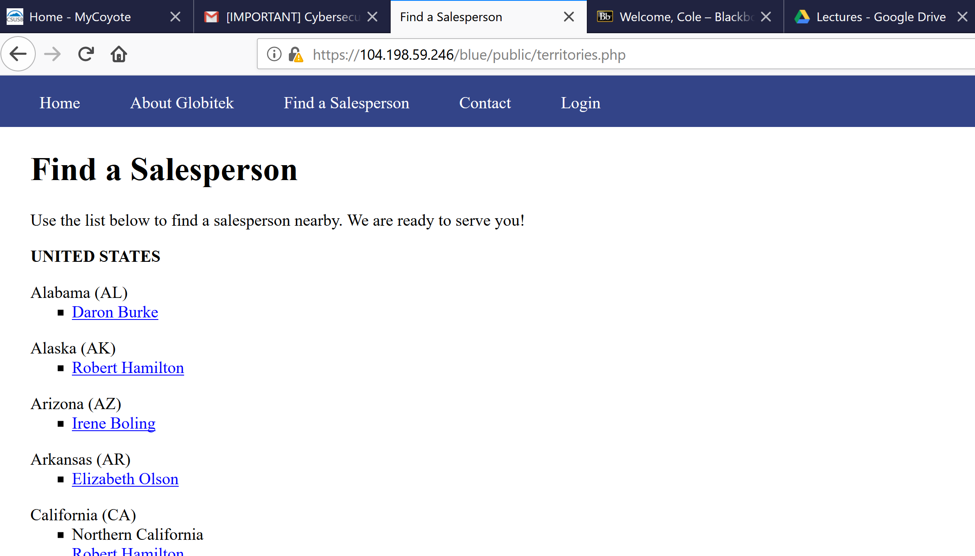

* The blue site wouldn’t allow IDOR attack as you can see from above.
* To start this attack, begin by add a different number into URL or HTML code.

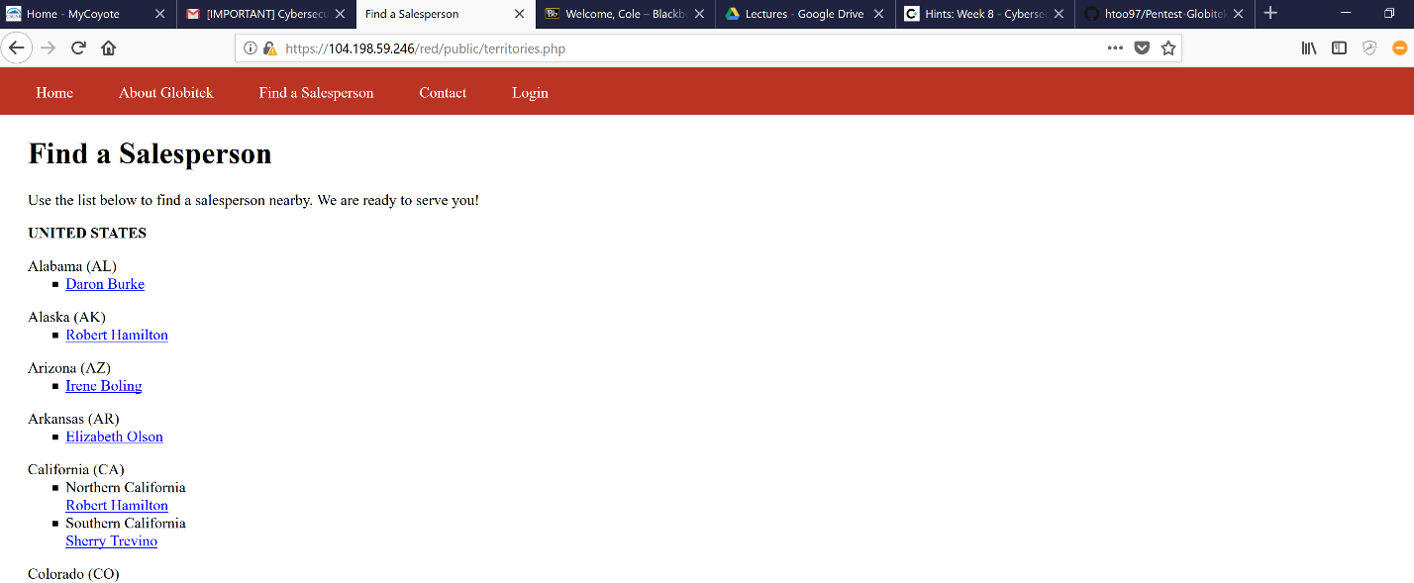

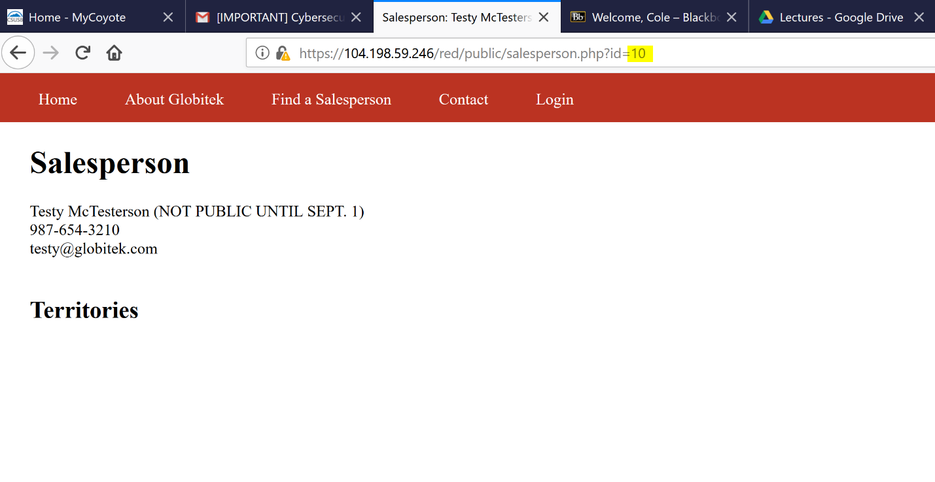

* The red site would allow an IDOR attack, by playing with the URL or HTML code.
* The why found this attack was playing with URL bar.
* This attack allow the hackers to change or shut down the site.