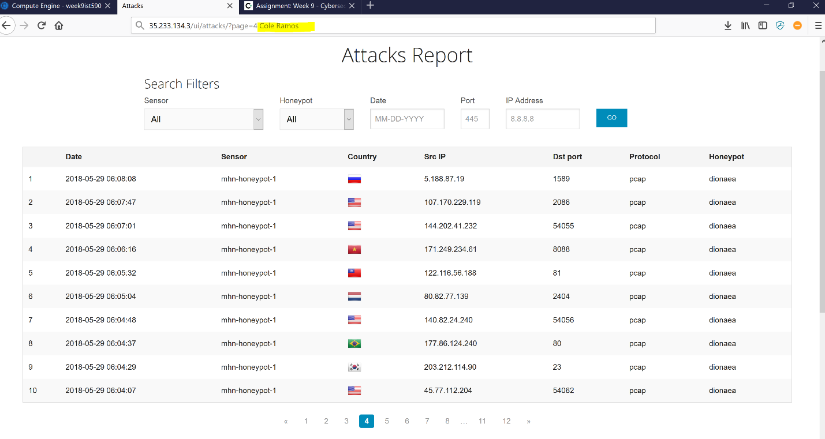

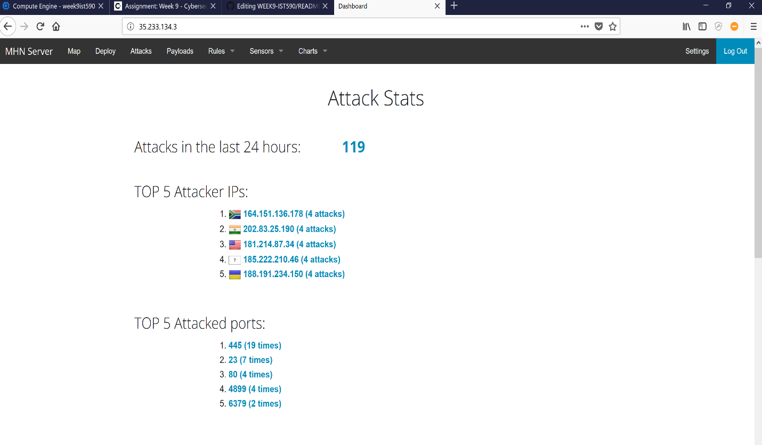

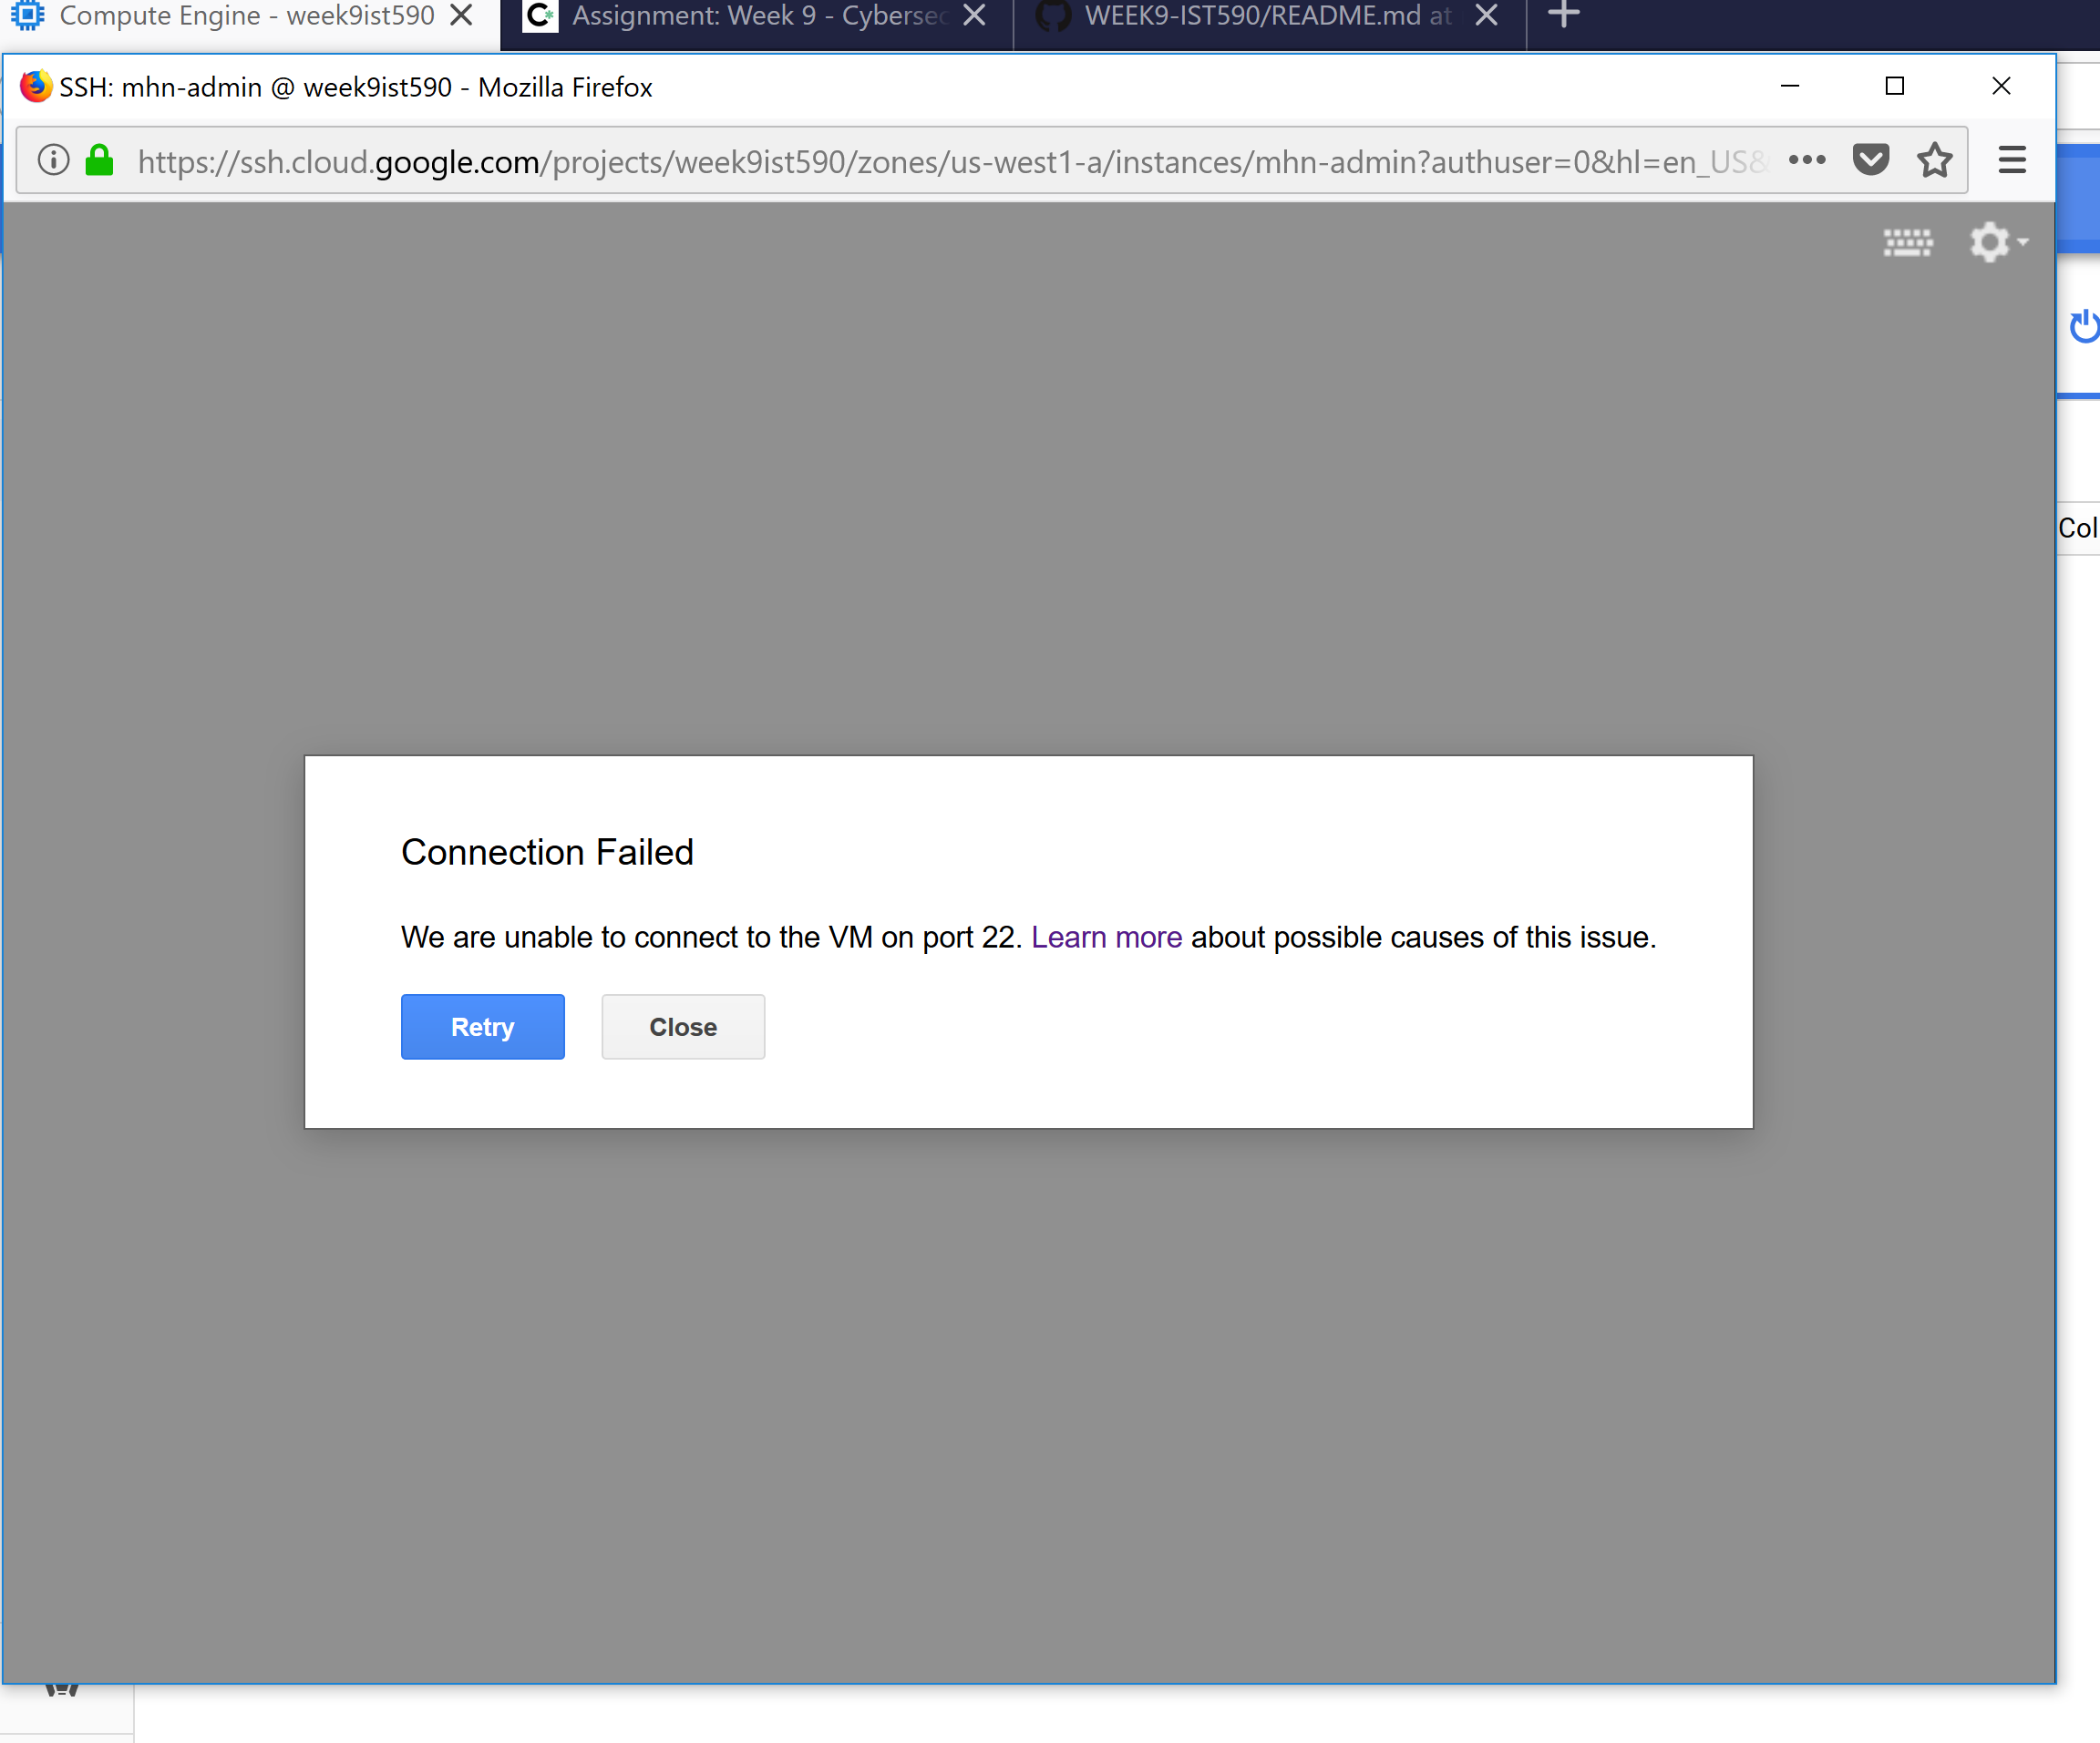

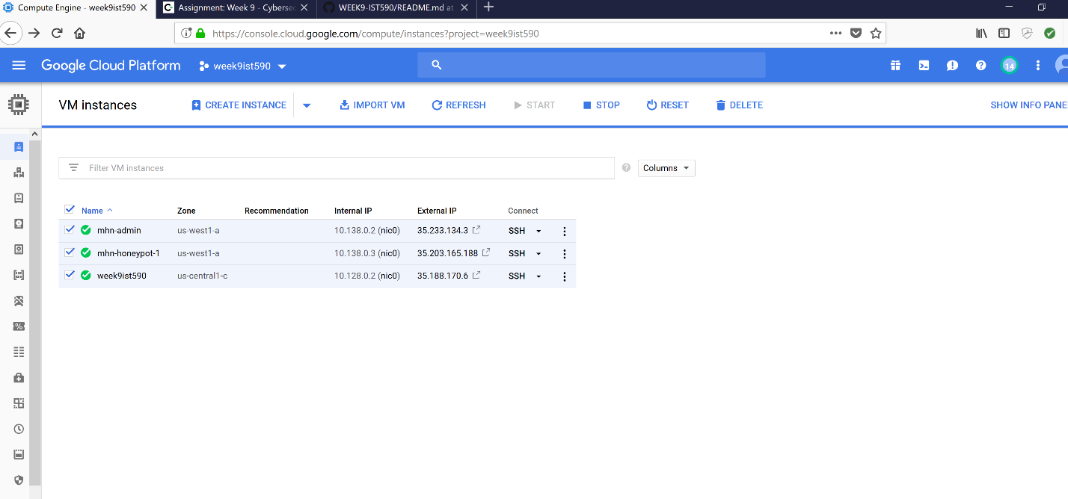

* The information above show attack on my honeypot, and breakdown of the what I did.
* Issue with creating session.json file after completing attack mhn-admin wouldn’t connect to my port 22. Still trying to troubleshoot, by re-connecting and re-confining the firewall rule, and will follow up with update.