1. It already does on line 13

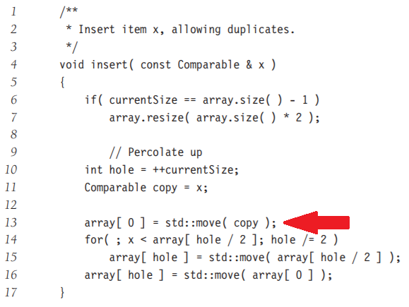

1. The running time of heapsort for pre-sorted input is the same and the running time for any other input. This is because adding items to the heap is still O(logn) and you still have to do it for each item, resulting in O(nlogn).
2. The table should have half the number elements as the table size before rehashing to a table half as large so that after rehashing, the table will have the same number of elements as the table size.
3. We can add a variable currentDelta to keep track of how much the keys have been decreased. The decreaseAllKeys function would simply need to decrease the currentDelta variable. Then, all of the other methods would need to be modified to consider the currentDelta when checking the keys of the items in the heap.
4. A, B, C, D, E, and G are strongly connected. F is not strongly connected to the graph because not all vertices are reachable from F. Within the larger strongly connected group of A, B, C, D, E, and G, there are several smaller groups which are strongly connected together:

A, B, C

A, B, C, D

A, B, C, E, D

A, B, G, E, D

A, C, D

A, C, E, D

1. See CuckooHash.cpp
2. See RoundRobin.cpp