**Daily Scrum or Standup Meeting**

Team name: Team 8

Scrum Master: Colton Hill

Date: Feb 27 2020

|  |  |  |  |
| --- | --- | --- | --- |
| **Team Member** | **What did you do since the last scrum?** | **What do you plan to do before the next scrum?** | **What obstacles do you have?** |
| Sally D. | Research / setup | Work on account creation with Jace. Create the layout of the landing page for an auction and coordinated the api calls with Jace. | Spring break trip |
| Connor G. | Backlog updates | Work on the Auction joining. Admin privileges of making an auction private and public. Users are able to see certain auctions. Create codes to join private auctions. | My understanding of the project, coding capabilities, understanding my purpose in this world, and being gone most of spring break. |
| Hunter H. | Docker, project layout. | Get docker finalized, get the Users database system working. Be less burnt out. | MATH2210 |
| Colton H. | Research/Planning | Have a prototype of the Item database that will allow for API development.   * Research examples * Make basic unit test * Overcome Existential Crises | What’s a PostgreSQL?   * Framework interaction * Quality control * Learn Dependencies |
| Jace L. | Research/setup | Work on the authentication api and hopefully get that up and running before the next sprint. | Learning the technology, understanding exactly what I’m doing, work with others as their databases are being created. |

# Burndown

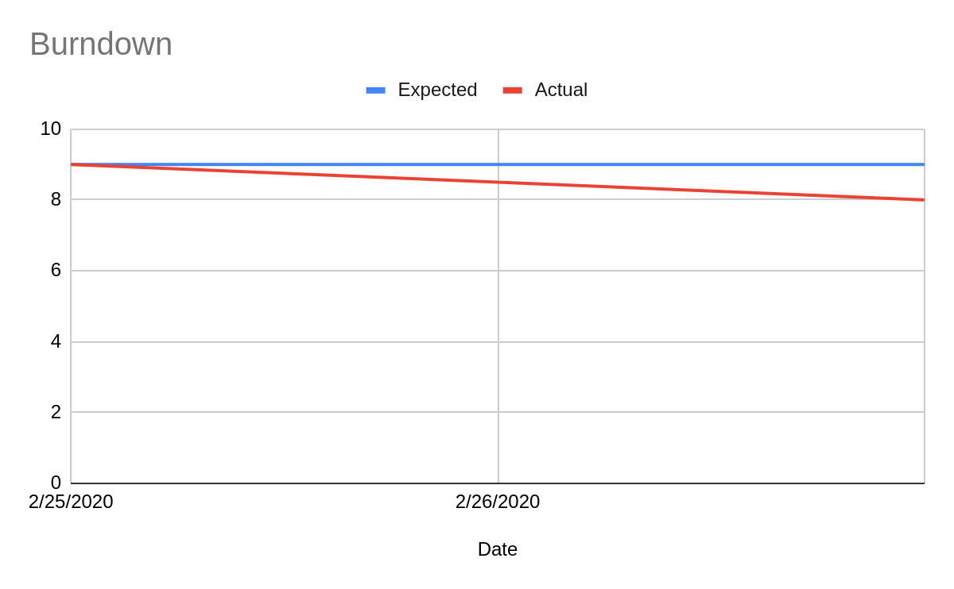

# Screenshot of you project board

