**Daily Scrum or Standup Meeting**

Team name: Team 8

Scrum Master: Colton Hill

Date: 3/10/2020

|  |  |  |  |
| --- | --- | --- | --- |
|  |  |  |  |
| **Team Member** | **What did you do since the last scrum?** | **What do you plan to do before the next scrum?** | **What obstacles do you have?** |
| Sally D. | Work on account creation with Jace. Create the layout of the landing page for an auction and coordinate the api calls with Jace. | Finish at least the two auction landing pages and make them look nice and have pretend skeletons for the unmade API. | Other classwork  Tailwind and styling stuff:( |
| Connor G. | Work on the Auction joining. Admin privileges of making an auction private and public. Users are able to see certain auctions. Create codes to join private auctions. | Hopefully I will finish my tasks. Talk with Hunter, understand the project better and get help with membership kicking/banning. | life, Discrete Math, building a pc, and other stuff. |
| Hunter H. | Got docker finalized, got the Users database system working. | Finish the Auction Membership backend/database. | MATH2210, Outside Commitments (mainly HvZ) |
| Colton H. | RHave a prototype of the Item database that will allow for API development.   * Research examples * Make basic unit test * Overcome Existential Crises | Make working tests  Make migrations  Add support for queries | * Syntax * ignorance |
| Jace L. | Learned node.  Started the basics of the authorization API. API currently can be reached, but can’t do much. I am currently working on the ability to allow a registration of a user. | Work on registration and directions to redirect once finished. | ditto ^  knowledge of what to do with correct/incorrect data.  testing |

# Burndown

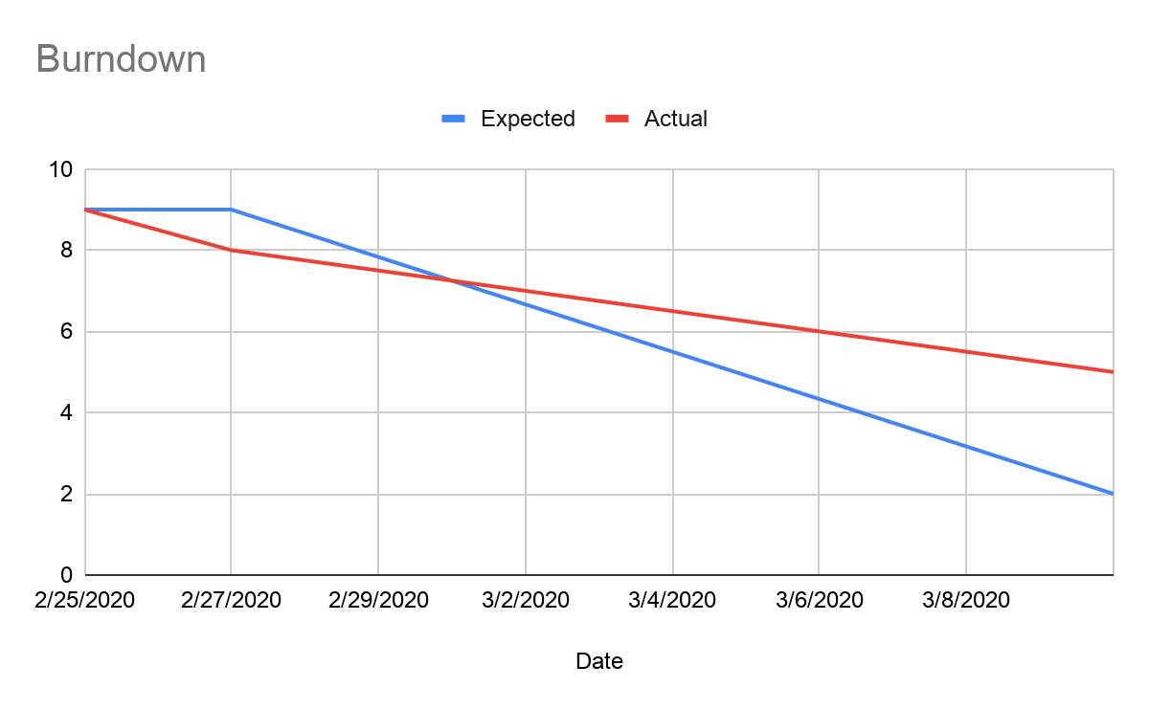

# Screenshot of your project board

